## **EECS 1500: Introduction to Programming - Laboratory 1 Week of January 22, 2024**

### Introduction

In this lab, we will try to familiarize you with the Visual Studio integrated development environment and have you input, run, modify, and submit a program. This is a dry run for the projects that you will be assigned during the semester.

### Step 1: Start Visual Studio

Go to the “Start” menu in the lower left-hand corner and select Visual Studio 2022 from the listed programs. This should start up Visual Studio. If you encounter a screen asking for you to sign into or create a Microsoft Account, you should be able to choose “not now”. Once the application finishes loading you should see a screen like the one shown below (or a slightly different one if you have never opened it before – I showed that example in class):

Choose “Create a new project” from the list on the right-hand side. This will take you to a screen with different types of projects that you can start.

You should choose to open an “Empty Project.” You may have to scroll through the list to find the empty project but it should be in the list. This starts you out fresh. Click on the “Next” button. This will let you name and choose a location for your project. The screen appears as: Graphical user interface, application

You should be able to type in only the Project Name – you may want to place your project on OneDrive, and this should work – you will need to change the location if that is your intention. Type in the name “Lab1LastName” in the space for the Project Name and then click on “Next.” Replace “LastName” with your last name.

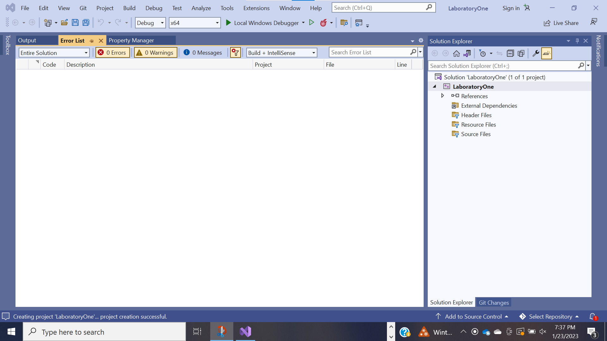

### Setting up You r File

On the right-hand side where it says “Source Files” do a right click. A menu should appear, and you should select “Add” > “New Item” You should have a window appear that looks similar to the one below: Graphical user interface, application

Replace the “Source.cpp” with “Laboratory.cpp” and then click on the Add button. When you return to the screen you should see a file Laboratory.cpp under the Source folder on the right hand side. Double click on the Laboratory.cpp file and an empty tab should appear in the application – this is the current state of your file (It is empty). We will fix that in a moment.

Start a browser and log into BlackBoard (if you are not already in BlackBoard). Go to this weeks materials and you should find a file “Starter.cpp”. Click on the file. The source should come up in your browser. Copy the text from the file and then go back to Visual Studio and paste it into your file. Your application should now look like this:

Before the line with the return 0; on it add the following statement to print out a message:  
 cout << "Who's on First? \n”.

Now, go to the top menu where it says Debug and select “Start Without Debugging.” This will cause the system to build and run your program. It should compile and a window should appear with your output in it:

Congratulations, you have input and run your first C++ program! We will now alter it by filling in the comments section at the top of the file. Where it says <Name of Program> replace it with “First Laboratory.”

Where it says <Your Name> replace it with your name. Where it says <today’s date> type in today’s date. Go up and run your program again and make sure it still works.

Now, we will add a calculation to the program. We will add a calculation for the size of a rectangle – area = length * width; To do this we will add a group of statements above the “Who’s on First” statement. Add the following lines to your program:

float width;

float length;

float area;

length = 4.5;

width = 3.35;

area = length * width;

cout << "Rectangle Area = " << area << "\n";

You should be able to run this program (if you have not made any mistakes in typing the lines in), and it should give you an area of 15.075 units.

### Looking at your source code

Back in Visual Studio go to the left-hand side and right click on the Lab1LastName. A menu should pop up, and close to the bottom, you should see “Open Folder in File Explorer” – do this and you should see a directory that looks like the one that follows: Graphical user interface, application

Now you know how to access the folder location of your code files.

Submission to Blackboard:

You are required to upload a screenshot of your program as well as the command window showing that it exectued properly. You can take multiple screenshots (as shown in the last two figures above) OR you can place the command prompt window over your code without hiding the actual code. Upload a single JPG or PDF file on Blackboard to get full credit for this lab.

If you go to BlackBoard, there will be a spot for you to upload a local file. Browse to the folder where your lab submisison file (jpg or pdf) is and select the file to upload it. Once you have done this you have completed this week’s laboratory. Nice Job!

You will have three attempts to submit your correct files in case you are not able to upload it the first time.