Generative AI, including technologies like large language models and generative adversarial networks (GANs), has become a pivotal force in software development. Why Generative AI can create text, images, music, and even code, providing new opportunities to innovate faster and smarter.

Generative AI can suggest creative solutions, produce ideas, and even create content autonomously. Automates repetitive tasks such as data processing, image generation, and text summarization, saving developers' time. By generating synthetic data or analyzing patterns, generative AI helps us make better, data-driven decisions.

---- TED summarize ----

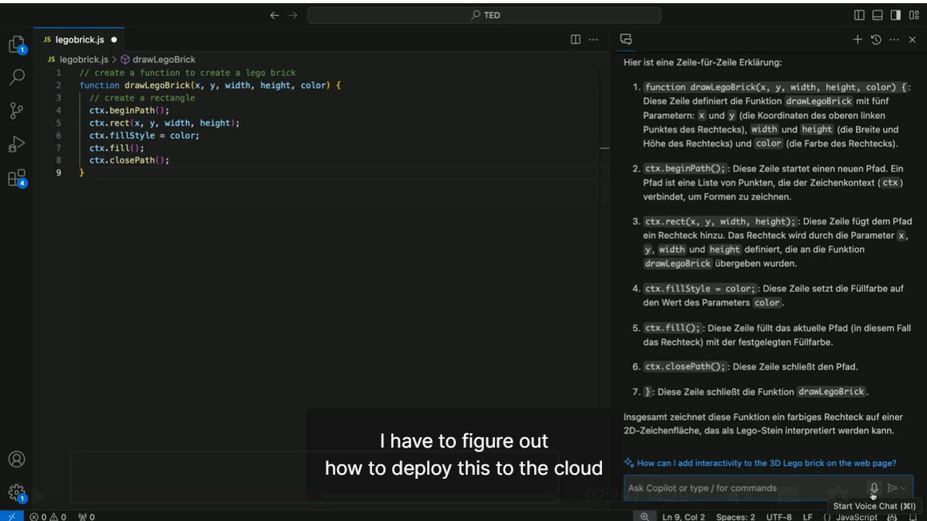

---- Building Software with AI copilot example ----





showing AI communication -> Generated Code -> result

find result

what is limitation and problem of AI copilot

1. version problem

2. business logic security

3. code written by AI copilot makes errors more than we expect

--- conclusion ---

The fact is it enhance productivity of code.