AILYZE PROJECT REPORT

www.ailyze.com

Index

1. Participant_01_hsgu3fx.docx ....

2. Participant_02_1mmSXto.docx ....

3. Participant_03_EiP6OaI.docx ....

4. Participant_04_Hs3jvym.docx ....

5. Participant_05_6COHzUo.docx ....

6. Understanding and Attitude towards Vaccination ....

7. Personal Experience with the Flu Vaccine ....

8. Awareness of Risks and Benefits of the Flu Vaccine ....

9. Parental Understanding and Concerns about Flu ....

10. Vaccination Considerations ....

11. Perceptions of Child's Health and Well-being ....

12. Perception of the Flu as Less Common ....

13. Variability of Flu Strains and Challenges of Vaccination ....

14. Impact of the COVID-19 Pandemic on Illness and Vaccination ....

15. Decision-making Process around Flu Vaccination ....

16. What information sources do parents rely on to learn about the flu and vaccine? ....

17. What role did healthcare professionals play in helping parents ensure their children get vaccinated? ....

SUMMARY OVERVIEW

Title: Insights into Parental Perspectives on Flu Vaccine and Vaccination  
  
Introduction:  
The provided context consists of transcripts of interviews conducted by Timothy Price with five participants, labeled as Participant 01 to Participant 05, regarding their thoughts and experiences related to the flu vaccine and vaccination in general. The interviews begin with the reading of consent forms and proceed to delve into the participants' understanding of the study and their willingness to participate. The conversations cover a wide range of topics, including the participants' experiences with the flu, their children's health, their understanding of flu symptoms, their approach to seeking medical information, their thoughts on the flu vaccine, and their experiences with obtaining vaccinations for their children.  
  
Understanding of the Flu and Child's Health:  
Participant 01 discusses their children's activities during the lockdown, their understanding of the flu as a sickness, and their thoughts on the flu vaccine for their children. They express concerns about their children potentially getting the flu and discuss their experiences with vaccinations, including the flu vaccine. Participant 02 shares their knowledge and concerns about the flu, particularly in relation to their child. They discuss their child's interests, their understanding of flu symptoms, and their approach to seeking information about illnesses, primarily relying on the NHS website and their GP. Participant 03 expresses their concerns about their child potentially getting the flu and discusses their thoughts on the benefits and downsides of the flu vaccine, their sources of information about vaccinations, and their experiences with obtaining the flu vaccine for their child. Participant 04 reveals their approach to seeking medical information, including consulting NHS websites, academic studies, and other parents. They express more concern about the impact of flu on their family rather than the severity of the illness for their children and mention using a parenting group on Facebook for advice. Participant 05 discusses their understanding of flu symptoms, their child's experience with the flu vaccine, and their own decision to receive the flu vaccine. They also share their thoughts on other vaccinations, including the MMR vaccine, and their decision-making process regarding vaccinations for their children.  
  
Experiences with Vaccinations:  
Participant 01 shares their interactions with healthcare professionals and their proactive approach to ensuring their child's immunization. Participant 02 expresses their belief in the importance of vaccinations, citing the protection they offer against dangerous diseases. They also discuss their attempts to obtain the flu vaccine for their child and themselves, highlighting the challenges faced due to supply issues. Participant 03 reflects on their increased nervousness about their child's immunization due to challenges in obtaining the flu vaccine and the impact of the COVID-19 pandemic on their proactive approach to vaccination. Participant 04 expresses trust in medical professionals and has vaccinated their child according to recommendations. Participant 05 discusses their research and decision-making process related to vaccinations, as well as their experience with the flu vaccine and their children's vaccinations.  
  
Conclusion:  
The interviews provide valuable insights into the participants' thoughts and experiences related to the flu vaccine, vaccination, and their proactive approach to ensuring their child's immunization. The conversations highlight the participants' concerns about their children potentially getting the flu, their trust in medical professionals, their experiences with obtaining vaccinations, and their decision-making process regarding vaccinations for their children.

SUMMARY DOCUMENT ANALYSIS

Participant_01_hsgu3fx.docx

The context provided is a transcript of an interview with Participant 01 regarding their thoughts on the flu vaccine and vaccination in general. The interviewer, Timothy Price, reads a consent form and proceeds to ask Participant 01 about their understanding of the study and their willingness to participate. The conversation then delves into Participant 01's experiences and opinions about the flu, their children, and vaccination. Participant 01 discusses their children's activities during the lockdown, their understanding of the flu as a sickness, and their thoughts on the flu vaccine for their children. They also share their experiences with vaccinations, including the flu vaccine, and their interactions with healthcare professionals. The interview concludes with Participant 01 expressing their views on the importance of vaccination and their personal experiences with the flu and vaccination.

Participant_02_1mmSXto.docx

The context provided is a transcript of an interview with Participant 02, conducted by Timothy Price, regarding the flu vaccine and vaccination in general. The interview begins with a consent sheet, ensuring Participant 02's understanding of the study and voluntary participation. The conversation then delves into Participant 02's knowledge and concerns about the flu, particularly in relation to their child. They discuss their child's interests, their understanding of flu symptoms, and their approach to seeking information about illnesses, primarily relying on the NHS website and their GP. Participant 02 also expresses their belief in the importance of vaccinations, citing the protection they offer against dangerous diseases. The interview concludes with a discussion about their attempts to obtain the flu vaccine for their child and themselves, highlighting the challenges faced due to supply issues.

Participant_03_EiP6OaI.docx

The context provided is a transcript of an interview with a participant discussing their thoughts and experiences related to the flu vaccine and vaccination in general. The participant, identified as Participant 03, engages in a conversation with Timothy Price, who reads a series of statements related to informed consent and then proceeds to ask questions about the participant's knowledge and concerns about the flu and their child's experiences. The participant expresses their agreement to the informed consent statements and discusses their understanding of the flu, their child's health, and their experiences with the flu vaccine.  
  
The participant shares their understanding of the flu, their child's health, and their experiences with the flu vaccine. They express their willingness to participate in the study and discuss their concerns about their child potentially getting the flu. The participant also shares their thoughts on the benefits and downsides of the flu vaccine, their sources of information about vaccinations, and their experiences with obtaining the flu vaccine for their child. Additionally, they discuss their views on vaccination as a collective benefit and express frustration with the challenges they faced in obtaining the flu vaccine for their child.  
  
The participant also discusses their experiences with routine vaccinations for their child and their concerns about the flu vaccine supply and administration process. They express their proactive approach to ensuring their child's immunization and their frustration with the bureaucracy and shortages related to the flu vaccine. The participant also reflects on their increased nervousness about their child's immunization due to these challenges and the impact of the COVID-19 pandemic on their proactive approach to vaccination.  
  
In summary, the interview provides insights into the participant's thoughts and experiences related to the flu vaccine, vaccination, and their proactive approach to ensuring their child's immunization.

Participant_04_Hs3jvym.docx

In the informed consent interview conducted by Timothy Price, Participant 04 willingly agrees to the study's terms. During the discussion, Participant 04 shares insights into their children's activities and flu vaccination status. They also reveal their approach to seeking medical information, which includes consulting NHS websites, academic studies, and other parents. Interestingly, Participant 04 expresses more concern about the impact of flu on their family rather than the severity of the illness for their children. They mention using a parenting group on Facebook for advice and evaluating information based on their instincts. The conversation primarily revolves around the parent's thoughts on the flu vaccine for their child. Notably, the parent is open to the flu vaccine for their child, considering the benefits and societal responsibility. They express trust in medical professionals and have vaccinated their child according to recommendations.

Participant_05_6COHzUo.docx

The context provided is a transcript of a conversation between Timothy Price and Participant 05 regarding the consent process for a study. The conversation covers various topics, including the participant's agreement to take part in the study, their understanding of the voluntary nature of participation, and their experiences with their children, particularly related to flu and vaccinations. The participant discusses their understanding of flu symptoms, their child's experience with the flu vaccine, and their own decision to receive the flu vaccine. Additionally, the participant shares their thoughts on other vaccinations, including the MMR vaccine, and their decision-making process regarding vaccinations for their children. The conversation also touches on the participant's research and decision-making process related to vaccinations, as well as their experience with the flu vaccine and their children's vaccinations. The participant expresses curiosity about the different types of flu vaccines administered to their children and the reasons behind these differences.

THEMES OVERVIEW

Understanding and Attitude towards Vaccination

In the introduction paragraph, the documents express a shared belief in the importance of vaccination. Participants 01, 02, 03, 04, and 05 all emphasize the significance of vaccinations in protecting against diseases and the benefits of immunization for both individual and community health.  
  
The shared viewpoints across most documents include a strong belief in the effectiveness and importance of vaccination. Participants 01, 02, 03, and 04 express confidence in the tried and tested nature of vaccinations, emphasizing their significance in preventing potential health risks. They also highlight the importance of child immunization as a civic duty and the benefits of vaccination programs in eradicating childhood diseases. Additionally, there is a preference for prevention over cure, with an understanding that while vaccines may not guarantee immunity, they significantly reduce the likelihood of contracting diseases.  
  
The unique or differing viewpoints provided by certain documents include Participant 03's nervousness about getting their child immunized due to their experience with the flu vaccine process and the impact of COVID, which has made them more proactive about ensuring their child receives the vaccine. Participant 05 also expresses a personal aversion to getting the flu, influenced by a family member's past experience with the illness. Furthermore, Participant 02 specifically mentions the flu vaccination for their child, emphasizing the desire for the family to avoid the flu and the unpleasant experience of illness.  
  
Overall, the documents collectively convey a strong understanding and positive attitude towards vaccination, with a focus on the preventive benefits and the civic responsibility of immunization.

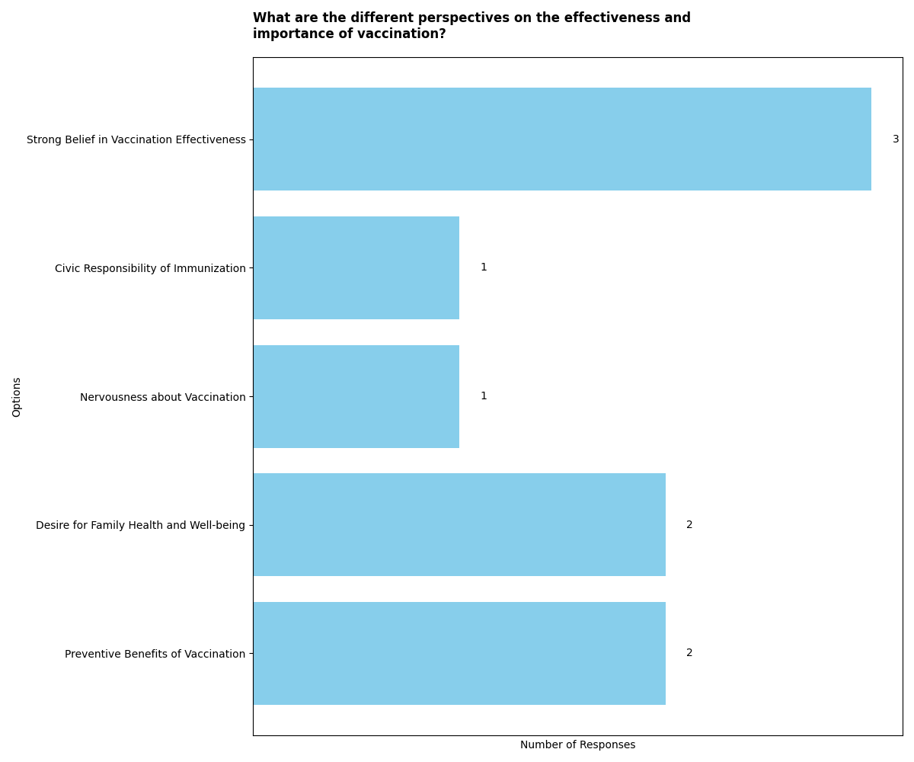

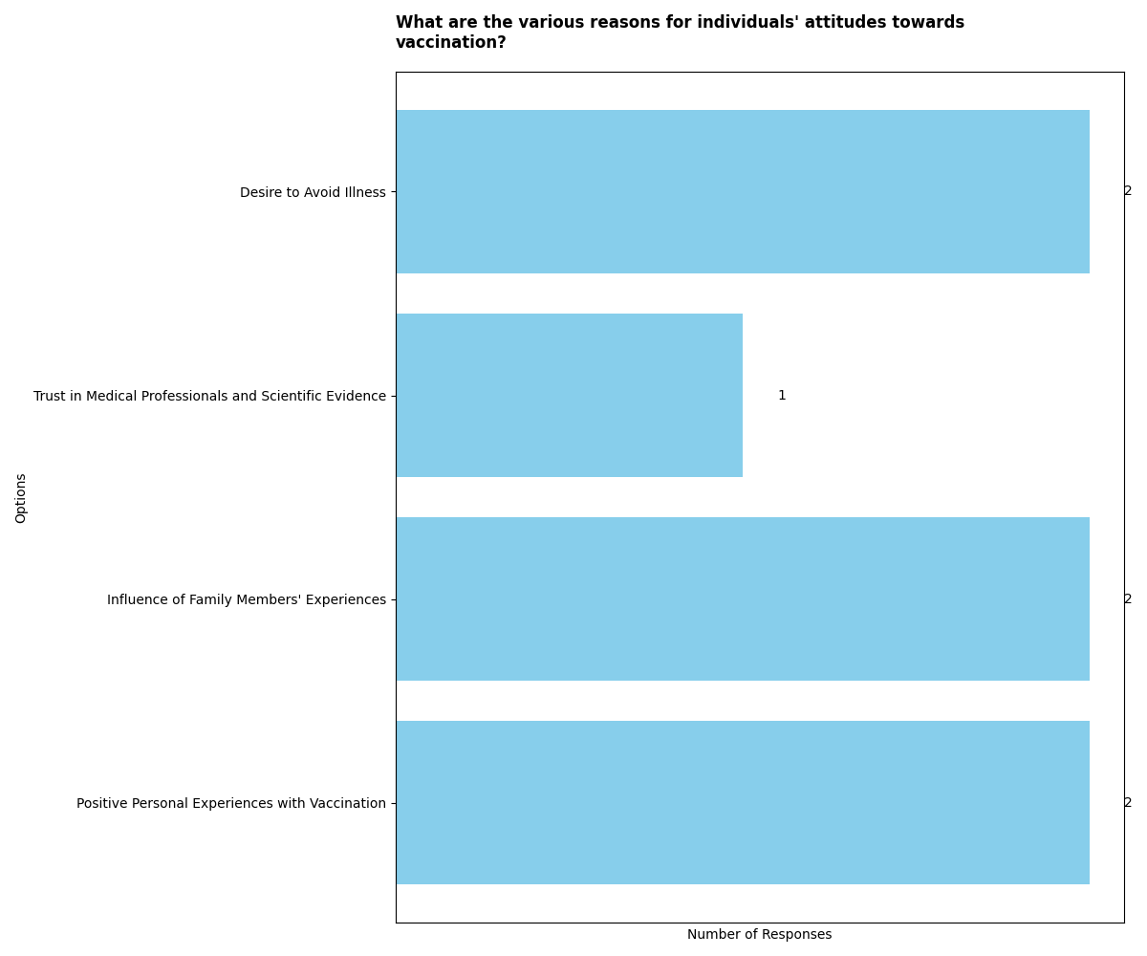

Personal Experience with the Flu Vaccine

In the introduction paragraph, the documents present a range of perspectives on the flu vaccine. Participant_01_hsgu3fx.docx initially did not feel the need for the flu vaccine but changed their stance after a health condition necessitated it. Participant_02_1mmSXto.docx encountered supply issues and was unable to get the vaccine despite being a keyworker. Participant_03_EiP6OaI.docx faced challenges and bureaucracy in accessing the flu vaccine, leading to increased anxiety. Participant_04_Hs3jvym.docx discussed the rarity of the flu and the difficulty in recognizing its severity in children. Participant_05_6COHzUo.docx emphasized the debilitating nature of the flu and its impact on individuals with underlying health conditions.  
  
The shared viewpoints across most documents include the challenges in accessing the flu vaccine, whether due to supply issues, bureaucracy, or prioritization of vulnerable categories. There is also a recognition of the seriousness of the flu, particularly for individuals with underlying health conditions and the elderly. Additionally, there is a common theme of heightened anxiety and concern related to the impact of the flu, especially in the context of other health conditions or the experience of loved ones.  
  
The unique or differing viewpoints provided by certain documents include Participant_01_hsgu3fx.docx's initial lack of perceived need for the flu vaccine, which changed after a health condition necessitated it. Participant_03_EiP6OaI.docx highlighted the impact of COVID-19 on the proactive stance towards vaccination. Participant_04_Hs3jvym.docx discussed the rarity of the flu and the difficulty in recognizing its severity in children, emphasizing the heightened worry for parents.

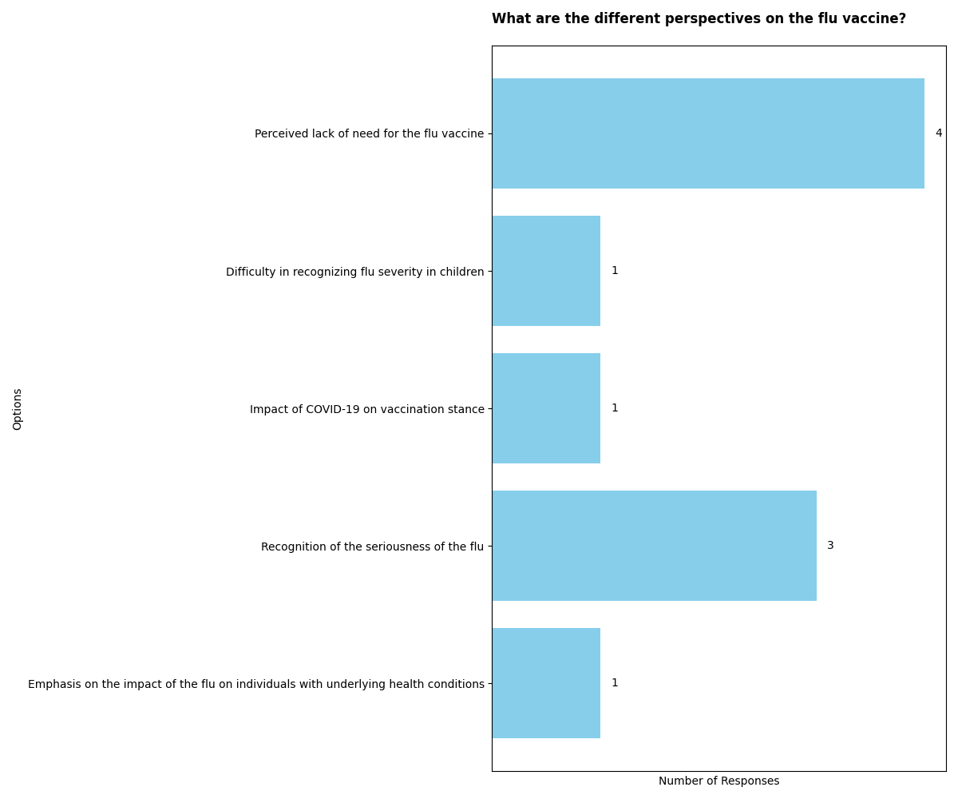

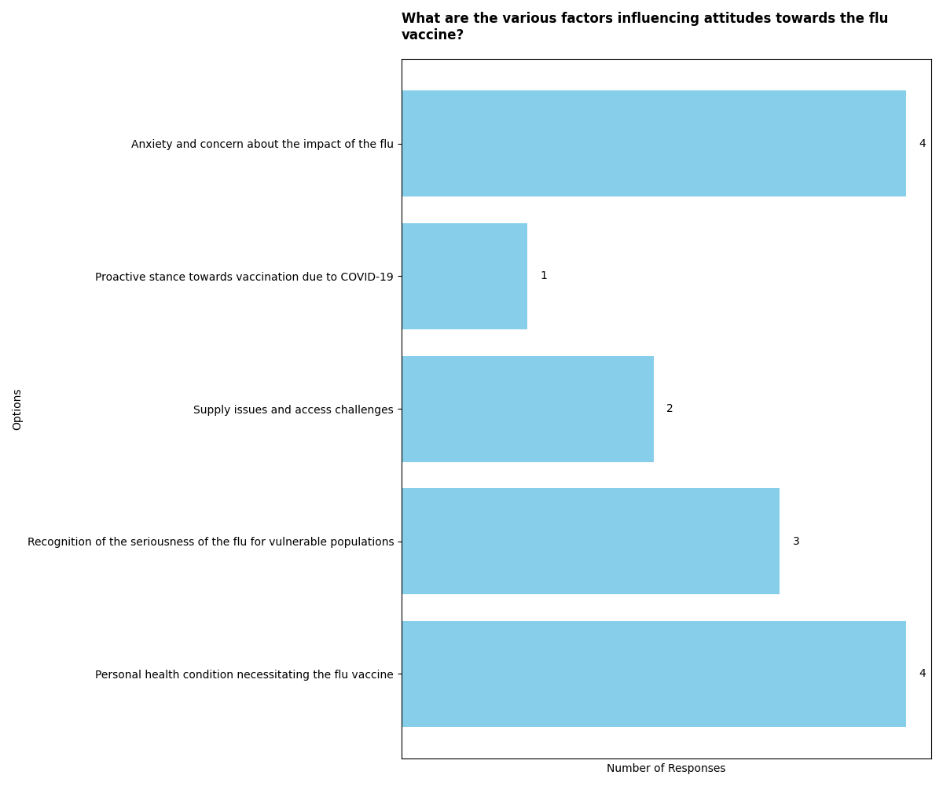

Awareness of Risks and Benefits of the Flu Vaccine

In the introduction paragraph, the documents express a generally positive awareness of the benefits of the flu vaccine. Participant_01_hsgu3fx.docx advocates for vaccines and emphasizes the positive aspects of vaccination. Participant_02_1mmSXto.docx also supports flu vaccination, particularly for children, highlighting the unpleasantness of the flu and the importance of prevention. Participant_03_EiP6OaI.docx mentions the benefits of protection from dangerous flu strains and minimal downsides. Participant_04_Hs3jvym.docx discusses the impact of illness on the family and expresses trust in recommended vaccinations. Participant_05_6COHzUo.docx acknowledges the vaccine's limitations but emphasizes its benefits.  
  
The shared viewpoints across most documents include a positive awareness of the benefits of the flu vaccine. Participants express a belief in flu vaccination, emphasizing its importance for preventing illness, particularly in children. They also acknowledge the potential side effects but generally consider them minimal compared to the benefits. There is a shared understanding that the flu vaccine offers protection from dangerous strains and reduces the likelihood and severity of illness.  
  
The unique or differing viewpoints provided by certain documents include Participant_02_1mmSXto.docx expressing concern about potential side effects and allergic reactions, despite ultimately supporting vaccination. Participant_04_Hs3jvym.docx discusses the impact of illness on the family and emphasizes trust in recommended vaccinations, dismissing the anti-vax debate. Participant_05_6COHzUo.docx acknowledges the limitations of the flu vaccine in guaranteeing immunity but emphasizes its overall benefits.

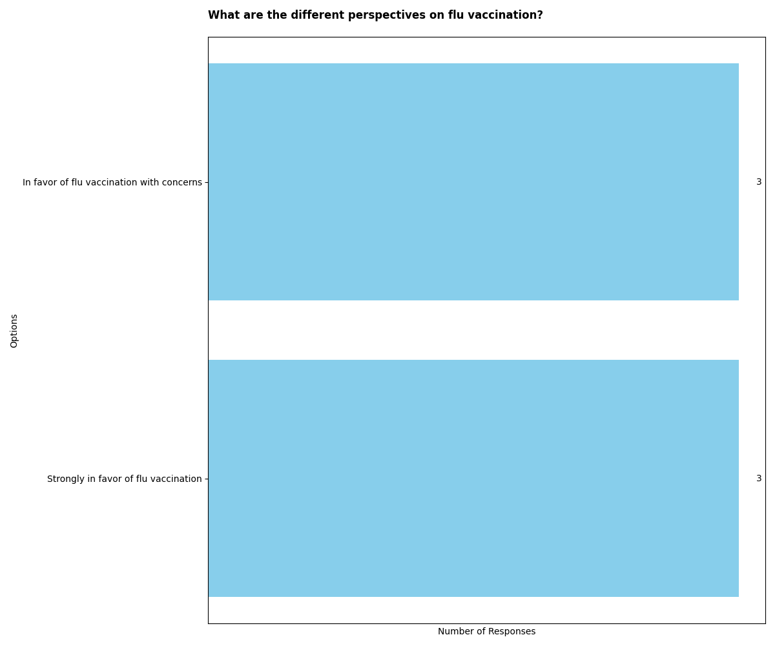

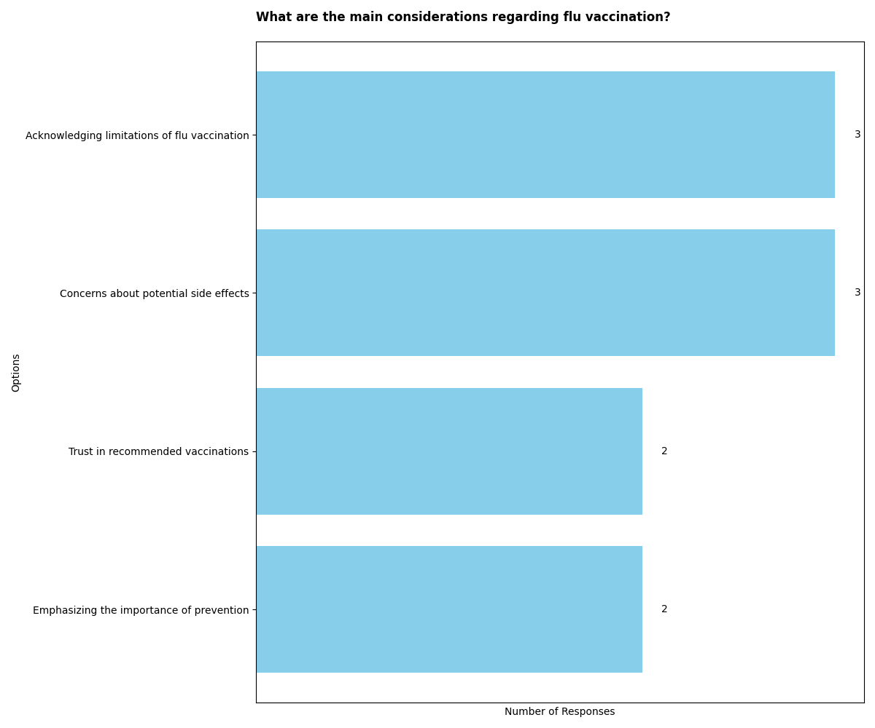

Parental Understanding and Concerns about Flu

In the introduction paragraph, the documents provide various perspectives on parental understanding and concerns about the flu. Participant_01 highlights the common perception of mistaking a bad cold for the flu, indicating a potential misunderstanding of the virus. Participant_02 discusses managing the flu at home, expressing a level of concern but also emphasizing the importance of flu vaccination for prevention. Participant_03 expresses a lack of preoccupation with the flu due to their child's overall good health but encountered challenges with flu immunization, leading to increased nervousness and anxiety. Participant_04 addresses the misconception of mistaking common illnesses for the flu and the challenge of recognizing the severity of illness in children. Participant_05 shares personal experiences with the debilitating nature of the flu and the family's strong desire to avoid it, particularly due to the husband's intensive care experience with the flu.  
  
The shared viewpoints across most documents include the recognition of the flu as a prevalent illness, particularly in winter, and the importance of prevention through vaccination. Participants express concerns about the severity of the flu, especially in vulnerable individuals such as children and elderly relatives. There is also a common understanding of the debilitating nature of the flu and the need to prioritize flu vaccination for prevention.  
  
The unique or differing viewpoints provided by certain documents include Participant_03's lack of preoccupation with the flu due to their child's overall good health, contrasting with Participant_05's strong desire to avoid the flu based on personal experiences. Participant_03 also highlights challenges with flu immunization, leading to increased nervousness and anxiety, which differs from Participant_02's favorable view towards vaccination.

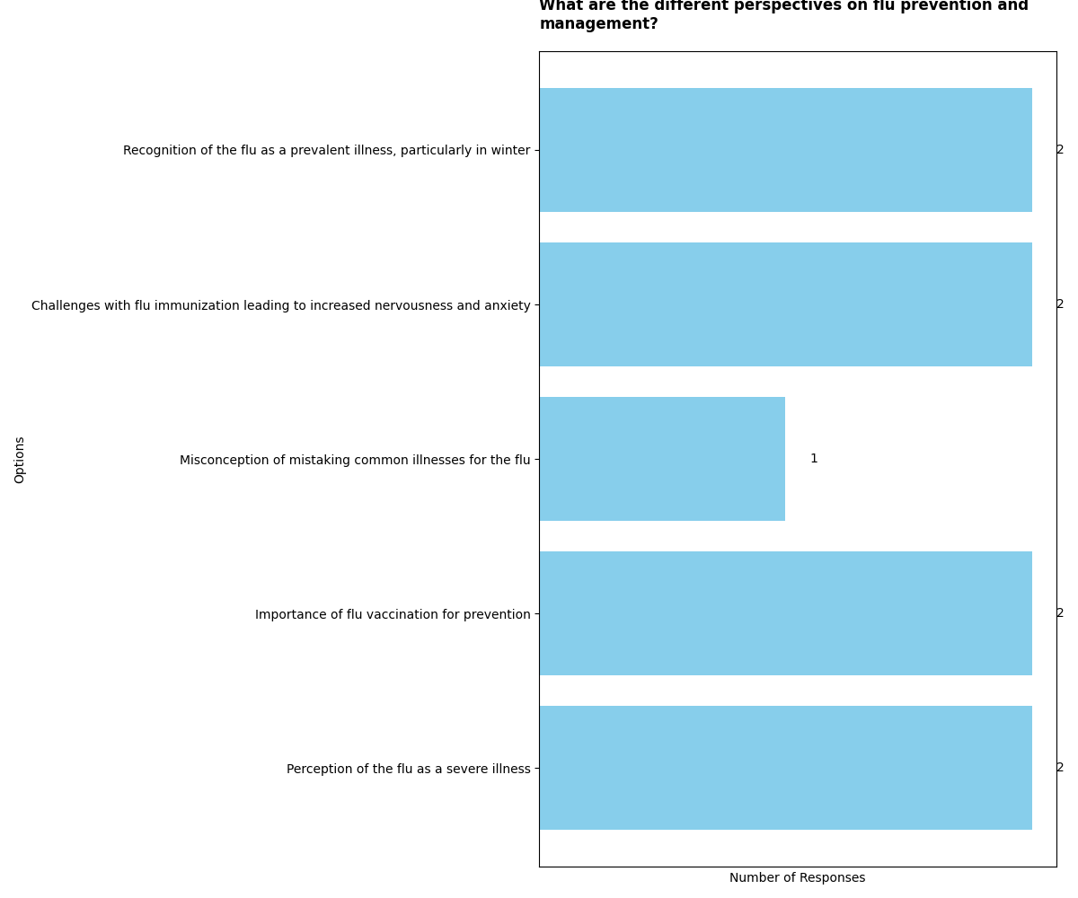

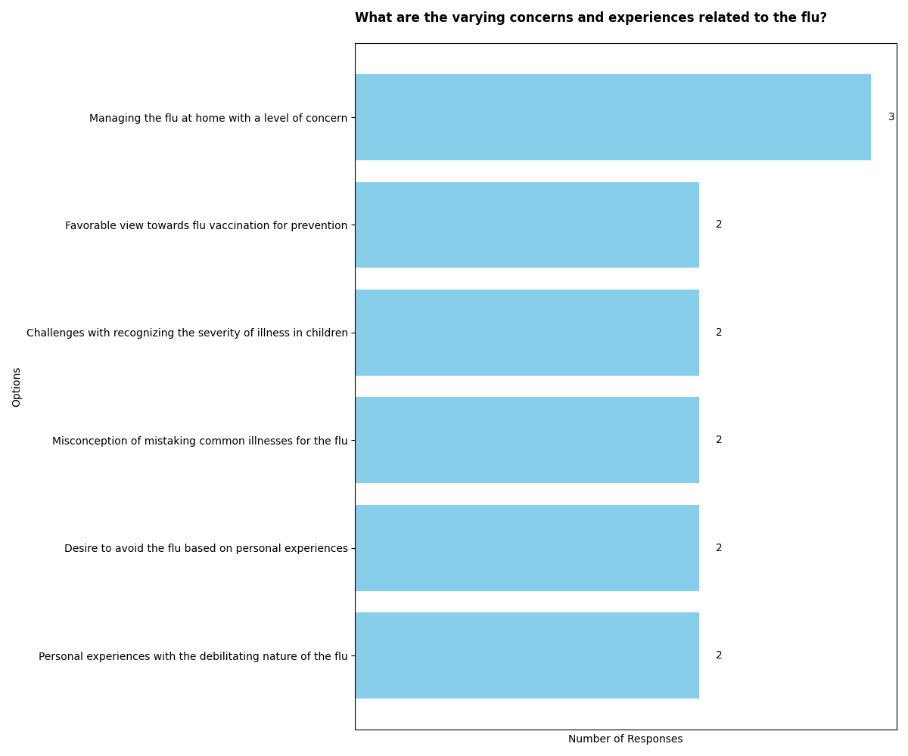

Vaccination Considerations

In the introduction paragraph, the documents present a range of views on vaccination considerations. Participant_01 and Participant_02 express strong support for vaccinations, emphasizing their importance and effectiveness. Participant_03 discusses challenges in accessing flu vaccination, leading to increased anxiety and proactive measures. Participant_04 dismisses anti-vax sentiments and strongly supports vaccination programs. Participant_05 acknowledges the benefits of vaccination but expresses reservations about the MMR vaccine due to concerns about autism and a previous adverse reaction.  
  
Shared viewpoints across most documents include the belief in the importance and effectiveness of vaccinations. Participants 01, 02, and 04 emphasize the proven track record of vaccinations in eradicating diseases and preventing serious health risks. They advocate for vaccinations as a preventive measure, highlighting their role in protecting individuals and communities from infectious diseases.  
  
Unique or differing viewpoints are provided by certain documents. Participant_03's experience highlights the challenges and anxiety associated with accessing flu vaccination, offering a perspective on the practical barriers to immunization. Participant_05 expresses nuanced considerations, acknowledging the benefits of vaccination in reducing the severity of flu while also voicing reservations about the MMR vaccine due to concerns about adverse effects and autism.  
  
Overall, the documents collectively underscore the importance of vaccinations in preventing diseases and protecting public health.

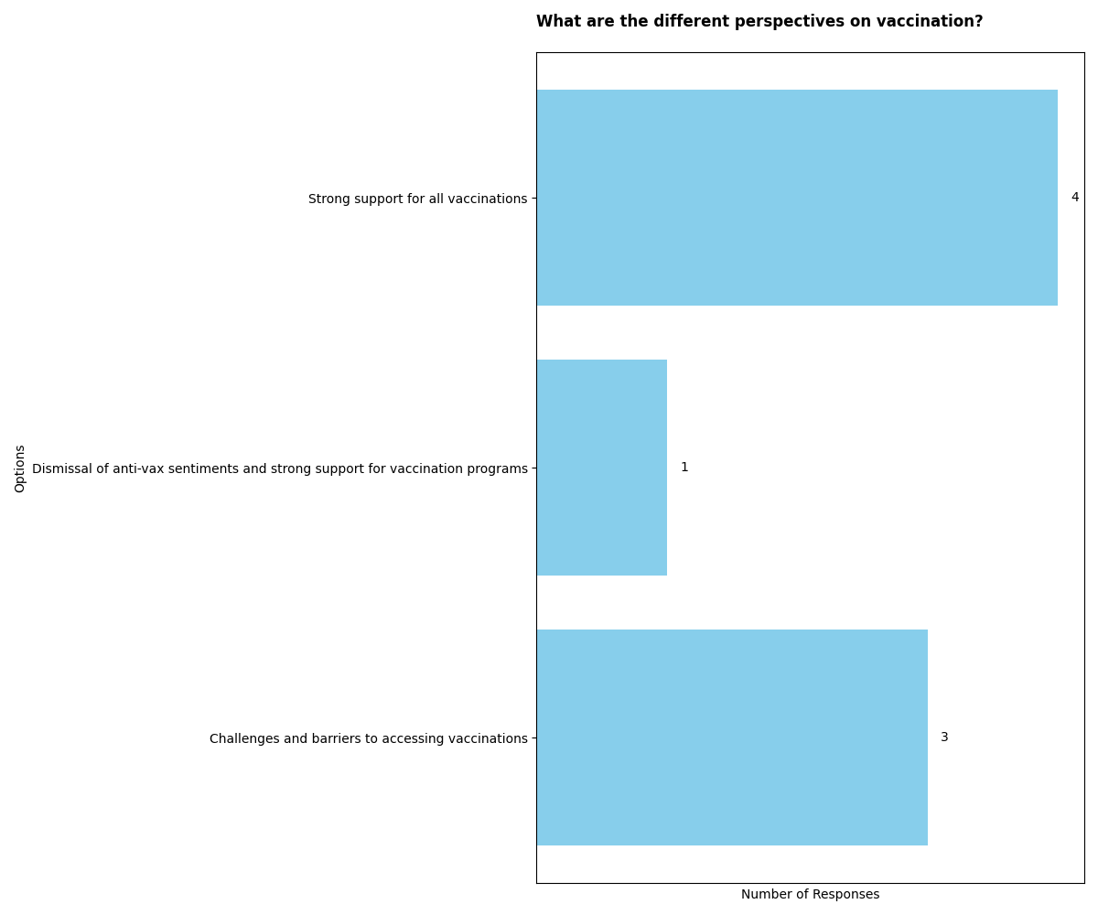

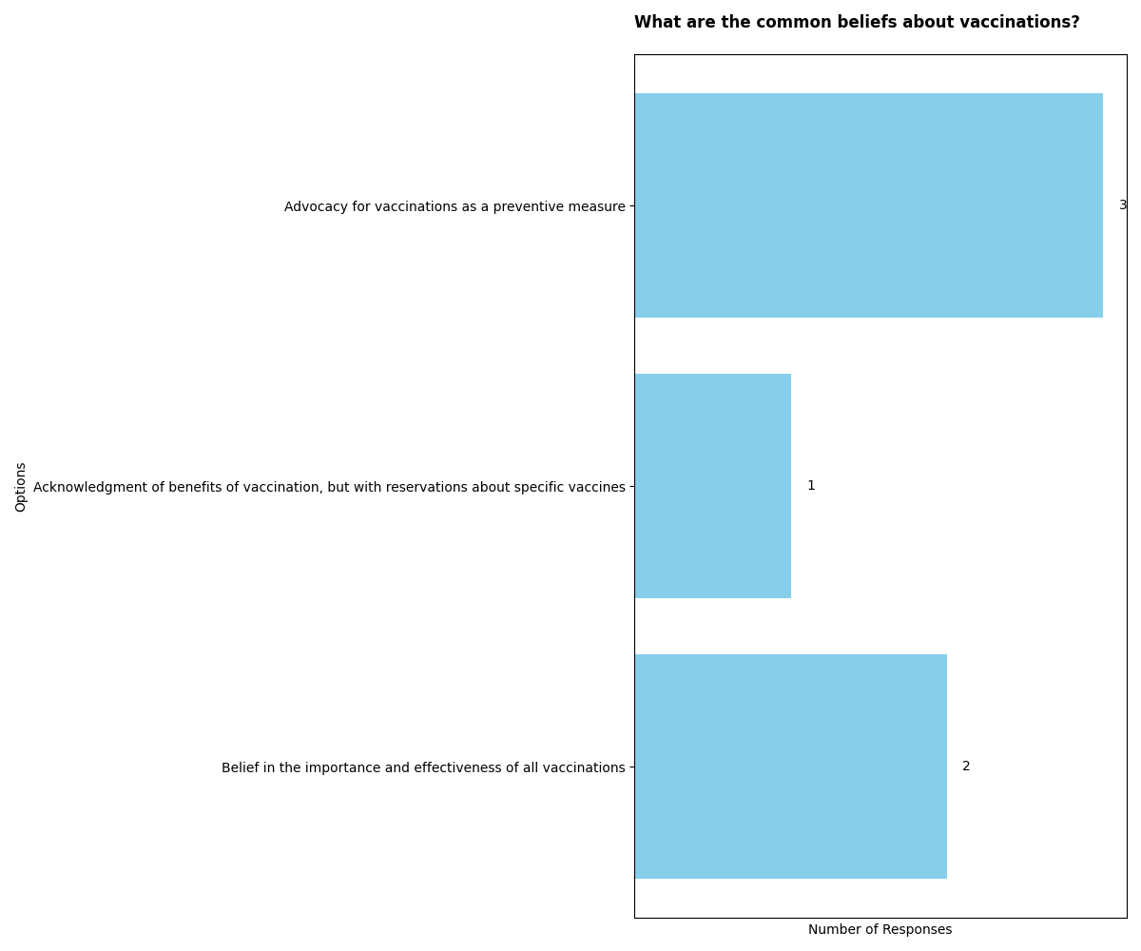

Perceptions of Child's Health and Well-being

In the introduction paragraph, the documents present various perspectives on the perceptions of a child's health and well-being. Participant_02_1mmSXto.docx expresses confidence in managing the flu at home and shows concern for others' well-being when their child is ill. Participant_03_EiP6OaI.docx and Participant_04_Hs3jvym.docx discuss concerns about differentiating between flu and other serious illnesses, as well as the difficulty in recognizing early signs of illness in children. Participant_05_6COHzUo.docx emphasizes the debilitating nature of the flu and the benefits of the flu vaccine. Participant_01_hsgu3fx.docx does not directly address the topic but focuses on the participant's consent for the study.  
  
Shared viewpoints across most documents include the recognition of the flu as a common illness, the importance of differentiating between flu and other illnesses, and the challenges in recognizing early signs of illness in children. Additionally, there is an understanding of the potential impact of the flu on a child's well-being and the benefits of the flu vaccine in reducing its likelihood and severity.  
  
Unique or differing viewpoints are presented in Participant_03_EiP6OaI.docx, where the participant expresses reduced worries about their child's health due to overall good health, despite concerns about the unpredictability of illness highlighted by the recent pandemic. Participant_02_1mmSXto.docx stands out for showing consideration for others' well-being when their child is ill and expressing confidence in managing the flu at home. Participant_05_6COHzUo.docx emphasizes the debilitating nature of the flu and the benefits of the flu vaccine, which are not explicitly discussed in the other documents.  
  
Overall, the documents collectively highlight the varying perceptions of a child's health and well-being, including concerns about differentiating between flu and other illnesses, the impact of the flu on children, and the benefits of the flu vaccine.

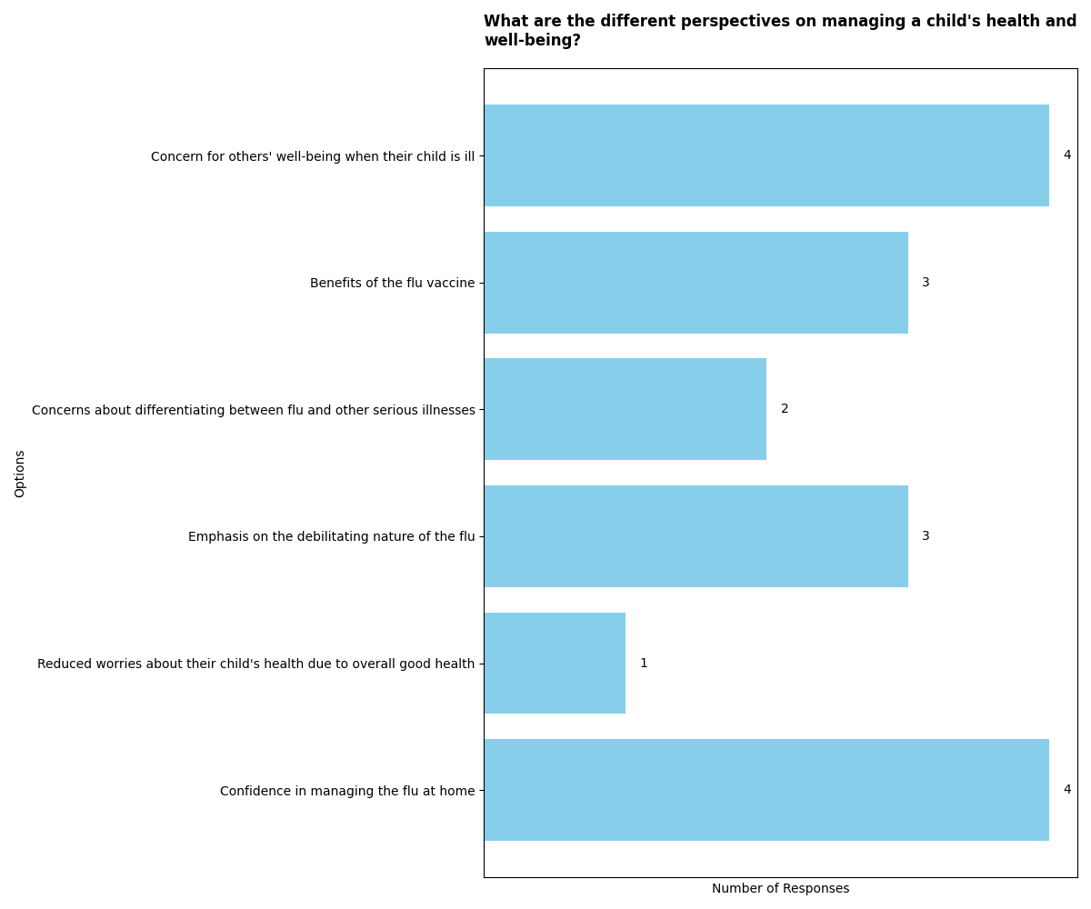

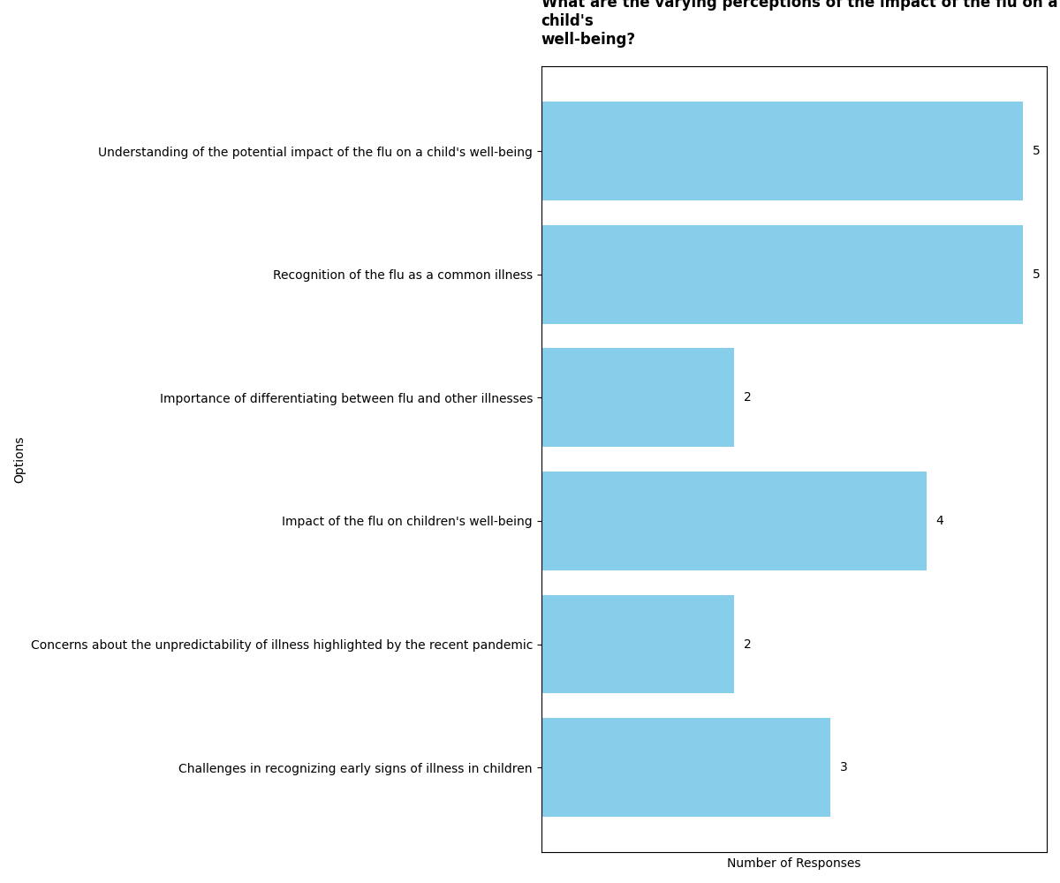

Perception of the Flu as Less Common

Introduction:  
Participant_01_hsgu3fx.docx, Participant_02_1mmSXto.docx, Participant_03_EiP6OaI.docx, Participant_04_Hs3jvym.docx, and Participant_05_6COHzUo.docx all provide insights into the perception of the flu as less common.  
  
Shared Viewpoints:  
Most participants express a perception that the flu is commonly mistaken for other illnesses, such as a bad cold. They also indicate a seasonal awareness of the flu, particularly during the winter. Additionally, there is a shared belief that the flu is a common occurrence in daily life, with some participants expressing a sense of commonality and sympathy towards those affected by the flu.  
  
Unique or Differing Viewpoints:  
Participant_04_Hs3jvym.docx presents a differing viewpoint by suggesting that the flu may be rarer than commonly thought, with many people mistaking other illnesses for the flu.

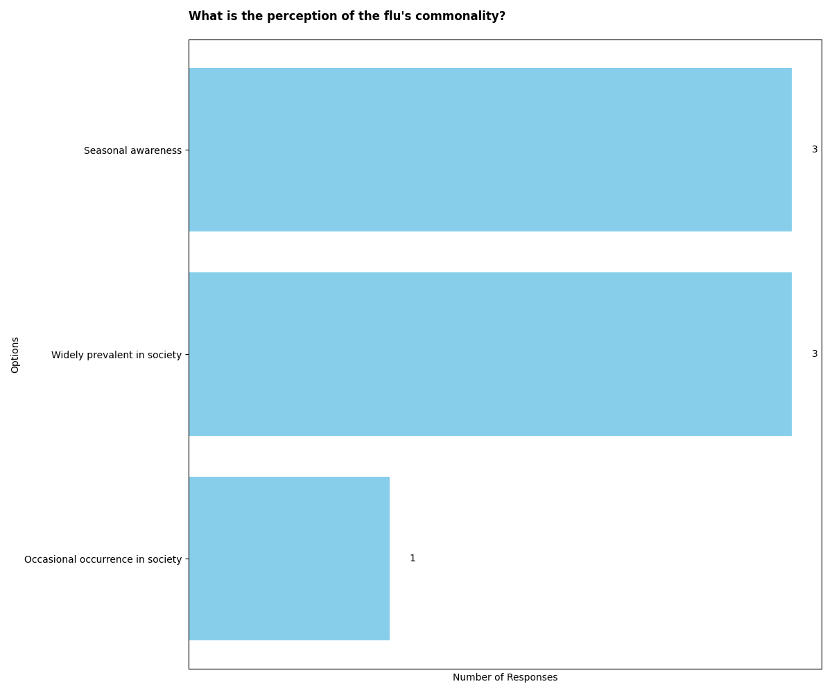

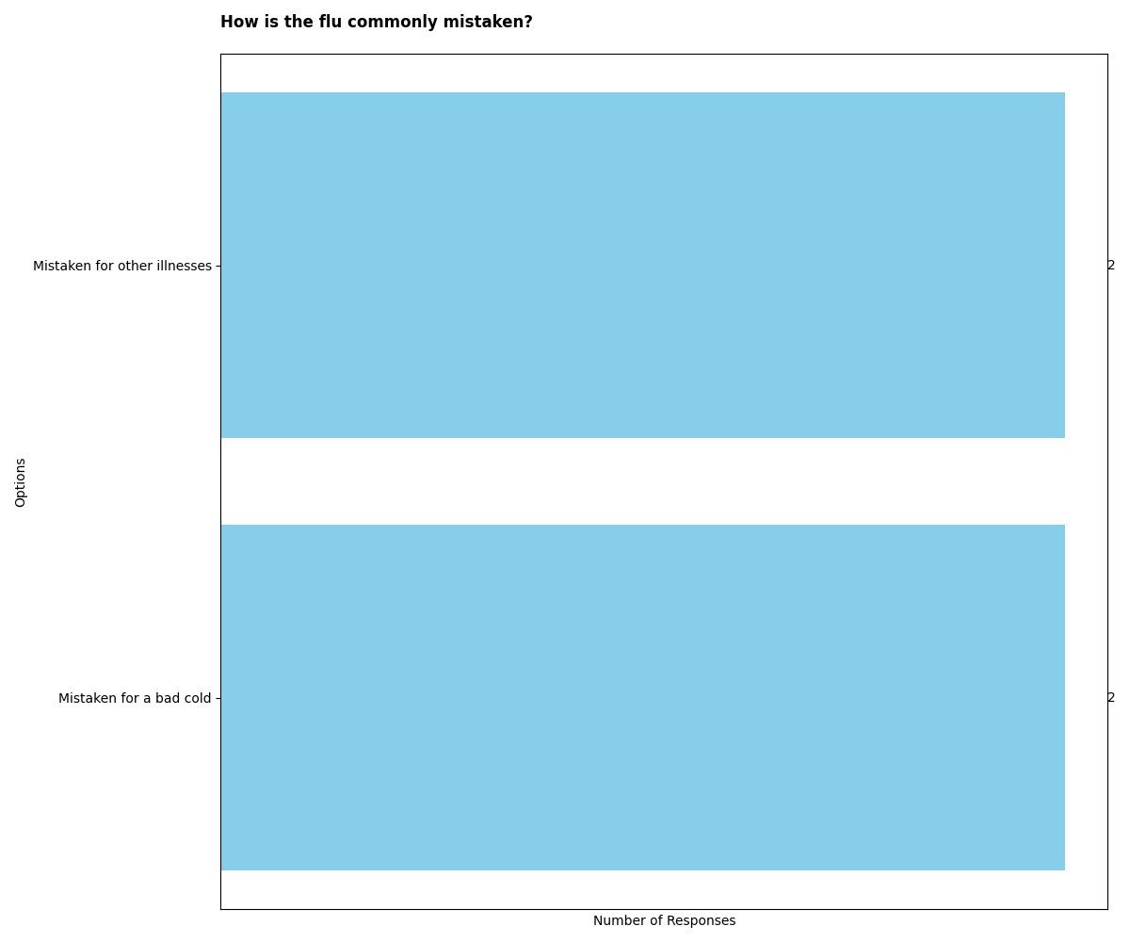

Variability of Flu Strains and Challenges of Vaccination

Introduction:  
Participant_01_hsgu3fx.docx discusses the variability of flu strains and the process of determining the next year's vaccine based on prevalent strains from the previous year. Participant_02_1mmSXto.docx emphasizes the seasonal nature of flu in the UK, its symptoms, and the benefits of flu vaccination, particularly for young children. Participant_03_EiP6OaI.docx describes the behavioral and physical symptoms of flu in children. Participant_04_Hs3jvym.docx mentions the debilitating effects of flu and the challenges in developing effective vaccines. Participant_05_6COHzUo.docx discusses the historical variability of flu strains and the uncertainty about the severity of "normal flu" to healthy individuals, as well as the limitations of flu vaccines.  
  
Shared Viewpoints:  
Most documents acknowledge the variability of flu strains and the challenges in developing effective vaccines. They also recognize the importance of flu vaccination in reducing the likelihood of getting the flu, particularly in vulnerable populations such as young children and the elderly. Additionally, there is a shared understanding that flu vaccines do not guarantee immunity but can lessen the severity of the illness if vaccinated individuals do get the flu.  
  
Unique or Differing Viewpoints:  
Participant_03_EiP6OaI.docx provides a unique perspective by describing the behavioral and physical symptoms of flu in children, focusing on the gradual onset of symptoms and the potential duration of the illness. Participant_05_6COHzUo.docx introduces uncertainty about the severity of "normal flu" to healthy individuals and questions the uniqueness of historical flu strains.

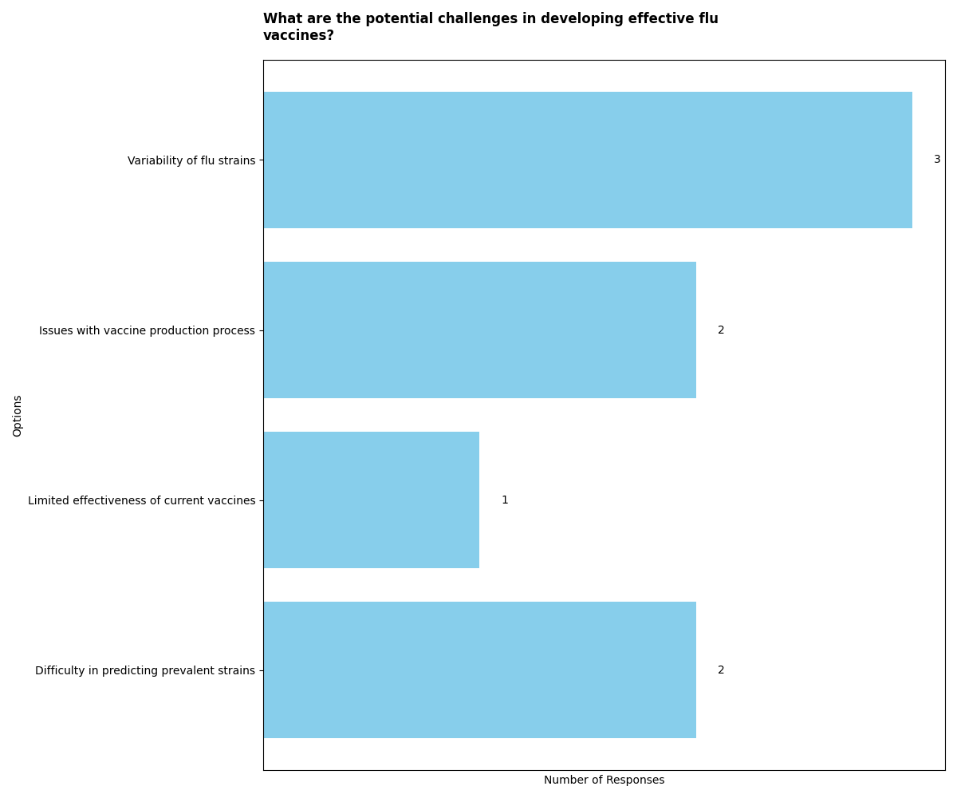

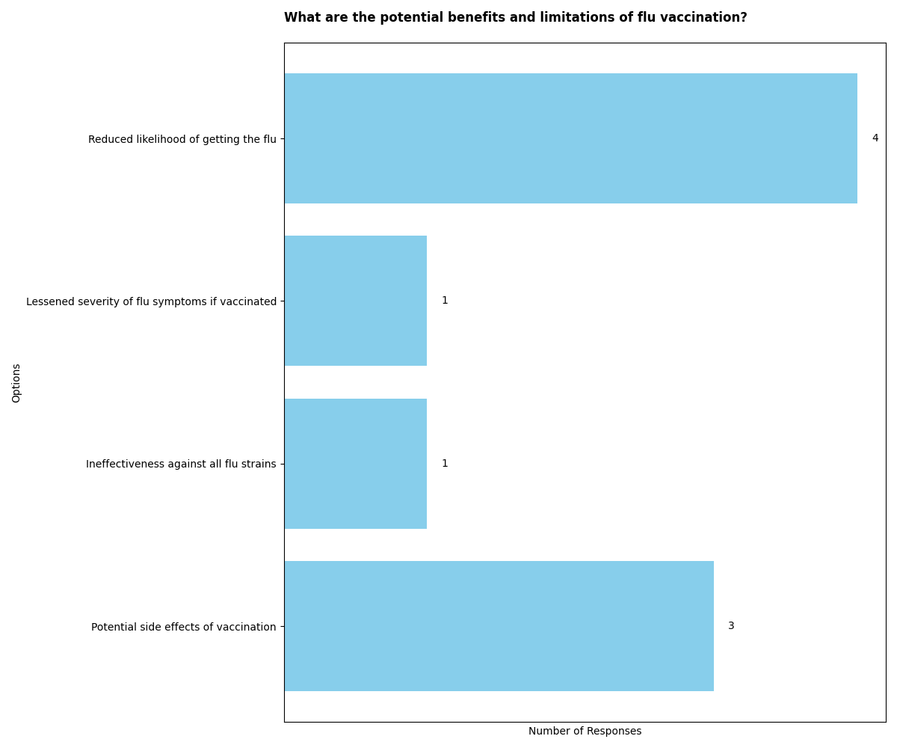

Impact of the COVID-19 Pandemic on Illness and Vaccination

In the context provided, the impact of the COVID-19 pandemic on illness and vaccination is discussed across multiple documents. Participant_02_1mmSXto.docx and Participant_03_EiP6OaI.docx both highlight challenges in obtaining the flu vaccine due to supply issues and bureaucracy, respectively. These shared viewpoints underscore the difficulties individuals face in accessing vaccinations during the pandemic.  
  
However, Participant_04_Hs3jvym.docx presents a unique perspective, expressing concerns about the rush to develop a COVID-19 vaccine and the potential unknown long-term effects, particularly for children. This viewpoint contrasts with the shared concern about flu vaccination access and bureaucracy, emphasizing the need for careful consideration in vaccine development and distribution.  
  
Additionally, Participant_05_6COHzUo.docx discusses the broader impact of the pandemic on children's daily routines and interactions, as well as the challenges faced by parents of sick children. This broader societal impact of illness and vaccination during the pandemic provides a unique perspective on the topic.  
  
Overall, while some participants share concerns about flu vaccine access and bureaucracy, others raise important considerations about the rush to develop a COVID-19 vaccine and the broader societal impact of the pandemic on children and families.

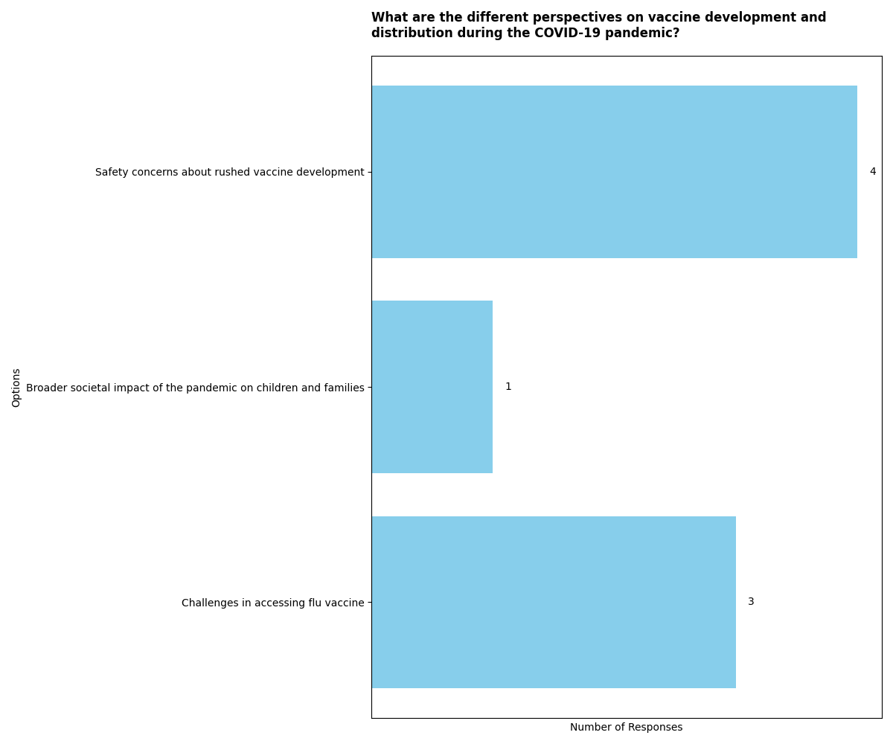

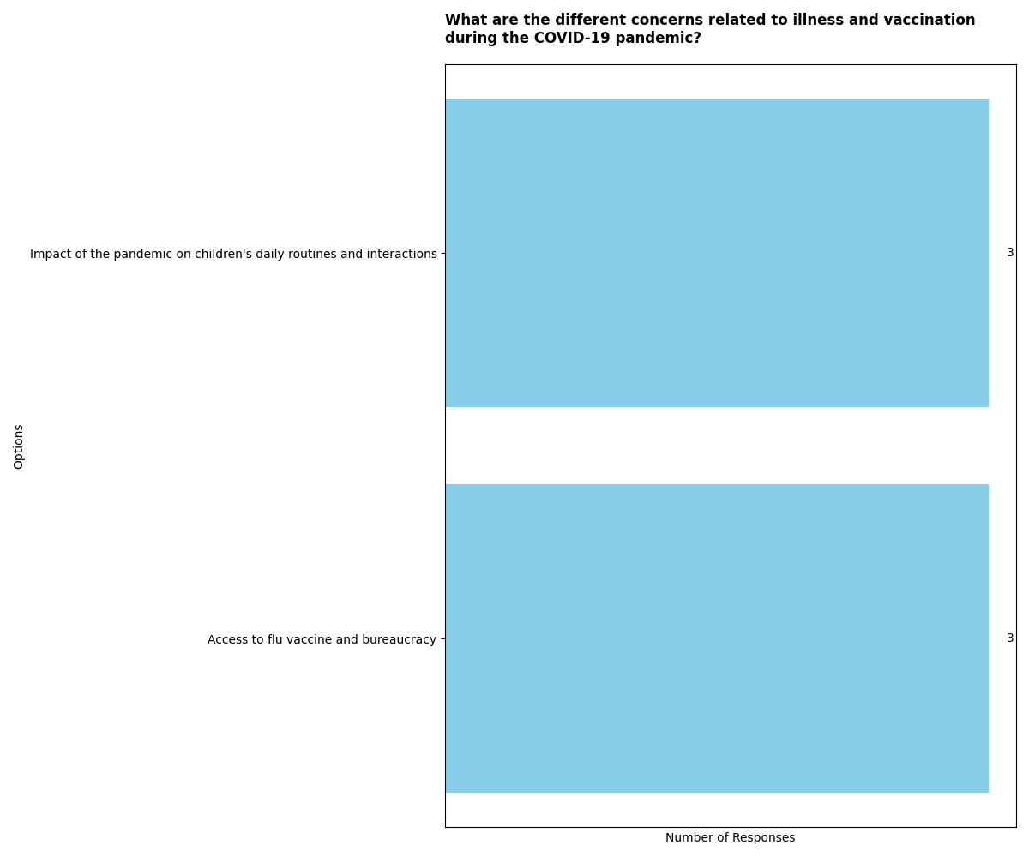

Decision-making Process around Flu Vaccination

In the introduction paragraph, the documents present varying perspectives on the decision-making process around flu vaccination. Participant_01 and Participant_02 express strong beliefs in the importance of vaccination, emphasizing the widespread evidence supporting its use. Participant_03 highlights the influence of the child's health status on the decision-making process, while Participant_04 discusses the trust in medical professionals' recommendations. Participant_05 expresses a willingness to get vaccinated but also acknowledges concerns about potential side effects.  
  
The shared viewpoints across most documents include a strong emphasis on the importance of vaccination and the trust in its effectiveness. Participants 01, 02, and 04 all express confidence in the tried and tested nature of vaccinations and the recommendations of medical professionals. This shared viewpoint underscores the belief in the value of vaccination as a protective measure against diseases.  
  
The unique or differing viewpoints provided by certain documents include Participant_03's emphasis on the influence of the child's health status on the decision-making process. This participant highlights how the child's overall health plays a significant role in the consideration of flu vaccination, with reduced preoccupation when the child lacks significant health complaints.

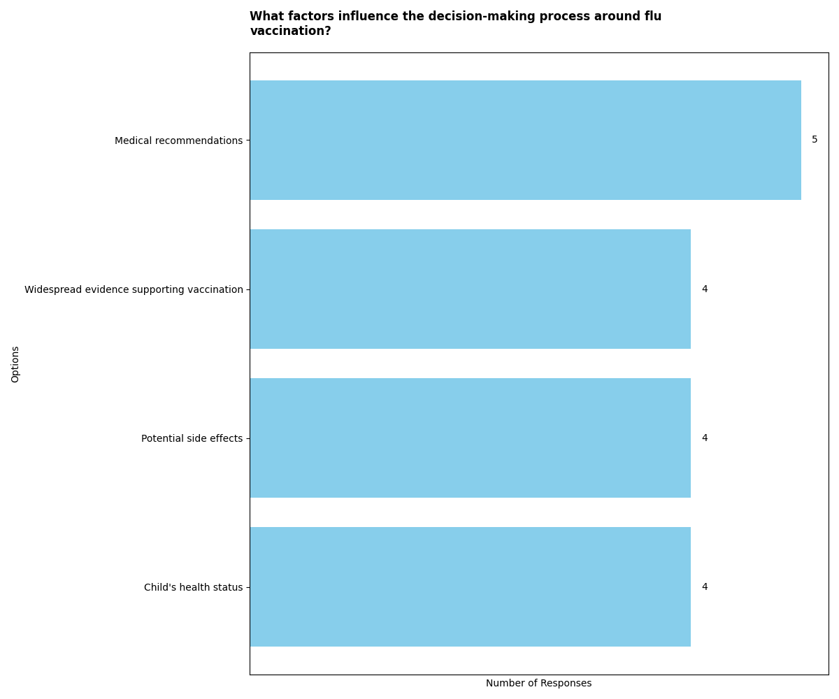

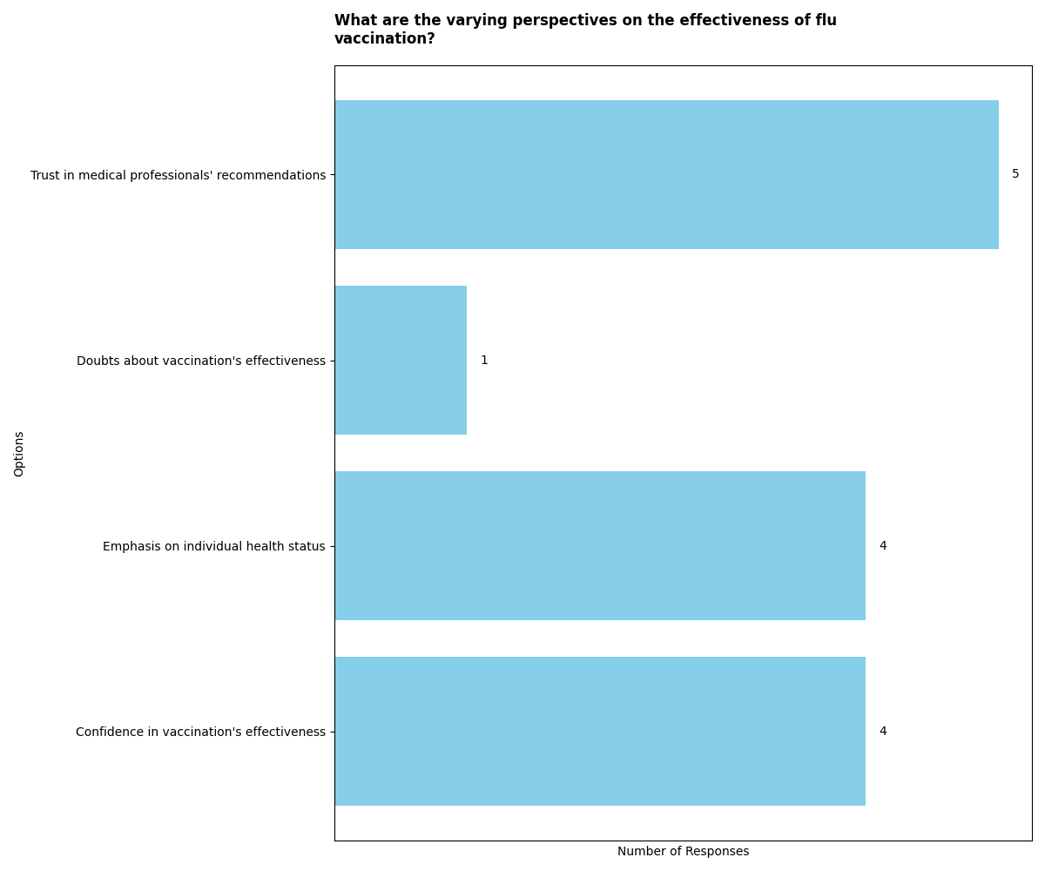

What information sources do parents rely on to learn about the flu and vaccine?

In the context of parents learning about the flu and vaccines, several sources are mentioned. Participant_01_hsgu3fx.docx highlights reliance on sources like Doctor Google and the Orange Book from health visitors. Participant_02_1mmSXto.docx emphasizes the NHS website as the primary source, expressing concerns about internet accuracy. Participant_03_EiP6OaI.docx also relies on the NHS website, avoiding mummy blogs and forums. Participant_04_Hs3jvym.docx mentions Google, NHS pages, reputable medical sites, and experienced GPs as sources. Participant_05_6COHzUo.docx mentions reliance on NHS net and WebMD due to differences in treatment rules between the UK and the US.  
  
Shared viewpoints across most documents include reliance on the NHS website for information about the flu and vaccines. Concerns about the accuracy of information available on the internet are also expressed, leading to a preference for trustworthy sources like the NHS. Additionally, reliance on reputable medical sites and experienced GPs for information is a common theme.  
  
Unique or differing viewpoints are provided by certain documents. Participant_01_hsgu3fx.docx mentions the use of the Orange Book from health visitors, which is not emphasized in other documents. Participant_03_EiP6OaI.docx avoids mummy blogs and forums, finding them less supportive, while Participant_04_Hs3jvym.docx considers the advice of experienced GPs, even if it may be anecdotal.

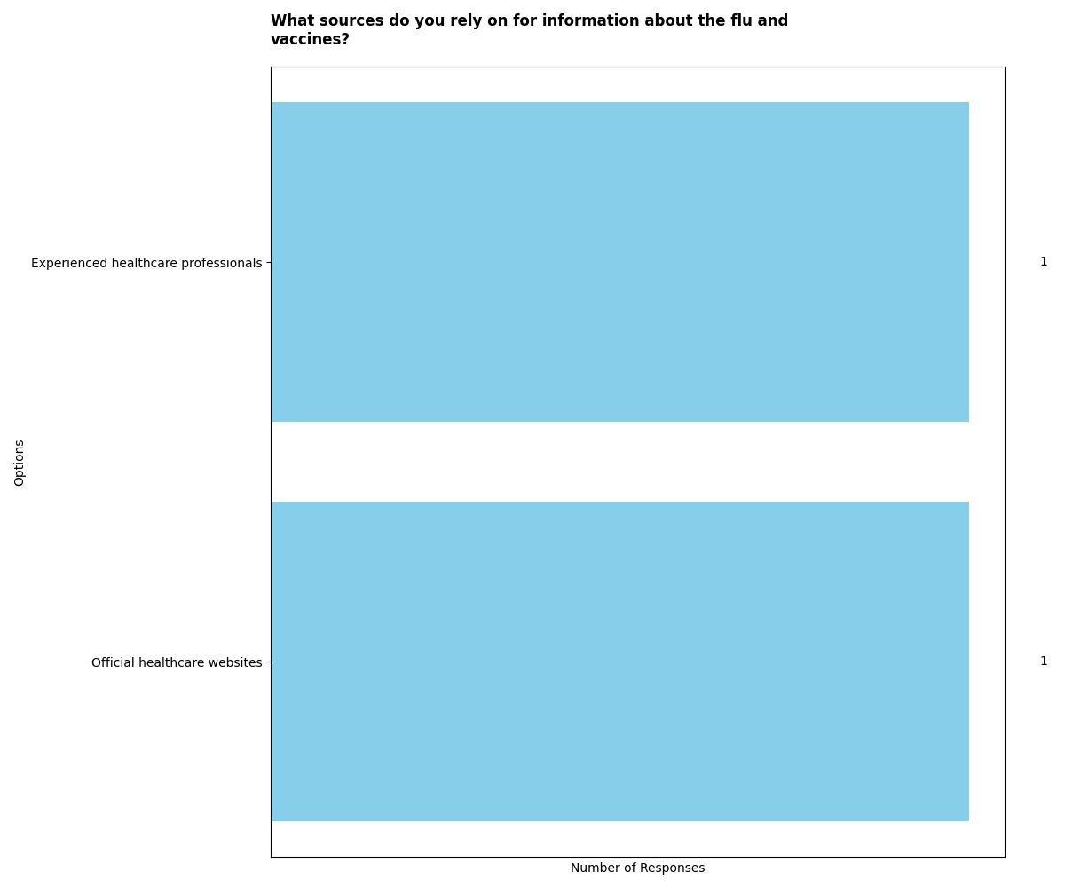

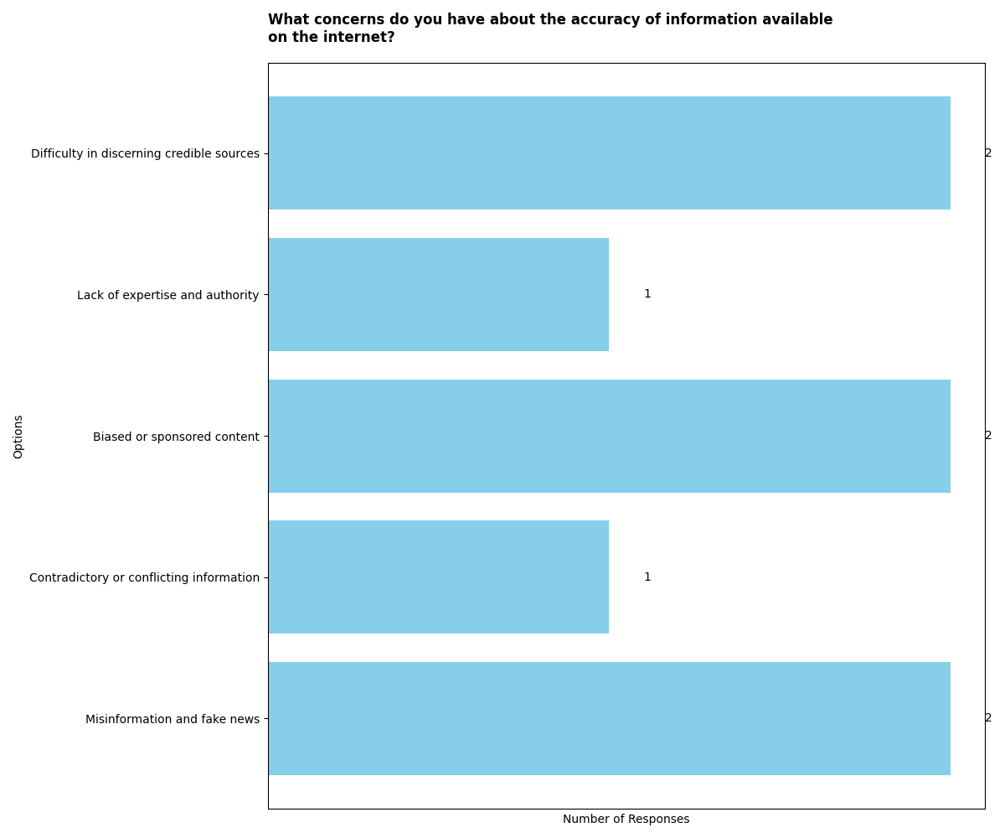

What role did healthcare professionals play in helping parents ensure their children get vaccinated?

In the context of parents ensuring their children get vaccinated, the role of healthcare professionals varied among the participants. Participant_01_hsgu3fx.docx highlighted that healthcare professionals, such as health visitors or GPs, were consulted when children were seriously ill or exhibited concerning symptoms, although not specifically about the flu. This suggests that healthcare professionals were sought for general health concerns rather than specifically for vaccination advice.  
  
Participant_02_1mmSXto.docx and Participant_03_EiP6OaI.docx did not directly discuss the flu vaccine with healthcare professionals, indicating that some parents may not feel the need to seek advice on vaccination from healthcare professionals unless their child is suspected of having the flu.  
  
In contrast, Participant_04_Hs3jvym.docx emphasized the value of healthcare professionals, particularly GPs, as sources of information and advice for parents regarding their children's health. The participant expressed trust in the experience and advice offered by GPs, even if anecdotal at times, indicating a reliance on healthcare professionals for guidance.  
  
Participant_05_6COHzUo.docx highlighted the significant role of healthcare professionals, particularly practice nurses, in providing information and guidance to parents about vaccinations. This participant also emphasized the influence of healthcare professionals' advice and support in the decision-making process, indicating that healthcare professionals played a crucial role in shaping parents' attitudes towards vaccination.  
  
Overall, while some parents may not directly consult healthcare professionals about flu vaccination unless their child is suspected of having the flu, others highly value the advice and guidance provided by healthcare professionals, particularly GPs and practice nurses.

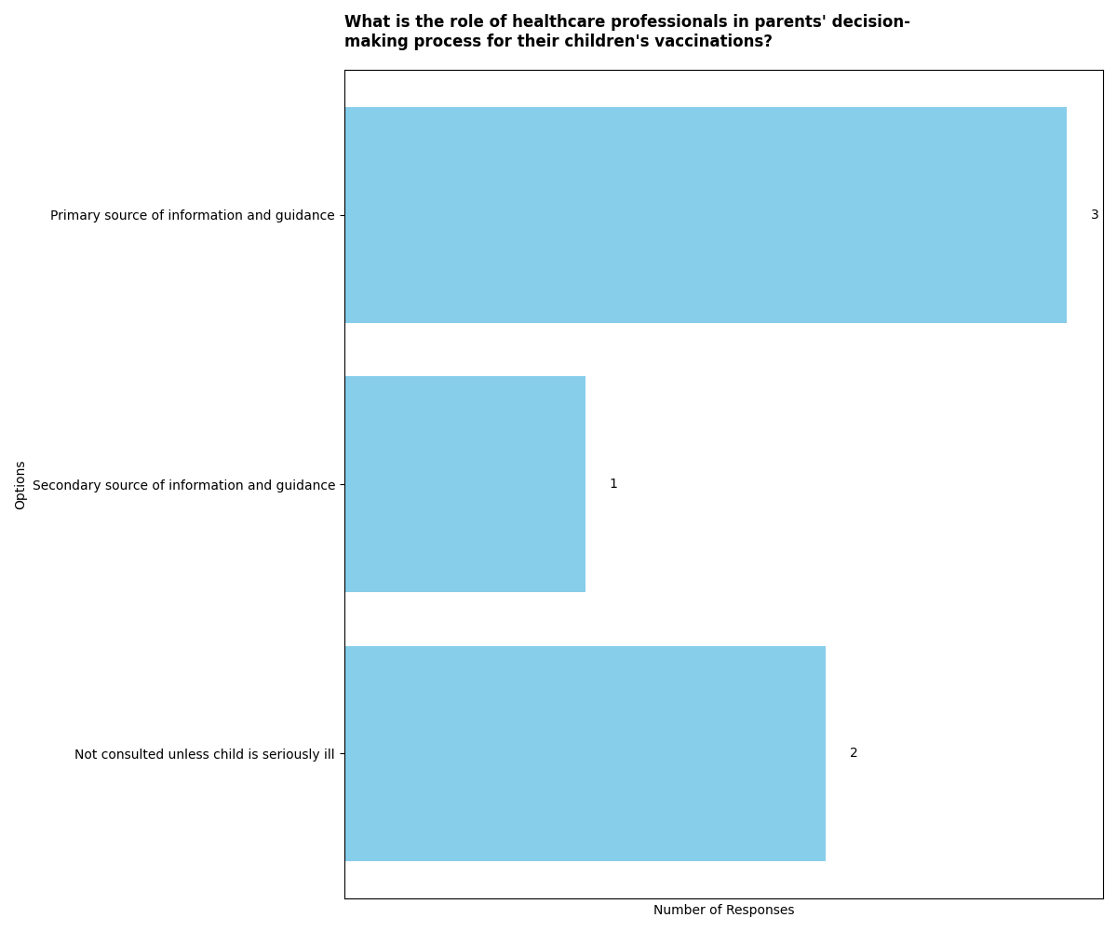

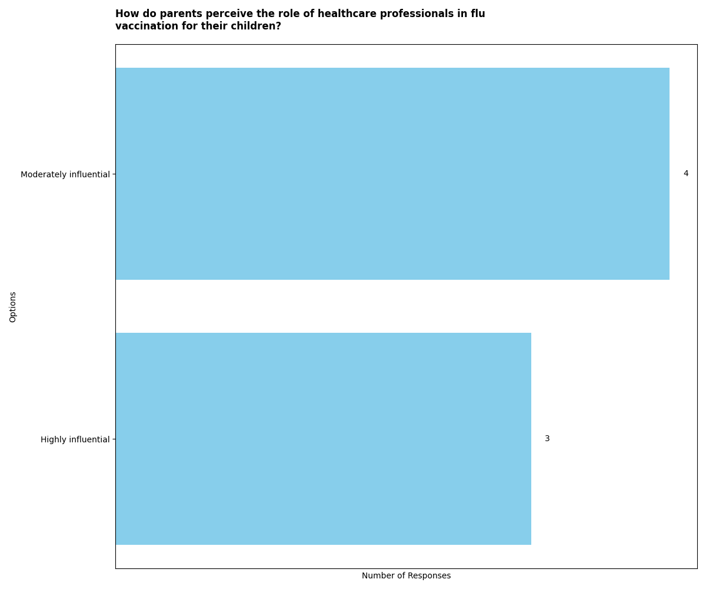

THEMES DOCUMENT ANALYSIS

Understanding and Attitude towards Vaccination(Participant_01_hsgu3fx.docx)

The participant expresses a strong belief in the importance of vaccination, stating that it wasn't even a decision to be made but rather something that should be done based on the evidence of its effectiveness.

Understanding and Attitude towards Vaccination(Participant_02_1mmSXto.docx)

The participant emphasizes the importance of vaccinations, highlighting the protection they offer against dangerous diseases. They express confidence in the tried and tested nature of vaccinations and their significance in preventing potential health risks.  
  
The participant believes in the flu vaccination and considers it for their child to avoid the unpleasant experience of illness. They express a preference for prevention over cure and emphasize the benefits of the vaccine in protecting their child from getting the flu.

Understanding and Attitude towards Vaccination(Participant_03_EiP6OaI.docx)

The participant expresses a strong belief in the importance of child immunization as a civic duty, emphasizing that it's not just about one's own child but about all children and the concept of herd immunity.  
  
The participant's experience with the flu vaccine process has made them more nervous about getting their child immunized, and the impact of COVID has made them even more proactive about ensuring their child receives the vaccine.

Understanding and Attitude towards Vaccination(Participant_04_Hs3jvym.docx)

The participant expresses a strong trust in the recommendations for childhood vaccinations, stating that they would never forgive themselves if something happened due to not following the recommendations. They also dismiss the anti-vax debate as nonsense and emphasize the benefits of vaccination programs in eradicating childhood diseases.

Understanding and Attitude towards Vaccination(Participant_05_6COHzUo.docx)

The participant expresses an understanding that the flu vaccine does not guarantee immunity from the flu, but believes that it significantly reduces the likelihood of contracting the flu. There is also a hope that if the vaccine is administered and the flu is contracted, it will not be as severe.  
  
The participant indicates a personal aversion to getting the flu and a desire for the family to avoid it. This sentiment is influenced by the experience of a family member having the flu in the past.

Personal Experience with the Flu Vaccine(Participant_01_hsgu3fx.docx)

I had my spleen out in February and it was at least six weeks before that, might have been at the very end of last year. It was an unusual situation. And I think because of the health condition I have I probably would have been a candidate for having the flu vaccination, but It wasn't something that I necessarily felt like I needed. if I did have a cold symptoms or the flu or anything like that I tended just to kind of have it one of those things where, well I'll cross that-  
  
However, now that I've had my spleen out I will be getting it!

Personal Experience with the Flu Vaccine(Participant_02_1mmSXto.docx)

The participant mentioned that they haven't had the flu vaccine this year due to supply issues. They tried to get one as they are classified as a keyworker and can claim the cost of the flu vaccination through their employer. However, the local pharmacies only provided vaccines for vulnerable categories, such as the over 65 and those who get them for free. This resulted in the participant being unable to get the flu vaccine this year despite trying.

Personal Experience with the Flu Vaccine(Participant_03_EiP6OaI.docx)

The participant expected the flu immunization to be a standard and easily accessible, but encountered challenges with the process, leading to increased nervousness and anxiety about her daughter getting vaccinated. The participant expressed concerns about the bureaucracy and shortages surrounding the flu vaccine, emphasizing the need for a more efficient infrastructure for immunization. Additionally, the participant's proactive stance on her daughter's vaccination has been further heightened by the impact of COVID-19.

Personal Experience with the Flu Vaccine(Participant_04_Hs3jvym.docx)

The participant mentioned that the flu is possibly rarer than people think and described the typical symptoms of the flu, such as high temperature, feeling lethargic, and experiencing aches and pains.  
  
The participant discussed the difficulty in recognizing the severity of illness in children, stating that it's not often until they're really poorly that the parent would know. The participant also expressed the concern that arises when the child is wiped out, indicating a heightened level of worry for the parent.

Personal Experience with the Flu Vaccine(Participant_05_6COHzUo.docx)

The participant describes their personal experience with the flu as completely debilitating, emphasizing that it wipes a person out and takes a few days to recover physical strength. They acknowledge the seriousness of the flu, especially for individuals with underlying health conditions, and express concern for their elderly parents. Additionally, the participant mentions their husband's experience of being in intensive care due to the flu, highlighting the severity of the illness.

Awareness of Risks and Benefits of the Flu Vaccine(Participant_01_hsgu3fx.docx)

The participant expressed a strong advocacy for vaccines, indicating a positive awareness of the benefits of vaccination.

Awareness of Risks and Benefits of the Flu Vaccine(Participant_02_1mmSXto.docx)

The participant expresses a belief in flu vaccination and considers it for their child, emphasizing the unpleasantness of the flu for young children and the importance of prevention over cure. They mention that young children may struggle to understand what they need to do to recover and express a preference for avoiding the flu through vaccination.  
  
The participant expresses concern about potential side effects of the flu vaccine, mentioning that they have received information from their GP practice about side effects. They also mention being concerned about allergic reactions but overall cannot identify a downside to vaccination.

Awareness of Risks and Benefits of the Flu Vaccine(Participant_03_EiP6OaI.docx)

The participant mentioned that the benefits of the flu vaccine include protection from the strains considered most dangerous during the winter period.  
  
Additionally, the participant indicated that the only downside to the flu vaccine would be potential side effects, but she mentioned that her daughter did not experience any side effects when she received the vaccine.

Awareness of Risks and Benefits of the Flu Vaccine(Participant_04_Hs3jvym.docx)

The participant expresses concern about the impact of illness on the family, particularly the worry of having to take time off work if the children get sick. However, the participant also mentions that the children are healthy and don't have any underlying conditions, so the concern is more about the impact on the family as a whole.  
  
The participant discusses their trust in the recommended vaccinations for children, expressing a willingness to go along with the recommendations and emphasizing the benefits of vaccination in eradicating serious childhood diseases. The participant also dismisses the anti-vax debate as based on poor research and expresses full support for vaccination programs.

Awareness of Risks and Benefits of the Flu Vaccine(Participant_05_6COHzUo.docx)

The participant expresses an understanding that the flu vaccine does not guarantee immunity from the flu, but it significantly reduces the likelihood of contracting it. There is also a hope that if the vaccine is administered and the individual still contracts the flu, the severity of the illness will be reduced.  
  
The participant acknowledges that there are overwhelming benefits of the flu vaccine that outweigh minor downsides, indicating a strong awareness of the potential advantages of vaccination.

Parental Understanding and Concerns about Flu(Participant_01_hsgu3fx.docx)

The participant acknowledges the voluntary nature of their participation and their right to withdraw at any time without giving a reason. They also understand that they can decline to answer any questions during the interview.  
  
The participant expresses a common perception that many people mistake a bad cold for the flu, indicating a potential misunderstanding of the virus.

Parental Understanding and Concerns about Flu(Participant_02_1mmSXto.docx)

The participant expresses an understanding of the flu being more prevalent in winter and acknowledges that it's something that everyone is likely to come into contact with in their daily lives. They mention managing the flu at home with paracetamol, rest, and hydration, and express a level of concern that is not excessive, particularly due to their child being generally healthy. Additionally, they highlight the importance of not exposing their child to elderly relatives if the child is ill, to prevent passing on the flu.  
  
The participant believes in flu vaccination and considers it for their child as a means to avoid the unpleasant experience of flu, especially for young children who may struggle to understand how to recover. They emphasize the importance of prevention over cure and express a favorable view towards the vaccine as a means to prevent their child from getting the flu.

Parental Understanding and Concerns about Flu(Participant_03_EiP6OaI.docx)

The participant expresses a lack of preoccupation with the flu due to the child's overall good health and a sense of confidence in not worrying about the flu. However, the recent pandemic has highlighted the potential for illness at any time, regardless of health status.  
  
The participant expected the flu immunization to be a standard and easily accessible process, but encountered challenges with bureaucracy and shortages, leading to increased nervousness and anxiety about getting her child immunized. The experience has made the participant more proactive, especially in the context of the COVID-19 pandemic.

Parental Understanding and Concerns about Flu(Participant_04_Hs3jvym.docx)

The participant discusses the misconception that people often mistake common illnesses for the flu, emphasizing that the flu would cause severe symptoms such as high temperature, lethargy, aches, and pains. They also mention the challenge of recognizing the severity of illness in children, as they may not express their symptoms until they are significantly unwell.

Parental Understanding and Concerns about Flu(Participant_05_6COHzUo.docx)

The participant describes their personal experience with flu, emphasizing its debilitating nature and the extended recovery time. They also express concern for elderly parents with underlying health conditions and acknowledge the seriousness of flu, especially in the context of their husband's intensive care experience with the flu.  
  
The participant expresses a strong desire to avoid getting the flu, citing their husband's previous experience with flu as a motivating factor for the family's decision to prioritize flu vaccination.

Vaccination Considerations(Participant_01_hsgu3fx.docx)

It wasn't even something that needed to be decided or discussed. The proof of vaccine is, is shown across the world. I wasn't, it wasn't even something that would have crossed my mind to, to even think of it as a decision, if that makes any sense yes. Just, you just do it.

Vaccination Considerations(Participant_02_1mmSXto.docx)

I just think that the vaccinations, they're important. I think the diseases they protect against whilst they're you know, really very low in this country, if not, you know, kind of really apparent at all, pockets of them do occur. And when they do they're dangerous. And the vaccinations have been, you know, running for a long while now and I think that um, you know they're tried and tested and that they're important.  
  
Yeah, well I mean flu vaccination is, something that I believe in and it is something that I would consider for him because obviously it's an unpleasant experience while he's young. And it can be avoided, so much the better. Um, just as I think it's quite frustrating for young children when they're ill. They can't fully understand what they need to do to recover and what you need to do to help them recover so they might be reluctant to take medicine, for example, or might be reluctant to rest or to drink as much as you might need them to and just I think prevention is better than cure. And if there's a chance for the vaccine would prevent him from getting flu than that's something that I would be in favor of

Vaccination Considerations(Participant_03_EiP6OaI.docx)

The participant expressed expectations of flu immunization being a standard social practice, but experienced challenges and bureaucracy in getting the flu vaccine for her daughter. This has made her more nervous and anxious about the upcoming flu season and has increased her proactive approach to ensuring her daughter's immunization, especially in the context of COVID-19.

Vaccination Considerations(Participant_04_Hs3jvym.docx)

The participant expresses strong support for vaccination programs and dismisses the anti-vax debate as nonsense based on poor research. They mention the eradication of childhood diseases through vaccination programs and express 100% support for vaccination.

Vaccination Considerations(Participant_05_6COHzUo.docx)

I do understand that when they get the vaccine, it's not necessarily a guarantee they won't get flu, but it vastly reduces the possibility that they will. I also have a kind of underlying hope that if they've had the vaccine and they do get flu, they won't have it as badly.  
  
The only one I had any reservations about was the MMR vaccination, just because it's had all that, a few years ago there was all that and discussion about whether it's caused autism. It's the only vaccination actually that she's had a reaction to.

Perceptions of Child's Health and Well-being(Participant_01_hsgu3fx.docx)

The participant acknowledges that their participation in the study is voluntary and that they can withdraw at any time without giving a reason. They also understand that they have the right to decline to answer any questions during the interview.  
  
The participant consents to the information collected during the interview being accessed by other researchers from Newcastle University who are involved in the study.

Perceptions of Child's Health and Well-being(Participant_02_1mmSXto.docx)

The participant expresses awareness of the flu, particularly in the winter, and acknowledges that it is something that everyone is likely to come into contact with in their daily lives. They mention that they can manage the flu at home and are confident in their ability to care for their child with rest, hydration, and medication. Additionally, they express concern about exposing their child to elderly relatives if the child is ill, showing consideration for others' well-being.

Perceptions of Child's Health and Well-being(Participant_03_EiP6OaI.docx)

The participant expressed that they were more worried about their child's health when she was younger, particularly in the first one to two years. They mentioned concerns about differentiating between flu and other illnesses like meningitis. However, they also emphasized that their child has been generally healthy, which has reduced their worries. The recent pandemic has highlighted the unpredictability of illness, but overall, the participant's child's health has not been a preoccupation for them.  
  
The participant reiterated their concerns about their child's health when she was younger, particularly regarding differentiating between flu and other serious illnesses. They emphasized that their child's overall good health has alleviated their worries, although the recent pandemic has underscored the potential for illness at any time. As a result, the participant's concerns about their child's health have been relatively low.

Perceptions of Child's Health and Well-being(Participant_04_Hs3jvym.docx)

The file provides insights into the perception of the flu as being rarer than commonly thought. It describes the typical symptoms of the flu, such as high temperature, lethargy, aches, and pains, and highlights the misconception that people often mistake other illnesses for the flu.  
  
Additionally, the file discusses the difficulty in recognizing early signs of illness in children, emphasizing that it's often not until they are significantly unwell that the severity of their condition becomes apparent to parents.

Perceptions of Child's Health and Well-being(Participant_05_6COHzUo.docx)

The file provides insights into the participant's perception of flu, describing it as completely debilitating and emphasizing the difference between flu and a common cold.  
  
The participant expresses an understanding of the flu vaccine's benefits, acknowledging that it may not guarantee immunity but can significantly reduce the likelihood and severity of flu.

Perception of the Flu as Less Common(Participant_01_hsgu3fx.docx)

The participant mentioned that many people may mistake a bad cold for the flu, indicating a perception that the flu is less common than it may actually be.

Perception of the Flu as Less Common(Participant_02_1mmSXto.docx)

The participant acknowledges that they are more aware of the flu during the winter season, indicating a seasonal perception of the flu. However, they also express the belief that regular flu is something that everyone is likely to come into contact with in their daily lives, suggesting a perception of the flu as a common occurrence.

Perception of the Flu as Less Common(Participant_03_EiP6OaI.docx)

The participant expresses a perception that the flu is common and not necessarily a significant concern, as indicated by the statement, 'I feel like flu would almost be like 'oh yeah that's bad but loads of people get flu'.  
  
Additionally, the participant mentions that if they heard about a friend's child having the flu, they would react with sympathy but also a sense of commonality, as stated, 'It just feels so common place that if I heard like one of my friends kids that had flu, I'd be like 'Aw that's really bad'.

Perception of the Flu as Less Common(Participant_04_Hs3jvym.docx)

The participant mentioned that the flu is possibly rarer than people think, and that most people mistake other illnesses for the flu. They described the typical symptoms of the flu, such as high temperature, feeling lethargic, and experiencing aches and pains.

Perception of the Flu as Less Common(Participant_05_6COHzUo.docx)

I suppose really my only experience of it is in adults. And so, and personal experience, that it's completely debilitating. So when people say, you know, they've been off work for a few days and come back and say "I've had flu." No, they haven't they've had cold. Because anybody who's really had flu knows it's, it's nasty, it completely wipes you out.  
  
I didn't want to get it and I've never had a flu vaccine before. But having John, I'm sorry I'm pointing over there, Just knowning John had it a couple years ago. As a family, I just don't want us to get flu. If we can avoid it. I'd rather not have it.

Variability of Flu Strains and Challenges of Vaccination(Participant_01_hsgu3fx.docx)

The participant mentioned understanding the variability of flu strains and the process of determining the next year's vaccine based on prevalent strains from the previous year.

Variability of Flu Strains and Challenges of Vaccination(Participant_02_1mmSXto.docx)

The file mentions that flu is expected to be a seasonal illness in the UK, with symptoms such as headache, cough, sinus congestion, and the understanding that it can be dangerous for certain people, particularly those with health conditions like asthma and the elderly.  
  
The file also discusses the belief in flu vaccination as a means to prevent the unpleasant experience of flu in young children. It highlights the frustration of young children being ill and the preference for prevention over cure, emphasizing the benefits of vaccination to prevent flu.

Variability of Flu Strains and Challenges of Vaccination(Participant_03_EiP6OaI.docx)

When I think about flu, I'd expect to see her like first I suppose, more than anything, behavior. I'd expect to see her sort of be a bit more grumpy or a bit more subdued. And that followed by probably finding that she had a temperature and she'd maybe be sleeping more, not eating. And so I think I'd probably see it starting with behavior and then would probably take her temperature. We've got a little under arm thermometer. And she might get a high temperature at some point. But that might not come the first day. It might sort of gradually gather pace. I probably see, I probably see her kind of maybe having temperatures being quite subdued, maybe a bit, sort of shaky and shuddery and shivery for like a day or two and then for that... So I'll probably only ever think of the flu in like maybe a sort of three to five days, sort of thing.

Variability of Flu Strains and Challenges of Vaccination(Participant_04_Hs3jvym.docx)

That the flu would absolutely floor you, you know, you'd be incredibly sick high temperature in bed feeling really lethargic aches, pains, that kind of thing. And the different strands each year. So it's something which changes therefore is hard. When it comes to things like vaccines to be absolutely sure you know that you're, yeah you don't get the vaccine and then you're completely immune from getting flu.  
  
I think of immediately. Yeah, that's great. So as far as symptoms you said like really high temperature you know, lethargic, at all that kind of stuff. Um, how, like, how is that are those are the things you would look out for, if you thought your child was getting the flu or is there anything else like you would expect to see if your kids got the flu?

Variability of Flu Strains and Challenges of Vaccination(Participant_05_6COHzUo.docx)

The file discusses the variability of flu strains, mentioning historical epidemics and pandemics like the Spanish flu. The participant expresses uncertainty about whether these strains are special or individual, and whether 'normal flu' is deadly to a healthy person.  
  
The file also highlights the participant's understanding that the flu vaccine does not guarantee immunity, but significantly reduces the likelihood of getting the flu. The participant also expresses hope that if vaccinated individuals do get the flu, it won't be as severe.

Impact of the COVID-19 Pandemic on Illness and Vaccination(Participant_01_hsgu3fx.docx)

The interview transcript does not directly address the impact of the COVID-19 pandemic on illness and vaccination. However, it does mention the sharing of information collected during the interview with other researchers for future research or teaching purposes, ensuring thorough anonymization of the data.

Impact of the COVID-19 Pandemic on Illness and Vaccination(Participant_02_1mmSXto.docx)

The participant mentioned facing challenges in obtaining the flu vaccine for themselves due to supply issues. Despite being classified as a keyworker and eligible to claim the cost of the flu vaccination through their employer, they encountered difficulties as local pharmacies were only providing vaccines for vulnerable categories such as the over 65 and those who receive them for free. This resulted in the participant not being able to receive the flu vaccine this year.

Impact of the COVID-19 Pandemic on Illness and Vaccination(Participant_03_EiP6OaI.docx)

The participant expresses concerns about the handling of the flu vaccine, mentioning issues with bureaucracy and shortages. This has made them more nervous and proactive about getting their child immunized, especially in the context of the COVID-19 pandemic.

Impact of the COVID-19 Pandemic on Illness and Vaccination(Participant_04_Hs3jvym.docx)

It's been really interesting actually talking about it and thinking about it. I suppose what I'm interested in and You're probably interested is what's going to happen around the current um vaccination debate. I suppose I want to ask you, as somebody who really knows more, what what do you think is gonna happen. They're not going to vaccinate everybody. Are they going to create a vaccine that if you're poorly, you might get it and you might have a greater chance of surviving or? It's not really about the flu, but just just  
  
Yeah, that's what's interesting is like for us all to get a, I don't know if I would feel a bit less comfortable in getting it compared to getting things like the flu vaccine because so many people have had that vaccine. You know the process. Now, is this obvious masses rush to develop something then, for me it's, what would, what would be the long term effects be? So, you know, I might be more fearful, particularly with the kids that if they said, "oh, we've developed the vaccine. We're going to give it to everybody who's, you know, we're going to give it to everybody." And then they give it to children and there was different reaction. So that's where there's that weighing up to to do. I think that's why it's going to be really, really difficult and part of me maybe thinks that would maybe be better if they just said to me, "Oh, you're not eligible for it, and neither are your kids" and then the risk is maybe a more known risk that as a healthy family, if we were to get coronavirus, we might be really sick. But we'd be okay. Whereas if we get the vaccine, it's the it's even more unknown, isn't it.

Impact of the COVID-19 Pandemic on Illness and Vaccination(Participant_05_6COHzUo.docx)

The impact of the COVID-19 pandemic on illness and vaccination is discussed in the file. One quote highlights the social aspect for kids their age and the challenges of homeschooling, indicating the impact of the pandemic on children's daily routines and interactions.  
  
Another quote emphasizes the disruption caused by a sick child, particularly for parents of young children, indicating the broader impact of illness on family dynamics and work responsibilities.

Decision-making Process around Flu Vaccination(Participant_01_hsgu3fx.docx)

The participant expressed a strong belief in the importance of vaccination, stating that it wasn't something that needed to be decided or discussed. They emphasized the widespread evidence supporting the use of vaccines and indicated that it was not a decision that required consideration.

Decision-making Process around Flu Vaccination(Participant_02_1mmSXto.docx)

The participant emphasizes the importance of vaccinations, highlighting the low prevalence of diseases in the country but acknowledging the potential danger when they occur. They express trust in the tried and tested nature of vaccinations and their significance in protecting against diseases.

Decision-making Process around Flu Vaccination(Participant_03_EiP6OaI.docx)

The participant expressed that the decision-making process around flu vaccination was influenced by the health status of the child. They mentioned that the worry about flu was more prominent when the child was younger, but as she grew healthier, the concern about flu diminished. The recent pandemic also influenced their perspective on illness and vaccination.  
  
The participant emphasized that the child's overall health played a significant role in their decision-making process regarding flu vaccination. They indicated that the child's lack of significant health complaints reduced the preoccupation with flu and vaccination.

Decision-making Process around Flu Vaccination(Participant_04_Hs3jvym.docx)

It sounds like what I'm understanding is that you knew what all the recommendations and everything, you knew that these were serious diseases. So there wasn't much research on your part that needed to be done essentially. You were content to, you know, accept that whatever medical professionals were saying to you was kind of the case.  
  
It is an interesting point that you would worry most about giving it to your kids because presumably. I mean, first of all, they're your children. You want to protect them, but also young people, you know, they, they have their whole lives for to be affected by whatever the side effects are whereas, as an adult, it feels. Well, I don't know. I also wouldn't want to deal with side effects either.

Decision-making Process around Flu Vaccination(Participant_05_6COHzUo.docx)

I would have done it anyway. I'm just glad I was at home. It was a good opportunity to have it done. When I was, I think, if I'd had it done and I've been at work I probably would have asked me mum to look after her for a couple of days. I might've take her out of nursery just to make sure that in the first 48 hours she was okay. Because the people who know them best will spot any symptoms and would get you straight away if they thought that they were unwell. So I think I would have probably still got it done, but I would have probably got someone to look after her other than the nursery.  
  
I didn't want to get it and I've never had a flu vaccine before. But having John, I'm sorry I'm pointing over there, Just knowning John had it a couple years ago. As a family, I just don't want us to get flu. If we can avoid it. I'd rather not have it.

What information sources do parents rely on to learn about the flu and vaccine?(Participant_01_hsgu3fx.docx)

Parents rely on sources like Doctor Google for information about the flu and vaccines.  
  
Additionally, they may refer to resources like the Orange Book received from the health visitor for information about the flu.

What information sources do parents rely on to learn about the flu and vaccine?(Participant_02_1mmSXto.docx)

The participant mentioned relying on the NHS website as the primary source of information about the flu and vaccine. They expressed concerns about the accuracy of information available on the internet and emphasized the trustworthiness of the NHS website.

What information sources do parents rely on to learn about the flu and vaccine?(Participant_03_EiP6OaI.docx)

The participant relies on the NHS website for information about the flu and vaccine. They avoid mummy blogs, websites, and forums, finding them less supportive or reassuring. They also mention absorbing media and public discourse about the importance of vaccines, possibly influenced by their role and exposure to health-related information. Additionally, they would read about the pros and cons on the NHS website.

What information sources do parents rely on to learn about the flu and vaccine?(Participant_04_Hs3jvym.docx)

Parents rely on a variety of sources to learn about the flu and vaccine, including Google, NHS pages, other reputable medical sites, and academic research papers. They also consider the advice of experienced GPs, even if it may be anecdotal.

What information sources do parents rely on to learn about the flu and vaccine?(Participant_05_6COHzUo.docx)

Parents rely on the NHS net and other online sources such as WebMD to learn about the flu and vaccines. They prefer to use NHS resources due to the differences in treatment rules between the UK and the US.

What role did healthcare professionals play in helping parents ensure their children get vaccinated?(Participant_01_hsgu3fx.docx)

Healthcare professionals, such as the health visitor or GP, were consulted when the children were particularly ill for an extended period, had a high temperature that didn't seem to be coming down, or exhibited other symptoms that caused concern. The parent would speak to the health visitor or GP in such cases, although it wasn't specifically about the flu.

What role did healthcare professionals play in helping parents ensure their children get vaccinated?(Participant_02_1mmSXto.docx)

The participant mentioned that they have not directly talked to healthcare professionals about the flu vaccine for their child, as they have not felt the need to do so.

What role did healthcare professionals play in helping parents ensure their children get vaccinated?(Participant_03_EiP6OaI.docx)

The file indicates that the participant did not specifically talk to healthcare professionals about the flu vaccine for their child, as they did not suspect their child had the flu. They mentioned that they would only talk to the GP or nurse practitioner if they suspected their child had the flu.

What role did healthcare professionals play in helping parents ensure their children get vaccinated?(Participant_04_Hs3jvym.docx)

Healthcare professionals, particularly GPs, are seen as valuable sources of information and advice for parents when it comes to their children's health. The participant mentioned that they believe in the experience and advice offered by GPs, even if it may be anecdotal at times.

What role did healthcare professionals play in helping parents ensure their children get vaccinated?(Participant_05_6COHzUo.docx)

The healthcare professionals, particularly the practice nurse, played a significant role in providing information and guidance to parents about vaccinations.  
  
The ability to be at home and closely monitor the child after vaccination was an important factor in the decision-making process, indicating the influence of healthcare professionals' advice and support.

FOOTNOTES ANALYSIS

1: The proof of vaccine is, is shown across the world. I wasn't, it wasn't even something that would have crossed my mind to, to even think of it as a decision, if that makes any sense yes. Just, you just do it.