**Install Confluent Kafka and monitor it using Prometheus and Grafana**

Below are the high-level steps:

1. Install Docker
2. Install Docker Compose
3. Edit Alert Manager config
4. Start the compose stack
5. Configure Grafana for Virtualization.

**1.Install Docker**

**Ubuntu/Debian:**

*sudo apt install apt-transport-https ca-certificates curl software-properties-common*

*curl -fsSL https://download.docker.com/linux/ubuntu/gpg | sudo apt-key add -*

*sudo add-apt-repository "deb [arch=amd64] https://download.docker.com/linux/ubuntu bionic test"*

*sudo apt update*

*sudo apt install docker-ce*

*sudo usermod -aG docker $USER*

**RHEL/Cent/Amazon:**

*sudo yum update -y*

*sudo yum install -y docker*

*sudo service docker start*

*sudo usermod -aG docker $USER*

Test if Docker is Installed by running “docker -v” command.



**2.Install Docker Compose**

*[sudo curl -L https://github.com/docker/compose/releases/download/1.21.0/docker-compose-$(uname -s)-$(uname -m) -o /usr/local/bin/docker-compose](https://docs.gitlab.com/ee/user/project/clusters/add_remove_clusters.html" \l "add-existing-cluster)*

*sudo chmod +x /usr/local/bin/docker-compose*

*sudo ln -s /usr/local/bin/docker-compose /usr/bin/docker-compose*

Check if Docker-Compose is installed by running docker-compose –version



1. **Edit Alert Manager Config.**

* Clone the below Repo and navigate to Kafka_Prometheus folder.

*git clone --single-branch --branch learning* [*https://github.com/budding-devops-blah/devops-practice.git*](https://github.com/budding-devops-blah/devops-practice.git)

* Enter below command

*vi config/alertmanager.yml*

* Edit your details and config under below place

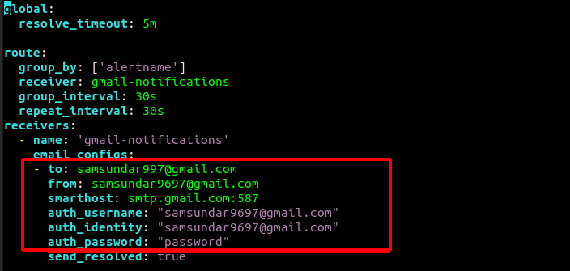

* Save the alertmanager.yml file with wq! Command
* View all the Kafka alerting rules under below file

*less config/prometheus.rules.yml*

* **Edit Alert Manager Config. For Slack**
* Edit Alert Manager for Slack
* Uncomment the below line in dockercompose.yaml

###For Slack Aler Manager

###- ./config/slack-alertmanager.yml:/alertmanager.yml

* Edit the below key value in slack-alertmanager.yml

- api_url: "put your slack webhook api here"

channel: '#slack channel name here'

**4. Start the compose stack**

* Start the compose stack by entering below command on “**Kafka_Prometheus**” folder.

*docker-compose up*

* 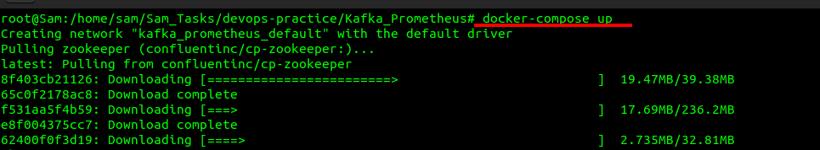Let the stack pull all images and start itself, in the mean time open 9090, 9092 and 3000 ports on security group to access the UI of Prometheus, Confluent kafka and Grafana.
* Access Prometheus on <Node_IP>:9090
* Grafana on <Node_IP>:3000
* Kafka on <Node_IP>:9092

**5. Configure Grafana for Virtualization.**

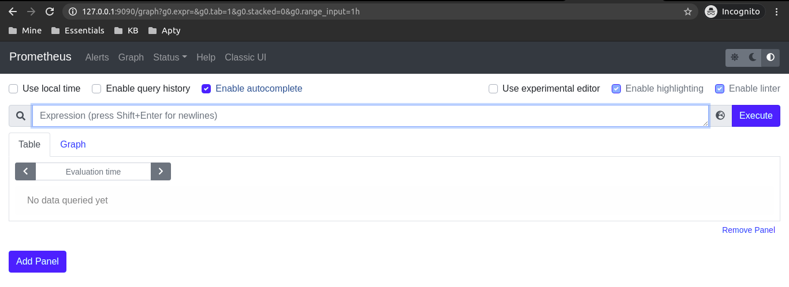Login into Grafana using admin as username and password. Once logged into Grafana, configure prometheus

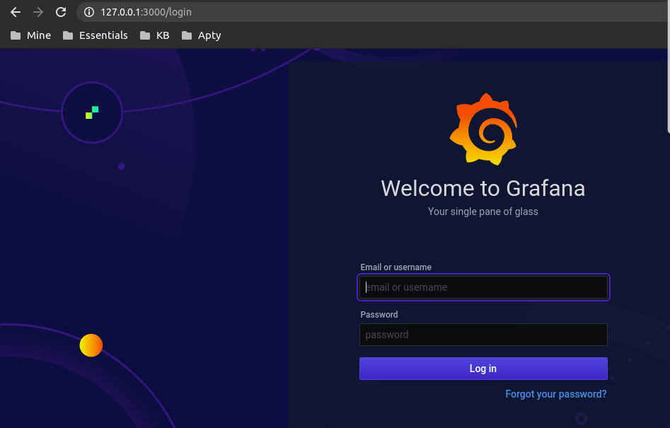

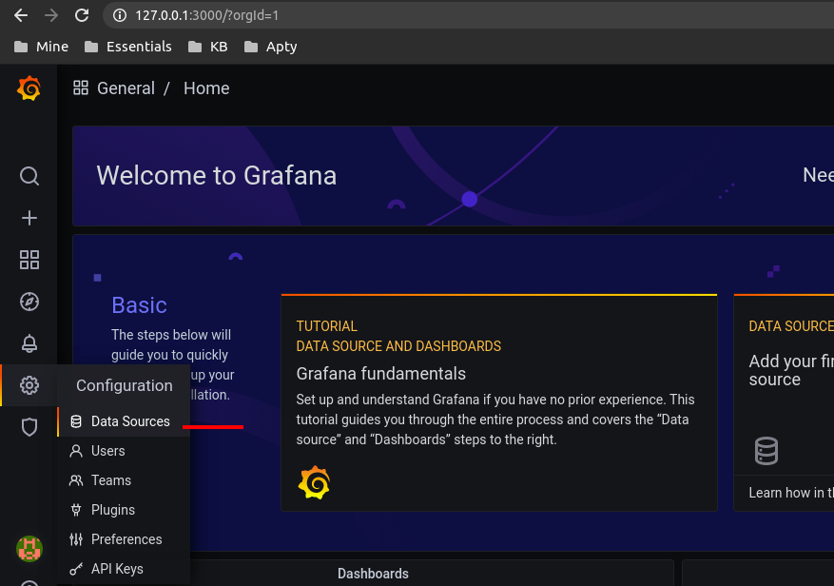

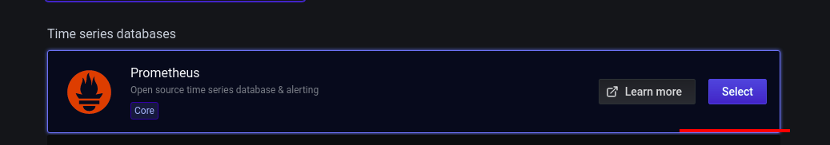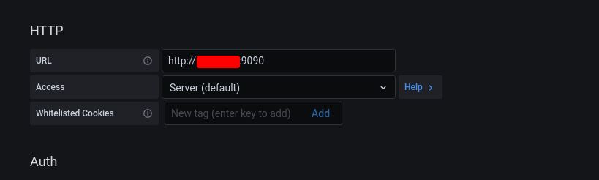

And save the datasource.

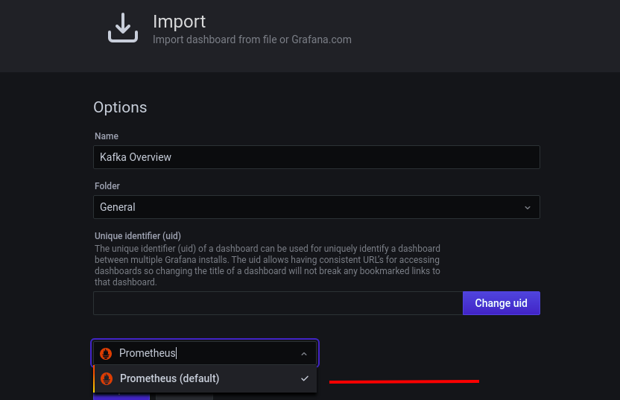Import Custom Grafana Dashboard file “*kafka_rev1.json*” into Grafana for customer dashboard.

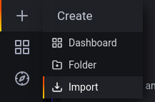

Once the dashboard json is uploaded, view metrics about Kafka in the created dashboard.

