INTERNSHIP REPORT

Ethical Hacking Task 01
Passive Reconnaissance Report
Target Website:
https://www.crunchyroll.com

Prepared by:
Sanjay
Cybersecurity Internship — Task 01
Date: June 27, 2026

Table of Contents

1. Objective
The objective of this task is to perform passive reconnaissance on the target website, www.crunchyroll.com, as part of an ethical hacking internship exercise. The goal is to gather publicly available information about the target using non-intrusive methods and open-source intelligence (OSINT) tools.
This report documents all findings in a structured and professional format. All techniques used are strictly passive, meaning no direct interaction with the target system beyond standard web browsing was performed.

2. Scope
This assessment is limited exclusively to passive reconnaissance techniques. No intrusive, active scanning, or exploitation activities were performed at any point during this task. The following boundaries apply:
- Only publicly accessible tools and resources were used (WHOIS lookup, DNS checkers, Wappalyzer, SecurityHeaders.com).
- No login credentials, authentication tokens, or private systems were accessed.
- No network packets were sent directly to the target server beyond what a standard browser request would produce.
- No vulnerability exploitation or security testing was attempted.
All information gathered is freely available to the public and does not constitute unauthorized access or intrusion.

3. Target Information
Website Name: Crunchyroll
URL: https://www.crunchyroll.com
Industry: Online Streaming / Anime & Entertainment
Owner: Sony Pictures Entertainment (via Funimation acquisition)

Reason for Selecting the Target:
- Crunchyroll is a globally recognized, large-scale web platform, making it a suitable candidate for studying real-world web infrastructure.
- The website utilizes a modern technology stack and enterprise-grade CDN services, offering practical exposure to production environments.
- As a publicly accessible platform, all reconnaissance information is legally obtainable without any ethical concerns.
- The selection is strictly for educational purposes within the internship framework.

4. Homepage Analysis
The homepage of www.crunchyroll.com was accessed using a standard web browser. The landing page presents Crunchyroll as the world's largest dedicated anime streaming platform, offering on-demand access to a vast library of anime titles. The page features a dark theme with prominent call-to-action buttons for user login and free trial registration.
The layout includes a full-screen hero section with animated anime thumbnails in the background, indicating heavy use of front-end JavaScript frameworks for dynamic rendering. Navigation options and branding are minimal and focused on user acquisition.


Figure 1: Crunchyroll Homepage (www.crunchyroll.com)

5. WHOIS Analysis
WHOIS lookup was performed using the ICANN WHOIS Lookup tool. The following domain registration details were retrieved from public registry records:
Domain Name: CRUNCHYROLL.COM
Registry Domain ID: 448045831_DOMAIN_COM-VRSN
Created Date: 2006-05-14 05:07:22 UTC
Expiry Date (Registry): 2027-08-28 03:59:59 UTC
Last Updated: 2024-09-23 13:31:30 UTC
Name Servers: CLINT.NS.CLOUDFLARE.COM, ZARA.NS.CLOUDFLARE.COM
Domain Status: clientDeleteProhibited, clientTransferProhibited, clientUpdateProhibited, serverDeleteProhibited, serverTransferProhibited, serverUpdateProhibited

The domain has been registered since 2006 and is currently managed through Cloudflare's name servers. The multiple "Prohibited" statuses on the domain indicate strong registry-level protection against unauthorized transfers or modifications.

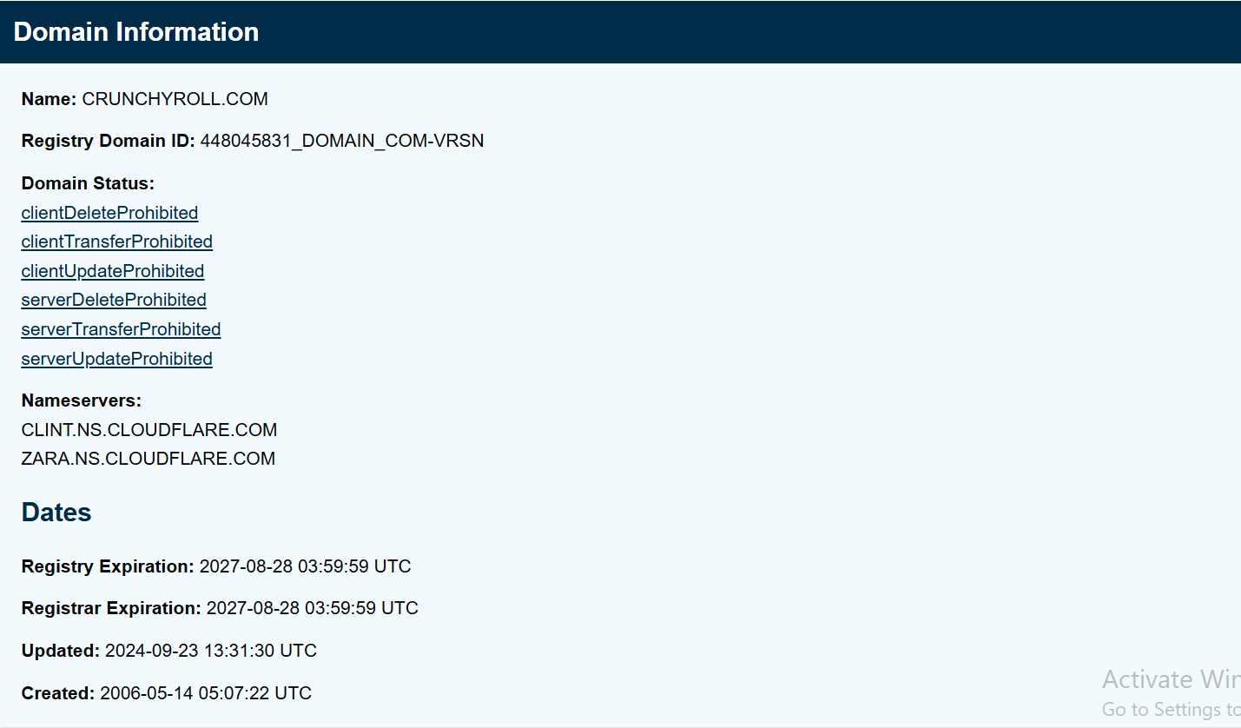
Figure 2: WHOIS Domain Information (ICANN Lookup)

6. DNS Enumeration
DNS records for www.crunchyroll.com were queried using DNSChecker. The results reveal the domain's IP addressing and infrastructure layout across IPv4 and IPv6 protocols.

6.1 A Records (IPv4)
Two A records were returned, both resolving to Cloudflare-owned IP addresses with a TTL of 300 seconds:
- 172.64.153.54 — Owner: Cloudflare Inc. (AS13335)
- 104.18.34.202 — Owner: Cloudflare Inc. (AS13335)
The presence of two A records indicates load balancing or redundancy through Cloudflare's anycast network.

6.2 AAAA Records (IPv6)
Two AAAA records were returned, also owned by Cloudflare Inc.:
- 2606:4700:4409::ac40:9936
- 2606:4700:4404::6812:22ca
IPv6 support confirms that Crunchyroll's infrastructure is modern and dual-stack enabled.

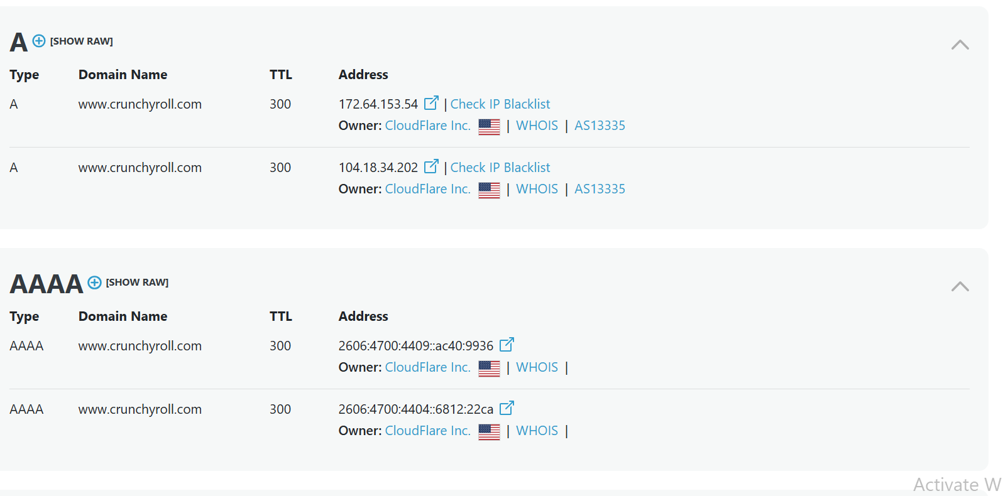
Figure 3: A and AAAA DNS Records for www.crunchyroll.com

6.3 MX, NS, CNAME, PTR & SRV Records
When queried specifically for the www subdomain, the DNSChecker tool returned no records for CNAME, MX, NS, PTR, or SRV types. This is expected behavior for the www subdomain, as MX and NS records are typically configured at the root domain level rather than the www subdomain. No anomalies were observed.

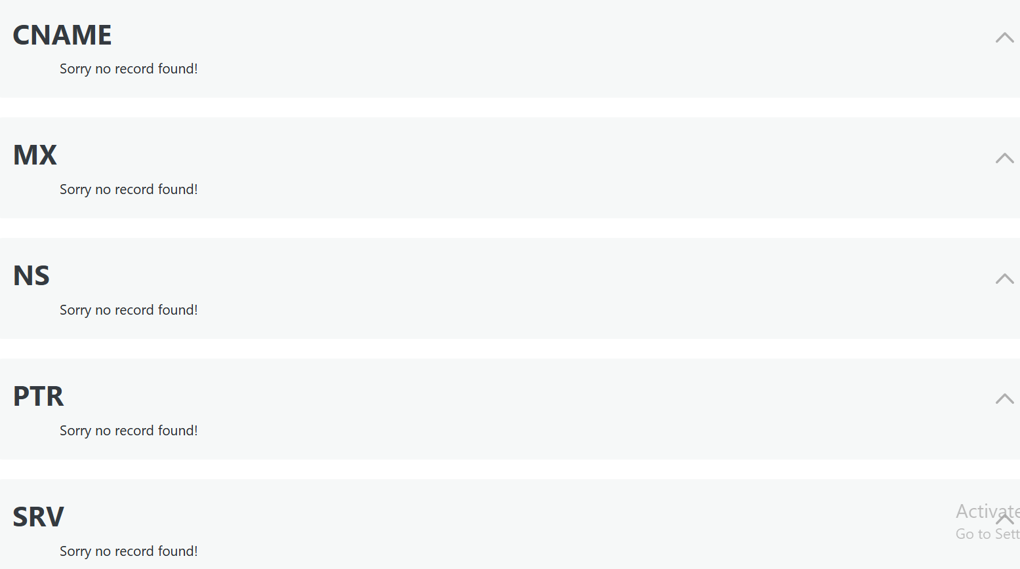
Figure 4: MX, NS, CNAME, PTR and SRV Records — No records found for www subdomain

7. Technology Identification
Technology identification was performed using Wappalyzer, a browser extension that detects web technologies. The following categories and technologies were identified on the Crunchyroll website:

7.1 Web Server
Wappalyzer identified Next.js (version 16.2.3) as the web server framework. Next.js is a React-based framework commonly used for server-side rendering and static site generation in modern web applications.

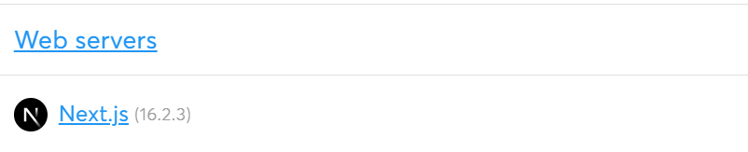
Figure 5: Web Server — Next.js (16.2.3) detected via Wappalyzer

7.2 JavaScript Frameworks
Multiple JavaScript frameworks and libraries were detected, indicating a complex and feature-rich front-end architecture. Notable identifications include React, Next.js, Backbone.js, React Router, Gatsby, styled-components, Mustache, Emotion, GSAP, Vue.js, and Angular. The simultaneous presence of multiple frameworks may indicate a large codebase developed over multiple generations.

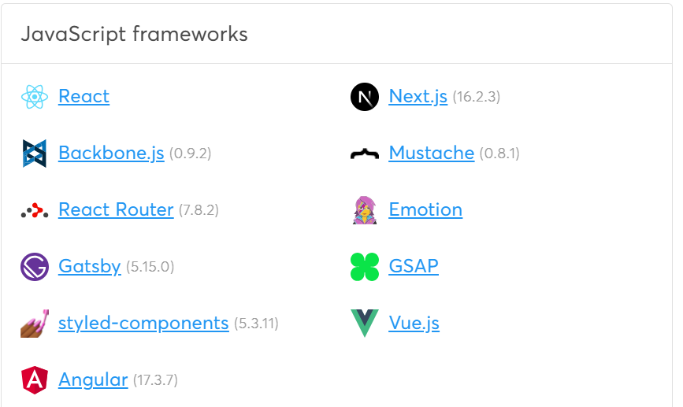
Figure 6: JavaScript Frameworks detected via Wappalyzer

7.3 Programming Language
TypeScript was identified as the programming language used on the front end. TypeScript is a statically typed superset of JavaScript, commonly adopted in large-scale applications to improve code reliability and maintainability.

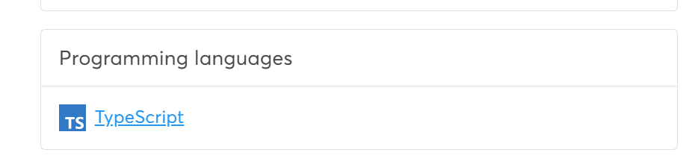
Figure 7: Programming Language — TypeScript detected via Wappalyzer

7.4 CDN / Cloud Infrastructure
Three CDN and cloud storage services were identified: Amazon CloudFront, Cloudflare, and Amazon S3. This combination suggests that Crunchyroll distributes its content (video, images, static assets) through multiple cloud providers for performance and redundancy. These are observations from the tool only and do not confirm backend architecture.

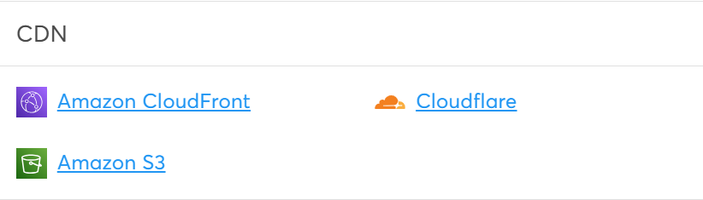
Figure 8: CDN Technologies — Amazon CloudFront, Cloudflare, and Amazon S3

8. HTTP Security Header Analysis
HTTP security headers for www.crunchyroll.com were analyzed using SecurityHeaders.com. The tool scanned the HTTP response headers returned by the server and produced a Security Report Summary.
The following is a direct report of what the tool displayed. These findings are tool observations only and should not be considered a complete or authoritative security assessment:
Site: https://www.crunchyroll.com/
IP Address: 172.64.153.54
Report Time: 27 Jun 2026 10:48:42 UTC
Overall Grade: F (as reported by SecurityHeaders.com)

The following security headers were reported as missing by the tool:
- Strict-Transport-Security
- Content-Security-Policy
- X-Frame-Options
- X-Content-Type-Options
- Referrer-Policy
- Permissions-Policy

Note: The grade and missing headers are as reported by SecurityHeaders.com at the time of the scan. This report does not make any independent security claims. The absence of certain headers as detected by a third-party tool does not necessarily confirm a vulnerability, and should not be interpreted as evidence of exploitable weaknesses.

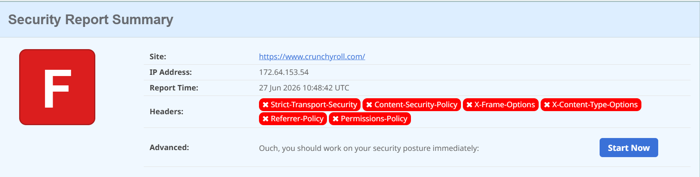
Figure 9: HTTP Security Report Summary from SecurityHeaders.com

9. robots.txt Analysis
The robots.txt file was accessed at https://www.crunchyroll.com/robots.txt. This file is publicly available and is used to instruct web crawlers which paths should not be indexed. Reviewing it is a standard passive reconnaissance technique.
The file specifies a wildcard User-agent (*), meaning the rules apply to all crawlers. A large number of paths are listed under Disallow, including internal application paths, user account areas, and administrative directories. Additionally, two sitemap references are declared at the top of the file.
Key observations from the robots.txt:
- Sitemap references: https://www.crunchyroll.com/sitemap.xml and https://www.crunchyroll.com/sitemap
- Disallowed paths include: /showtag, /search, /facebook, /css/, /js/, /ajax/, /files/, /captchas/, /tmp/, /flash/, /server/, /sitedown/, /ads/, /status/, /client/, /common/, /user, /store/, /email, /account, /watchlist, /history, /crunchylists, and several editorial paths.
The robots.txt reveals the general structure of the application, including the existence of user account systems, content management paths, and internal tooling directories. No security assessment is made based on this file.

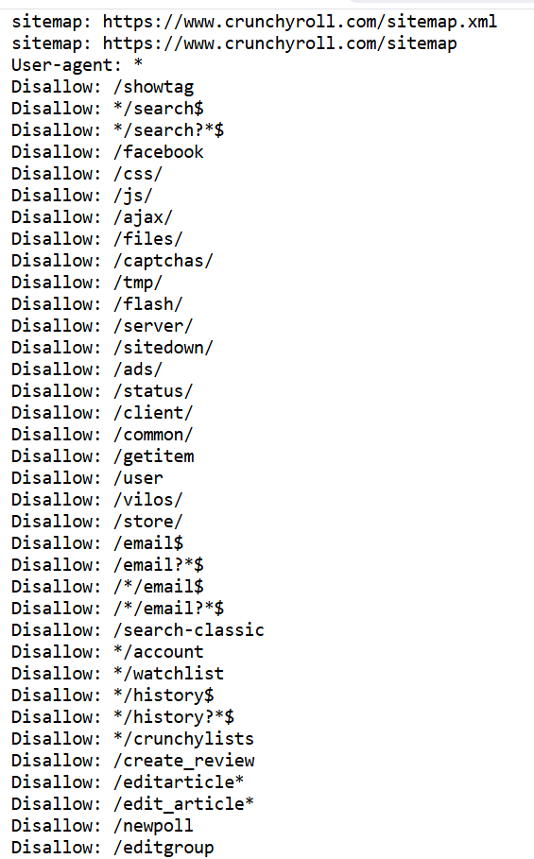
Figure 10: robots.txt file contents for www.crunchyroll.com

10. sitemap.xml Analysis
The sitemap index file was accessed at https://www.crunchyroll.com/sitemap.xml. This file is a standard XML sitemap index that references multiple child sitemaps, each covering a different content category or language region.
The sitemap index references the following child sitemaps:
- /sitemaps/static_routes.xml — Static pages and routes
- /sitemaps/extras.xml — Additional content
- /sitemaps/videos.xml — Video content
- /sitemaps/simulcasts.xml — Simulcast content
- /sitemaps/news/en-US/categories.xml — English (US) news categories
- /sitemaps/news/es-ES/categories.xml — Spanish news categories
- /sitemaps/news/ar-SA/categories.xml — Arabic news categories
- /sitemaps/news/pt-PT/categories.xml — Portuguese news categories
- /sitemaps/news/it-IT/categories.xml — Italian news categories
- /sitemaps/news/ru-RU/categories.xml — Russian news categories
- /sitemaps/news/de-DE/categories.xml — German news categories
- /sitemaps/news/fr-FR/categories.xml — French news categories
The sitemap confirms that Crunchyroll supports multiple languages and serves a global audience. The existence of separate sitemaps for simulcasts and videos reflects the platform's primary content type. All sitemap URLs are publicly accessible.

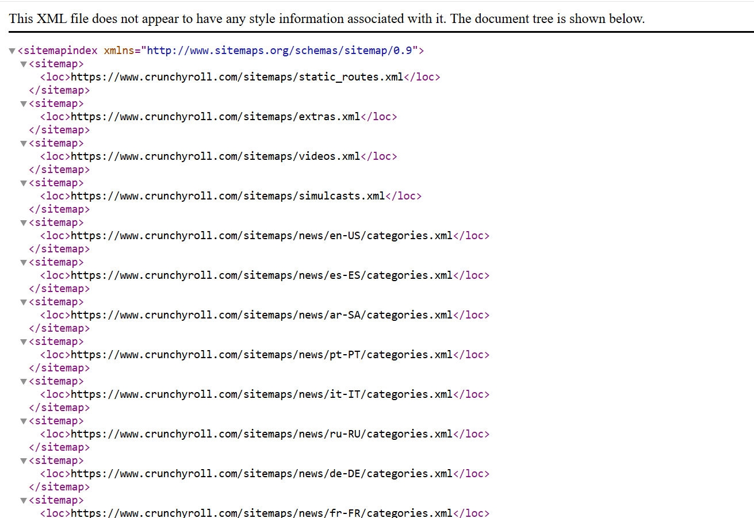
Figure 11: sitemap.xml Index File for www.crunchyroll.com

11. Overall Findings Summary
The following table summarizes the key information gathered during passive reconnaissance:

Category | Finding
Domain | CRUNCHYROLL.COM — Registered 2006, expires 2027
Name Servers | CLINT.NS.CLOUDFLARE.COM, ZARA.NS.CLOUDFLARE.COM
Domain Status | Locked — 6 Prohibited statuses (no unauthorized transfer/edit)
IPv4 (A Records) | 172.64.153.54, 104.18.34.202 — Both owned by Cloudflare AS13335
IPv6 (AAAA Records) | 2606:4700:4409::ac40:9936, 2606:4700:4404::6812:22ca (Cloudflare)
MX / NS / CNAME | No records found for www subdomain (expected)
Web Server | Next.js 16.2.3
JS Frameworks | React, Next.js, Backbone.js, React Router, Gatsby, Vue.js, Angular, GSAP
Programming Language | TypeScript
CDN / Cloud | Amazon CloudFront, Cloudflare, Amazon S3
Security Headers | Grade F (per SecurityHeaders.com) — 6 headers reported missing
robots.txt | Multiple disallowed paths; 2 sitemap references
sitemap.xml | 12+ child sitemaps across multiple languages and content types

All findings are derived exclusively from the screenshots collected during the reconnaissance session. No additional sources, assumptions, or inferences beyond what is visible in the evidence have been included.

12. Conclusion
This report documents the passive reconnaissance conducted on www.crunchyroll.com as part of Ethical Hacking Task 01. Using only publicly available tools and techniques — including WHOIS lookup, DNS enumeration, technology fingerprinting, HTTP header analysis, and review of robots.txt and sitemap.xml — a meaningful profile of the target's public-facing infrastructure was compiled.
The reconnaissance successfully identified the domain registration details, IP addressing scheme, CDN providers, front-end technology stack, and publicly visible structural information. All information was gathered without interacting with, exploiting, or attempting to compromise the target system in any way.
This exercise demonstrates that a substantial amount of information about a web platform can be collected passively through open-source intelligence, highlighting the importance of organizations being mindful of the information they expose publicly.
No security vulnerabilities are claimed or confirmed by this report. All tool outputs presented herein represent observations made at the time of data collection and are subject to change.

Appendix — All Screenshots
The following appendix contains all screenshots collected during the passive reconnaissance exercise, presented in the order they appear in the report.


Appendix A: Crunchyroll Homepage

Appendix B: WHOIS Domain Information

Appendix C: A and AAAA DNS Records

Appendix D: MX, NS, CNAME Records (No records found)

Appendix E: Web Server — Next.js

Appendix F: JavaScript Frameworks

Appendix G: Programming Language — TypeScript

Appendix H: CDN Technologies

Appendix I: HTTP Security Header Analysis

Appendix J: robots.txt File

Appendix K: sitemap.xml Index

