INTERNSHIP REPORT

Ethical Hacking Task 02
Nmap Localhost Scanning Report

Prepared by:
Sanjay
Cybersecurity Internship — Task 02
Target: localhost (127.0.0.1)
Date: June 28, 2026

Table of Contents

1. Objective
The objective of this task is to perform authorized Nmap scans on the localhost interface (127.0.0.1) as part of Ethical Hacking Task 02. The purpose is to practice fundamental network reconnaissance commands, understand their outputs, and document findings in a structured professional format.
This exercise covers four key Nmap operations: version verification, basic port scanning, service/version detection, and operating system fingerprinting. All scans were performed exclusively on the local machine within the internship lab environment.

2. Introduction to Nmap
Nmap (Network Mapper) is an industry-standard, open-source tool for network discovery and security auditing. Originally released in 1997, it is widely used by penetration testers, system administrators, and security researchers to enumerate active hosts, discover open ports, and identify running services on a network.
Nmap operates by sending network packets to target hosts and analyzing the responses. It supports a wide range of scan types including TCP SYN scans, UDP scans, version detection, OS fingerprinting, and scripted scanning via the Nmap Scripting Engine (NSE). Nmap is pre-installed on Kali Linux and is considered an essential tool in any cybersecurity toolkit.

2.1 Nmap Version Used
Version 7.94SVN was used for this task, running on Kali Linux (x86_64-pc-linux-gnu). The version was confirmed using the nmap --version command prior to scanning.

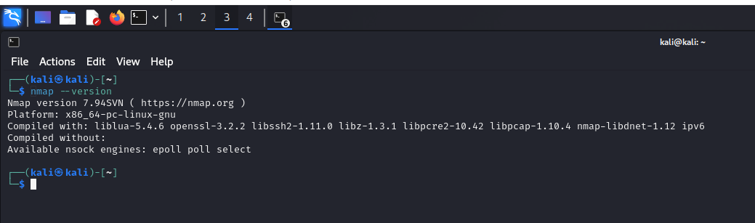
Figure 1: nmap --version output confirming version 7.94SVN

3. Methodology
This task followed a passive, non-intrusive methodology limited to the localhost loopback interface. No external hosts, networks, or production systems were scanned. The following approach was used:
- Environment: Kali Linux terminal running as user "kali".
- Target: localhost (127.0.0.1) — the local loopback address of the scanning machine.
- Authorization: Scans were performed on the student's own machine within the internship lab environment. No third-party systems were involved.
- Scope: Four Nmap commands were executed in sequence, progressing from version verification to OS detection.
- Documentation: All command outputs were recorded via screenshots for inclusion in this report.

4. Commands Used

4.1 nmap --version
Verifies the installed Nmap version and displays compilation details including supported libraries and socket engines.
$ nmap --version

4.2 nmap localhost
Performs a default TCP connect scan against localhost, scanning the top 1000 most common TCP ports. No elevated privileges are required. Reports the host status and port states.
$ nmap localhost

4.3 nmap -sV localhost
Extends the basic scan with service and version detection. Nmap probes any open ports to determine the application name and version number running on each port.
$ nmap -sV localhost

4.4 sudo nmap -O localhost
Performs OS detection using root privileges. Nmap sends specialized probe packets and matches response signatures against an internal fingerprint database to identify the operating system.
$ sudo nmap -O localhost

5. Scan Results

5.1 Basic Port Scan (nmap localhost)
The basic scan completed in 0.15 seconds. All 1000 scanned TCP ports on localhost (127.0.0.1) were reported as being in ignored states (closed). No open ports were detected. The host was confirmed as up with a latency of 0.00025 seconds.

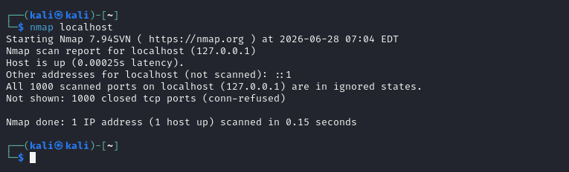
Figure 2: Basic Nmap scan of localhost — all 1000 ports closed

5.2 Service and Version Detection (nmap -sV localhost)
Service detection was performed using the -sV flag. The scan completed in 0.55 seconds. As no ports were found open in the preceding basic scan, the service detection phase had no ports to probe and returned no service information. The tool confirmed that service detection was performed but produced no version data.

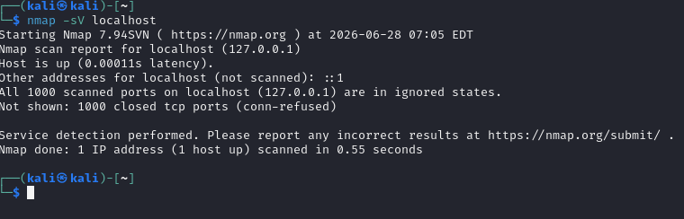
Figure 3: Service detection scan (-sV) — no services identified due to no open ports

5.3 OS Detection (sudo nmap -O localhost)
OS detection was attempted using root privileges (sudo). The scan completed in 1.67 seconds. Nmap reported "Too many fingerprints match this host to give specific OS details." This is a known limitation when scanning a loopback interface with no open ports — OS fingerprinting relies on responses from open ports to narrow down the match. Network Distance was reported as 0 hops.

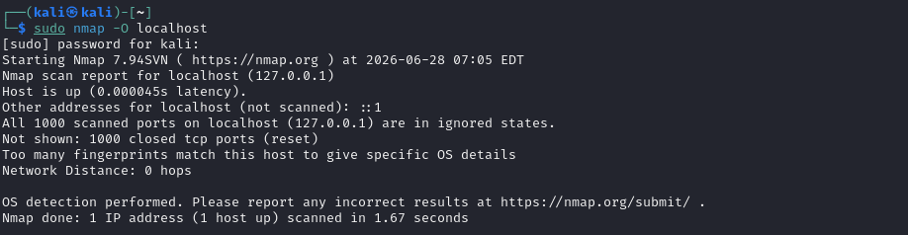
Figure 4: OS detection scan (-O) — fingerprinting inconclusive due to no open ports

6. Port Research
The following table documents commonly known ports researched as part of this task. These ports represent standard network services. None of these ports were observed as open during the localhost scans.

Port(s) | Service | Description
20 / 21 | FTP | File Transfer Protocol — transfers files; Port 21 is control, Port 20 is data.
22 | SSH | Secure Shell — provides encrypted remote login and secure command execution.
23 | Telnet | Telnet — unencrypted remote terminal; deprecated due to security risks.
25 | SMTP | Simple Mail Transfer Protocol — handles sending of outgoing email.
53 | DNS | Domain Name System — translates domain names to IP addresses.
80 | HTTP | Hypertext Transfer Protocol — standard unencrypted web communication.
110 | POP3 | Post Office Protocol v3 — retrieves emails from a remote server.
143 | IMAP | Internet Message Access Protocol — allows email access from multiple devices.
443 | HTTPS | HTTP Secure — web traffic encrypted with TLS/SSL.
445 | SMB | Server Message Block — Windows file/printer sharing and authentication.
3389 | RDP | Remote Desktop Protocol — graphical remote access for Windows systems.

7. Analysis
The results of all four Nmap scans were consistent and as expected for a default Kali Linux installation with no additional services running:
- The absence of open ports confirms that no unnecessary services are currently active on the localhost. This is a secure baseline configuration.
- Service detection (-sV) was unable to identify any applications, which is a direct consequence of having no open ports to probe. This does not indicate a tool failure — it accurately reflects the system state.
- OS fingerprinting (-O) returned an inconclusive result because Nmap's OS detection engine relies on analyzing responses from open ports. With no open ports available, the fingerprint database could not narrow down the match to a specific OS.
- The extremely low latency values (sub-millisecond) are characteristic of loopback interface communication, which does not traverse physical network hardware.
- All scan behaviors observed were consistent with standard Nmap documentation for a localhost environment.

8. Recommendations
- Keep unnecessary network services disabled at all times to minimize the attack surface exposed to potential adversaries.
- Configure and enable a host-based firewall (e.g., ufw on Linux) to restrict inbound and outbound traffic to only what is required.
- Conduct periodic Nmap scans on your own systems to audit the current state of open ports and detect any unauthorized or unexpected services.
- Apply operating system and application security updates on a regular schedule to remediate known vulnerabilities.
- Enable only the services that are strictly necessary for the intended function of the system.
- Review system logs periodically for signs of unexpected connection attempts or port activity.

9. Conclusion
This report documents the Nmap localhost scanning exercise conducted as part of Ethical Hacking Task 02. Four Nmap commands were executed against the local machine (127.0.0.1) running Kali Linux, and all outputs were recorded and analyzed.
The scans confirmed that no TCP ports were open on the system at the time of scanning. As a result, service version detection returned no data and OS fingerprinting was inconclusive — both of which are expected and technically accurate outcomes for this environment, not errors.
This exercise provided practical exposure to core Nmap scanning techniques and demonstrated how to interpret scan results in context. The experience reinforces the importance of maintaining a minimal attack surface by disabling unnecessary services, and of using tools like Nmap for regular self-auditing of network exposure.

