 

**Placement Empowerment Program**

***Cloud Computing and DevOps Centre***

Host a Static Website Locally: Set Up a Local Server Apache and Host a Simple HTML page with your name

Name: Samiya Afreen J Department : CSE



**Introduction and Overview**

In this POC, we will learn how to host a static website locally using the Apache HTTP Server in macOS. This process involves setting up a local web server, configuring it correctly, and hosting a simple HTML page. By following these steps, you’ll get hands-on experience with configuring and running a local Apache server, which is a foundational skill for web hosting and server management.

**Objective**

The goal of this project is to:

1. Set up a local web server using Apache.

2. Configure the server to host static files.

3. Create and host a simple HTML page displaying your name.

**Importance of Local Hosting**

Local hosting is an essential skill for developers, as it allows them to test and experiment with web applications in a controlled environment. It offers several advantages, such as:

**Hands-On Learning:** Gain practical experience with server setup and configuration.

**Testing Ground:** Safely test and debug websites before deploying them to a live server.

**Offline Development:** Work on web projects without requiring an active internet connection.

**Step-by-Step Overview**

Step1:

Enable Apache on macOS:

Apache is pre-installed on macOS. Open Terminal and start Apache with:

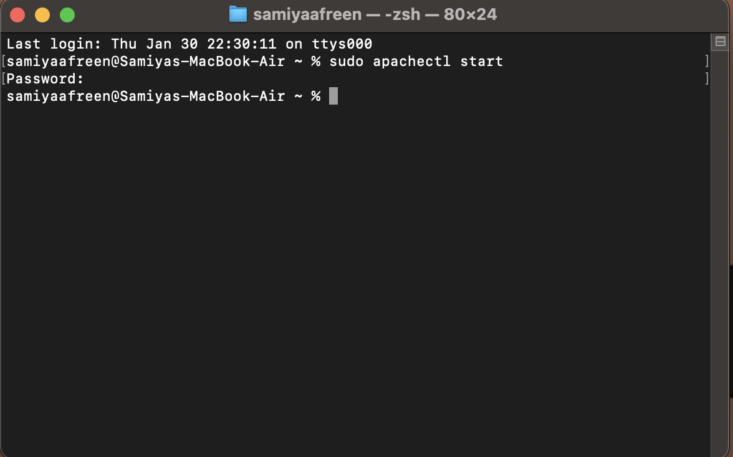

Step 2 :

Verify Apache is Running:

Open your browser and enter http://localhost/. You should see the default Apache page.

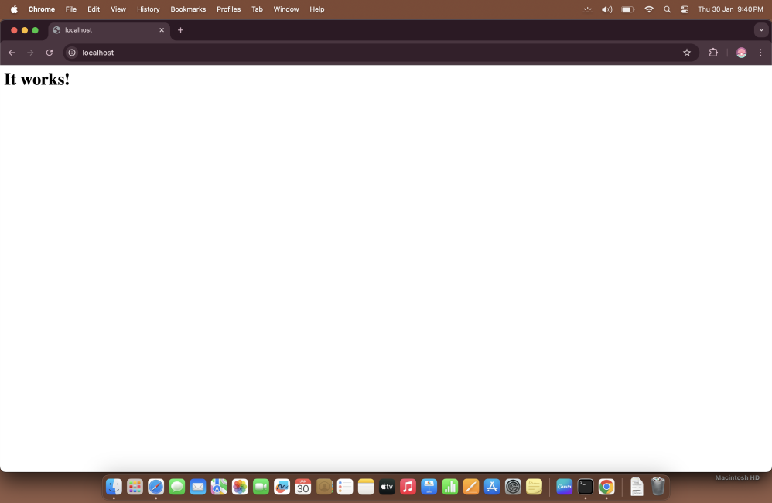

Step 3 :

Navigate to Apache’s Document Root:

Apache's default document root (where website files are stored) is located at /Library/WebServer/Documents/. Use this command to navigate to that directory:

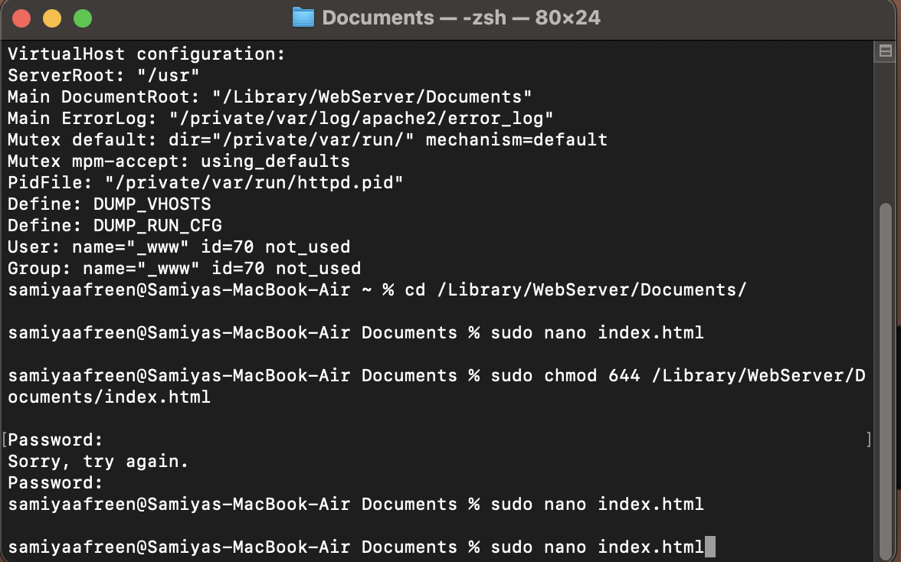

Step 4 :

Create a new HTML file:



Add the following HTML code:

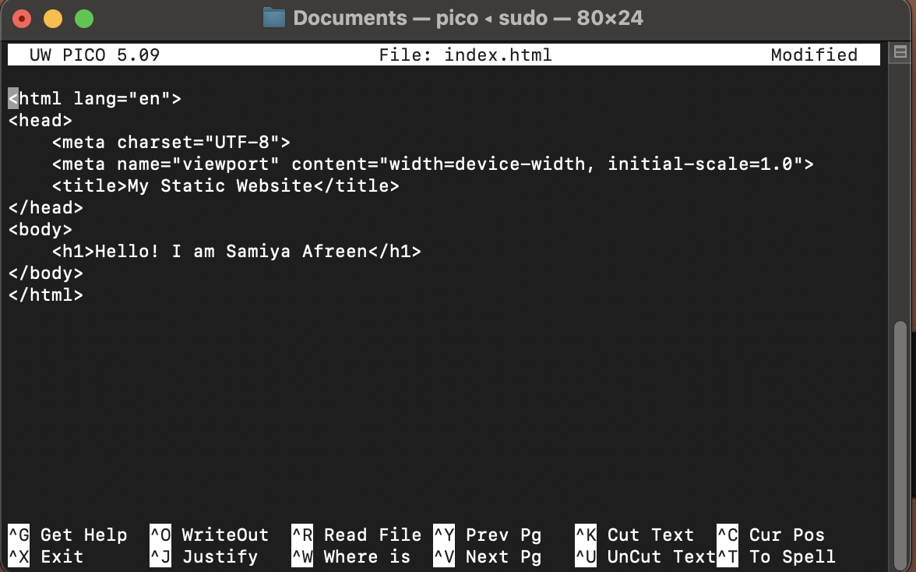

Save and exit **nano**

Step 5:

Set Permissions for the HTML File:

Make sure that the file you created has the correct permissions so that Apache can serve it properly. Run the following command to set the correct permissions:



Step 6 :

Access Your Website:

Open your browser and enter http://localhost/index.html. You should see your webpage displayed.

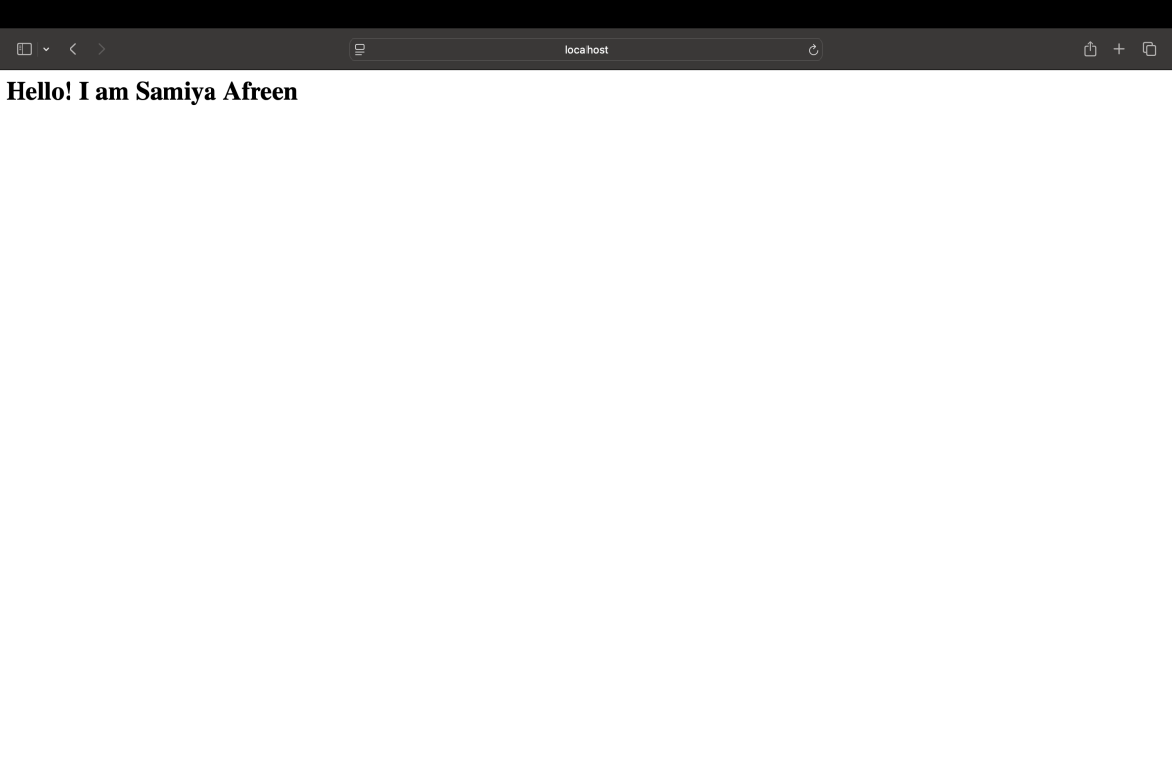

**Expected Outcome**

By completing this POC, you will:

1. Successfully configure and run an Apache server locally.

2. Host a static HTML website that displays your name.

3. Understand the basics of web server configuration and file hosting.