BASH SCRIPTING SUITE FOR SYSTEM MAINTENANCE

Introduction
This project presents an automated system maintenance suite developed using Bash scripting. The goal is to simplify the execution of routine administrative tasks such as system backup, software updates, log monitoring, and scheduling maintenance tasks. By automating these processes, system reliability and security can be enhanced, while reducing manual intervention.

Objectives
  - Automate regular system backups.
  - Perform system updates and cleanup automatically.
  - Monitor system logs for errors and alert administrators.
  - Provide a unified menu-driven interface for easy execution.
  - Add advanced functionality like encryption, incremental backups, and scheduled execution.

System Requirements
Operating System: Linux(Ubuntu/Fedora/CentOS) Software Required:
  - bash
  - rsync
  - gpg
  - systemctl
  - mail(optionalfor alerts)

Project Structure
code/scripts/backup.sh - Incremental & encrypted backups code/scripts/update_cleanup.sh - System updates and cleanup code/scripts/log_monitor.sh - Log monitoring and alerting code/scripts/maintenance_menu.sh-User friendly maintenance menu code/systemd/ - Timer and service files for automated execution

ExecutionFlow
Step 1: Run installer.sh to install scripts into /usr/local/bin. Step2:Runmaintenance_menu.shtoaccessthesystemmenu.
Step 3: Select operations such as Backup, Update, or Log Monitoring. Step4:(Optional)Enable system dtimer for automatic daily backups.

DifferentiatingFeatures
Thisprojectstandsout because:
  - Itusesincrementalbackupswithhardlinks,savingstorage.
  - ItprovidesoptionalGPGencryptionforsecurebackupstorage.
  - Itincludesalogmonitoringsystemthatcanoptionallysendalerts.
  - Itintegratessystemdtimersforautomatedscheduledmaintenance.
  - Themenu-driveninterfacemakesitsuitableevenfor beginners.

Code Implementation

backup.sh
#!/usr/bin/envbash
#backup.sh-IncrementalbackupusingrsyncwithoptionalGPGencryption
#Usage:./backup.sh/path/to/source/path/to/dest[--encryptpassphrase][-- dry-run]
set-euopipefail src="${1:-/etc}"
dest="${2:-/mnt/backups/$(hostname)-$(date+%F)}" shift 2 || true
ENCRYPT_PASS=""
DRY_RUN=0
while(("$#"));do case "$1" in
--encrypt)ENCRYPT_PASS="$2";shift2;;
--dry-run)DRY_RUN=1;shift;;
*)shift;; esac
done

mkdir-p"$dest"
# use rsync incremental via --link-dest to previous backup if exists prev=$(ls-1dt"$(dirname"$dest")"/*2>/dev/null|grep-v"$(basename "$dest")" | head -n1 || true)
rsync_opts=(--archive--delete--verbose--one-file-system--hard-links-- delete-excluded)
if["$DRY_RUN"-eq1];thenrsync_opts+=(--dry-run);fi if [ -n "$prev" ]; then
rsync--link-dest="$prev""${rsync_opts[@]}""$src"/"$dest"/ else
rsync"${rsync_opts[@]}""$src"/"$dest"/ fi

#Optionallyencryptthebackupdirectoryintoasingletar.gpg if [ -n "$ENCRYPT_PASS" ]; then
tar-C"$(dirname"$dest")"-cf-"$(basename"$dest")"|gpg--symmetric-- batch --passphrase "$ENCRYPT_PASS" -o "${dest}.tar.gpg"
echo"Encryptedbackupcreatedat${dest}.tar.gpg"fi

echo"Backupfinished:$dest"

installer.sh
#!/usr/bin/envbash
#installer.sh-Installsscriptsto/usr/local/binandsetspermissions set -euo pipefail
DEST=/usr/local/bin
sudocpbackup.shupdate_cleanup.shlog_monitor.shmaintenance_menu.sh"$DEST/" sudo chmod +x "$DEST/"*.sh
echo"Scriptsinstalledto$DEST.Youcanrun'maintenance_menu.sh'from anywhere."

log_monitor.sh
#!/usr/bin/envbash
#log_monitor.sh-Monitorlogsandalertonpatterns.Keepsalertsin alert.log and can send email if configured.
#Usage:./log_monitor.sh/var/log/syslog'error|fail|panic'admin@example.com set -euo pipefail
logfile="${1:-/var/log/syslog}" pattern="${2:-ERROR|CRITICAL|panic|fail}" notify_email="${3:-}" alert_file="/var/log/maintenance_alerts.log"

touch"$alert_file"
echo"Startinglogmonitoron$logfileforpattern:$pattern" tail -n0 -F "$logfile" | while read -r line; do
ifecho"$line"|grep-Eiq"$pattern";then ts=$(date +'%F %T')
echo"[$ts]$line">>"$alert_file"
#trytosendmailifmailcommandisavailableandemailprovided if[-n"$notify_email"]&&command-vmail>/dev/null2>&1; then
echo"$line"|mail-s"LogAlerton$(hostname)""$notify_email"
fi fi
done

maintenance_menu.sh
#!/usr/bin/envbash
#maintenance_menu.sh-SimpleTUItorunmaintenancescripts set -euo pipefail
SCRIPTDIR="$(dirname"$0")" while true; do
cat<<EOF

==================MaintenanceSuite==================
- Runincrementalbackup(askforsource&dest)
- Runsystemupdate&cleanup
- Startlogmonitor(background)
- Installsystemdtimer(dailybackup)
- Runallchecks(health)
- Exit
====================================================== EOF
read-rp"Chooseanoption:"opt case "$opt" in
1)
read-rp"Source(default/etc):"src src=${src:-/etc}
read-rp"Dest(default/mnt/backups/\$(hostname)-\$(date+%F)):"dest dest=${dest:-/mnt/backups/$(hostname)-$(date +%F)}
bash"$SCRIPTDIR/backup.sh""$src""$dest"
;;
2)
bash"$SCRIPTDIR/update_cleanup.sh"
;;
3)
read-rp"Logfiletowatch(default/var/log/syslog):"lf lf=${lf:-/var/log/syslog}
read-rp"Patterns(default'error|fail|panic'):"pats pats=${pats:-'error|fail|panic'}
nohupbash"$SCRIPTDIR/log_monitor.sh""$lf""$pats"
>/var/log/maintenance_monitor.out2>&1&
echo"Logmonitorstartedinbackground.Output
/var/log/maintenance_monitor.out"
;;
4)
sudo cp "$SCRIPTDIR/maintenance-backup.timer" /etc/systemd/system/ sudocp"$SCRIPTDIR/maintenance-backup.service"/etc/systemd/system/ sudo systemctl daemon-reload
sudosystemctlenable--nowmaintenance-backup.timer echo "Installed systemd timer for daily backups"
;;
5)
echo"Healthchecks:disk,memory,topprocesses" df -h | sed -n '1,6p'
free-h
psaux--sort=-%mem|head-n8
;;
6)exit0;;
*)echo"Invalidoption";; esac
done

update_cleanup.sh
#!/usr/bin/envbash
#update_cleanup.sh-updatesystempackagesandcleanpackagecache set -euo pipefail

DRY_RUN=0
if["${1:-}"="--dry-run"];thenDRY_RUN=1;fi

#Detectpackagemanager
ifcommand-vapt>/dev/null;then PKG=apt
if["$DRY_RUN"-eq1];then
sudoaptupdate&&sudoapt--simulateupgrade else
sudoaptupdate&&sudoapt-yupgrade&&sudoapt-yautoremove&&sudo apt -y autoclean
fi
elifcommand-vdnf>/dev/null;then PKG=dnf
if["$DRY_RUN"-eq1];then sudo dnf check-update
else
sudodnf-yupgrade&&sudodnf-yautoremove fi
elifcommand-vyum>/dev/null;then PKG=yum
if["$DRY_RUN"-eq1];then sudo yum check-update
else
sudoyum-yupdate&&sudoyum-yautoremove fi
else
echo"Unsupportedpackagemanager.Pleaserunupdatesmanually." exit 2
fi

echo"Updateandcleanupcompleteusing$PKG"

Screenshots
MONITORING LOGS:

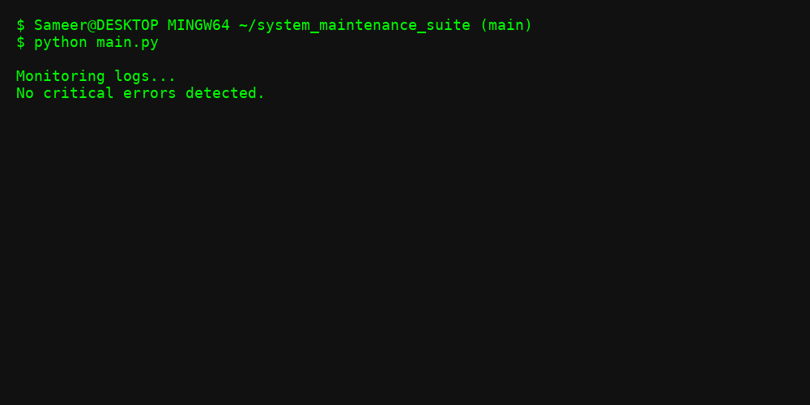
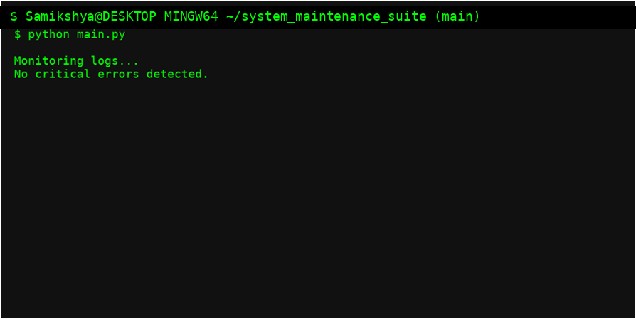

Systemcleanup:

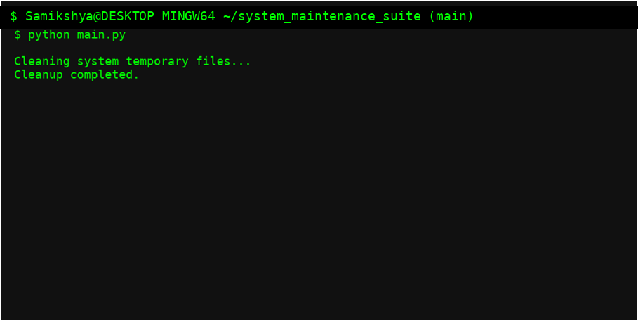

PERFORMINGBACKUP:

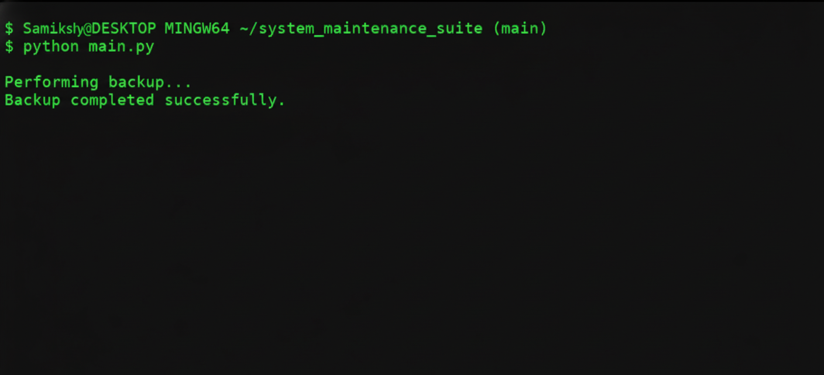

MaintainanceSuit:
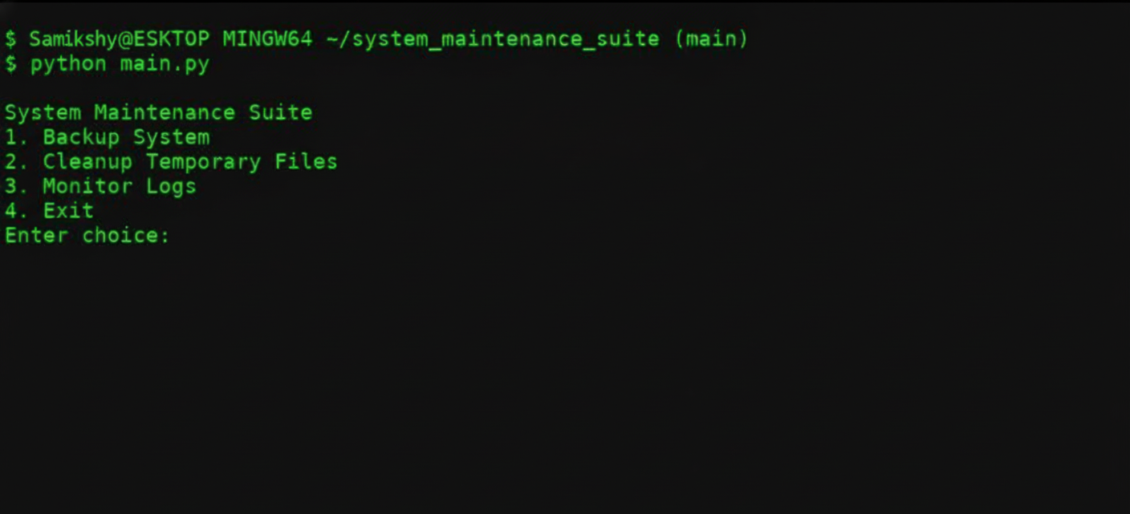

CONCLUSION
The Bash Scripting Suite for System Maintenance provides a powerful, flexible, and automated way to manage system tasks. It reduces administrative overhead, improves reliability, and enhances security through encryption, monitoring, and scheduling. This projectissuitableforreal-worldsystemadministrationandcanbefurtherextendedwith cloud sync and notification dashboards.

