Exercises 2/6/’26
Assume that you have the vets table in your database, loaded from VV.csv, as we did previously.
The following questions pertain to this table.
1. You can alias selected column names to provide more descriptive output. Run the following:
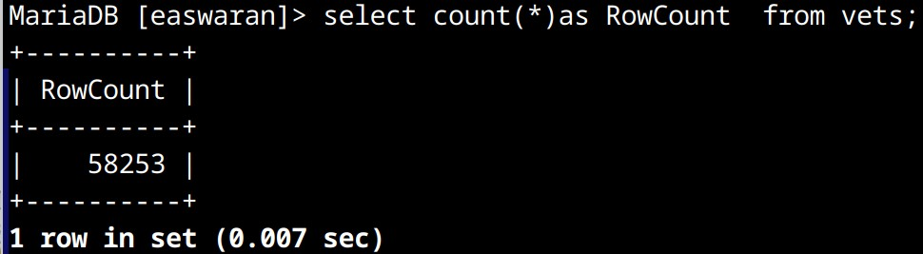
‘as’ followed by alias name is used to rename a column for output. This doesn’t change the table column name in the database.
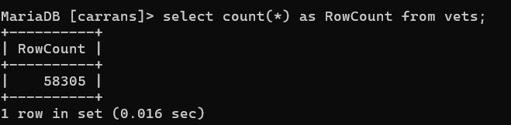

2. Run the query:
SELECT count(*) FROM vets where trim(state) = state;
What do you think this implies?
- Implies that some states have extra space and that the data has to be cleaned.
- Use sql DELETE statement to delete all the empty rows in the vets table. How many empty rows were there?
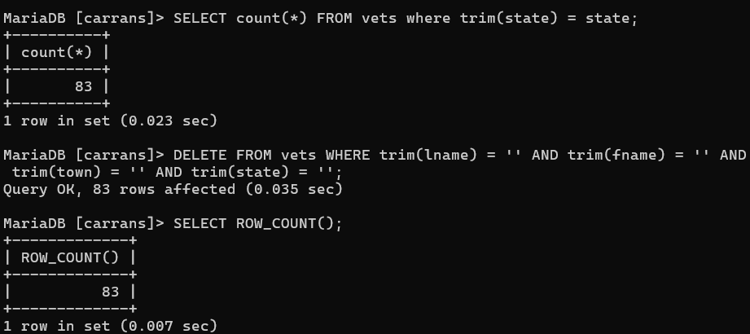
The original CSV file had blank lines, so they were read in as empty rows. This is one thing you should be aware of when reading in CSV files.
- What SELECT ROW_COUNT does is that will grab the the rows you have previously made a change on, for example, if you have 100 rows and you are asked to delete 75 of them, what SELECT ROW_COUNT does is show 75

- After deleting empty rows use sql UPDATE statement to update values in state column by trimming leading and trailing spaces in that column.
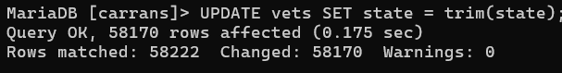
- Update each of the other columns by trimming the leading and trailing white spaces.Now a query like the following should give correct results.
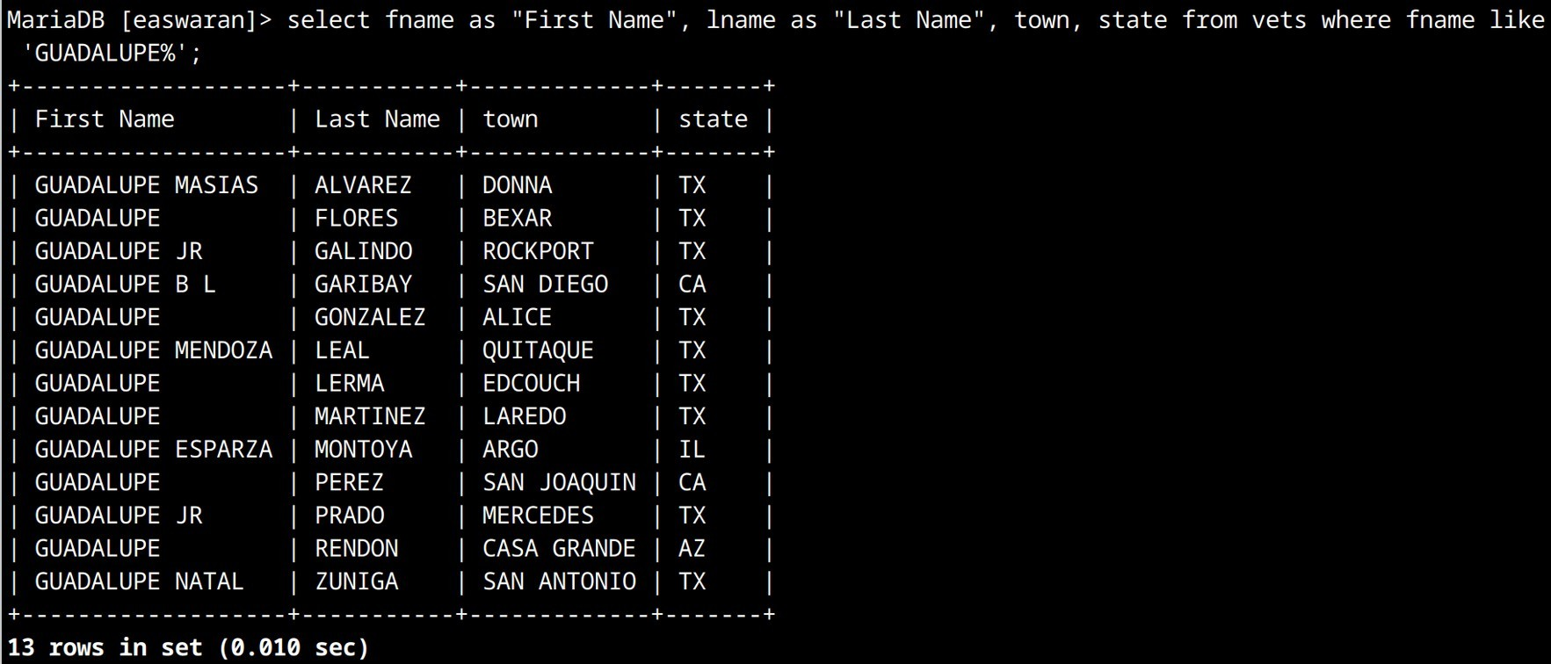
Notice the use of LIKE condition. In the expression LIKE ‘XXXXX%’ , the % satisfies one or more characters.
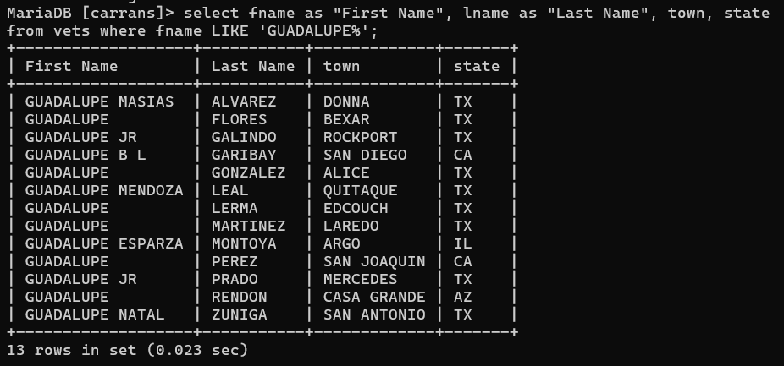
- Find (using SQL) how many towns are in the data that starts with ‘LOS ‘, such as ‘LOS ANGELES’
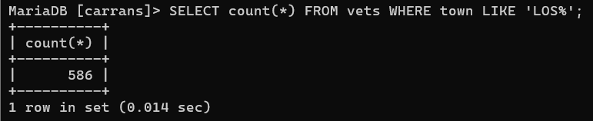

- Using SQL, determine how many are from LOS ANGELES and how many are from other towns with names starting with ‘LOS ‘.
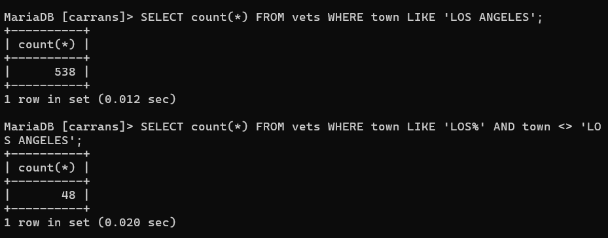

- Look up the use of GROUP BY to group results in SQL.
Get a count by state of people who are not from LOS ANGELES but from other towns starting with ‘LOS ‘
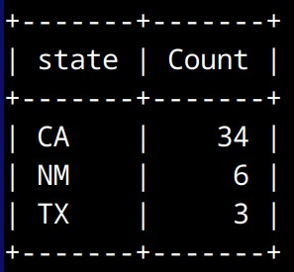

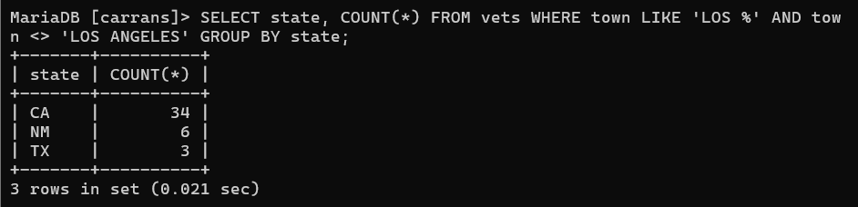

- Look up ORDER BY clause to display results of SELECT statements ordered by some criterion. What SQL will give a list of vets from GUAM (GU) ordered by their last names?
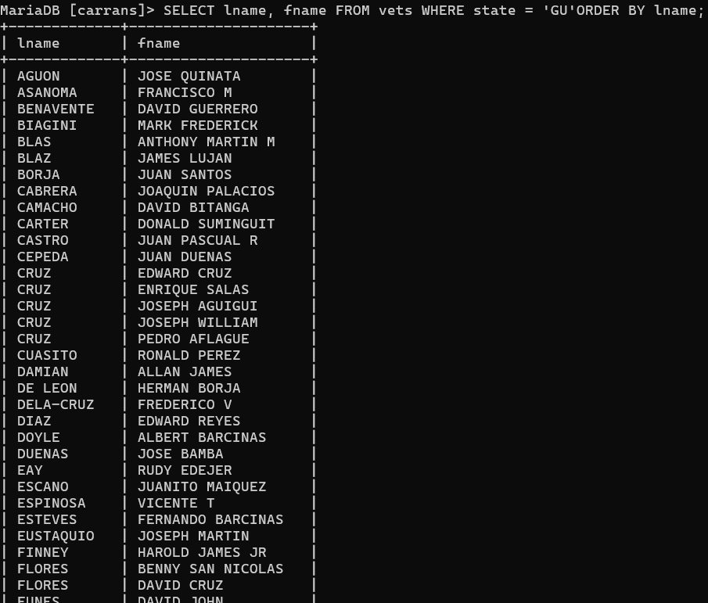
- Create a new table States
create table States(State varchar(30), Abbreviation varchar(10) primary key)
This will create a table with Abbreviation as primary key.
Load the given States.csv file into the table. Examine the table. Notice any problems?
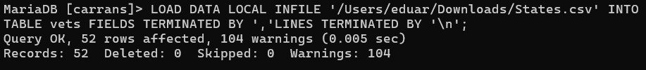

- It gave me a lot of warning, it might be because there might be extra spaces, and duplicates that are overlapping between each other

