Source Populate_Database_mynewpaltz.sql provided to create/fill three tables:
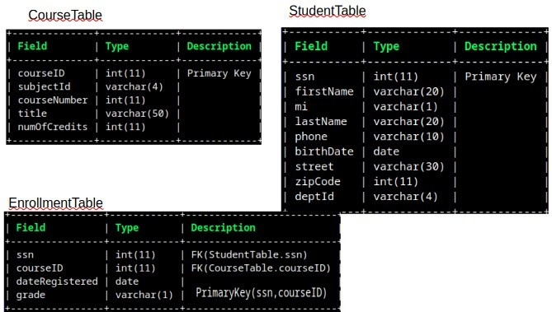
- List students by name and ssn who are taking 5 courses
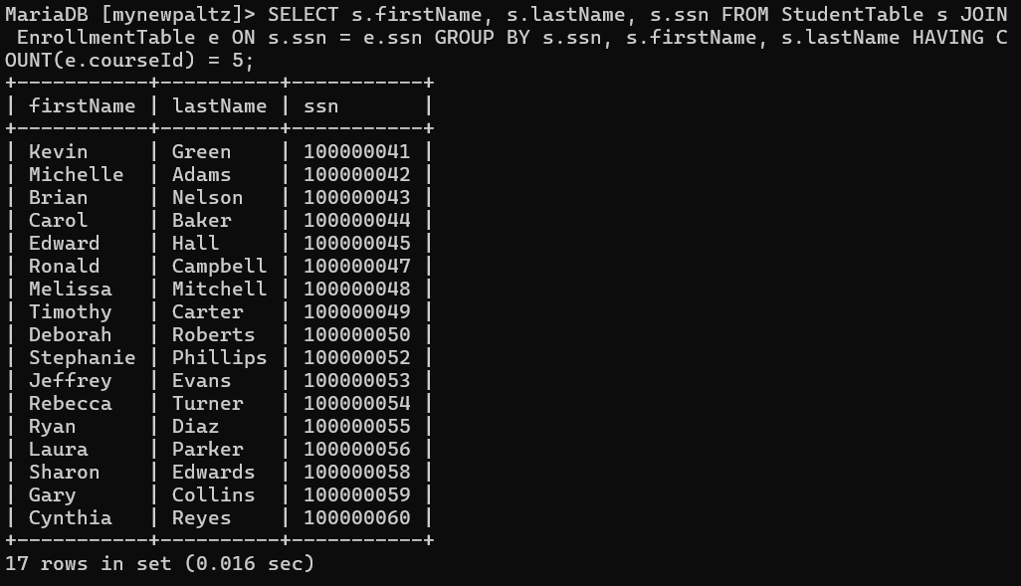

- List students by name and ssn who are taking 4 courses
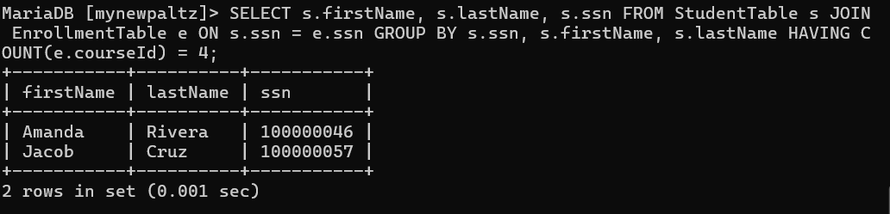
- List students by name and ssn who are taking 3 courses
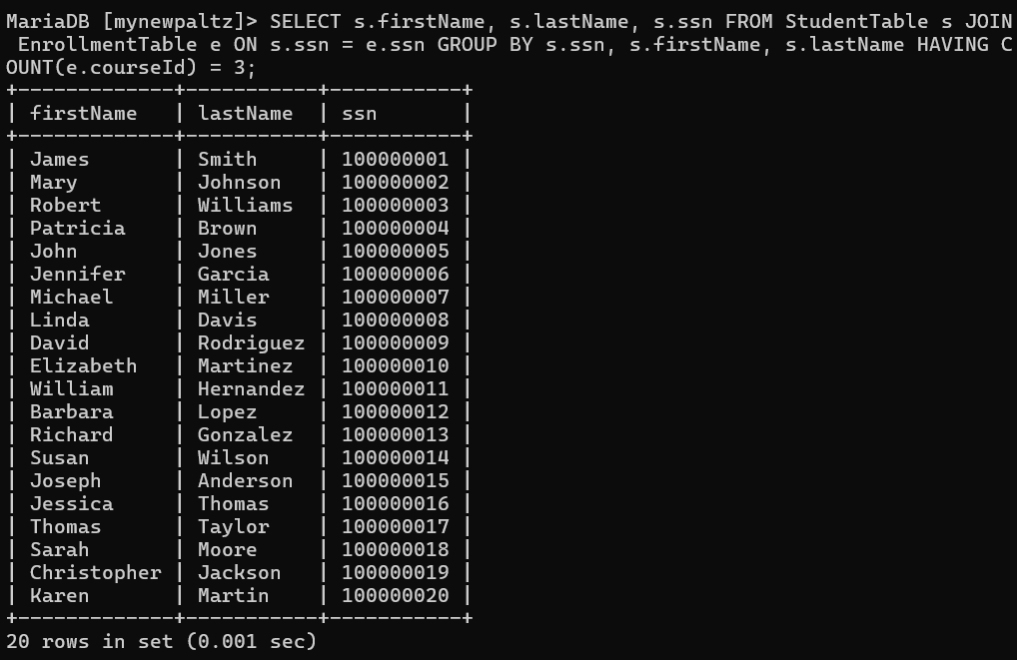

- List students by name and ssn who are taking 2 courses
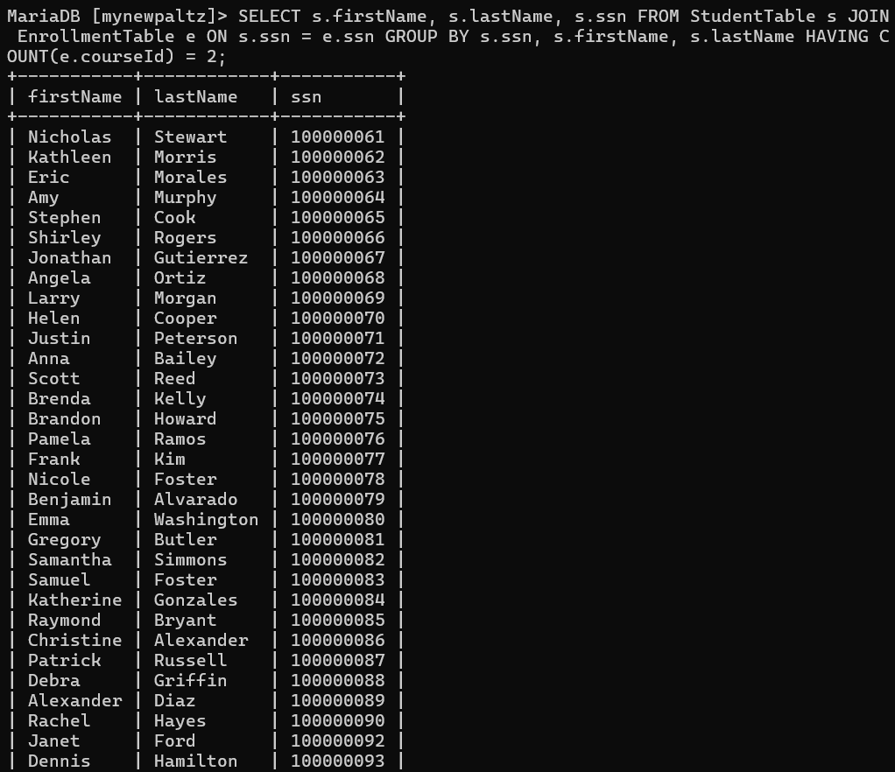

- List students by name and ssn who are taking 1 course
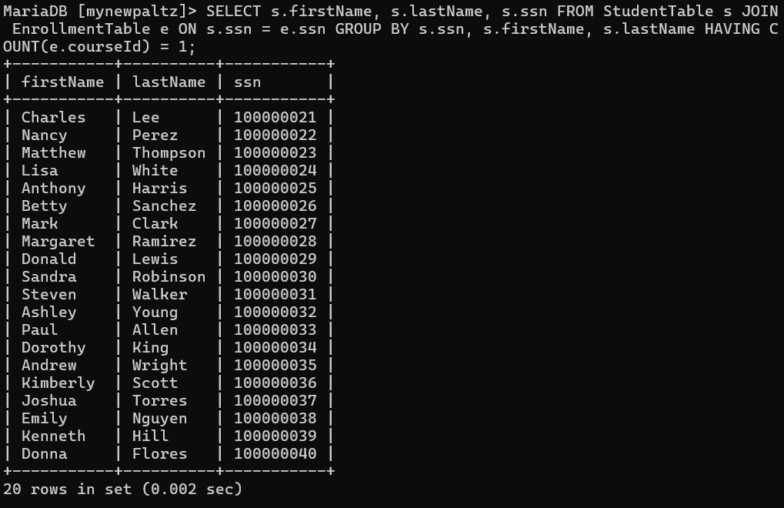
- List students by name and ssn who are taking 0 courses
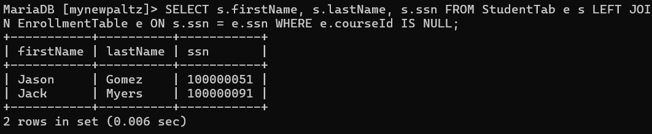
- Give a count of 4 credit courses by subjectID (# of 4-credit courses in each subject).
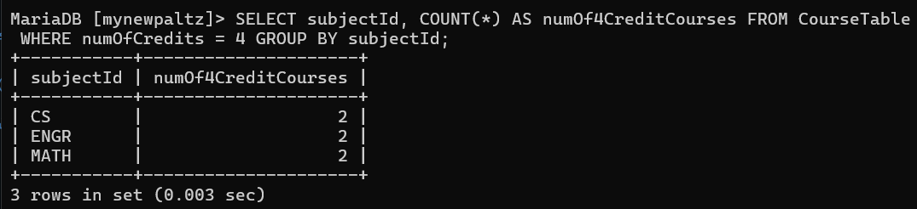

- Give a count of 3 credit courses by subjectID
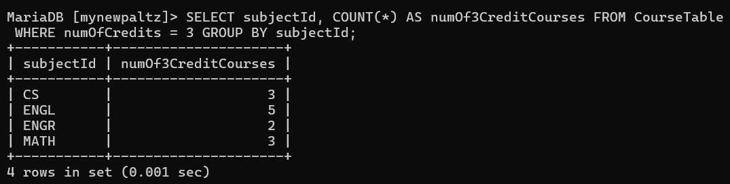
- Give a count of 2 credit courses by subjectID
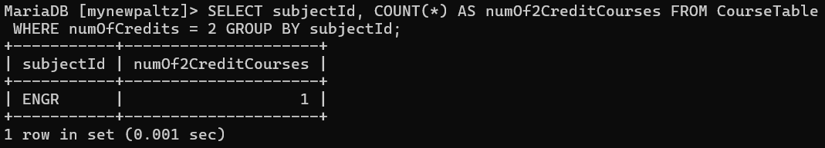
- Are there any 5 credit courses?Are there any 1 credit courses?
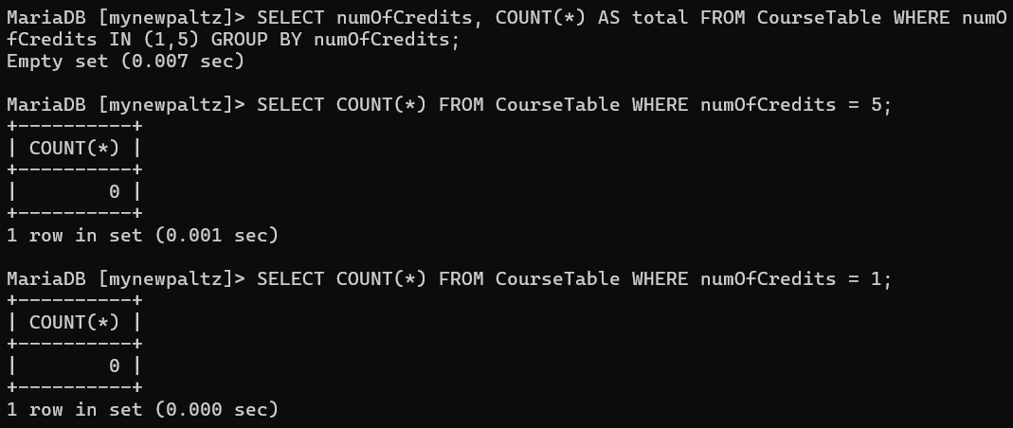

- List all enrolled students by name and their grades in each enrolled course
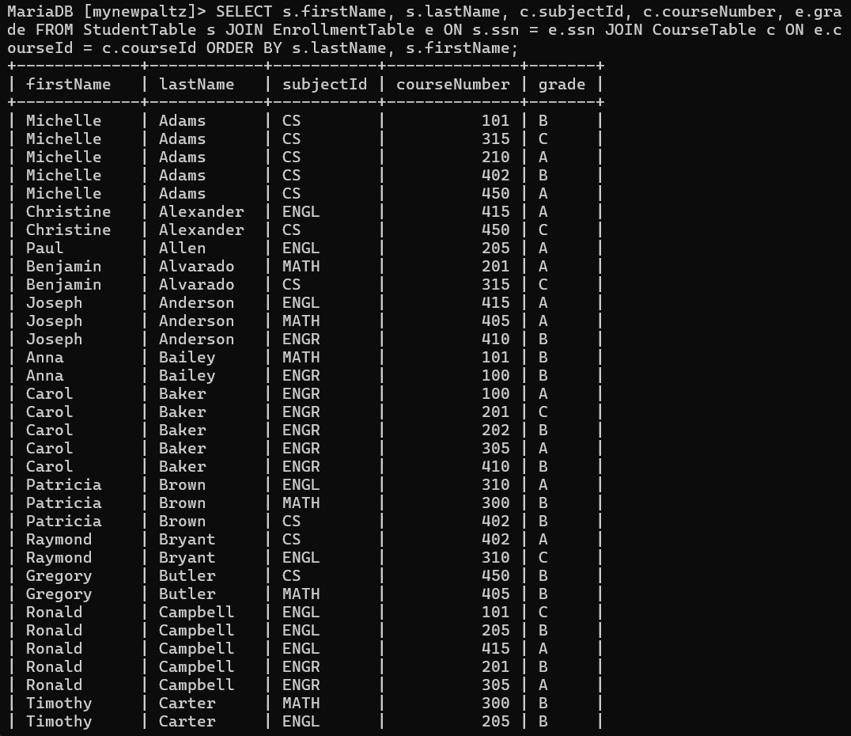
- For the course identified by courseID of 10, list the number of students enrolled, course number as well as subjectID.
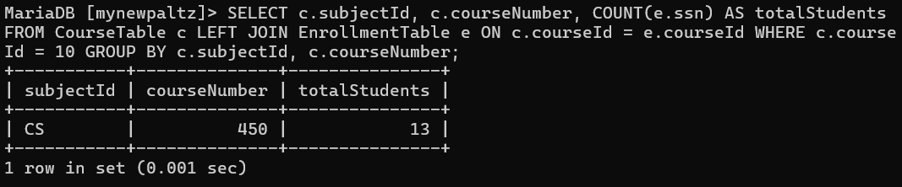

- How many students are in each course (identified uniquely by courseID)?
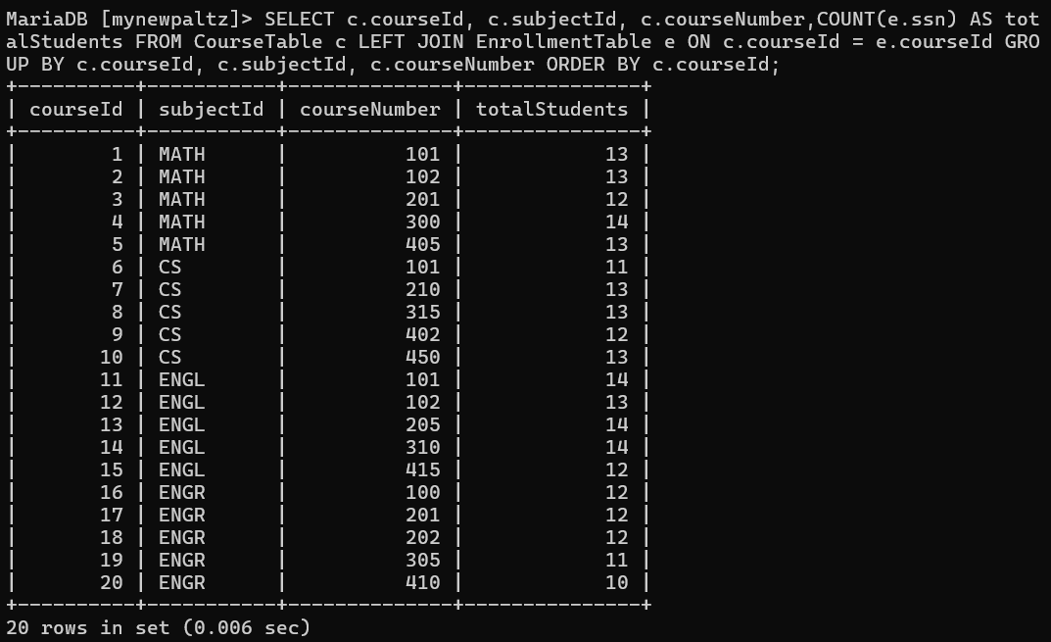

- For each student enrolled, list the first name, last name, and number of credits that student was taking.
