Exercise Week 4_2
When you source the EmployeesDatabase.sql file, you would be in a database called employee, with two tables, employees and departments.
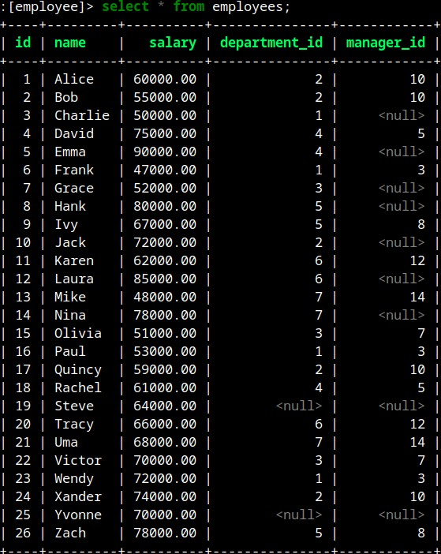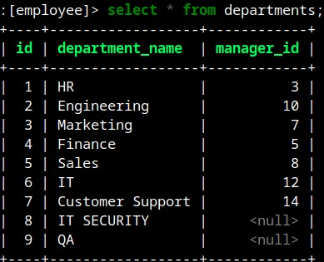

Use SQL to do the following. Use JOINS if possible.
- List employee names and their department names; only include employees who are currently assigned to a department.
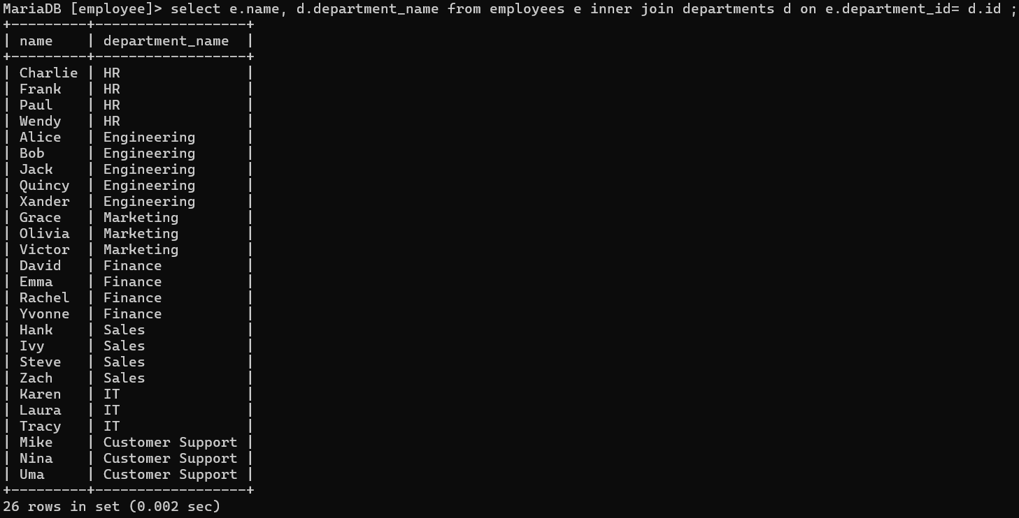
- List employee names and their department names including those who are not assigned a department.
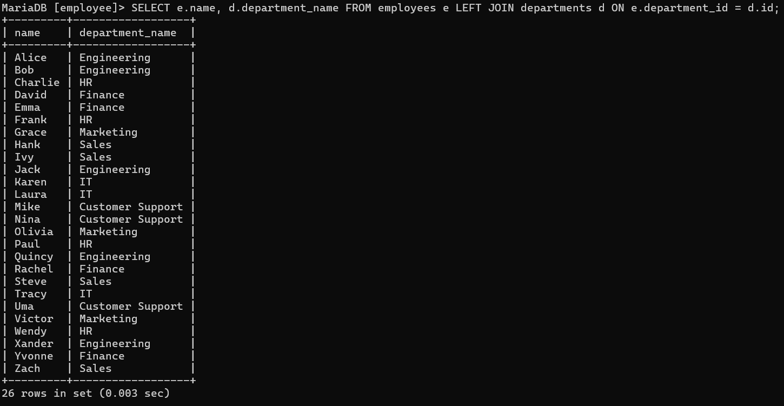
- List all department names and the employees assigned to them. List all departments, even if they have no employees assigned to them.
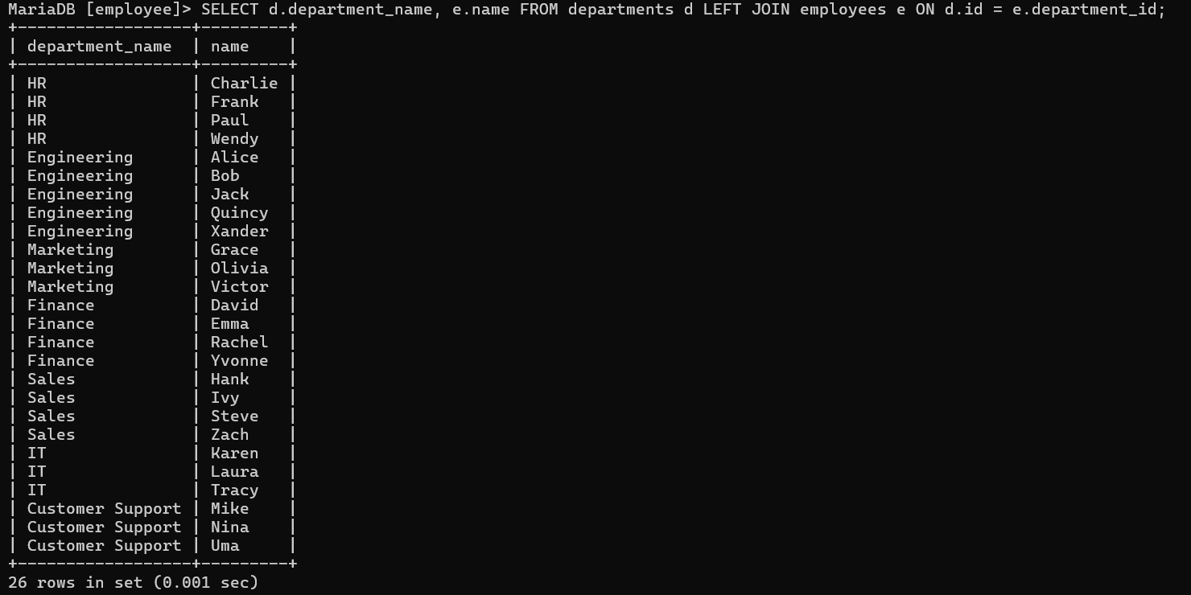

- List all employee names and their manager’s names. List only those employees who have a manager.
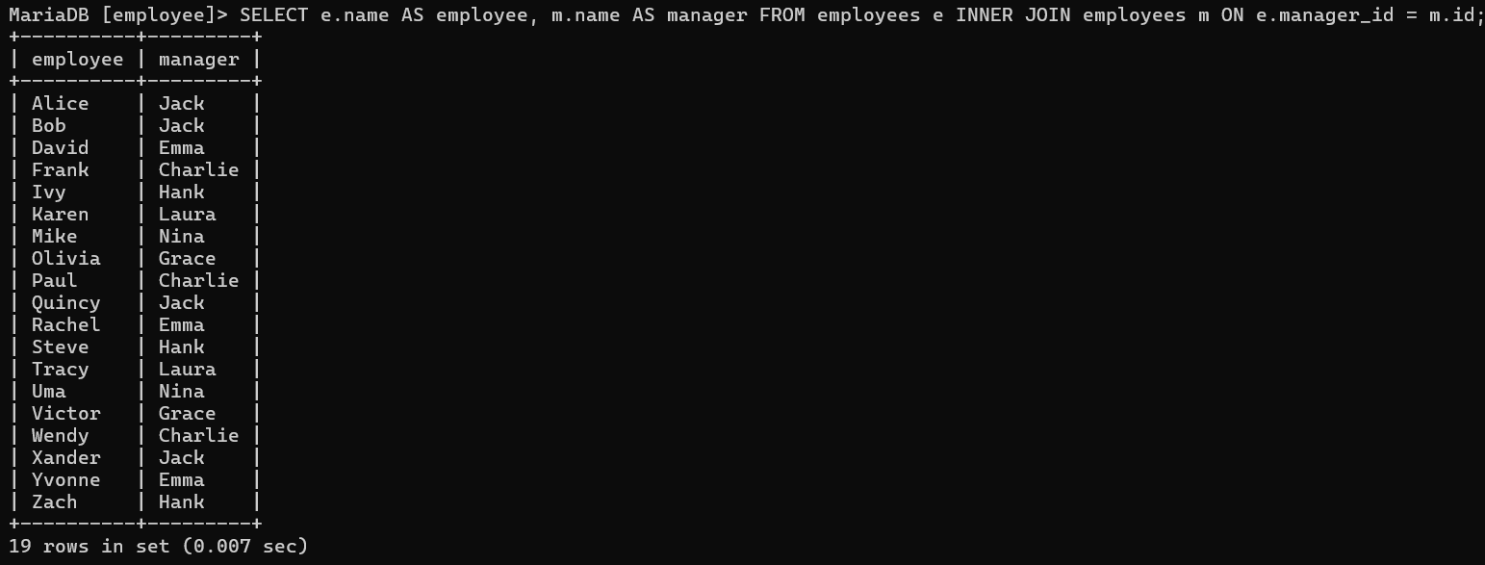
- List employees and their department names
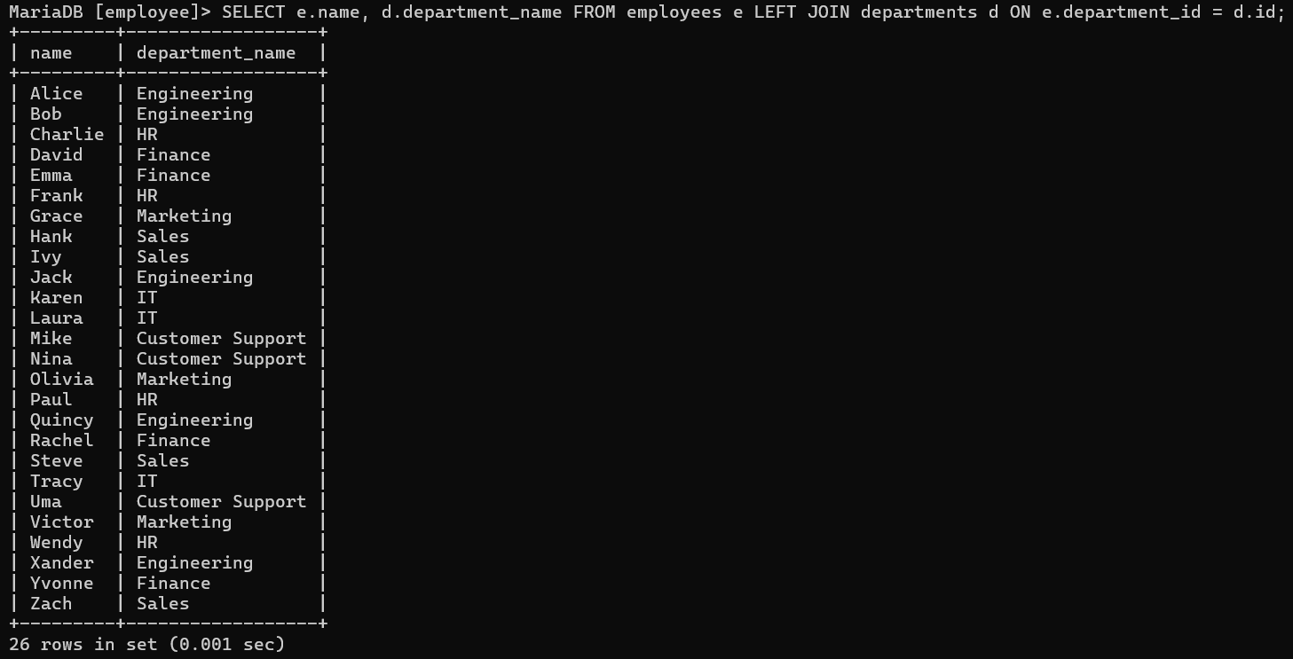
- List name and salary of employee with highest salary
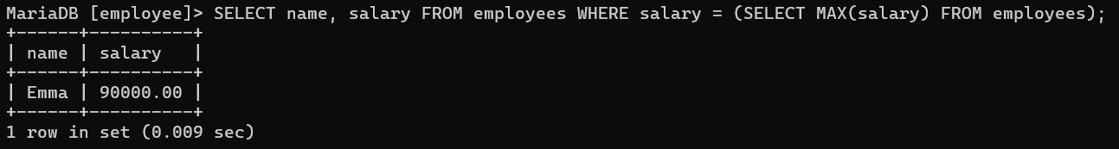

- List name, department_name and and salary of employee with highest salary
