The dump file of a database in given in a file employee_dump_20260223.sql
Load it into a database “employee”. (If you already have tables in employee database, save them and drop them first). When you load the dump file, you will have two tables employees and departments.
List employees and their managers
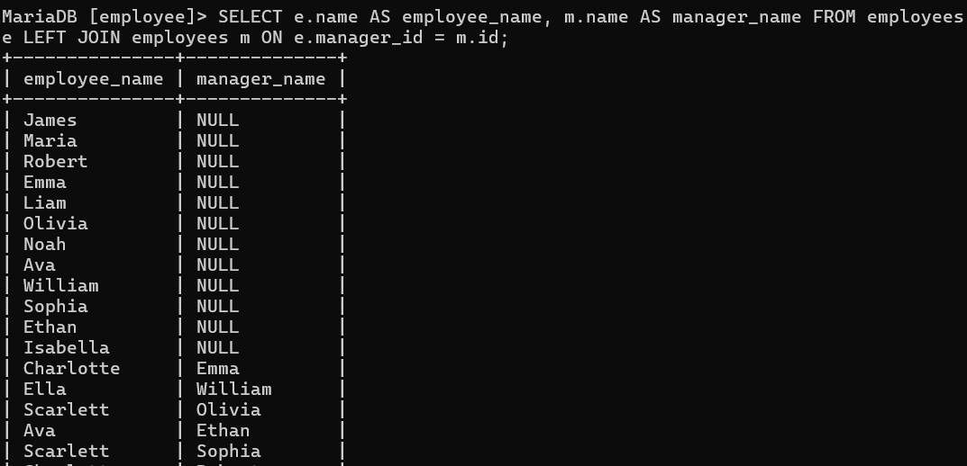
List departments and their managers
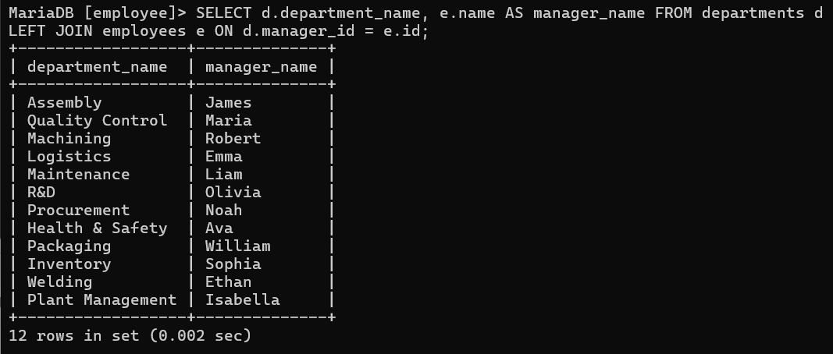
List the department each person works in
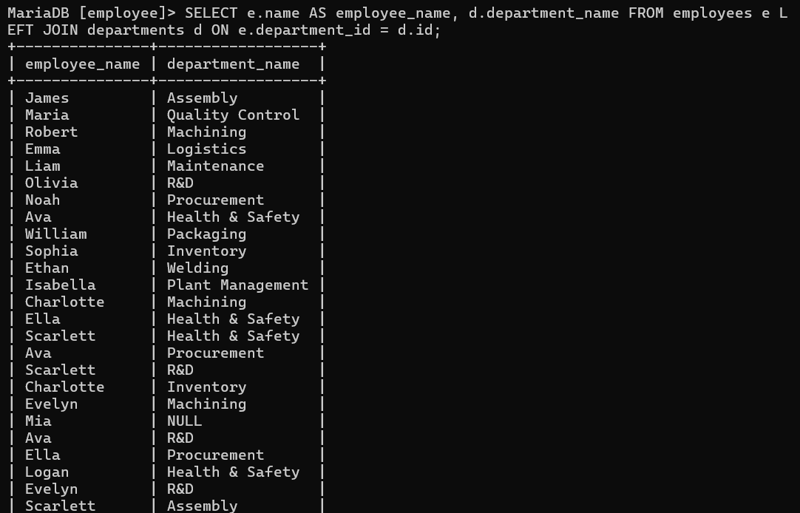
Find employees who have no manager
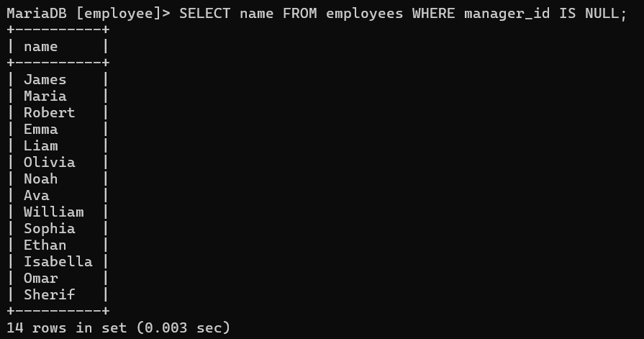

Find employees who have no departments
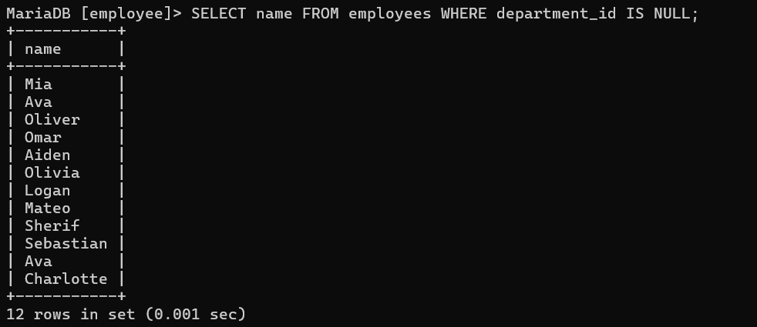
Show a count of employees in each department, including those who have no departments.
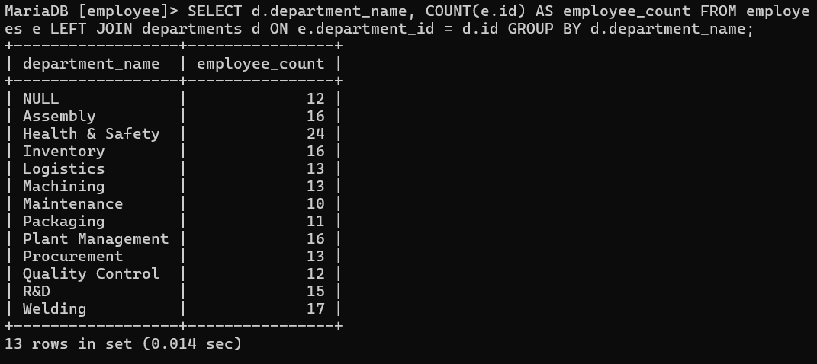
List name, salary, and department name of managers (those who have a department but no manager).
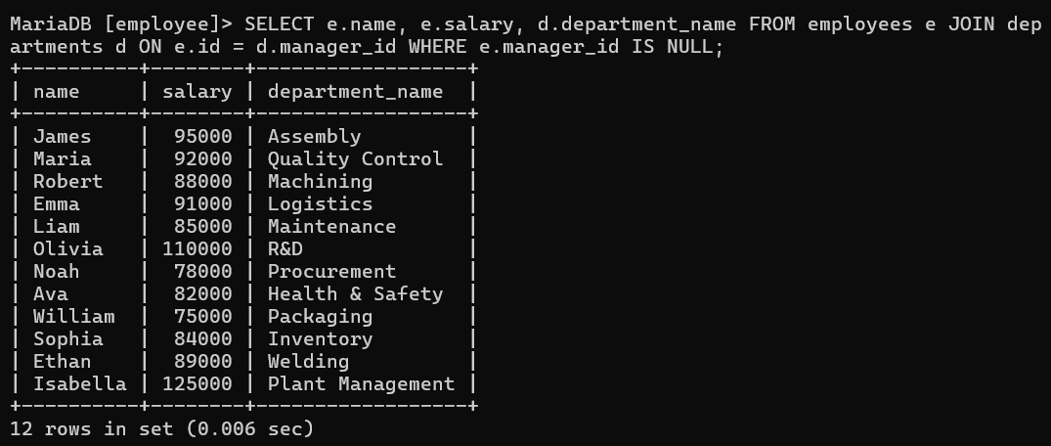
List employees whose salaries are higher than their manager’s salaries.
