CPX-SYS-03_REV-A
Complete System Architecture
Project: CARAPACE

Figure 1. High-Level System Block Diagram
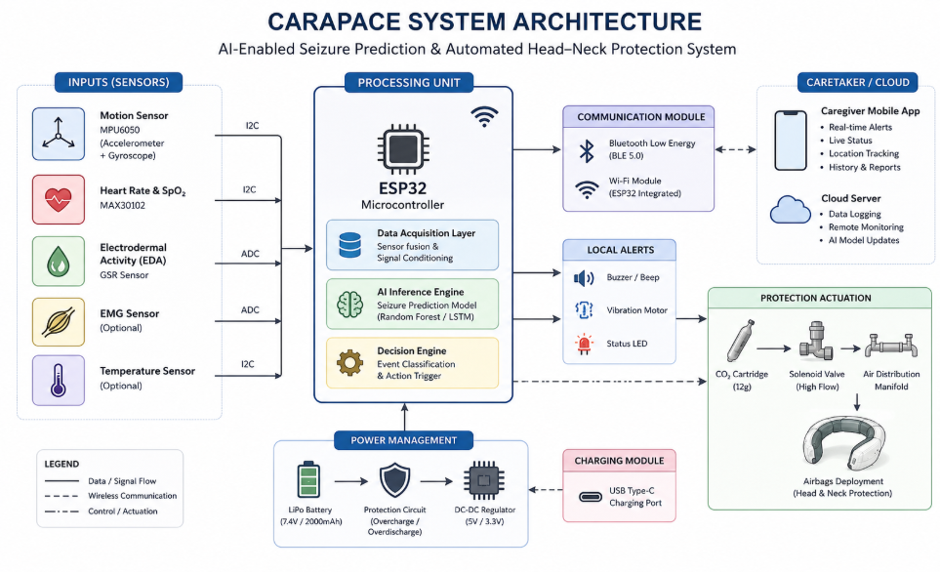

Figure 2. Hardware Architecture
Battery
│
Power Regulation
│
ESP32
├── MPU6050 (I²C)
├── MAX30102 (I²C)
├── EDA Sensor (ADC)
├── GSM Module (UART)
├── GPS Module (UART)
└── Protection Controller
│
├── MVP: Electric Air Pump
└── Future: Solenoid + CO₂ Cartridge

Figure 3. Software Architecture
Main Controller
│
├── Sensor Manager
├── Signal Processing
├── AI Inference
├── Decision Manager
├── Deployment Manager
├── Communication Manager
├── Logger
└── Power Manager

Figure 4. Operational Workflow
Power ON
↓
Initialize Sensors
↓
Continuous Monitoring
↓
Signal Processing
↓
AI Inference
↓
Decision Logic
↓
Deploy Protection (if threshold met)
↓
Send SMS + GPS
↓
Log Event
↓
Resume Monitoring

Figure 5. MVP vs Commercial Architecture
Subsystem | MVP | Commercial
Inflation | Electric Air Pump | CO₂ Cartridge + Solenoid
AI | Development Pipeline | Embedded AI
Alerts | SMS Demo | Full GSM/GPS
Storage | Local Log | Cloud + App

