Backend
administrator@WIN-VFLQGJQ8RJG:~/langgraph_projects/ai-pdf-chatbot-langchain/backend$ yarn add @langchain/core
administrator@WIN-VFLQGJQ8RJG:~/langgraph_projects/ai-pdf-chatbot-langchain/backend$ yarn add @langchain/ollama
administrator@WIN-VFLQGJQ8RJG:~/langgraph_projects2/ai-pdf-chatbot-langchain/backend$ yarn add @langchain/core
change openai to ollama
backend\__tests__\retrieval_graph\integration.test
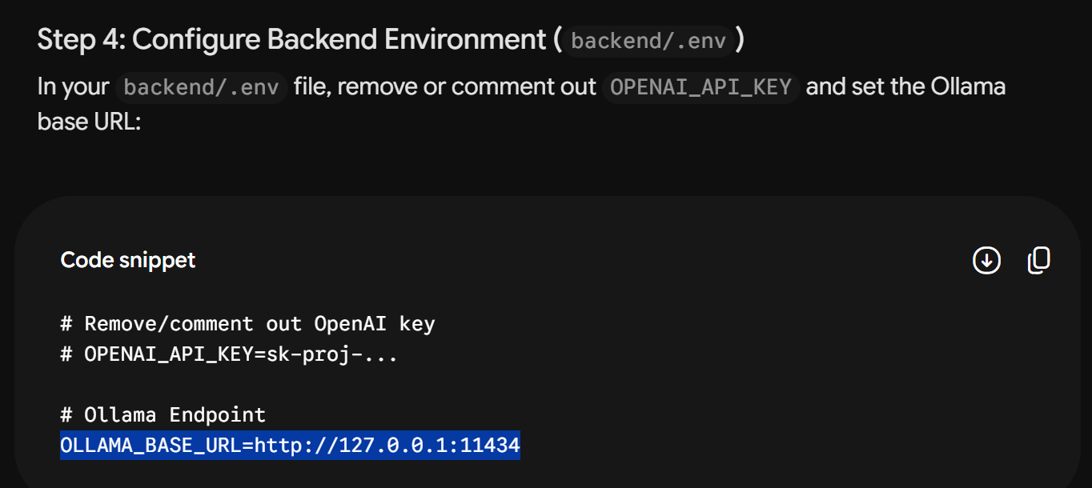
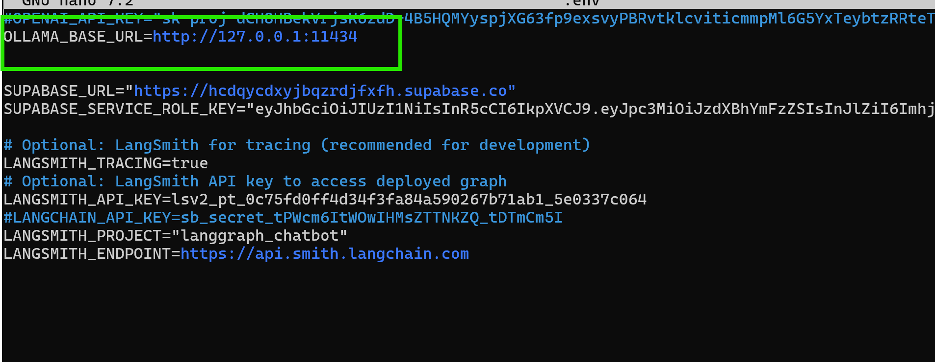

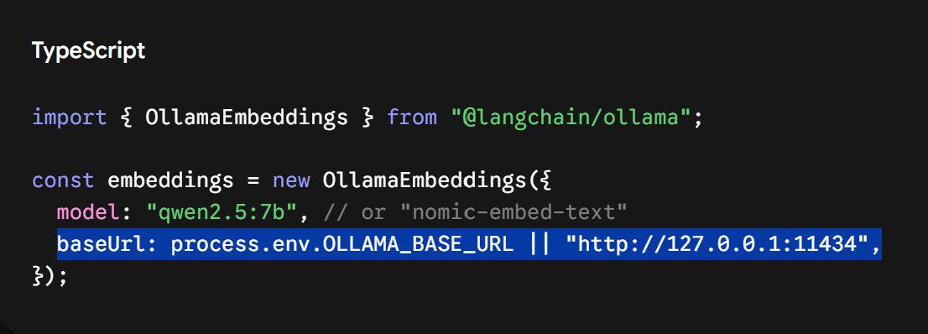
\ai-pdf-chatbot-langchain\backend\src\retrieval_graph\configuration

\backend\src\shared\retrieval

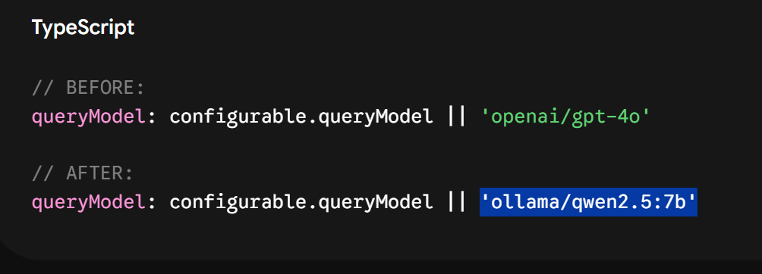
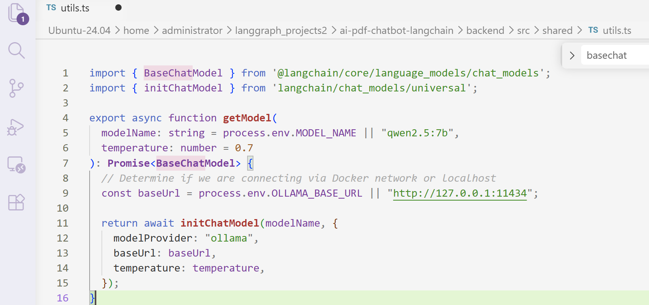
/Backend/package
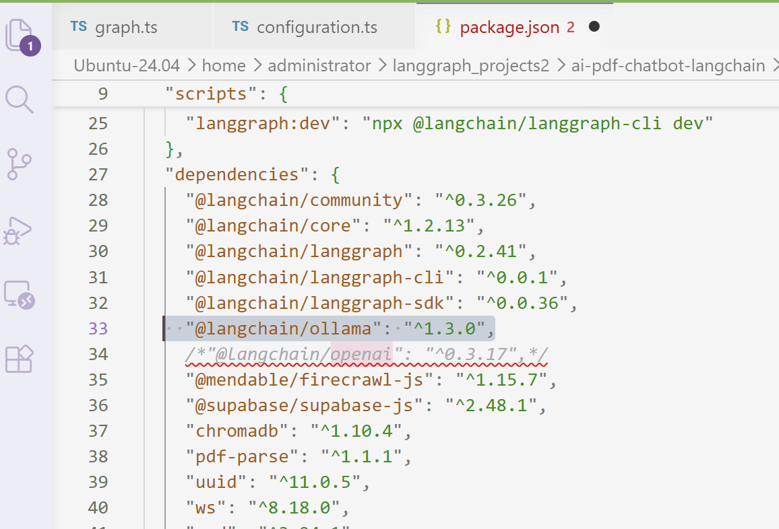

\backend\node_modules\@langchain\langgraph
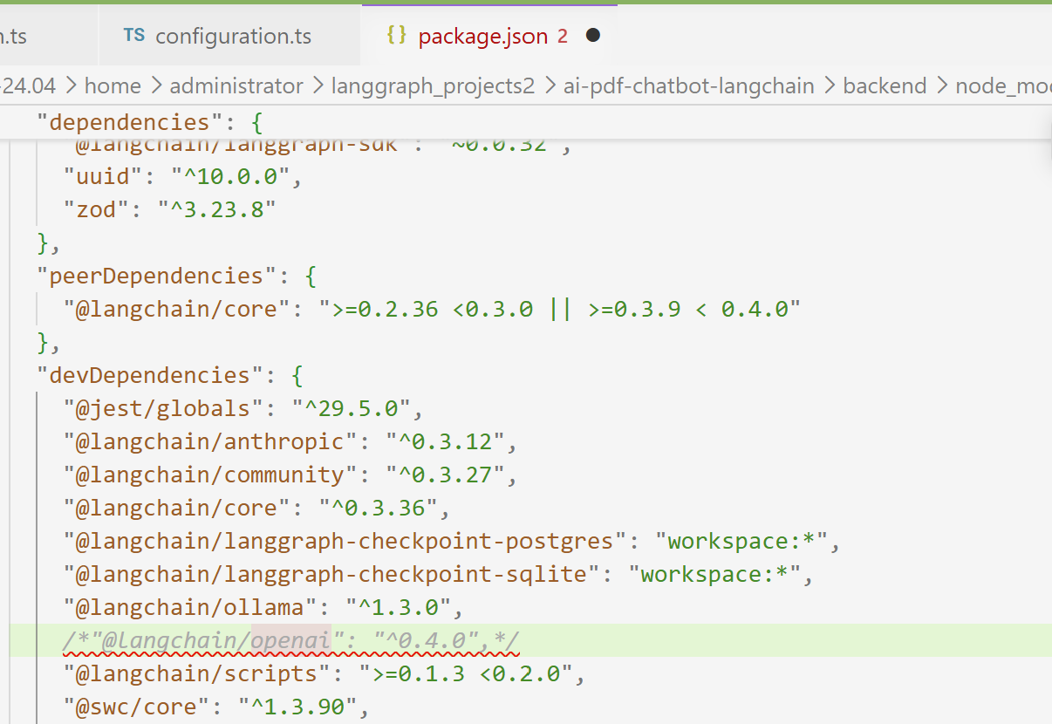

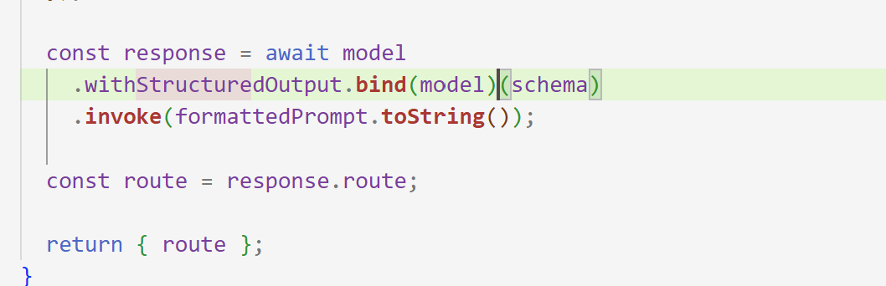
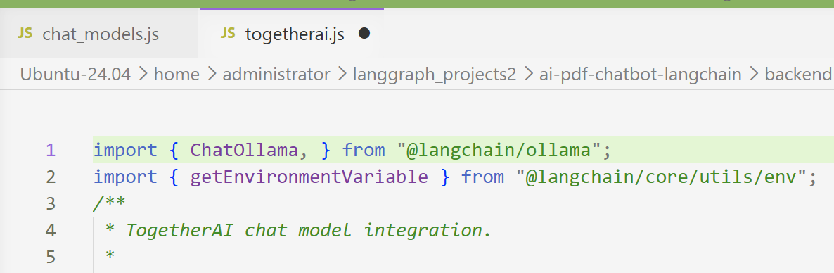
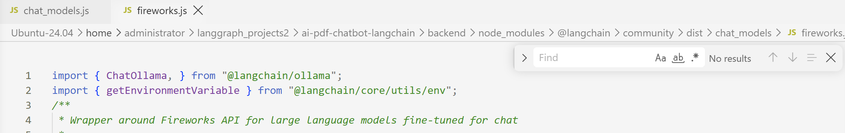
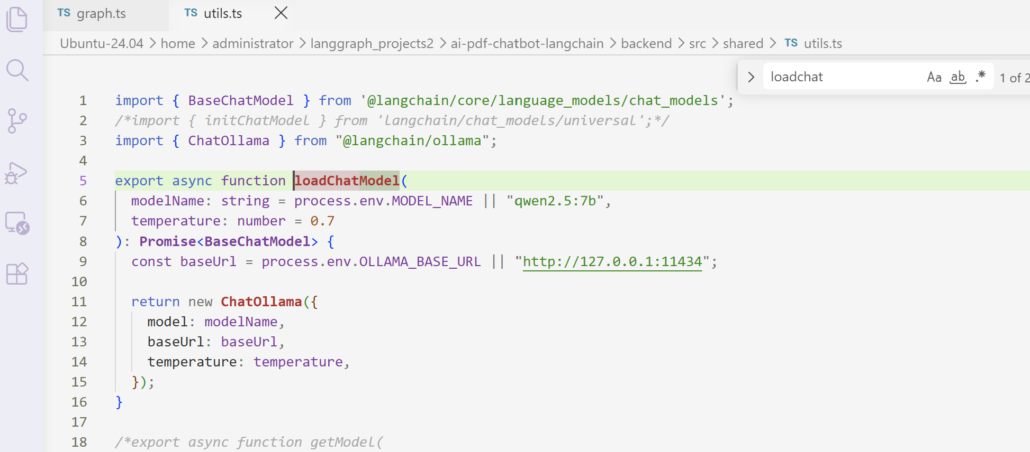

administrator@WIN-VFLQGJQ8RJG:~/langgraph_projects2/ai-pdf-chatbot-langchain$ grep -rn "openai/gpt-4o-mini\|gpt-4o-mini\|queryModel" \
--include="*.ts" --include="*.tsx" --include="*.js" --include="*.json" .
