Syam Evani

MECE 6397: HW 1

The problem statement can be summarized according to the key changes needed for the provided sample script below. Please note, my full python code is provided at the end of this document and I have also created a github repo that has my hw1 files [here](https://github.com/Sam-v6/mece-6397-doe/tree/main/hw1)

**1. Model Replacement: The LinearRegression model is replaced with**

* + **DecisionTreeRegressor**
  + **RandomForestRegressor**
  + **SupportVectorRegression (SVR)**
  + **K-Nearest Neighbors Regressor (KNN)**

I have created a simple dictionary and loop structure that fits our transformed x data with our y training data to evaluate all regressors. These are added to appropriate keys in our *models* dictionary which is used downstream to evaluate our error.

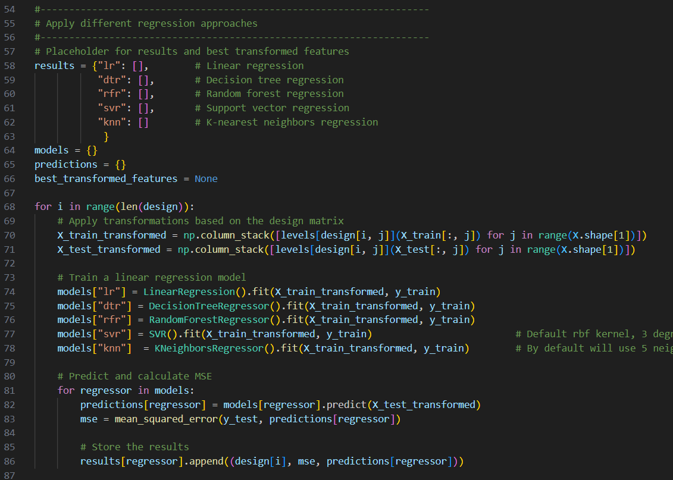

**2. Three-Level Design: Each factor in the design matrix now has three levels, accommodating different transformations: no transformation, logarithmic, and square**

I have updated our design to have 3 factors, each with 3 levels.



**3. Safety in Transformations: A small constant (0.1) is added to X where logarithmic transformations are used to avoid taking the logarithm of zero**

As seen in line 32, I have added a small constant to X to ensure logarithmic transformations avoid taking log of zero

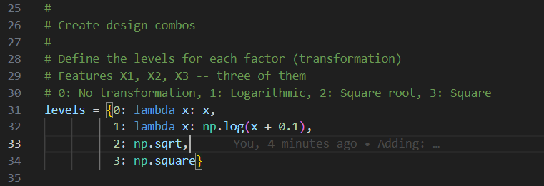

**4. This setup allows you to explore the impact of different nonlinear transformations on the dataset using a model that can capture such nonlinearities effectively**

No commentary needed here, agreed!

**5. Compare the results for MSE for the regressor models explored**

| Regressor Type | Design with Lowest MSE | MSE |
| --- | --- | --- |
| Linear | 0 0 1 | 0.0024587061343516194 |
| Decision Tree | 0 1 1 | 0.07440568140632621 |
| Random Forest | 1 1 1 | 0.05500079319645723 |
| Support Vector | 0 1 2 | 0.01248389784244165 |
| K-Nearest Neighbors | 1 1 2 | 0.046979637634902816 |

I’ve also visualized these different regressors by plotting the expected values vs our predicted values (along with a red trendline to indicate what a perfect prediction would be). Those plots are provided below with some commentary that concludes this report.

***Linear***

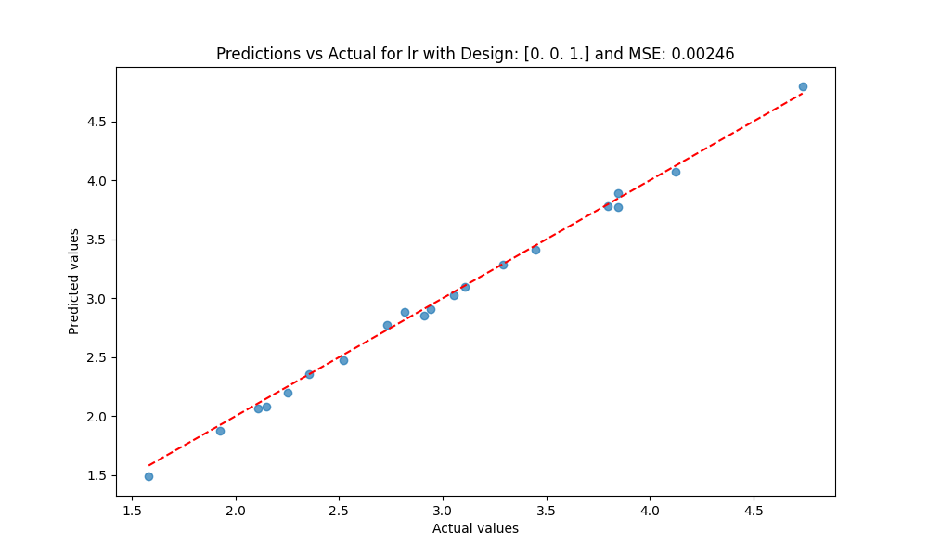

***Decision Tree***

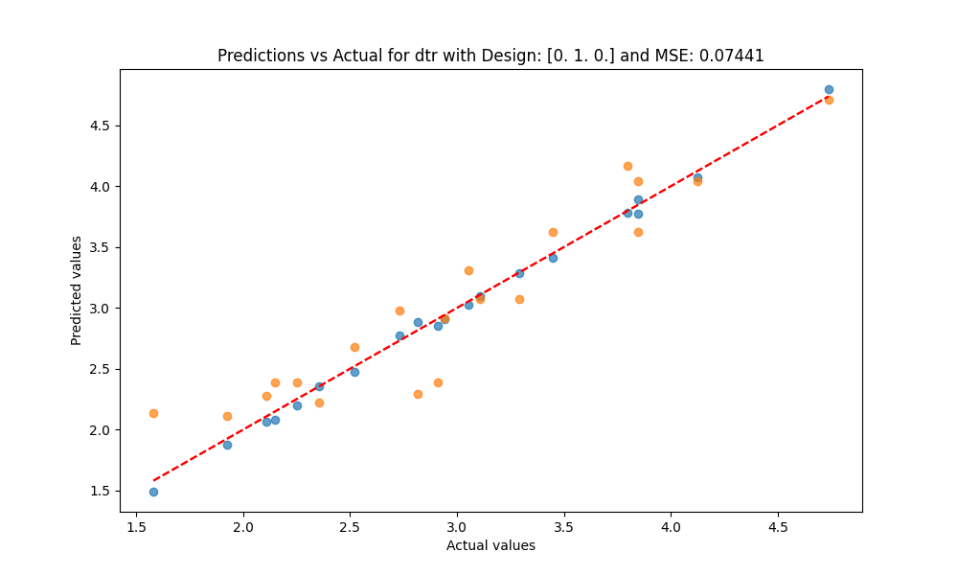

***Random Forest***

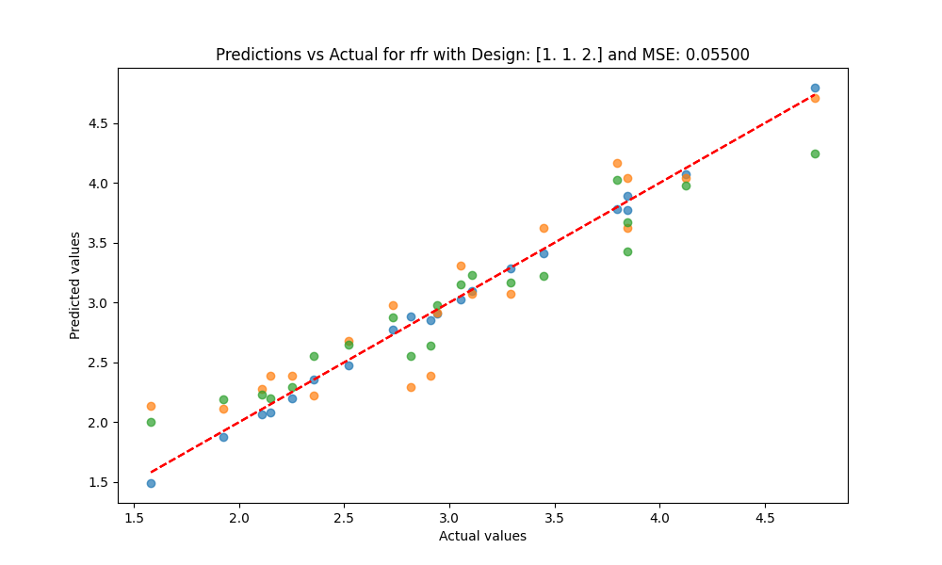

***Support Vector***

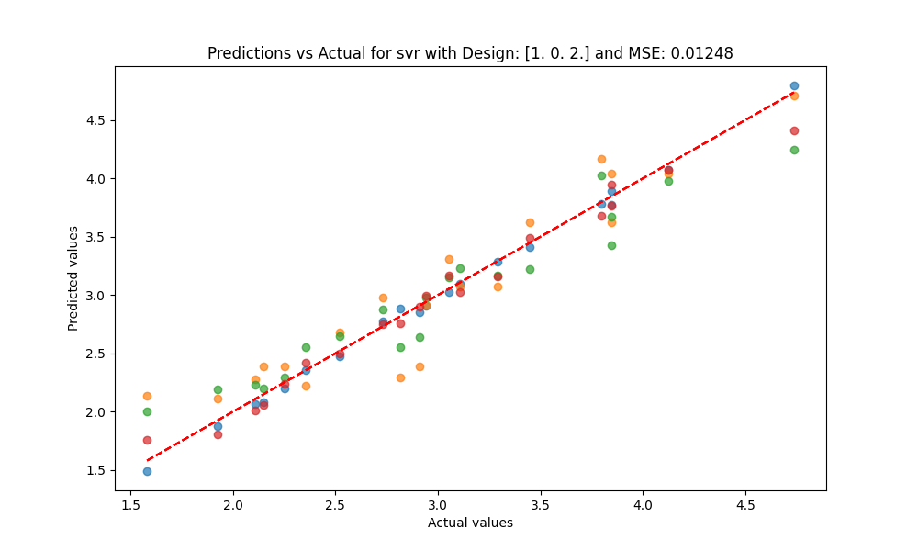

***K-Nearest Neighbors***

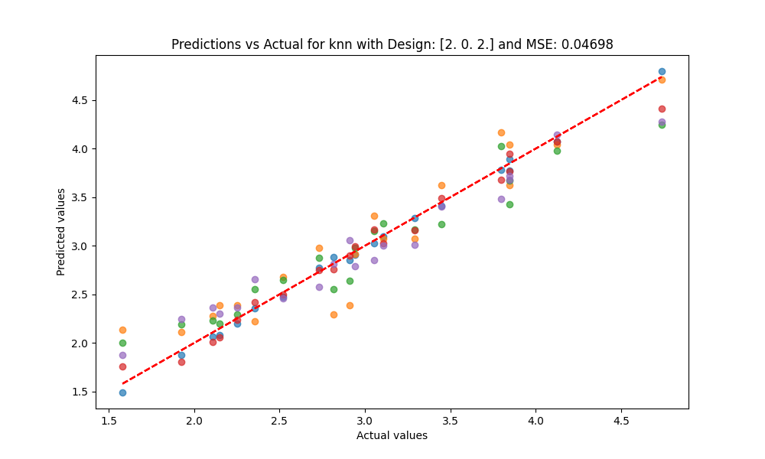

Looking at the results from both our table and plots, interestingly we see that for this relatively simple data linear regression provides the best predictions for our training data outputs. Following this, all models perform relatively similar but grade out in the following order (of least MSE aka best predictions):

1. Linear
2. Support Vector
3. K Nearest Neighbor
4. Random Forest
5. Decision Tree

A linear regression model as it might imply in the name, excels in linear relationships, has fast training and prediction, but can be prone to underfitting complex data. A decision tree regression model can capture nonlinear relationships and special interactions between features. However, it can be prone to overfitting in deep tree structures. Random forest regression constructs multiple decision trees and averages all trees to create predictions. This reduces overfitting, handles high dimension data well, but can be more computationally challenging and understandable than a single decision tree regression model. Support vector regression is a computationally advantageous model that is effective in high dimensional spaces (in this model we used the default, RBF kernel). Kernel choice does greatly impact the results of predictions. Finally, K-Nearest Neighbor predicts the value of a single data point by averaging values of its nearest neighbors. This can capture complex patterns however is sensitive to the distance metric selected.

"""

Purpose: HW1 - Evaluate different regressors for a 3 factor, 3 level model with different design combos

Author: Syam Evani

"""

# Standard imports

import os

# Additional imports

import pandas as pd

import numpy as np

from sklearn.model_selection import train_test_split

from sklearn.linear_model import LinearRegression

from sklearn.tree import DecisionTreeRegressor

from sklearn.ensemble import RandomForestRegressor

from sklearn.svm import SVR

from sklearn.neighbors import KNeighborsRegressor

from sklearn.metrics import mean_squared_error

from pyDOE3 import fullfact

import matplotlib.pyplot as plt

# Local imports

# None

#--------------------------------------------------------------------

# Create design combos

#--------------------------------------------------------------------

# Define the levels for each factor (transformation)

# Features X1, X2, X3 -- three of them

# 0: No transformation, 1: Logarithmic, 2: Square root, 3: Square

levels = {0: lambda x: x,

1: lambda x: np.log(x + 0.1),

2: np.sqrt,

3: np.square}

# Generating a full factorial design for 3 factors, each with 3 levels

design = fullfact([3, 3, 3])

# Show the design matrix

# print(design)

print(f"Number of Design:",len(design))

#--------------------------------------------------------------------

# Create sample dataset

#--------------------------------------------------------------------

# Sample dataset

# Replace this with your actual dataset

X = np.random.rand(100, 3) # 100 samples, 3 features

y = 2*X[:, 0] + 3*np.log(X[:, 1] + 1) + np.sqrt(X[:, 2]) # Sample target variable

# Splitting the dataset into training and testing sets

X_train, X_test, y_train, y_test = train_test_split(X, y, test_size=0.2, random_state=42)

#--------------------------------------------------------------------

# Apply different regression approaches

#--------------------------------------------------------------------

# Placeholder for results and best transformed features

results = {"lr": [], # Linear regression

"dtr": [], # Decision tree regression

"rfr": [], # Random forest regression

"svr": [], # Support vector regression

"knn": [] # K-nearest neighbors regression

}

models = {}

predictions = {}

best_transformed_features = None

for i in range(len(design)):

# Apply transformations based on the design matrix

X_train_transformed = np.column_stack([levels[design[i, j]](X_train[:, j]) for j in range(X.shape[1])])

X_test_transformed = np.column_stack([levels[design[i, j]](X_test[:, j]) for j in range(X.shape[1])])

# Train a linear regression model

models["lr"] = LinearRegression().fit(X_train_transformed, y_train)

models["dtr"] = DecisionTreeRegressor().fit(X_train_transformed, y_train)

models["rfr"] = RandomForestRegressor().fit(X_train_transformed, y_train)

models["svr"] = SVR().fit(X_train_transformed, y_train) # Default rbf kernel, 3 degree polynomial kernel function, uses 1/(n_features) * X.var()) as gamma

models["knn"] = KNeighborsRegressor().fit(X_train_transformed, y_train) # By default will use 5 neighbors

# Predict and calculate MSE

for regressor in models:

predictions[regressor] = models[regressor].predict(X_test_transformed)

mse = mean_squared_error(y_test, predictions[regressor])

# Store the results

results[regressor].append((design[i], mse, predictions[regressor]))

#--------------------------------------------------------------------

# Post process and plot different regressors for comparison

#--------------------------------------------------------------------

# Plotting predictions against actual values

plt.figure(figsize=(10, 6))

# Post-process different regression approaches

for regressor in results:

# Find the design with the lowest MSE

min_mse_design, min_mse, best_predictions = min(results[regressor], key=lambda x: x[1])

# Print the design, MSE, and feature values with the lowest error

print(f"Regressor: {regressor}")

print(f"Design with lowest MSE: {min_mse_design}, MSE: {min_mse}")

plt.scatter(y_test, best_predictions, alpha=0.7)

plt.plot([min(y_test), max(y_test)], [min(y_test), max(y_test)], color='red', linestyle='--')

plt.xlabel("Actual values")

plt.ylabel("Predicted values")

plt.title(f"Predictions vs Actual for {regressor} with Design: {min_mse_design} and MSE: {"{:.5f}".format(min_mse)}")

plt.savefig(os.path.join('hw1', 'output', regressor + ".png"))