

Course: Mechatronic engineering

Individual project:

ENGD3000

**Report of research, design and prototyping of a robotic waiter**

Module leader: Dr Seng Chong

Student: Samuel Towner

P Number: P2448117

Year of study:   
2020-2021

# Abstract:

< Purpose of section is to summarise whole project on one page. Communicating it’s purpose, process, outcome and conclusions >

The following research and development project report looks at the development of a wheel-based robot platform capable of delivering food from kitchen to table. To achieve this the open-source framework ROS[ ] (Robot Operating System) was used on a Jetson Nano 2GB machine allowing for all computation on board, while destination data will be sent wirelessly over the network.

With the Covid pandemic having hit globally the focus of this robot will be to reduce human contact within a restaurant setting by cutting out the physical interaction made when ordering and delivering food. The result is a robotic platform that can navigate to predetermined points throughout a restaurant floorplan while monitoring its surroundings using a 360 LiDAR scanner.

# Acknowledgements:

< Purpose of section is to list people that have helped and other inspirations, mention University >

Contents

Abstract: 2

Acknowledgements: 3

1. Introduction: 6

1.1 Background and problem formulation: 6

1.2 Project specification, aims and objectives: 7

1.2.1 Aims: 7

1.2.2 Objectives: 7

2 Design and development: 8

2.1 Research and background information: 8

2.2 Approach: 10

2.3 Project management: 11

2.4 System specifications: 11

2.4.1 Requirement specification: 11

2.4.2 Design specification: 11

2.5 Design concepts: 12

2.5.1 Design concept 1: 12

2.5.2 Design concept 2: 13

2.5.3 Chosen design: 13

2.6 Physical development and CAD: 14

2.7 Electronics and power: 19

2.8 Software and Programming: 19

2.9 Results: 19

3 Discussion: 19

4 Conclusion and recommendation: 19

5 References: 19

6 Appendices: 19

# Introduction:

< Purpose of section is to enable the reader to understand the rational behind project, problem it is trying to solve and the specific aims and objectives of the project >

This report focuses on the full process from idea/design conception to a working prototype of a ROS driven robot capable of mapping its surroundings and actively avoiding collision in order to transport food from the kitchen to a designated table, allowing for minimal physical interaction between restaurant staff and customers with the desire to lower the chances of spreading bacteria and/or virus’.

With the prototype’s motivation being to lower the spread of infection for the wider public an inherited requirement is to keep the cost of production low with ‘off the shelf’ parts therefore allowing it to be accessible to smaller restaurant businesses.

## Background and problem formulation:

< Purpose of section is to give historical background to robotic waiters, outline the problem focused on resolving and why a robotic waiter would be a good response to the problem >

Robotic waiters are not a new concept with the first 2 being employed in 1983.[ ] However, since then they are becoming smarter and more widely available with modern robotic waiters boasting self-driven navigation and obstacle avoidance.

With the use of robotics within everyday life and industry increasing over time and the global Covid pandemic hitting causing the population to follow social distancing rules, a more socially distanced way to deliver food from kitchen to table within a restaurant setting would be favoured in the endeavour to lower spread within an establishment. With this in mind a robot waiter able to carry out this transportation would be ideal. However, the currently available robotic waiters can cost a restaurant up to thousands causing the accessibility of these machines to be out of reach for many. It is because of this that the following report focuses on the development of a robotic waiting platform capable of self-navigation which is made up of off the shelf and relatively cheap components.

## Project specification, aims and objectives:

< Purpose of section is to specifically list aims and objectives of the project. Include mention of changes from the interim report >

### Aims:

* To take idea from conception to prototype for a ROS based robotic system that is capable of actively delivering food from kitchen to table by monitoring its surroundings within a restaurant setting.
* To have the final prototype be accessible to many establishments, because of this off the shelf components must be used for a relatively low overall cost of production.

### Objectives:

* Carry out research into currently available robotic waiters.
* Create a system and design specification providing guidelines for the following prototyping.
* Develop design concepts before selecting a final design for prototyping.
* Create any CAD required for the chosen design before 3D printing required parts.
* Assemble and test prototype functionality.
* Discuss test results identifying the successes and failures of the robot compared to the system and design specifications.
* Create a conclusion including the possible positive changes to the next design iteration.

These aims and objectives differ from the interim report found within the appendix [ ] to accommodate a more focused and realistic scope for the project.

# Design and development:

< Purpose of section is to report chronologically the main tasks of the project from initial research through development, to results >

## Research and background information:

< Purpose of section if to outline my research to provide information on the current related markets and options available in order to provide enhanced background information of the project >

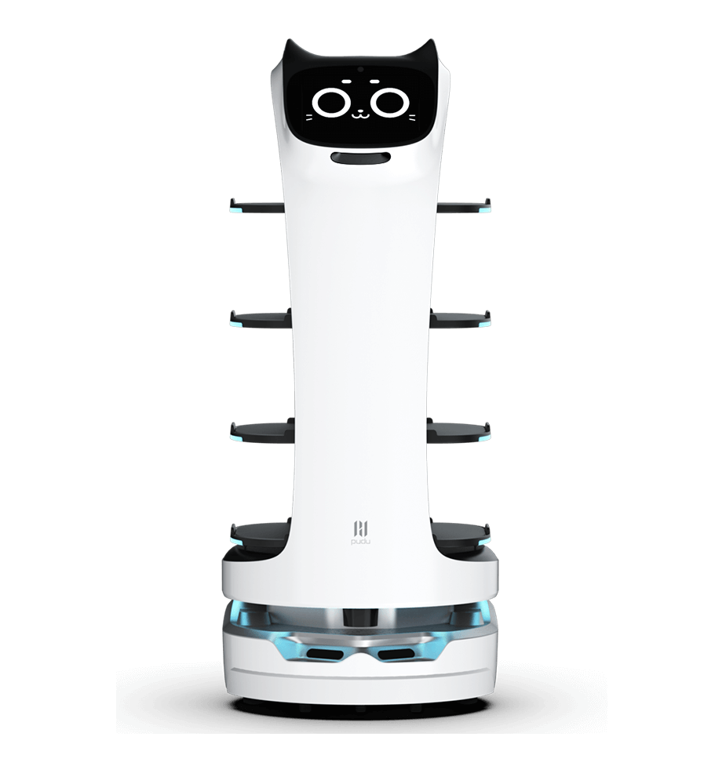Below are some examples of modern robotic waiters accompanied by their advertised features:

Figure 2.1: BellaBot [ ]

|  |  |
| --- | --- |
| Dimensions | 565*537*1290mm |
| Weight | 57kg |
| Material | ABS/Aviation-grade aluminium alloy |
| Charge time | 4.5H |
| Battery life | 12-24H (Replaceable batter) |
| Safety | Speed: 0.5-1.2m/s (Adjustable) | Climbing angle: ≤ 5° |
| Load capacity | Max 40kg, 10kg/tray |
| Positioning method | Marker Positioning: Supports a maximum height of 8 meters （optional high-level code)  Laser Positioning: Code-free with no height restrictions |

Table 2.1: BellaBot features [ ]

|  |  |
| --- | --- |
| Dimensions | 519*531*1256mm |
| Weight | 52kg |
| Payload | Upper layer = 5kg Rest = 10kg |
| Charge time | 4H |
| Standby time | >48H |
| Maximum speed | 0.9m/s |
| Maximum climbing angle | ≤ 5° |
| Power information | Capacity: DC 48V 12Ah  Rated power: 50W  Standby current: < 0.5A |

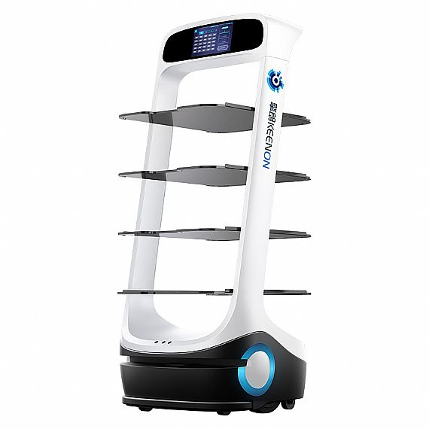Table 2.2:Deliver Robot-T6 features [ ]

Figure 2.2: Delivery Robot-T6 [ ]

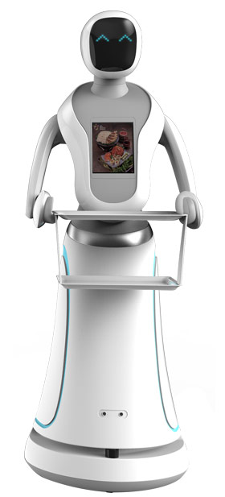

|  |  |
| --- | --- |
| Dimensions | 780*560*1500mm |
| Weight | Approx. 56kg |
| Payload | 10kg |
| Charge time | < 10hr per day |
| Working time | > 10hr per day |
| Battery Capacity | 24V 20Ah |
| Key navigation system | SLAM Lidar Sensor |
| Operating system | Linux – Backend  Android – UI |

Table 2.3: Amy waitress features [ ]

Figure 2.3: Amy Waitress [ ]

|  |  |
| --- | --- |
| Dimensions | 445*430*1046mm |
| Weight | 33kg |
| Payload | 30kg |
| Charging type | Wall charger: input 100~240V AC 3.5A 50/60Hz, Output 28.6V DC, 8.0A |
| Battery life | 8 – 12hrs |
| Number of trays | 2 trays of 16inch diameter, 1 bus tub |
| Controller | External tablet or attached touchscreen |

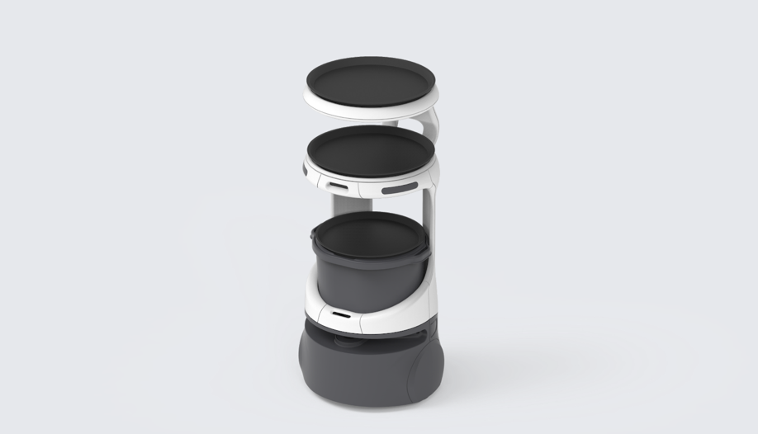Table 2.4:Servi Robot features [ ]

Figure 2.4:Servi [ ]

The features of these currently available waiting robots were taken into account when creating the system specifications for this projects robot.

## Approach:

< Purpose of section is to outline the method of approach taken alongside the factors that would affect said approach >

The main approach adopted for the production of this robot was an iterative approach. This allowed for quick production and alteration of versions lowering the time investment for each step at the cost of possible redesigns being necessary. Focussing on minimising time input was crucial for this project as its window for completion was very tight.

To complement this iterative approach the use of FDM 3D printing was incorporated in manufacturing as many parts as it allowed. Because of this, parts can be designed, printed and refined in a relatively short period of time. In addition to 3D printing the use of off the shelf electronic components allowed for quick setup and testing since designing custom PCBs and outsourcing their manufacture to companies could take weeks to produce and ship.

## Project management:

< Purpose of section is to outline the project management methodology used to deliver this project, limit to select few >

## System specifications:

### Requirement specification:

< Purpose is to describe what the final product should be capable of achieving >

A requirement specification table was created as a quick reference list of required features that the final system should adhere to:

|  |  |  |  |
| --- | --- | --- | --- |
| Function | Performance | Interface | Constraints |
| * Wheel powered movement * 360° LiDAR scanning * On board computation * Active obstruction avoidance * Wireless network connection | * Adequate movement speed (0.25-0.5m/s) * Fast navigation calculation * PID controller | * Available for VNC connection * Locally run web server | * 3D printed mechanical parts * Off the shelf electronic components * Required relatively low cost |

Table 2.5: Requirement specification.

### Design specification:

< Purpose is to describe the specific product design parameters (More fixed numerical values) >

A design specification table was created as a quick reference list for all the features that the final robot must adhere to.

|  |  |
| --- | --- |
| Descriptor | Specification |
| Dimensions | 500*600*1200mm |
| Weight | < 20kg |
| Payload | 5kg |
| Number of trays | 1 |
| Operating system | Linux (For Jetson Nano 2GB) |
| Software framework | ROS (Robot Operating System) |
| Navigation system | SLAM LiDAR sensor |

Table 2.6: Design specification

The above specification was created with a bare minimum approach for the sake of getting a working prototype functional and once a successful prototype is developed it can be expanded upon.

## Design concepts:

< Purpose is to outline multiple concept options along with their pros and cons before choosing final design >

Following the creation of the System specifications, design concepts were sketched up and compared before a final decision was made as to which would be used.

### Design concept 1:

|  |  |
| --- | --- |
| Pros | Cons |
| Good traction because of tracks | Only one point of support for food try |
| Only one blind spot from tray support | Many moving parts because of tracks |

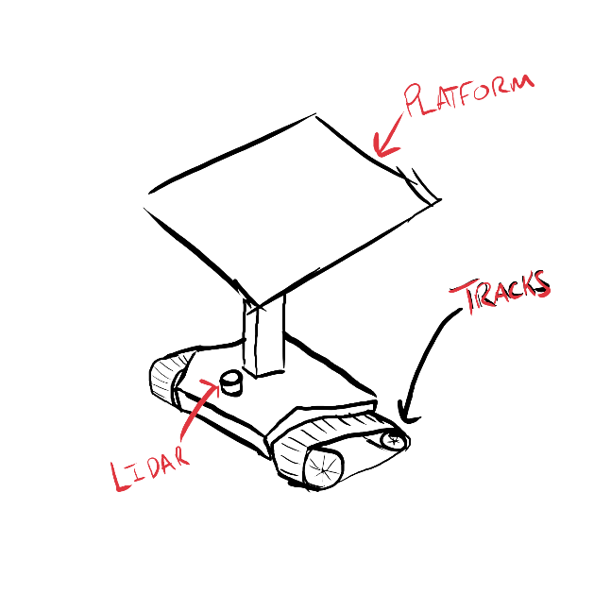

### Design concept 2:

|  |  |
| --- | --- |
| Pros | Cons |
| Less moving parts than track counter design | Less ground contact because of individual wheels |
| Multiple food tray supports | Three possible blind spots because of tray supports |

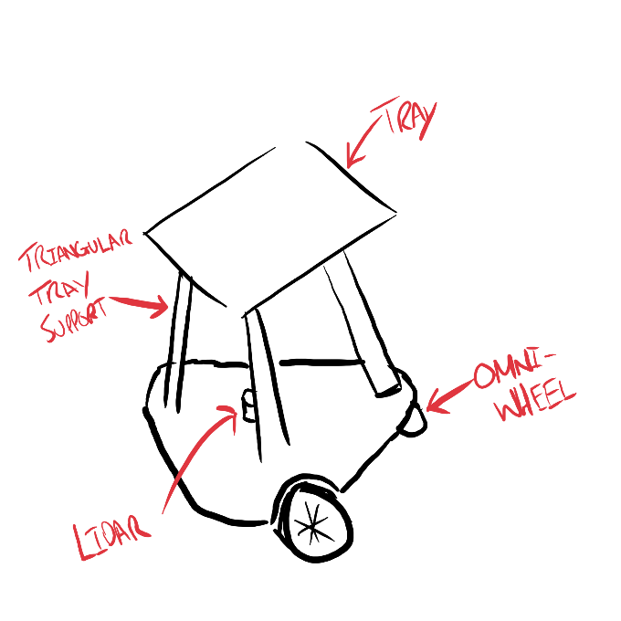

### Chosen design:

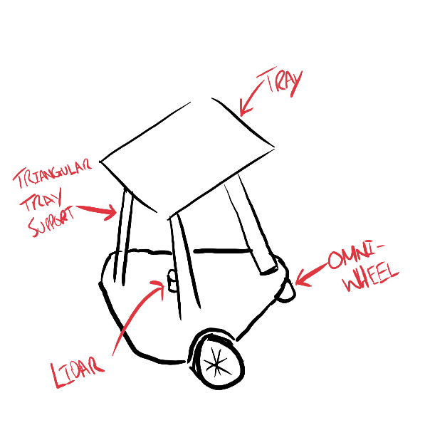Design concept two was chosen because its greater food tray stability and lower part count both lend themselves to a simple and effective design.

It was also chosen because looking into general LiDAR scanners it seems that it is possible to set a minimum scannable distance meaning that its three possible blind spots disadvantage can be mitigated.

## Physical development and CAD:

< Purpose is to tell the physical development story. What I did to design and create the physical components of the prototype, problems encountered and resolutions >

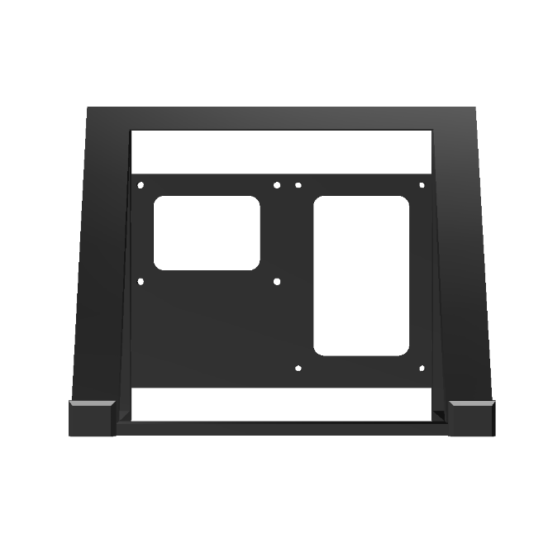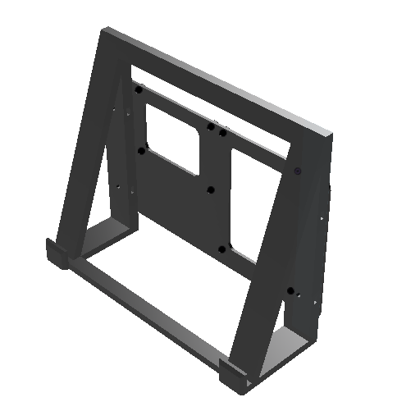With a final design chosen the next step in Robot development was to create a workstation capable of holding both the Jetson Nano 2GB and a screen. Below are three views of the created CAD of mentioned workstation:

Figure 2.5:ROS Workstation top right view

Figure 2.6:ROS Workstation front view

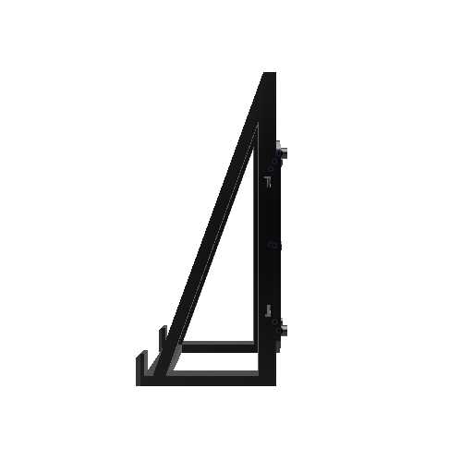

Figure 2.7:ROS Workstation side view

Within this design a tilted screen holder was incorporated along with a rear mounting plate with raised M3 mounting holes allowing for both the screens PCB and the Jetson to be screwed in.

With the CAD complete for the workstation this design was 3D printed and set up allowing for the beginning of software development.

The software development process is recorded in section 2.7 of the report.

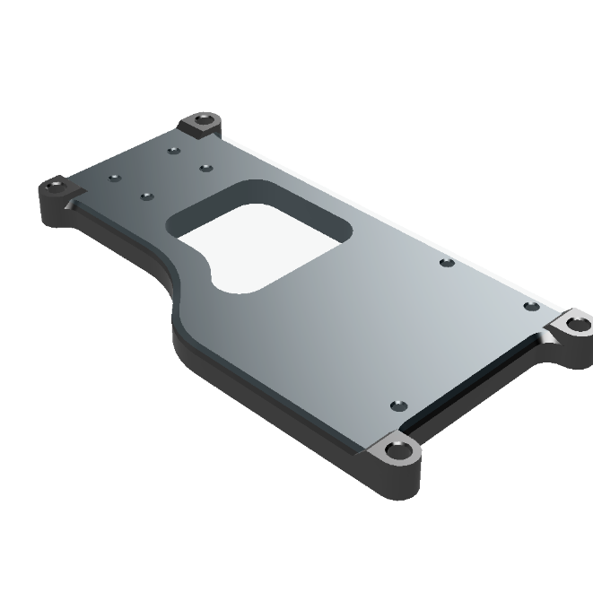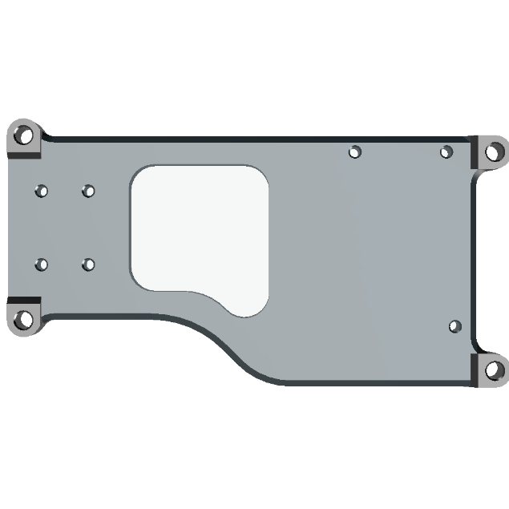The next group of CAD models produced were the motor and main electronic mounts as seen in Figure 2.8 and 2.9:

Figure 2.8: Left motor & Arduino mount  
top-down view

Figure 2.9:Left motor & Arduino mount   
isometric view

This design allows for the motor to be mounted with its shaft overhanging the left edge of the body while the Arduino has 3 mounting holes toward the right. The Arduino mounting hole dimensions were taken from its datasheet. [ ] While allowing the mounting of these components the design also has 4 reinforced holes for attaching itself to the robot base.

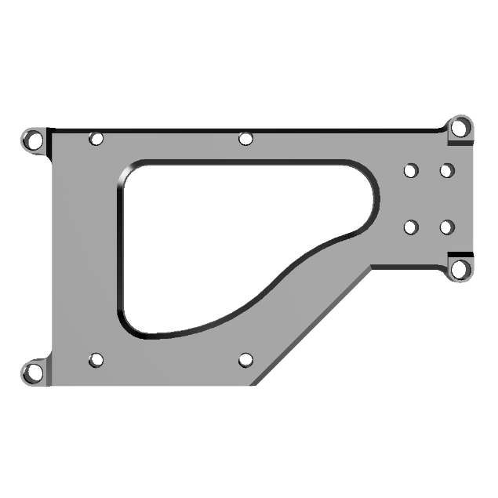Due to the nature of 3D printing using thermoplastics heat-set threaded inserts are used throughout most of the CAD designs within the project. This heavy incorporation is due to them being a quick and effective way of implementing sturdy metal threaded holes into any 3D printed component.

Figure 2.10: Right motor & Jetson Nano mount   
top-down view

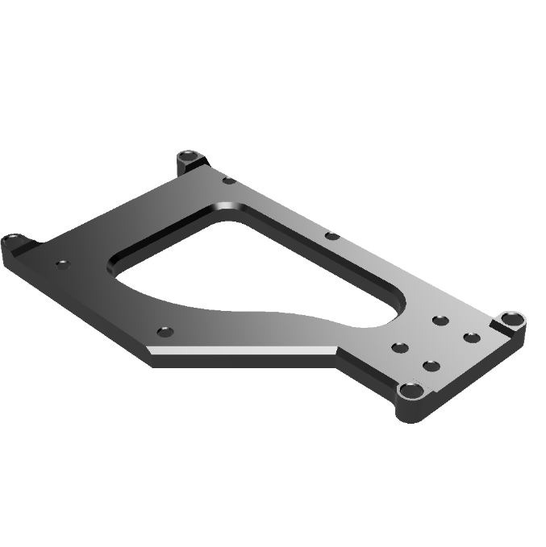With the left motor mount complete the next CAD model created was the right motor mount seen in Figure 2.10 and 2.11:

Figure 2.11: Right motor & Jetson nano mount   
isometric view

The right mount like its left side counterpart has all its mounting holes designed specifically to accommodate heat set-inserts however the right side has a deeper inner section allowing it to have mounting holes for a Jetson Nano 2GB rather than an Arduino. The Jetson mounting hole dimensions were taken from its data sheet. [ ]

Once both mounts were printed, and their fit tested the wheels were designed. When designing the wheels, a main consideration was the print bed size of the 3D printer. With the X and Y axis only being 220mm X 220mm respectively the diameter could not exceed this limit. Because of this 216.45mm was used for the wheel diameter, this was chosen because it gave a wheel circumference of 680mm.

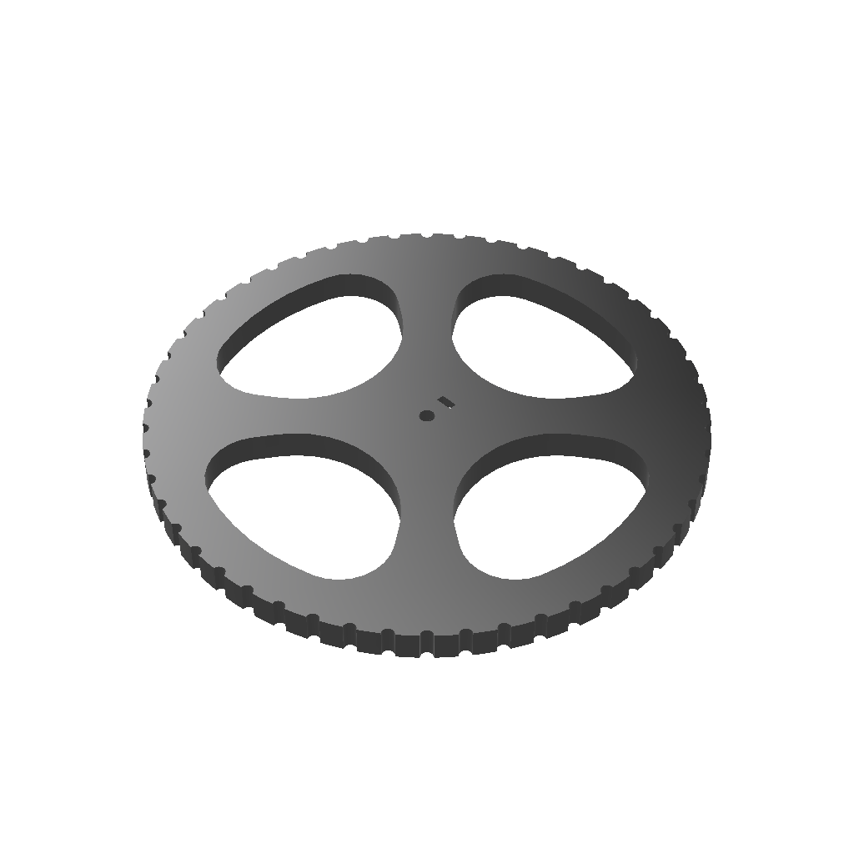To secure the wheels to the motor shaft an embedded M3 nut along with an M3 bolt hole was included within the model.

Figure 2.12: Wheel isometric view

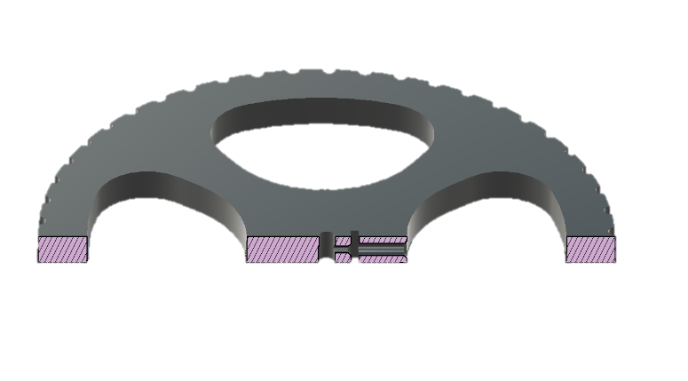

Figure 2.13: Wheel section view

Figure 2.13 shows a section view of the wheel model allowing for the embedded nut and bolt design to be seen.

The wheel design had to be redesigned after printing and testing due to the initial design having its embedded nut and bolt hole going through the full ‘spoke’ length causing it to require a long Allen key to tighten. This modification streamlined the robot’s assembly by relocating the embedded nut and bolt hole between the ‘spokes’.

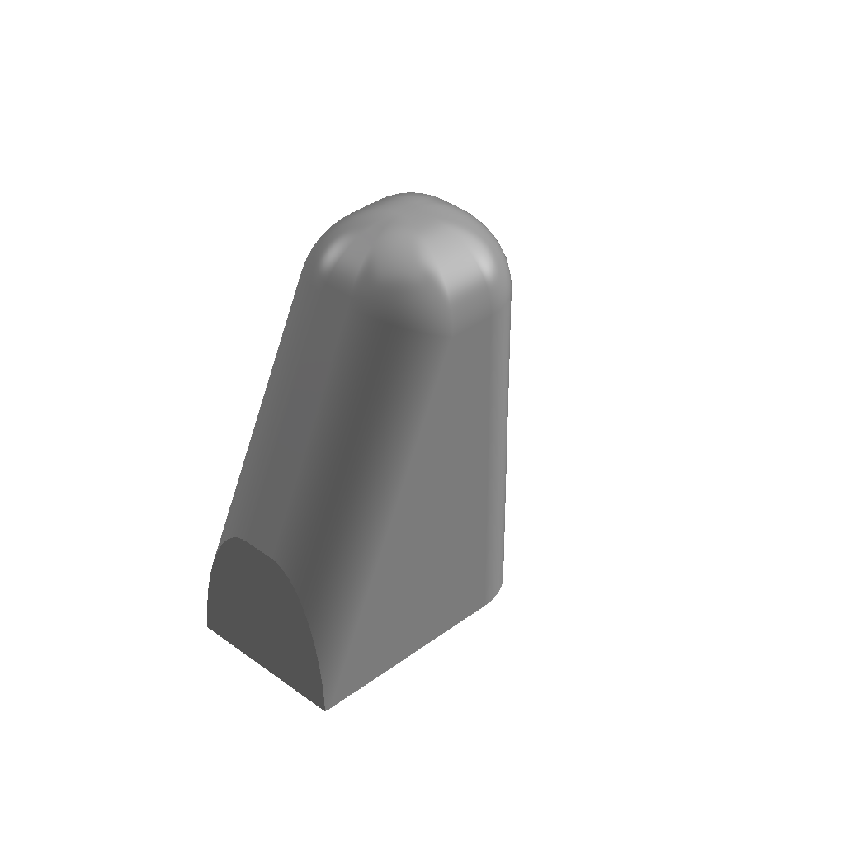The chosen design features an omni wheel as its third point of contact with the ground however to reduce cost and number of moving point and therefore possible points of failure this was replaced with a static curved 3D printed piece as seem in Figure 2.14.

Figure 2.14:Rear base support isometric view

Figure 2.15: Rear base support section view

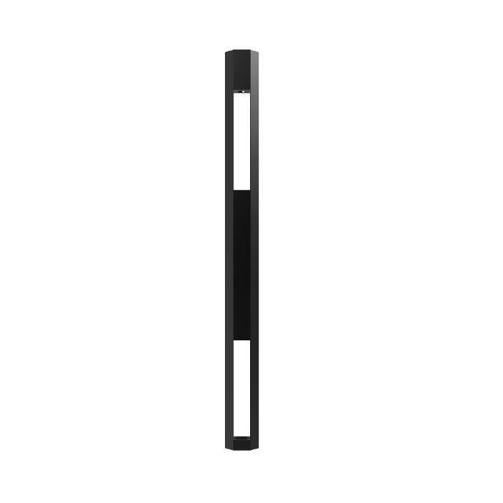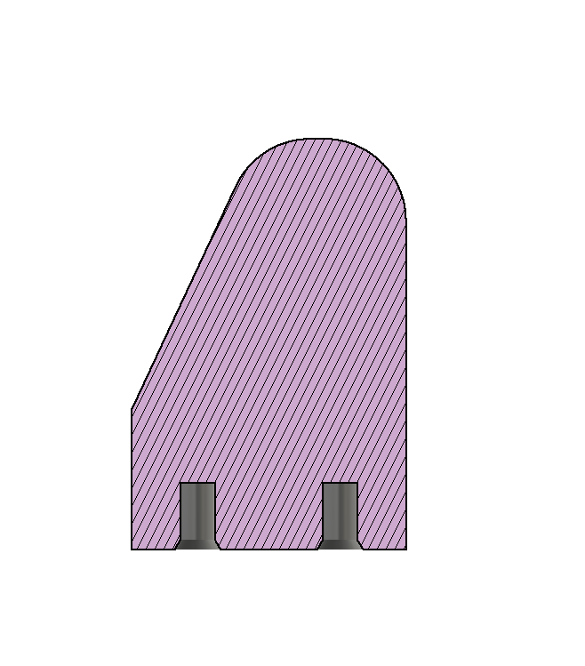  
  
Figure 2.15 is a section view of the rear base support allowing for the hole design of the heat-set threaded insert to be seen. For best results the inserts hole should be approximately 1.5 times its height, equal diameter and have a slight chamfer to guide the insert to its correct position.

Figure 2.16: LiDAR standoff front view

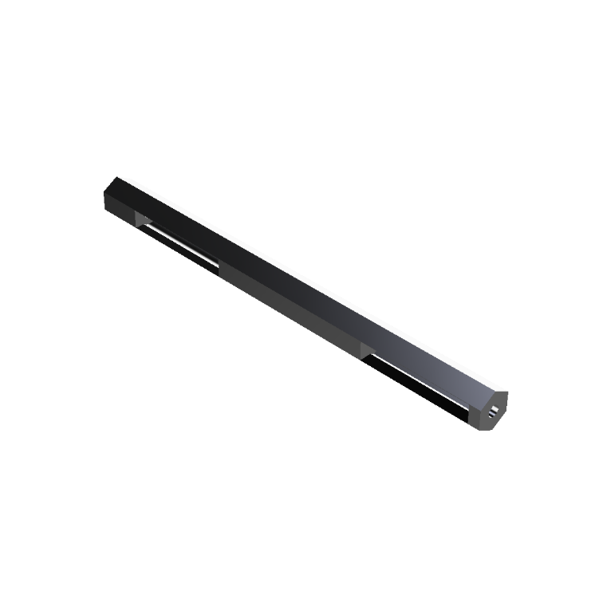The final pre-planned CAD model required was a standoff for the LiDAR component. This was to raise the LiDAR enough for its scanning field of view to not interact with the wheels as this could cause the navigation system to confuse itself by trying to avoid itself.

Figure 2.17: LiDAR standoff isometric view

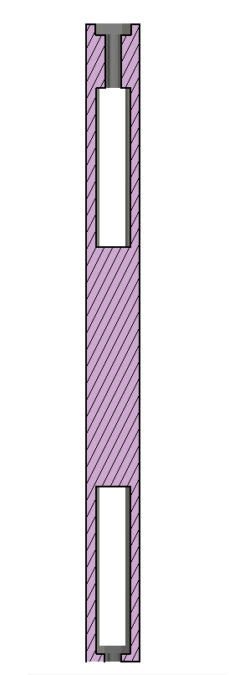The LiDAR standoff, as seen in Figures 2.16-2.18, was designed to house the hexagonal feet of the LiDAR with a through hole allowing for a bolt to secure it in place.

Figure 2.18: LiDAR standoff section view

On the opposite end of the standoff there is a small hexagonal recess allowing for an embedded nut to be press fit which in turn acts as a place for securing it to the main robot base. Both the hexagonal holes for the embedded nut and LiDAR foot can be seen within the section view seen in Figure 2.18.

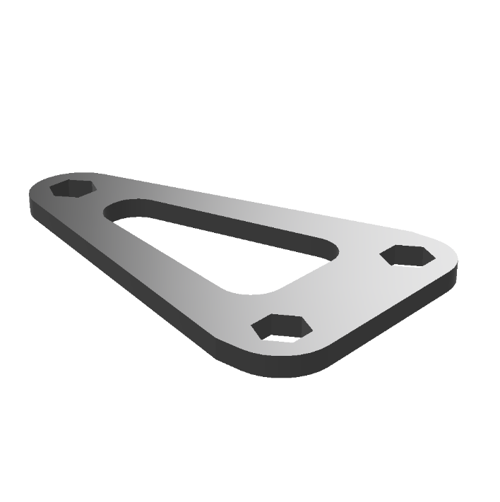After printing and testing the standoff it was clear that without a spacer to hold the legs the correct distance apart there would be serious oscillations (Due to the LiDARs rotating head) causing the LiDAR scan data to be unreliable and erratic. Because of this the model seen in Figure 2.19 was created.

Figure 2.19: LiDAR standoff spacer

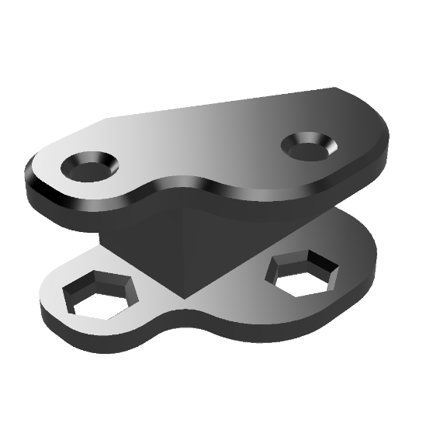The measurements used for the placements of the hexagonal holes in this design were taken from the YDLiDAR X2 datasheet [ ], this ensured that the distance between the legs of the standoffs were kept constant where this part was attached.

Figure 2.20: Base plate connector left

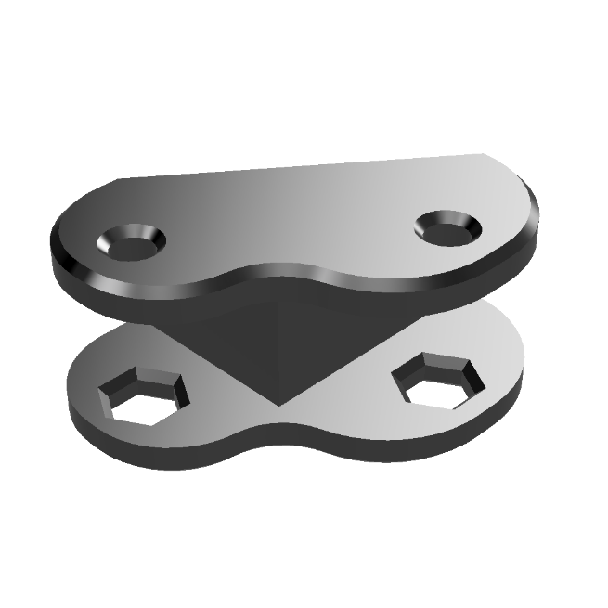Because of material limitations the robot’s baseplate had to be made from two separate pieces of wood which prompted the design and printing of two extra pieces, both of which are seen in Figures 2.20-2.21. These pieces were used to secure both wooden pieces together using nuts and bolts. Along with this hardware glue was also used where both wooden boards meet.

Figure 2.21: Base plate connector right

## Electronics and power:

< Purpose is to tell the electronics development story. What I did to design and create the electronic components of the prototype, problems encountered and resolutions >

With the requirement of using ‘off the shelf’ electronics components to keep the cost of the robot minimal the BOM seen in Table 2.7 was created.

|  |  |  |  |
| --- | --- | --- | --- |
| Component | Quantity | Unit cost (£) | Total cost |
| Jetson Nano 2GB | 1 | 68.91 [ ] | 68.91 |
| Arduino Uno | 1 | 7.36 [ ] | 7.36 |
| Uno motor shield | 1 | 13.25 [ ] | 13.25 |
| YDLiDAR X2 | 1 | 60.95 [ ] | 60.95 |
| Geared DC Motor | 2 | 27.99 [ ] | 55.98 |
|  |  | Overall total: | 206.45 |

Table 2.7: BOM for bought components

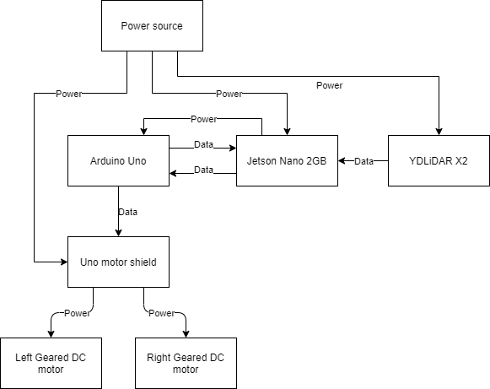With the list of components finalised the block diagram seen in Figure 2.22 was created for a visual breakdown of how each component will interact with one another.

Figure 2.22: Component block diagram

The Jetson Nano 2GB USB ports are used for both the YDLiDAR – Jetson data connection and the Arduino Uno – Jetson data and power connection. Because of the use of the on-board USB ports on the Jetson both YDLiDAR and Arduino components can be set up extremely quickly. On top of this, the use of an Uno motor shield means that all Arduino – Motor shield connections are made by simply plugging the shields pins directly into the already lined up Arduino I/O ports.

With all the simple connections made the Arduino/Motor shield – Motor connections were made according to the Motor shields documentation [ ] and the DC motors documentation [ ]. Figure 2.23 shows this wiring diagram, keep in mind that the motor shields lined up I/O ports act as a passthrough to the Arduino electrically.

Arduino

Motor Shield

I/O passthrough

Right Motor with Encoder

Left Motor with Encoder

12V Power

5V Power

5V

GND

Hall sensor Vcc

Hall sensor GND

Motor +

Mot A +

Mot A -

2

4

Mot B +

Mot B -

3

6

Motor -

Hall sensor B OUT

Hall sensor A OUT

Hall sensor B OUT

Hall sensor A OUT

Motor -

Motor +

3

5

= I/O pin

#

Figure 2.23: Arduino - Motor shield - Motors wiring diagram

The wiring variation between the left and right motor seen within Figure 2.23 is due to the Arduino Uno only having 2 interrupt pins. These interrupts are found on I/O pins 2 and 3, each motor has to have at least one of its Hall sensor OUT wires connected to either of these pins for the firmware to function correctly. This wiring became an issue however since the motor shield uses pin 3 as one of its PWM pins. The solution was to bypass Hall sensor A OUT straight to the Arduinos pin 3 and reroute a different PWM capable I/O pin to the motor shields pin 3, pin 5 was chosen for rerouting but it could have been any that were capable of PWM output.

While on board power was the original plan, the project timeline was running behind and as it was not completely necessary to test the prototypes function a tethered approach was used instead. This meant that though the LiDAR scanner was powered by an on-board battery pack both the Jetson and the Motor shield were plugged into mains power.

## Software and Programming:

< Purpose is to tell the software development story. What I did to design and create the programming components of the prototype, problems encountered and resolutions >

## Results:

< Purpose is to give a description of the final prototype. Compare reality to original specification (Table) >

# Discussion:

< Purpose is to provide a retrospective discussion based on points of interest throughout the projects design and manufacture. >

# Conclusion and recommendation:

< Purpose is to draw out specific conclusions which in turn lead to specific recommendations for if project is redone or continued. What worked well, not so well and what to do differently (Start with no more than 6) >

# References:

< Formal list using word referencing feature and in IEEE format >

# Appendices:

< Collection of documents referred to throughout the report >