**Business Scenario : V – Medicare**

V - Medicare is an online medical provider app that connects patients with healthcare professionals. For this ER diagram, we will focus on the staff members of V - Medicare, including doctors, nurses, and administrative staff.

**Entities:**

1. Staff
2. Role
3. Specialty

**Relationships:**

1. **Staff - Role:** Each staff member has a specific role within the organization.
2. **Staff - Specialty:** Some staff members might have specialties.

**Attributes:**

1. **Staff:** Staff ID, Name, Role ID, Specialty ID, Contact Information
2. **Role:** Role ID, Role Name
3. **Specialty:** Specialty ID, Specialty Name

**Cardinality:**

1. Each staff member can have only one role, but each role can be associated with multiple staff members.
2. Each staff member may have one or no specialty, but each specialty can be associated with multiple staff members.

Now, let's represent this information in an ER diagram:

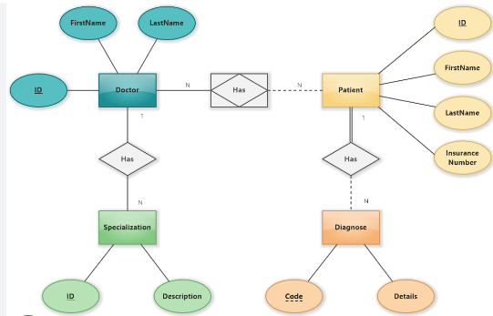

1. **Atomicity:** This property ensures that either all the operations within a transaction are successfully completed, or none of them are. If any part of the transaction fails, the entire transaction is rolled back to its original state.
2. **Consistency:** This ensures that the database remains in a consistent state before and after the transaction. In other words, the integrity constraints are maintained, and the database transitions from one valid state to another valid state.
3. **Isolation:** This property ensures that the operations within a transaction are isolated from other transactions, meaning the intermediate states of a transaction are not visible to other transactions until the transaction is commited .
4. **Durability:** Once a transaction is committed, the changes made by that transaction are permanent and will not be lost, even in the event of a system failure.