**Assignment 2: The General Linear Model**

Samuel Obeng Nkrumah

Department of Psychiatry, Dalhousie University

PSYR 6003: Fundamentals of Applied Statistics

Dr. Sandra M. Meier

March 16, 2025

**The General Linear model**

**Results**

The dataset originally included 137 undergraduate participants and 21 variables. Following data inspection and cleaning, six incomplete cases were removed, resulting in a final dataset of 131 participants with 21 variables. Among these participants, there are 119 females (coded as 0) and 19 males (coded as 1).

**Observation of the results of the Univariate distribution**

The Negative Affect distribution is roughly symmetrical with slight right skewness, centering around a mean of 2.5 and ranging from 1 to 5. Conscientiousness shows a more uneven, slightly left-skewed distribution, concentrated between values of 2 and 6. SPP presents a relatively uniform spread with peaks around 4 and 6, while Sex displays a heavily imbalanced distribution with one category dominating the sample. Overall, the distributions reflect meaningful variability in participants' traits and characteristics (**Appendix A**).

**Assumption Testing**

The assessment of model assumptions indicates that the assumptions of normality, linearity, homoskedasticity, and independence are largely satisfied (**Appendix B**). The histogram of residuals reveals a roughly symmetrical distribution centered around zero, resembling a normal distribution. Although some deviations from perfect normality are present, no extreme skewness or severe outliers were observed, suggesting that the normality assumption is reasonably met. Linearity was evaluated using the Residual Dependence Plot. The residuals are mostly random around the zero line, indicating acceptable linearity. Although a slight curve suggests mild non-linearity, it is not substantial enough to violate the linearity assumption. The assumption is largely met, but minor non-linearity may warrant further investigation (consideration of polynomial terms). Homoskedasticity was examined through the Scale-Location (S-L) plot, which demonstrates a slight increase in the spread of residuals as fitted values increase. However, this trend appears minimal and unlikely to significantly violate the assumption of constant variance. Lastly, while independence of observations is not directly assessed through visual plots, it is typically ensured through appropriate study design. Assuming proper data collection procedures were followed, this assumption is reasonably upheld. Overall, the assumptions are sufficiently met for the regression model to be considered appropriate for interpretation, despite minor concerns regarding potential heteroskedasticity. The Shapiro-Wilk test was run to check or confirm whether the dataset follows a normal distribution. W statistics= **0.98** suggests the data is fairly close to normal. Additionally, p-value = **0.07** is greater than 0.05, meaning we do not reject the null hypothesis (i.e., we cannot conclude that the data is significantly different from a normal distribution).

**Descriptive Statistics**

**Table 1** displays the means, standard deviations (SDs), and range of values: Negative Affect, Conscientiousness, and Socially Prescribed Perfectionism. The descriptive statistics reveal notable differences across gender in the measured psychological constructs. In terms of Negative Affect, females reported higher mean scores (2.50) compared to males (2.07), suggesting that women may experience stronger negative emotional states on average. Additionally, the greater variability in females' scores (SD = 0.99 vs. 0.84) and their wider range (maximum score of 4.83 vs. 3.83) indicate that some women experience notably higher levels of negative affect. For Conscientiousness, females also scored higher on average (4.11) compared to males (3.61), again with greater variability (SD = 1.31 vs. 1.07). Interestingly, the minimum score for females was zero, suggesting the presence of some outliers or individuals with exceptionally low conscientiousness. In contrast, the male range was narrower, with scores starting at 2 and reaching a maximum of 6. Socially Prescribed Perfectionism, the mean scores for females (4.38) and males (4.42) were nearly identical, indicating little gender difference in this trait. However, the variability in scores was slightly higher for females (SD = 1.46 vs. 1.26), and their range extended from 1 to 7, compared to 2 to 6.4 for males. This suggests that while average levels of perfectionism are consistent across genders, females may experience a broader spectrum of perfectionism-related behaviors. Overall, these findings suggest that while females tend to report higher levels of negative affect and conscientiousness, they also show greater variability in these traits

**Table1**

*Descriptive Statistics Means, Standard Deviations, and a bivariate correlation matrix.*

|  |  |  |  |  |  |
| --- | --- | --- | --- | --- | --- |
| **variables** | **sex** | **Mean** | **SD** | **Min** | **max** |
| Negative Affect | Female | 2.50 | 0.99 | 1.00 | 4.83 |
| Male | 2.07 | 0.84 | 1.00 | 3.83 |
| Conscientiousness | Female | 4.11 | 1.31 | 0.00 | 6.00 |
| Male | 3.61 | 1.07 | 2.00 | 6.00 |
| Socially Prescribed Perfectionism | Female | 4.38 | 1.46 | 1.00 | 7.00 |
| Male | 4.42 | 1.26 | 2.00 | 6.40 |

**Regression Analysis**

**Table 2** shows the estimates (B), standard errors (SE), 95% CIs, and Pseudo R2 of all the predictor variables. The regression analysis results indicate that Conscientiousness, Socially Prescribed Perfectionism (SPP), and Sex are significant predictors of NegativeAffect. Conscientiousness was found to have a significant negative association with Negative Affect (B=−0.26, SE=0.06, 95% CI [−0.37, −0.14]), suggesting that individuals with higher Conscientiousness scores tend to report lower levels of Negative Affect (**see Appendix C**). Conversely, Socially Prescribed Perfectionism was positively associated with Negative Affect (B=0.20, SE=0.05, 95%CI [0.10,0.31]) indicating that individuals with higher levels of SPP are more likely to experience greater Negative Affect. The effect of Sex approached significance (B=−0.58, SE=0.21,95%CI [−1.16,0.01] with the confidence interval narrowly including zero. Overall, the findings highlight that both personality traits (Conscientiousness and SPP) significantly contribute to variations in Negative Affect, while the role of Sex may require further investigation to confirm its influence. Additionally, the result from the estimates indicates that for every one-point increase in conscientiousness and SPP, Negative Affect go up by 0.26 and 0.20 points respectively.

**Table 2**

*Regression Analysis*

|  |  |  |  |
| --- | --- | --- | --- |
| **Predictors** | **B** | **SE** | **95% CI**  **(LL, UL)** |
| Intercept  Conscientiousness | 2.67  -0.26 | 0.38  0.06 | (1.93, 3.41)  (-0.37, -0.14) |
| Socially Prescribed Perfectionism | 0.20 | 0.05 | (0.10, 0.31) |
| Sex | -0.58 | 0.21 | (-1.16, 0.01) |

B: estimates, SE: Standard error

**Hypothesis Testing**

**Hypothesis 1:** **Sex, conscientiousness, and SPP will all significantly predict negative affect, in the manner described above.**

**linear model equation:**

Negative Affect= b0 + b1*Sex + b2*Conscientiousness + b3*SPP + e

**Identify parameters of interest:**

Negative Affect= b0 + ***b1*Sex + b2*Conscientiousness + b3*SPP*** + e

**Set up a full and a reduced model**

Reduced: Negative Affect= b0 + e

Full: Negative Affect= b0 + b1*Sex + b2*Conscientiousness + b3*SPP + e

**Where:**

***Negative Affect***: The dependent variable or the outcome variable

***b0 (intercept):*** The expected value of Negative Affect when all predictor variables (Sex, Conscientiousness, and SPP) are zero

***b1, b2, and b3***: are the regression coefficient for sex, conscientiousness and socially prescribed perfectionism.

***e (Error term):*** This represents the unexplained variance in Negative Affect that is not accounted for by the predictors.

**Comparing full and reduced model for hypothesis 1**

**Table 3** shows the comparison of the full and reduced model for hypothesis 1. The comparison reveals key differences in model fit and explanatory power. The full model includes additional predictors and demonstrates a notably better fit compared to the reduced model. This is evidenced by the lower Akaike Information Criterion (AIC) value of 333.3 for the full model, compared to 368.3 for the reduced model. Similarly, the Bayesian InformationCriterion(BIC) is lower in the full model (347.6) than in the reduced model (374.0), further supporting the improved fit of the full model. The Bayes Factor is extremely large (543,039.5), which provides overwhelming evidence in favor of the full model over the reduced model. The model comparison estimates suggest that our predictive model can account for up to 1.5 points in negative affect. The selected model (full model) explains **27%** of the variance in the Negative Affect while the reduced model explains virtually none (**R² = 0.00**), with conscientiousness contributing the largest portion at 14%. Sex and socially prescribed perfectionism (SPP) account for 4.3% and 8.7% of the variance, respectively. Overall, these results demonstrate that the full model provides a much stronger and more effective explanation of the outcome than the reduced model.

**Table3**

*Comparing full and reduced model for hypothesis 1*

|  |  |  |  |  |
| --- | --- | --- | --- | --- |
| **Model** | **AIC** | **BIC** | **Bayes Factor** | **R2** |
| Reduced | 368.3 | 374.0 | 0.0 | 0.00 |
| Full | 333.3 | 347.6 | 543039.5 | 0.27 |

The confidence interval for SPP (0.20 [0.10, 0.31]) lies entirely above zero, indicating a consistently positive and statistically significant effect. Similarly, the confidence interval for conscientiousness (-0.26 [−0.37 to −0.14]) is entirely below zero, showing a consistently negative and significant effect. The effect of sex (B = −0.58, p = .051) is marginally significant, suggesting a weaker contribution. Hence, hypothesis 1 is Supported — All three variables contribute to predicting negative affect, though sex has a weaker effect.

**Hypothesis 2: SPP will predict unique variance in negative affect over and above sex and conscientiousness in a meaningful way.**

***linear model equation*:**

Negative Affect= b0 + b1*Sex + b2*Conscientiousness + b3*SPP + e

**Identifying parameters of interest:**

Negative Affect= b0 + b1*Sex + b2*Conscientiousness ***+ b3*SPP*** + e

**Set up a full and a reduced model**

Reduced: Negative Affect= b0 + b1*Sex + b2*Conscientiousness+ e

Full: Negative Affect= b0 + b1*Sex + b2*Conscientiousness + b3*SPP + e

**Comparing full and reduced model for hypothesis 2**

Table 4 shows comparison of the full and reduced model for hypothesis 2. Controlling for conscientiousness and sex, there seems to be a slight positive relationship between SPP and negative affect. No need to check assumptions again, model is the same as for hypothesis 1.

The full model can predict differences in negative affect by up to 0.64 points. It remains the stronger model, evidenced by its lower AIC and BIC values, a Bayes Factor exceeding 100, and its ability to explain 27% of the variance in negative affect. In comparison, the reduced model accounts for only 18.5% of the variance.

**Table 4**

*Comparing full and reduced model for hypothesis 2*

|  |  |  |  |  |
| --- | --- | --- | --- | --- |
| **Model** | **AIC** | **BIC** | **Bayes Factor** | **R2** |
| Reduced | 345.6 | 357.1 | 0.009 | 0.185 |
| Full | 333.3 | 347.6 | 111.4 | 0.269 |

Since the full model explained 27% of the variance in Negative Affect (R² = 0.269) and the reduced model explained only 18.5% (R² = 0.185), this indicates that adding SPP uniquely accounted for 8.4% of the variance in Negative Affect. Therefore, hypothesis 2 is Supported — SPP uniquely predicts a significant amount of variance in Negative Affect beyond the effects of Sex and Conscientiousness.

**Discussion**

The findings of this study highlight the significant role of socially prescribed perfectionism (SPP) and conscientiousness in predicting negative affect. The results showed that conscientiousness had a significant negative relationship with negative affect, while SPP demonstrated a significant positive relationship. Although gender's effect approached significance, it was less pronounced. The comparison between the full and reduced models demonstrated that the inclusion of SPP notably enhanced the model’s predictive power. This supports the claim that SPP contributes unique variance in explaining negative affect beyond the effects of conscientiousness and gender. Consequently, both hypotheses were supported: (1) Sex, Conscientiousness, and SPP were meaningful predictors of negative affect, and (2) SPP uniquely predicted additional variance in negative affect. These findings emphasize the importance of addressing socially prescribed perfectionism in interventions targeting emotional well-being, particularly in undergraduate populations. Future research may benefit from exploring additional psychological factors that interact with SPP to better understand its impact on mental health outcomes.

**Conclusion**

The study provides valuable insights into the psychological factors influencing negative affect in undergraduate students. The results confirm that socially prescribed perfectionism (SPP) and conscientiousness are significant predictors of negative affect, with conscientiousness acting as a protective factor and SPP contributing to increased distress. While the effect of gender approached significance, its influence was less substantial. Model comparison analyses reinforced these findings, revealing that the full model — which included all three predictors — provided significantly greater explanatory power than the reduced models. Importantly, the findings demonstrate that SPP predicts unique variance in negative affect, underscoring its distinct role in shaping emotional well-being. These results highlight the need for targeted interventions that address the pressures of socially prescribed perfectionism, particularly in educational settings. By recognizing the impact of perfectionism alongside personality traits like conscientiousness, mental health strategies can be better tailored to support students’ emotional well-being.

**Appendix A**

*Visualizing univariate distributions*

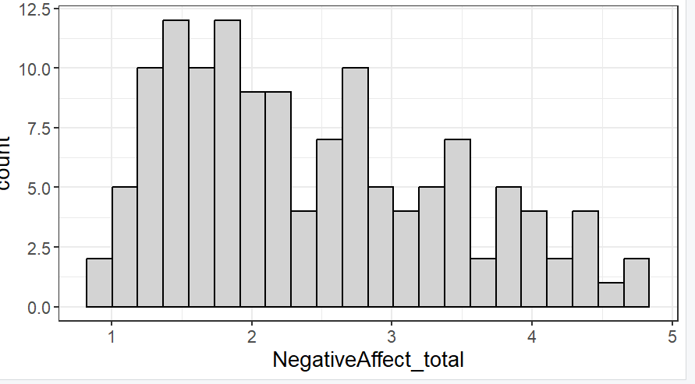

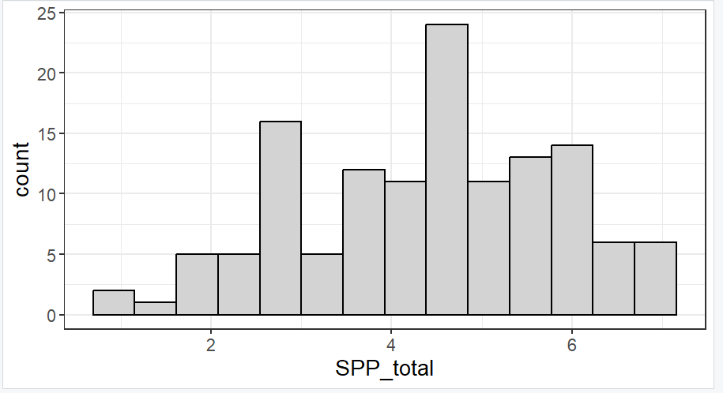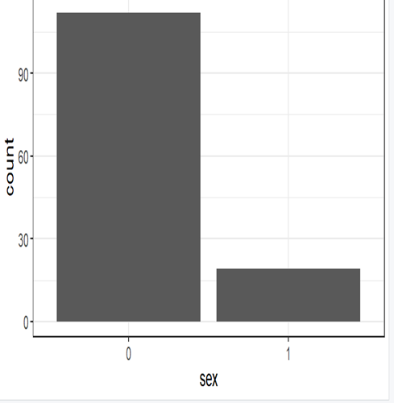

**Appendix B**

*Visualizing the model*

**Appendix C**

*Visualizing relationship between Negative Affect and the predictors (SPP, Conscientiousness and Sex)*

