**Q1. IPL tournament**

Ans:

DWH diagram (Star Schema)

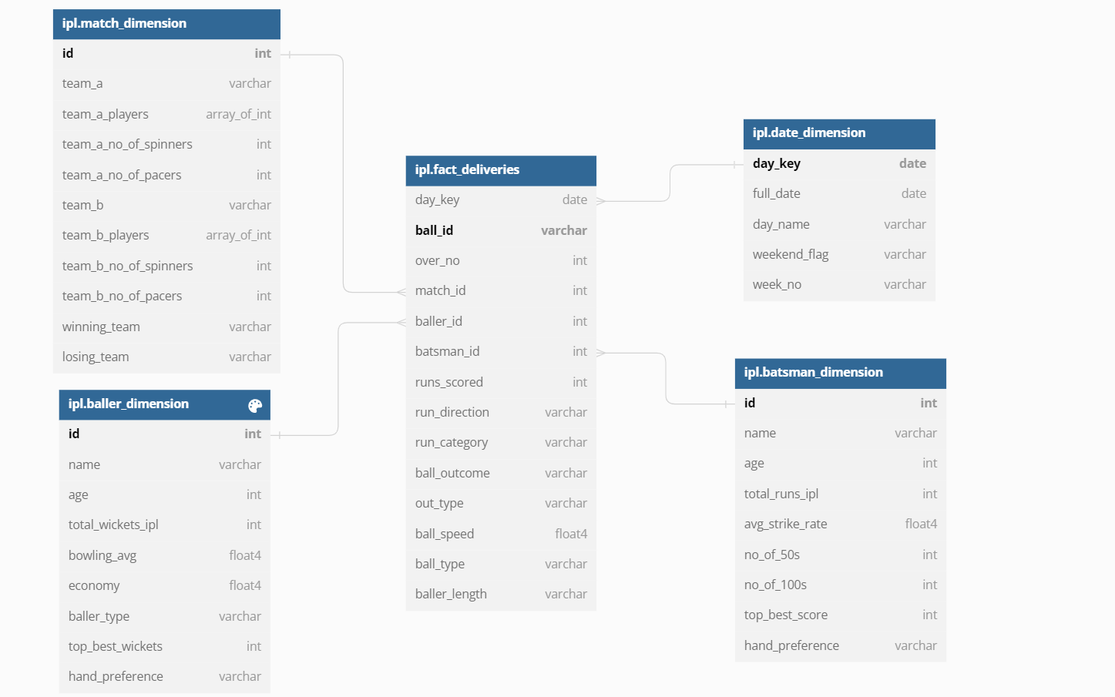

**List of Dimensions and their definition:**

**All the dimensions shall be maintained in SCD-Type1 fashion**

Table ipl.batsman_dimension {

id int [pk]

name varchar

age int

total_runs_ipl int

avg_strike_rate float4

no_of_50s int

no_of_100s int

top_best_score int

hand_preference varchar

}

Table ipl.baller_dimension {

id int [pk]

name varchar

age int

total_wickets_ipl int

bowling_avg float4

economy float4

baller_type varchar

top_best_wickets int

hand_preference varchar

}

Table ipl.match_dimension {

id int [pk]

team_a varchar

team_a_players array_of_int

team_a_no_of_spinners int

team_a_no_of_pacers int

team_b varchar

team_b_players array_of_int

team_b_no_of_spinners int

team_b_no_of_pacers int

winning_team varchar

losing_team varchar

}

Table ipl.date_dimension {

day_key date [pk]

full_date date

day_name varchar

weekend_flag varchar

week_no varchar

}

**Facts and their definition:**

Table ipl.fact_deliveries {

day_key date [ref: > ipl.date_dimension.day_key]

ball_id varchar [pk]

over_no int

match_id int [ref: > ipl.match_dimension.id]

baller_id int [ref: > ipl.baller_dimension.id]

batsman_id int [ref: > ipl.batsman_dimension.id]

runs_scored int

run_direction varchar

run_category varchar

ball_outcome varchar

out_type varchar

ball_speed float4

ball_type varchar

baller_length varchar

}

**Insightful reports:**

1. **How much runs were scored in each direction (legside, offside, longoff, longon, thirdman) in a particular match?**

Ans:

Select sum(runs_scored), run_direction

from ipl.fact_deliveries d

Inner join match_dimension m

on d.match_id= m.id

and m.team_a=’Rajasthan Royals’ and m.team_b=’Mumbai Indians’

group by run_direction

1. **What type of runs (1’s, 2’s, 3’s etc) were scored on each baller length (yorker, length, good_length, short_length) MATCHWISE?**

Ans: Select count(case when d.runs_scored=1 then ‘1’s’

When d.runs_scored=2 then ‘2’s’

When d.runs_scored=3 then ‘3’s’

When d.runs_scored=4 then ‘4’s’

When d.runs_scored=6 then ‘6’s’

End) as run_category_count,

case when d.runs_scored=1 then ‘1’s’

When d.runs_scored=2 then ‘2’s’

When d.runs_scored=3 then ‘3’s’

When d.runs_scored=4 then ‘4’s’

When d.runs_scored=6 then ‘6’s’

End as run_category

, d.baller_length,

m.team_a, m.team_b

from ipl.fact_deliveries d

left join match_dimension m

on d.match_id= m.id

group by case when d.runs_scored=1 then ‘1’s’

When d.runs_scored=2 then ‘2’s’

When d.runs_scored=3 then ‘3’s’

When d.runs_scored=4 then ‘4’s’

When d.runs_scored=6 then ‘6’s’

End,

, d.baller_length,

m.team_a, m.team_b

Q2. Swiggy DWH

Ans:

DWH diagram (Star Schema)

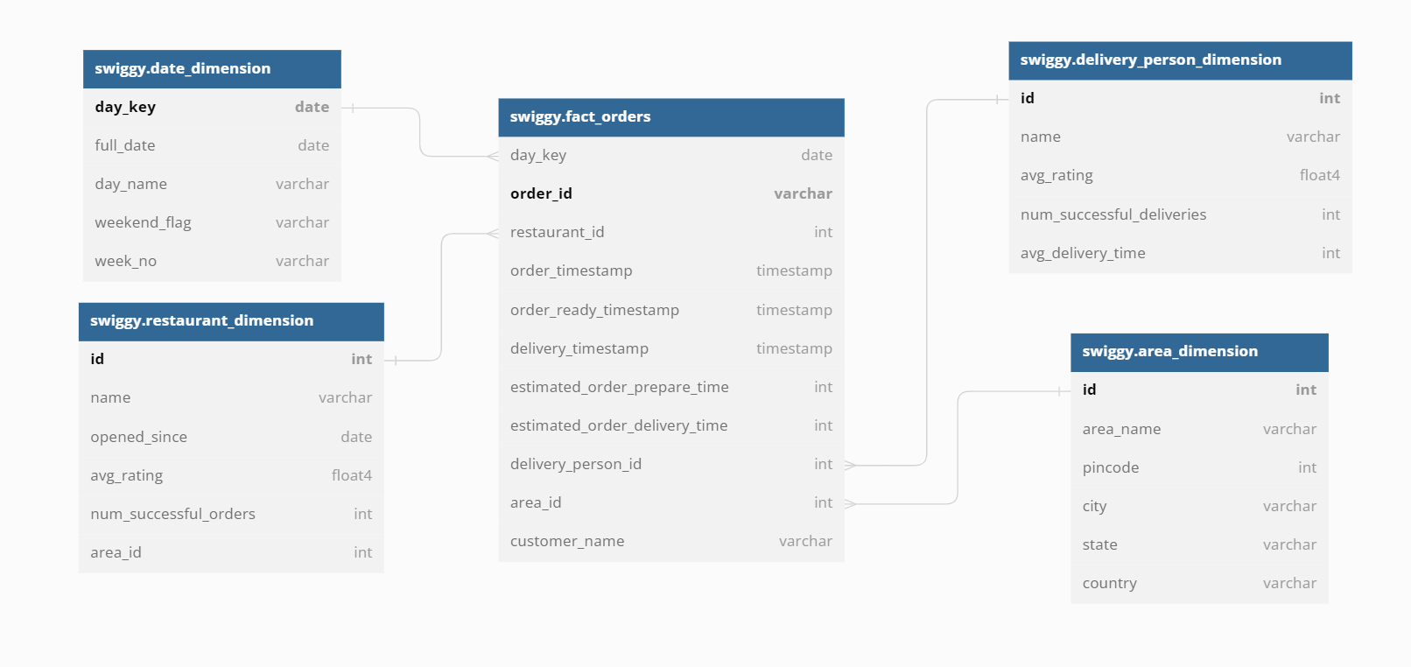

**List of Dimensions and their definition:**

**All the dimensions shall be maintained in SCD-Type1 fashion**

Table swiggy.restaurant_dimension {

id int [pk]

name varchar

opened_since date

avg_rating float4

num_successful_orders int

area_id int

}

Table swiggy.area_dimension {

id int [pk]

area_name varchar

pincode int

city varchar

state varchar

country varchar

}

Table swiggy.delivery_person_dimension {

id int [pk]

name varchar

avg_rating float4

num_successful_deliveries int

avg_delivery_time int

}

Table swiggy.date_dimension {

day_key date [pk]

full_date date

day_name varchar

weekend_flag varchar

week_no varchar

}

**Facts and their definition:**

Table swiggy.fact_orders {

day_key date [ref: > swiggy.date_dimension.day_key]

order_id varchar [pk]

restaurant_id int [ref: > swiggy.restaurant_dimension.id]

order_timestamp timestamp

order_ready_timestamp timestamp

delivery_timestamp timestamp

estimated_order_prepare_time int

estimated_order_delivery_time int

delivery_person_id int [ref: > swiggy.delivery_person_dimension.id]

area_id int [ref: > swiggy.area_dimension.id]

customer_name varchar

}

**Insightful reports:**

1. **What is the area wise percentage of orders delivered on time?**

**Ans:**

with cte as

(

select a.area_name, a.pincode, count(*) ontime_deliveries from swiggy.area_dim a

inner join

swiggy.fact_orders f

on a.id= f.area_id

where TIMESTAMPADD(MINUTE,estimated_order_delivery_time,order_timestamp) <= order_timestamp

group by a.area_name, a.pincode

),

cte1 as

(

select a.area_name, a.pincode, count(*) total_deliveries from swiggy.area_dim a

inner join

swiggy.fact_orders f

on a.id= f.area_id

group by a.area_name, a.pincode

)

select cte.area_name,cte.pincode, (ontime_deliveries*100/total_deliveries) area_wise_percentage

from cte

inner join cte1

on cte.area_name=cte1.area_name and cte.pincode=cte1.pincode;

1. **What is the area from which most orders are received?**

**Ans:** with cte as

(

select a.area_name, a.pincode, count(*) total_deliveries from swiggy.area_dim a

inner join

swiggy.fact_orders f

on a.id= f.area_id

group by a.area_name, a.pincode

)

Select * from cte

Order by total_deliveries desc limit 1;

1. **Who’s fault was there in a particular area for delayed deliveries (restaurant or delivery person)?**

Ans:

select a.area_name, a.pincode,

case

when TIMESTAMPADD(MINUTE, estimated_order_prepare_time,order_timestamp) > order_ready_timestamp then ‘Restaurant’s fault’

when TIMESTAMPADD(MINUTE, estimated_order_delivery_time,order_timestamp) > delivery_timestamp then ‘Delivery person’s fault’

end Delay_Reason

from swiggy.fact_orders f

inner join

swiggy.area_dim a

on a.id= f.area_id

where a.area_name=’Kondapur’ and a.pincode=500084

Q3.

Ans:

**DWH diagram (Star Schema)**

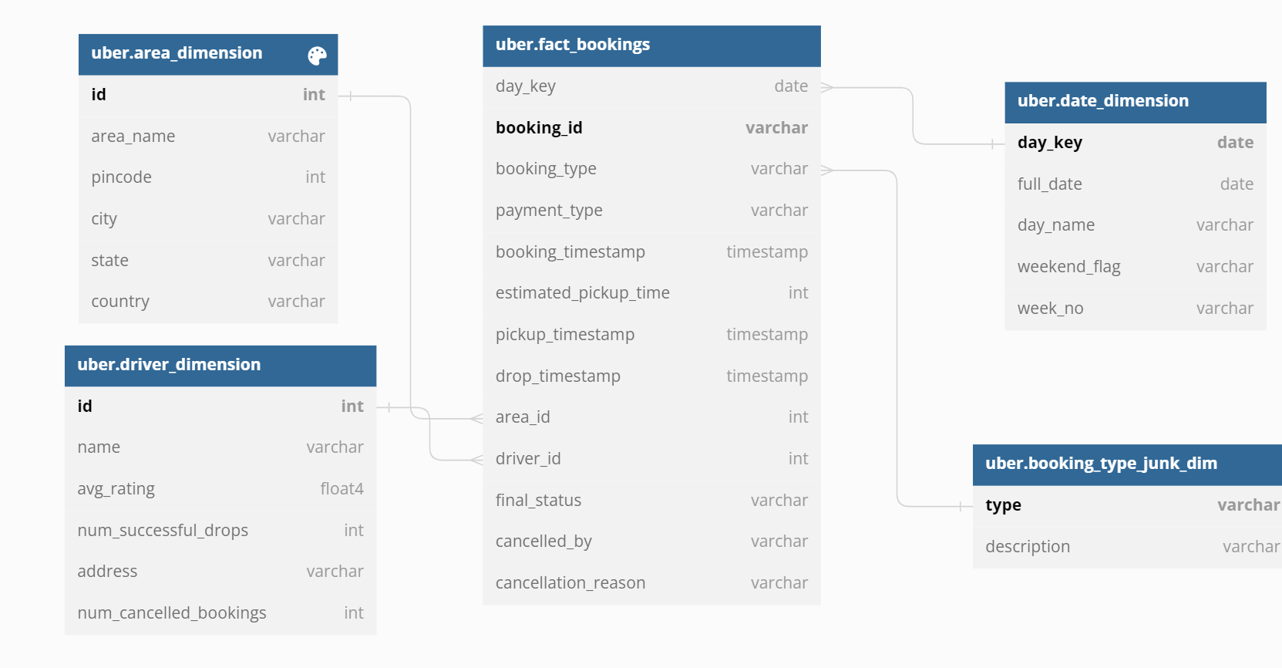

**List of Dimensions and their definition:**

**All the dimensions shall be maintained in SCD-Type1 fashion**

Table uber.area_dimension {

id int [pk]

area_name varchar

pincode int

city varchar

state varchar

country varchar

}

Table uber.driver_dimension {

id int [pk]

name varchar

avg_rating float4

num_successful_drops int

address varchar

num_cancelled_bookings int

}

Table uber.date_dimension {

day_key date [pk]

full_date date

day_name varchar

weekend_flag varchar

week_no varchar

}

**Facts and their definition:**

Table uber.fact_bookings {

day_key date [ref: > uber.date_dimension.day_key]

booking_id varchar [pk]

booking_type varchar

payment_type varchar

booking_timestamp timestamp

estimated_pickup_time int

pickup_timestamp timestamp

drop_timestamp timestamp

area_id int [ref: > uber.area_dimension.id]

driver_id int [ref: > uber.driver_dimension.id]

final_status varchar

cancelled_by varchar

cancellation_reason varchar

}

**Insightful reports:**

1. **What is the area wise count of ride bookings on a particular day?**

**Ans:**

select count(*) num_of_rides,f.booking_type , a.area_name, a.city, a.state from

uber.fact_bookings f left join uber.area_dimension a

on f.area_id=a.id

where f.day_key='2022-01-05'

group by f.booking_type , a.area_name, a.city, a.state;

1. **Percentage of rides which have abnormally long pickup time daywise?**

**Ans:**

with cte as

(

select f.day_key, count(*) delayed_pickup_num from uber.fact_orders f

inner join

uber.area_dim a

on a.id= f.area_id

where TIMESTAMPADD(MINUTE,estimated_pickup_time,booking_timestamp) > pickup_timestamp

group by f.day_key

),

cte1 as

(

select f.day_key, count(*) total_drops from uber.fact_orders f

inner join

uber.area_dim a

on a.id= f.area_id

where f.final_status='Dropped successfully'

group by f.day_key

)

select cte.day_key, (cte.delayed_pickup_num*100/cte1.total_drops) day_wise_percentage

from cte

inner join cte1

on cte.day_key=cte1.day_key;

1. **Daywise, Areawise, peak time of the day (in terms of hour of the day)?**

**Ans:**

with cte as

(

select f.day_key, hour(f.booking_timestamp) hour_of_booking , a.area_name, a.city, a.state,

count(*) num_of_rides,

from

uber.fact_bookings f

inner join uber.area_dimension a

on f.area_id=a.id

group by f.day_key , hour(f.booking_timestamp), a.area_name, a.city, a.state

order by count(*) desc limit 1

)

select * from cte

Q4. Dineout Datawarehouse

Ans:

**DWH diagram (Snowflake Schema)**

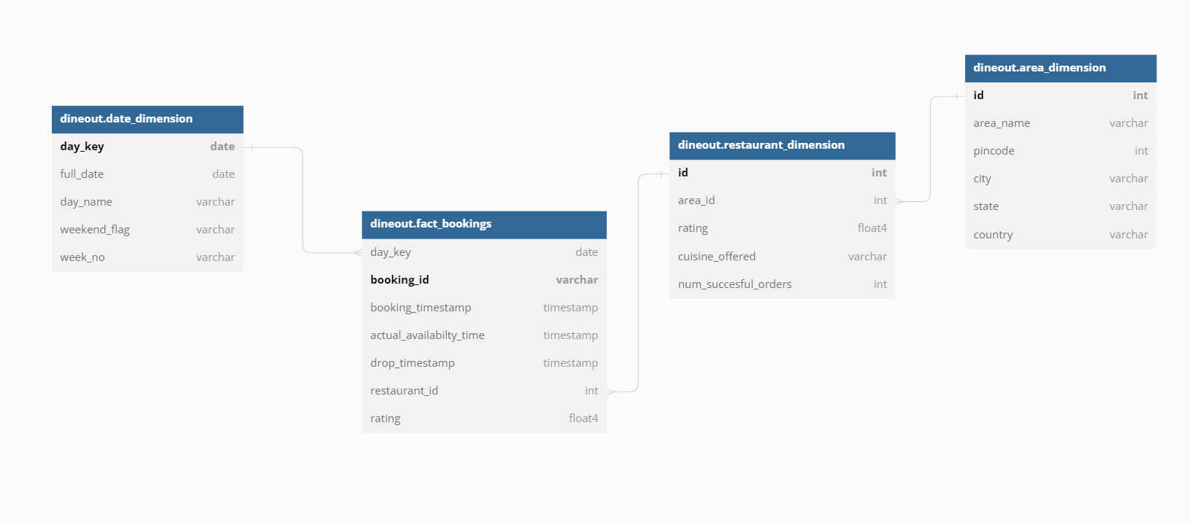

**List of Dimensions and their definition:**

**All the dimensions shall be maintained in SCD-Type1 fashion**

Table dineout.restaurant_dimension {

id int [pk]

area_id int [ref: > dineout.area_dimension.id]

rating float4

cuisine_offered varchar

num_succesful_orders int

}

Table dineout.area_dimension {

id int [pk]

area_name varchar

pincode int

city varchar

state varchar

country varchar

}

Table dineout.date_dimension {

day_key date [pk]

full_date date

day_name varchar

weekend_flag varchar

week_no varchar

}

**Facts and their definition:**

Table dineout.fact_bookings {

day_key date [ref: > dineout.date_dimension.day_key]

booking_id varchar [pk]

booking_timestamp timestamp

est_availability_time timestamp

actual_availabilty_time timestamp

drop_timestamp timestamp

restaurant_id int [ref: > dineout.restaurant_dimension.id]

rating float4

final_status varchar

}

**Insightful reports:**

1. **What is the area wise percentage of tables provided to the customer on time?**

**Ans:**

with cte as

(

select a.area_name, a.city,a.state, count(*) ontime_bookings from dineout.fact_bookings f

inner join

dineout.area_dim a

on a.id= f.area_id

where actual_availabilty_time <= est_availabilty_time

group by a.area_name, a.city,a.state

),

cte1 as

(

select a.area_name, a.city,a.state, count(*) total_bookings from dineout.fact_bookings f

inner join

dineout.area_dim a

on a.id= f.area_id

where f.final_status='success'

group by a.area_name. a.city,a.state

)

select a.area_name, a.city,a.state, (cte.ontime_bookings *100/cte1.total_bookings) area_wise_percentage

from cte

inner join cte1

on cte.area_name =cte1. area_name

and cte.city =cte1.city

and cte.state =cte1.state

1. **How many bookings (percentage) were cancelled because of delayed table availabilty, area wise?**

**Ans:**

with cte as

(

select a.area_name, a.city,a.state, count(*) late_bookings from dineout.fact_bookings f

inner join

dineout.area_dim a

on a.id= f.area_id

where actual_availabilty_time > est_availabilty_time

and final_status=’cancelled’

group by a.area_name, a.city,a.state

),

cte1 as

(

select a.area_name, a.city,a.state, count(*) total_bookings from dineout.fact_bookings f

inner join

dineout.area_dim a

on a.id= f.area_id

group by a.area_name. a.city,a.state

)

select a.area_name, a.city,a.state, (cte.late_bookings *100/cte1.total_bookings) area_wise_percentage

from cte

inner join cte1

on cte.area_name =cte1. area_name

and cte.city =cte1.city

and cte.state =cte1.state

;

Q4. Covid Vaccination Datawarehouse

Ans:

**DWH diagram (Snowflake Schema)**

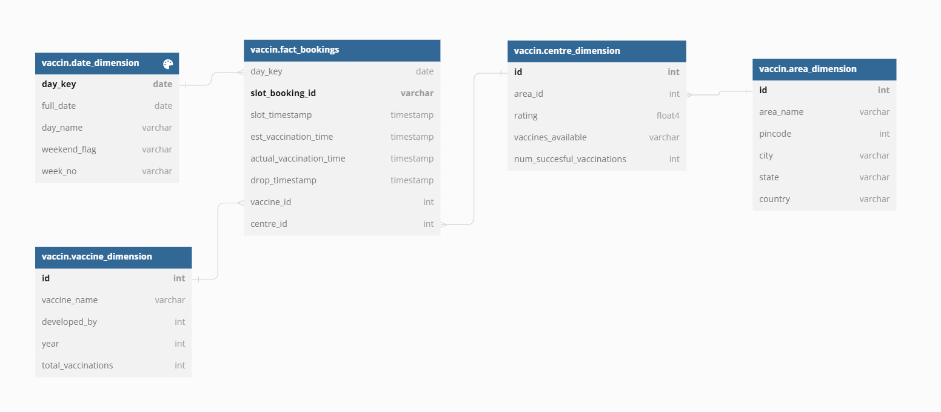

**List of Dimensions and their definition:**

**All the dimensions shall be maintained in SCD-Type1 fashion**

Table vaccin.centre_dimension {

id int [pk]

area_id int [ref: > vaccin.area_dimension.id]

rating float4

vaccines_available varchar

num_succesful_vaccinations int

}

Table vaccin.area_dimension {

id int [pk]

area_name varchar

pincode int

city varchar

state varchar

country varchar

}

Table vaccin.date_dimension {

day_key date [pk]

full_date date

day_name varchar

weekend_flag varchar

week_no varchar

}

Table vaccin.date_dimension {

day_key date [pk]

full_date date

day_name varchar

weekend_flag varchar

week_no varchar

}

**Facts and their definition:**

Table vaccin.fact_vaccinations {

day_key date [ref: > vaccin.date_dimension.day_key]

slot_booking_id varchar [pk]

slot_timestamp timestamp

est_vaccination_time timestamp

actual_vaccination_time timestamp

drop_timestamp timestamp

vaccine_id int [ref: > vaccin.vaccine_dimension.id]

centre_id int [ref: > vaccin.centre_dimension.id]

}

**Insightful reports:**

1. What is the area wise percentage of vaccinations done on time?

Ans:

with cte as

(

select a.area_name, a.city,a.state, count(*) ontime_vaccinations from vaccin.fact_vaccinations f

inner join

vaccin.centre_dimension c

on c.id= f.centre_id

inner join

vaccin.area_dimension a

on a.id= c.area_id

where actual_vaccination_time <= est_vaccination_time

group by a.area_name, a.city,a.state

),

cte1 as

(

select a.area_name, a.city,a.state, count(*) total_vaccinations from vaccin.fact_vaccinations f

inner join

vaccin.centre_dimension c

on c.id= f.centre_id

inner join

vaccin.area_dimension a

on a.id= c.area_id

group by a.area_name. a.city,a.state

)

select a.area_name, a.city,a.state, (cte.ontime_vaccinations *100/cte1.total_vaccinations) area_wise_percentage

from cte

inner join cte1

on cte.area_name =cte1. area_name

and cte.city =cte1.city

and cte.state =cte1.state

**2. What was the peak time of slot bookings, area wise , day wise?**

Ans:

with cte as

(

select a.area_name, a.city,a.state,f.day_key,f.day_name,hour(f.slot_timestamp) hour,

count(*) over (partition by a.area_name, a.city,a.state,f.day_key,f.day_name,hour(f.slot_timestamp)) total from vaccin.fact_vaccinations f

inner join vaccin.date_dimension d

d.day_key=f.day_key

inner join

vaccin.centre_dimension c

on c.id= f.centre_id

inner join

vaccin.area_dimension a

on a.id= c.area_id

),

cte1 as

(

select

cte.area_name, cte.city,cte.state,cte.day_key,cte.day_name,cte.hour hour,

dense_rank() over(partition by cte.area_name, cte.city,cte.state,cte.day_key,cte.day_name order by cte.total desc) rnk

from cte

)

select *

from cte1

where rnk=1