**BLOCKCHAIN TECHNOLOGY AND BLOCKCHAIN**

**BASED VOTING**

SEMINAR REPORT

*Submitted by*

**SAM SAJU**

**to**

**The APJ Abdul Kalam Technological University**

**in partial fulfilment of the requirements for the award of the Degree of**

***Bachelor of Technology***

***In***

***Computer Science and Engineering***



**DEPARTMENT OF COMPUTER SCIENCE AND ENGINEERING**

SREE NARAYANA GURUKULAM COLLEGE OF ENGINEERING , KADAYIRUPPU

682311

**NOVEMBER 2022**

## DEPARTMENT OF COMPUTER SCIENCE AND ENGINEERING,

## SREE NARAYANA GURUKULAM COLLEGE OF ENGINEERING, KADAYIRUPPU, 682311

(Affiliated to APJ Abdul Kalam Technological University& Approved by A.I.C.T.E)



**CERTIFICATE**

This is to certify that the seminar report, **“BLOCKCHAIN TECHNOLOGY AND BLOCKCHAIN BASED VOTING”** is the work done by **SAM SAJU** to the **APJ Abdul Kalam Technological University in partial fulfilment of the requirements for the award of the Degree of Bachelor of Technology in Computer Science and Engineering during the year 2023.**

### Head of the Department Coordinated by

**(Dr.) Smitha Suresh DIVYA K.S**

(Prof., CSE Dept) (Asst. Prof. CSE Dept)

# ACKNOWLEDGEMENT

Dedicating this project to the Almighty God whose abundant grace and mercy enabled its successful completion, we would like to express our profound gratitude to all the people who had inspired and motivated us to undertake this project.

We wish to express our sincere thanks to our Head of the Department, **Prof. (Dr.) Smitha Suresh,** for providing us the opportunity to undertake this seminar.

I extend my deep sense of gratitude to my guide **Mrs. Divya K.S Assistant Professor** in the Department of Computer Science and Engineering, for providing me with valuable advice and guidance during the seminar.

Finally, I would like to express my gratitude to Management and Principal, Sree Narayana Gurukulam College of Engineering for providing me with all the required facilities without which the successful completion of the seminar work would not have been possible.

# ABSTRACT

Increasingly digital technology in the present helped many people lives. Unlike the electoral system, there are many conventional uses of paper in its implementation. The aspect of security and transparency is a threat from still widespread election with the conventional system (offline). General elections still use a centralized system, there is one organization that manages it. Some of the problems that can occur in traditional electoral systems is with an organization that has full control over the database and system, it is possible to tamper with the database of considerable opportunities. Blockchain technology is one of solutions, because it embraces a decentralized system and the entire database are owned by many users. Blockchain itself has been used in the Bitcoin system known as the decentralized Bank system. By adopting blockchain in the distribution of databases on e-voting systems can reduce one of the cheating sources of database manipulation. This research discusses the recording of voting result using blockchain algorithm from every place of election. Unlike Bitcoin with its Proof of Work, this thesis proposed a method based on a predetermined turn on the system for each node in the built of blockchain

ii

# CONTENTS

ABSTRACT ii

LIST OF FIGURES iii

CHAPTER 1. INTRODUCTION 1

* 1. GENERAL BACKGROUND 1
  2. OBJECTIVE 1
  3. INTRODUCTION TO TOPIC 2

CHAPTER 2.LITERATURE SURVEY 3

CHAPTER 3. PROPOSED WORK 5

3.1 WHAT IS BLOCKCHAIN...................................................................................................5

### 3.1.1 BLOCKCHAIN BASED VOTING………………………………………………………..5

3.2 BLOCKCHAIN TRANSACTION PROCESS..................................................................6

3.2.1 DOWNSIDES OF BLOCKCHAIN VOTING 6

3.2.2 BLOCKCHAIN UTILIZATION  7

3.2.3 HOW BLOCKCHAIN VOTING SYSTEM FACILITATES SIMPLE, SAFER..7

3.3  HOW DOES A VOTER CAST VOTE IN BLOCKCHAIN............................................ 7

3.3.1 ARCHITECTURE OF DECENTRALIZED VOTING........................................ 8

3.3.2 LAYERS OF BLOCKCHAIN BASED VOTING………………………………… 9

3.4 ADAVANTAGES AND DISADVANTAGES OF BLOCKCHAIN VOTING..............10

CHAPTER 4. PROBLEM DEFINITION…………………………………………………………………11

4.1 BLOCKCHAIN VOTING…………………………………………………………………………...11

APPLICATION 12

CONCLUSION 14

REFERENCES 15

# LIST OF FIGURES

|  |  |  |
| --- | --- | --- |
| No. | Title | Page Number |
| 3.1 | ARCHITECTURE OF BLOCKCHAIN | 5 |
| 3.2 | BLOCKCHAIN TRANSACTION PROCESS | 6 |
| 3.3.1 | ARCHITECTURE OF E-BASED VOTING | 8 |
| 3.3.2 | LAYERS OF BLOCKCHAIN BASED VOTING | 9 |

iii

## 

## CHAPTER 1

## INTRODUCTION

### GENERAL BACKGROUND--Blockchain has gotten an ample amount of appreciation in the most recent couple of years, with the potential to come across as an extraordinary power to transform businesses. Blockchain technology is a computerized record of an action that is copied and conveyed across the whole organization of the blockchain platform through computer networks. Sounds confusing, isn’t it? Truth to be told, Blockchain is much easier to understand than the above description. For understanding the concept, it is feasible to look back at its historical background and learn about its origin to significant turns of events and innovations. Bits of knowledge into the background of Blockchain will assist us with addressing these queries like the exact meaning of the term, working environment, problems it can solve, and where it can be implemented. All these insights will help us to place the right expectations for its future.

### OBJECTIVE

To explain about the working, Advantages and Disadvantages of blockchain technologies and its one of the applications which is Blockchain based voting.

### INTRODUCTION TO TOPIC

Voting is a method for a group of individuals to make a collective decision or voice their cumulative opinion to arrive at a consensus. The results of a vote can have far reaching consequences due to which it is imperative to maintain integrity by ensuring that there is no scope for fraud or cheating to occur while the votes are being cast. It is highly crucial that voting is carried out in a fair and just manner. This Electronic Voting System has been developed to help eliminate any chance of tampering and improve the reliability and dependability of a voting system. This system consists of two entities namely; The Admin and The Voter (The User). Once the Voter has logged in to the system using their valid username and password, they can view the upcoming elections and the candidates contesting the election. Users can also view results once the elections have concluded. This system also shows user the elections that they have participated in so far. On the other side of the application, the admin can view the list of candidates contesting, the list of voters, and the list of elections. Since this system maintains the data using blockchain, it is highly dependable and can be easily scanned to check for signs of tampering and malpractice. In this system, the admin is the sole authority to manage elections, candidates and voters. Admin can also view the votes. Admin can also check if any vote is tampered, thus checking and verifying the block. Voter can view Elections and cast their vote, also can view the winner but cannot see the winning ratio or votes etc. The system uses Blockchain technology to create a block of every vote thus protecting its identity.

## CHAPTER 2

## LITERATURE SURVEY

The purpose of a literature review is to, as the name suggests, “review” the literature surrounding a certain topic area. The word “literature” means “sources of information” or “research.” The literature will inform us about the research that has already been conducted on our chosen subject. As discussed, earlier blockchain based voting is still an active research in the field of election. To address the issues related to e-voting many researchers have proposed different technologies, each approach or technology tries to address the issues in different why. In forthcoming section, we present a detailed survey of approaches proposed to handle the issues related to e-voting.

[Nir Kshetri](https://ieeexplore.ieee.org/author/37394408400) Bryan.[1] Blockchain-enabled e-voting (BEV) could reduce voter fraud and increase voter access. Eligible voters cast a ballot anonymously using a computer or smartphone. BEV uses an encrypted key and tamper-proof personal IDs. This article highlights some BEV implementations and the approach’s potential benefits and challenges.

[Ashok T. Gaikwad](https://ieeexplore.ieee.org/author/37542548200). [2] When the voter wants to access the E-voting system through the web application, there are requirements such as a web browser and a server. The voter uses the web browser to reach to a centralized database. The use of a centralized database for the voting system has some security issues such as Data modification through the third party in the network due to the use of the central database system as well as the result of the voting is not shown in real-time. However, this paper aims to provide an E-voting system with high security by using blockchain. Blockchain provides a decentralized model that makes the network Reliable, safe, flexible, and able to support real-time services.

[Punith M S](https://ieeexplore.ieee.org/author/37089589082) [3] Blockchain is a strong tool because of its smart contracts and several features that outperform older systems. Smart contracts are significant bits of code that must be inserted into blockchain and implemented according to the plan in all phases of the blockchain update process. Online voting has become a talk and subject in the world of internet services. The blockchain appears to be a promising option for application in the construction of safer, more secure voting system. A voting application system has been created as a smart transaction in this project to examine the use of blockchain to construct distributed electronic voting systems.

[Syada Tasmia Alvi](https://ieeexplore.ieee.org/author/37088413016) [4] elections are surrounded by vote falsification, bribery and other voting problems. Often an individual must stand in a long line of people while casting votes and the procedure is quite lengthy. There has to be an exceptional feature of modern technologies to upgrade the existing system. Block chain provides the various features that will alter the scenario. But to implement ethereum based blockchain is expensive as for each transaction there is a computation cost. So we have used the sidechain concept to provide a cost effective blockchain based voting mechanism as sidechain extends the capabilities of blockchain by performing some operation besides it using duplicate currency and returns the result to mainchain for its use.

[Friðrik Þ. Hjálmarsson](https://ieeexplore.ieee.org/author/37087897677) [5] Building a secure electronic voting system that offers the fairness and privacy of current voting schemes, while providing the transparency and flexibility offered by electronic systems has been a challenge for a long time. In this work-in-progress paper, we evaluate an application of blockchain as a service to implement distributed electronic voting systems. The paper proposes a novel electronic voting system based on blockchain that addresses some of the limitations in existing systems and evaluates some of the popular blockchain frameworks for the purpose of constructing a blockchain-based e-voting system. In particular, we evaluate the potential of distributed ledger technologies through the description of a case study; namely, the process of an election, and the implementation of a blockchain-based application, which improves the security and decreases the cost of hosting a nationwide election.

[Cosmas Krisna Adiputra](https://ieeexplore.ieee.org/author/37086593324). [6] The Estonian electronic voting system which is a leading electronic voting system still suffers from universal verifiability issues and may need improvement of its availability. To solve the problems, in this paper we propose a blockchain-based electronic voting system. A blockchain is a distributed database, where the complete data is shared among all participants in the network. A blockchain system by its nature has several advantages that suit an electronic voting system. Its distributed architecture provides high availability to the system because it does not rely on a centralized server. As all participants have complete data, the protocol allows them to verify each block that is appended to the chain. We try to combine the double envelope encryption technique and blockchain technology for our proposed electronic voting system.

## CHAPTER 3

## PROPOSED WORK

* 1. **WHAT IS BLOCKCHAIN?**

Blockchain is a shared, immutable ledger that facilitates the process of recording transactions and tracking assets in a business network. An *asset* can be tangible (a house, car, cash, land) or intangible (intellectual property, patents, copyrights, branding). Virtually anything of value can be tracked and traded on a blockchain network, reducing risk and cutting costs for all involved

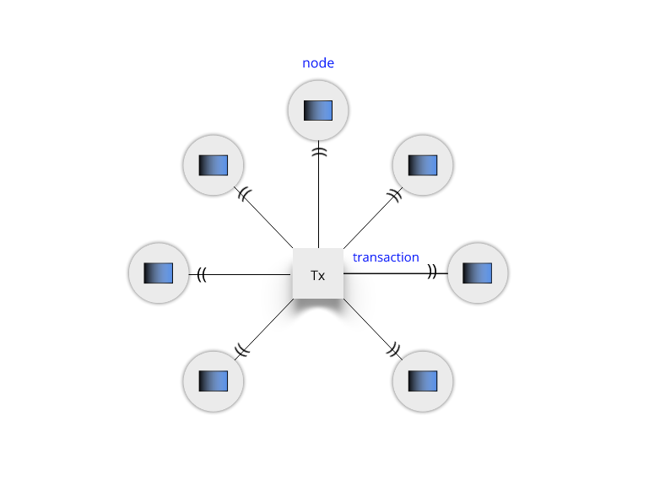

*Fig 3.1 Architecture of Blockchain*

### 3.1.1 Blockchain Based voting

Blockchain technology’s main use case was initially financial transactions, but it has since expanded to serve other functions. As a secure network, a blockchain can be very useful for any type of data transmission operation. One potential use case is for voting, which traditionally involves casting paper ballots in person. In recent years, some voices have been calling for a shift to digital voting methods like blockchain voting. In fact, some governments have already tried using it, including the US states of West Virginia in the [2018 midterm elections](https://www.washingtonpost.com/technology/2018/11/06/west-virginians-countries-have-voted-by-mobile-device-biggest-blockchain-based-voting-test-ever/) and Utah in the [2020 Presidential election](https://www.govtech.com/products/utah-county-makes-history-with-presidential-blockchain-vote.html). After the COVID-19 pandemic forced many services to go digital, the debate around the concept of digital voting reached a whole new level.

5

**3.2 BLOCKCHAIN TRANSACTION PROCESS**

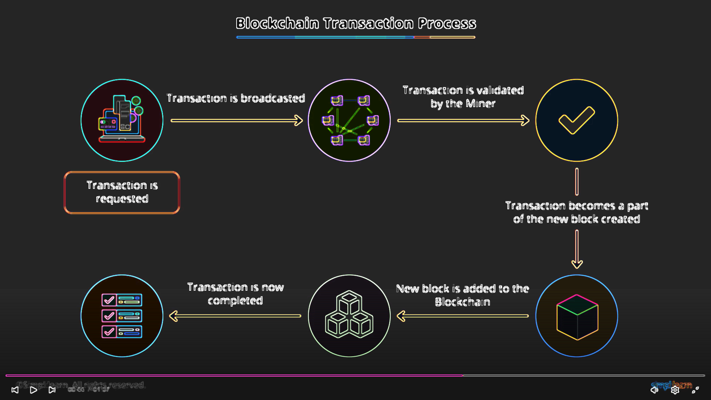

**.**

### 3.2.1 WHAT ARE THE POSSIBLE DOWNSIDES OF BLOCKCHAIN VOTING

There are still concerns about digital voting becoming the mainstream due to the security concerns that surround it. [Cybersecurity experts](https://www.computerworld.com/article/3430697/why-blockchain-could-be-a-threat-to-democracy.html) believe that implementing blockchain is not enough to prevent the other risks that come with digital voting. The issues surrounding online voting can include malware on a client’s device, server penetration attacks and denial of service attacks which can mean that computers with these issues could affect the vote overall and in turn, the way that the ballots are counted. If blockchain was implemented as the main source of voting it could still be manipulated and be open to cyber-attacks and many people, including those in politics, are very sceptical about it and would prefer more traditional methods.

.

### 

### 3.2.2 HOW ELSE CAN BLOCKCHAIN BE UTILISED

Although the use of blockchain within voting is seemingly an advantage, there are still other ways that this technology can be used for decision making and in turn simplify and secure smaller votes and elections. Outside of politics, the use of blockchain within a corporate setting could still very much ensure that a fair playing field is encouraged. The use of blockchain is becoming more and more popular across many different sectors and countries and there are ways it can still be creatively and effectively utilised.

### 3.2.3 HOW BLOCKCHAIN BASED VOTING SYSTEM CAN FACILITATE SIMPLE, SECURE AND EFFICIEWNT ELECTIONS?

1. [Conducting elections during pandemic](https://blog.accubits.com/blockchain-based-voting-system/#section-1)
2. [Drawbacks of traditional voting systems](https://blog.accubits.com/blockchain-based-voting-system/#section-2)
3. [Using blockchain voting systems for safer elections](https://blog.accubits.com/blockchain-based-voting-system/#section-3)
4. [Voting options in a blockchain voting system](https://blog.accubits.com/blockchain-based-voting-system/#section-4)
5. [A potential approach for implementing a blockchain voting system](https://blog.accubits.com/blockchain-based-voting-system/#section-5)
6. [Benefits of blockchain voting systems](https://blog.accubits.com/blockchain-based-voting-system/#section-6)
7. [Examples](https://blog.accubits.com/blockchain-based-voting-system/#section-7)

## 3.3 How Does a Voter Cast a Blockchain-based Vote?

1. A voter downloads the relevant blockchain voting program, registers, and proves their citizenship.
2. The blockchain records and encrypts the voter’s credentials on its network with the voter’s public key.
3. A ballot token is deposited into the voter’s wallet on the network.
4. To cast a vote, the voter sends the token to the address or wallet corresponding to the candidate or party they wish to vote for. Each token represents one vote.
5. To determine the winner, the counting staff members check and compare the number of tokens in the addresses

.

## 3.3.1 ARCHITECTURE OF DECENTRALIZED VOTING SYSTEM USING BLOCKCHAIN

## See the source image

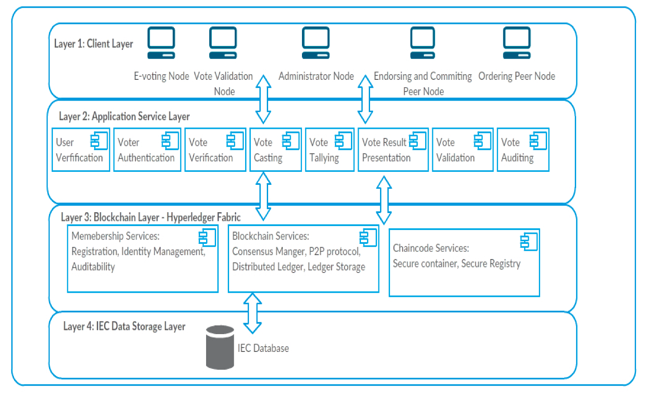

Fig 3.3.2: LAYERS Of BLOCKCHAIN BASED VOTING

**Client layer**: This layer contains the various electronic devices and systems with which users interact with the blockchain e-voting system. These devices are the peer nodes of the e-voting blockchain that interact via smart contracts, referred to as "chaincode" in the Hyperledger Fabric. The different types of peer nodes and their assigned responsibilities are:

* 1. E-Voting nodes: The primary purpose of these nodes is to enable voters authentication and casting of votes, and to ensure that all blockchain transactions are recorded. Informatics 2020, 7, 16 8 of 22
  2. Administrator nodes: These nodes are used to configure blockchain network channels, assign roles to the nodes of the blockchain, grant permissions, and set the level of access control for specific nodes.
  3. Public nodes: These are the nodes that enable view-only public access to transact tions of the e-voting blockchain.
  4. Vote validation: These nodes are responsible for vote validation. They are also used to ensure the authenticity of transactions that are included in a block.
  5. Committing nodes: These are the nodes that validate and commit new blocks to the blockchain.

**Application Service Layer**: This consists of a set of services that are available in the e-voting system. The level of access control and the defined permissions level determines the type of services that a node can access in the blockchain.

**Blockchain Layer**: This is composed of the Hyperledger Fabric V2.0, which is a modular blockchain architecture framework that facilitates blockchain information system solutions. It supports the creation of permissioned blockchain networks that have in-built properties such as security, and privacy protection [37]. The Hyperledger Fabric has “ordering nodes” which ensures consistency of the blockchain by ensuring that only ordered blocks of an endorsed transaction are made available to the committing peer nodes before they are added to the blockchain [37].

**IEC Data Storage Layer**: This contains the relevant databases that store information on the profile of registered voters, political offices being contested for, and all political candidates. This database is used as the basis to authenticate and authorise voters to vote.

## 3.4.1 What Are the Advantages of Blockchain Voting?

## Convenience and accessibility:With blockchain voting, people can vote via their computers or phones instead of visiting a polling location.

## Error reduction: In analog voting, voters must trust poll workers, the counting staff, and the independent observers for the proper handling and counting of votes.

## Efficiency: Current voting systems involve hand counting and mechanical counting, which take time and resources.

## 3.4.2 What Are the Disadvantages of Blockchain Voting?

## The public nature of the ledger: A voter can show a third party where they sent their coins or tokens as proof of how they voted. This opens up possibilities for a third party to buy votes or coerce voters to vote a certain way.

## Denial-of-service attacks: Attackers may try to disrupt network connectivity during the election period to prevent votes from being cast and validated in time.

## CHAPTER 4

## PROBLEM DEFINITION

## 4.1 Online voting is a trend that is gaining momentum in modern society. It has great potential to decrease organizational costs and increase voter turnout. It eliminates the need to print ballot papers or open polling stations-voters can vote from wherever there is an Internet connection. Despite these benefits, online voting solutions are viewed with a great deal of caution because they introduce new threats. A single vulnerability can lead to large-scale manipulations of votes. Electronic voting systems must be legitimate, accurate, safe, and convenient when used for elections. Nonetheless, adoption may be limited by potential problems associated with electronic voting systems. Blockchain technology came into the ground to overcome these issues and offers decentralized nodes for electronic voting and is used to produce electronic voting systems mainly because of their end-to-end verification advantages. This technology is a beautiful replacement for traditional electronic voting solutions with distributed, non-repudiation, and security protection characteristics. The following article gives an overview of electronic voting systems based on blockchain technology. The main goal of this analysis was to examine the current status of blockchain-based voting research and online voting systems and any related difficulties to predict future developments. This study provides a conceptual description of the intended blockchain-based electronic voting application and an introduction to the fundamental structure and characteristics of the blockchain in connection to electronic voting. As a consequence of this study, it was discovered that blockchain systems may help solve some of the issues that now plague election systems. On the other hand, the most often mentioned issues in blockchain applications are privacy protection and transaction speed. For a sustainable blockchain-based electronic voting system, the security of remote participation must be viable, and for scalability, transaction speed must be addressed. Due to these concerns, it was determined that the existing frameworks need to be improved to be utilized in voting systems.

### 

### APPLICATION OF BLOCKCHAIN

### ****Supply Chain Management****

Blockchain has the unique ability to enhance the overall efficiency of the supply chain. Blockchain provides accurate identification of the location of items on the supply chain. Thus removing the need for paper-based trails. This paperless approach of the Blockchain helps prevent data damage and misplacement. Blockchain also helps in monitoring the quality of products during production.

### ****Digital Identification****

With an estimate of more than 1 billion people worldwide with no identity, Microsoft is working on creating IDs to empower poor people and refugees. This is going to help in connecting them with the formal financial sector. Microsoft aims to achieve this through its Authenticator app, which would be based on Blockchain tech. Authenticator doesn’t just use passwords. Authenticator uses multiple layers of security that use a code or token to identify the returning user or device. Digital ID is an ideal way for users to take control of their digital identity.

### ****Healthcare System****

The patient is the central point of the healthcare ecosystem. The patient should also get accurate information about their health status and various procedures performed. The accuracy of a patient’s medical history can be seen as a matter of life and death. Privacy and security of health data are crucial. Blockchain tech can keep track of serial and batch numbers of prescription drugs. Hospitals have moved away from paper for record-keeping, and they use blockchain technology to store patient data, which is kept confidential. The patient will be given a digital ID or a number key to access these records. Thus, Blockchain gives the patient control over who can see that data. The patient’s diagnosis can also be stored so that the patient’s health history can be tracked.**Food Safety & Security**Blockchain in food security is an interesting use. Blockchain has the ability to trace your food from its origin to your plate. Using the immutable nature of Blockchain, the movement of food products from their origin to the supermarket can be traced. The source of the contaminant can be traced quickly and accurately in the case of foodborne illnesses.

### ****Copyright, Royalty and Trademark Security****

Copyright, trademark, and ownership laws on music, videos, blogs, and other online content give the original creator the recognition needed. They are a must in today’s technologically advanced era. Blockchain can make these laws secure through blockchain technology. Digital content download is a good option as it ensures that the artist or creator of the content also gets their fair share. The Blockchain will also provide real-time and authentic royalty distribution data to content creators and musicians.

### ****Digital Voting****

Voter fraud is a major concern. Blockchain has the ability to eliminate this concern. Blockchain can make your vote truly count with its immutable nature. The use of Blockchain will make voting transparent, and the regulators will easily catch any changes to the network. Blockchain has created a token-based system that will ensure a system of one irrevocable vote per person.

### ****Will or Inheritance****

Wills or inheritances have been recorded on paper until now. These paper documents can now be replaced with digital ones created and stored using blockchain networks. Will or Inheritance can be used with smart contracts because it will make the document legally binding. Thus, bringing clarity about what assets must be acquired by whom or distributed to whom in a particular scenario.

### ****Real Estate Security****

Ownership and title details are safely stored on the Blockchain, making it easy to transfer ownership and trace ownership. Blockchain removes physical paper from the equation, and it gives a clear view of legal ownership. Titles stored on the blockchain network can be viewed, changed, and updated whenever necessary. A secure Digital ID can be used to access the documents without worrying about the safety and security of the documents.

### ****Data Sharing****

Introduced and developed by IOTA Foundation, a distributed ledger technology involves using Blockchain to share or sell unused data. Enterprises’ unused data bundles can be sent to the places that need them most. Blockchain can also be used as a marketplace to store data that can be used to improve many industries.

### ****Safe Weapon Tracking****

Blockchain technology can enable the government and law enforcement to track weapon or gun ownership. Blockchain can act as an immutable and transparent registry. Blockchain will also help in keeping

### 

### CONCLUSION

In this paper, I proposed and discussed Blockchain and its Blockchain based voting. This is a wide area for researcher in election field. A lot of research work has been done and is still being done in this field using blockchain technology. More and more researchers are attracted to this challenging field. Each stage of E-voting has its own significance and should be designed properly for better results.

## REFERENCES

### P. A. Azocar, "Youth voter participation: involving today's young in tomorrow's democracy", International IDEA Stockholm, 2019.

### V. C. Eze and K. Obono, "The influence of internet use on the political participation of youth in ikeja lagos", Journal of Pan African Studies, vol. 11, no. 6, 2018.

### Ajit Kulkarni, "How to Choose Between Public And Permissioned Blockchain For Your Project" in Chronicled, 2018.

### X. Zou, H. Li, F. Li, W. Peng and Y. Sui, "Transparent auditable and stepwise verifiable online e-voting enabling an open and fair election", Cryptography, vol. 1, pp. 13, 08 2020.

### D. K. N and R. Bhakthavatchalu, "Parameterizable FPGA Implementation of SHA-256 using Blockchain Concept", 2019 International Conference on Communication and Signal Processing (ICCSP), pp. 0370-0374, 2019.

### Y. Zhang, Y. Li, L. Fang, P. Chen and X. Dong, Privacy-protected Electronic Voting System Based on Blockchin and Trusted Execution Environment, 2020.

### J. Demuro, "Here Are the 10 Sectors That Blockchain Will Disrupt Forever", TechRadar Pro, Jan. 2018, [online] Available: <https://www.techradar.com/news/here-are-the-10-sectors-that-blockchain-will-disrupt-forever>.

### W. Zhang et al., "A Privacy-Preserving Voting Protocol on Blockchain", IEEE International Conference on Cloud Computing CLOUD, 2021.