

What is constructor?

Rules for Defining a constructor

Constructor overloading

**What is constructor?**

Constructors are definition blocks in java which is used to initialize non-static variables.

**Constructor:**

1. Used to create an object.
2. Used to initialize non-static variables.

**Rules for defining a constructor**

* The constructor name should be same as class name.
* It should not have return type.
* It can have parameters.
* It can contain all java legal statements except return statement i.e. we cannot have return in constructor.



Here new keyword calls the constructor. Constructor creates the object. d1 is the reference variable of type Demo and the Demo class object is assigned to d1. If we print d1 (ref var) we get the address of the object it is referring. You cannot create an object without a class (new is a keyword).

**Example**

class Constructor{

int i, j;

Constructor(){

i=100;

j=200;

}

}

class Demo{

public static void main(String args[]){

Constructor c1 = new Constructor();

System.out.println(“i=”+c1.i);

System.out.println(“j=”+c1.j);

}

}

Constructor does not have a return type and we can have a method with same name as class.

Example

class Demo{

Demo(){ //Constructor

}

void Demo(){ //Method

}}

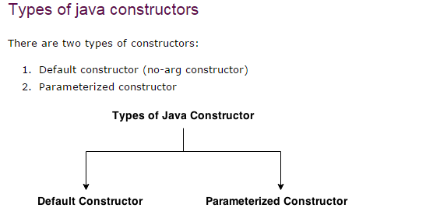

1. **Default Constructor**

The constructor which created by compiler is called

Default Constructor. In java, every class in java should contain at least one constructor. If not, the compiler writes constructor in the class which is known as “**Default Constructor”**.

Example:

class DefaultConstructor{

pubic static void main(String args[]){

DefaultConstructor dc = new DefaultConstructor();

}

}

Compiler:

DefaultConstructor(){

}

1. **Parameterized Constructor**

The constructor with argument or the constructor that have parameters is called Parameterized Constructor.

Parameterized constructor is used to provide different values to the objects.

Example:

class ParameterizedConstructor{

int i;

int j;

ParameterizedConstructor(int valOfI, int valOfJ){

i=valOfI;

j=valOfJ;

}

void display(){

System.out.println(“Value of i: “+i);

System.out.println(“Value of j: “+j);

}

public static void main(string args[]){

ParameterizedConstructor pc = new ParameterizedConstructor(); //compile time error.

ParameterizedConstructor pc1 = new ParameterizedConstructor(10,20);

ParameterizedConstructor pc2 = new ParameterizedConstructor(30,40);

}

}

**Constructor Overloading**

When we have more than one constructor for a class we call it as constructor overloading.

**Note:** When you overload the constructor the number of argument should be different OR types of argument should be different OR sequence of argument should be different.

Example:

**class** ConstructorOverloading{

**long** i;

**long** j;

/*ConstructorOverloading(){

System.out.println(“No argument constructor”);

i=10;

j=20;

}*/

ConstructorOverloading(**int** k){

System.***out***.println("Number of argument is different");

i=k;

}

ConstructorOverloading(**int** a, **int** b){

i=a;

j=b;

}

ConstructorOverloading(**long** a, **long** b){

System.***out***.println("Type of argument is different");

i=a;

j=b;

}

ConstructorOverloading(**int** a, **long** b){

i=a;

j=b;

}

ConstructorOverloading(**long** a, **int** b){

System.***out***.println("sequnce of argument is different");

i=a;

j=b;

}

**public** **static** **void** main(String args[]){

//ConstructorOverloading co1=new ConstructorOverloading();

//System.out.println(co1.i + " " + co1.j);

ConstructorOverloading co2=**new** ConstructorOverloading(10);

System.***out***.println(co2.i + " " + co2.j);

ConstructorOverloading co3=**new** ConstructorOverloading(10,20);

System.***out***.println(co3.i + " " + co3.j);

ConstructorOverloading co4 = **new** ConstructorOverloading(10l,20l);

System.***out***.println(co4.i + " " + co4.j);

ConstructorOverloading co5 = **new** ConstructorOverloading(10,20l);

System.***out***.println(co5.i + " " + co5.j);

ConstructorOverloading co6 = **new** ConstructorOverloading(20l,10);

System.***out***.println(co6.i + " " + co6.j);

}

}

Output:

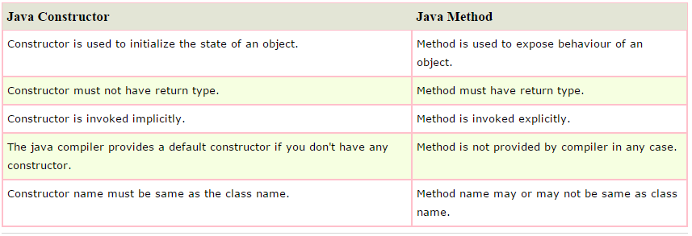

**Why we need to create our own constructor**

If we need to create an object of a class based on specific criteria then we need to create our own constructor