Homework 6

Name: Weicheng Zhang JHID: wzhang81

A1:

Code:

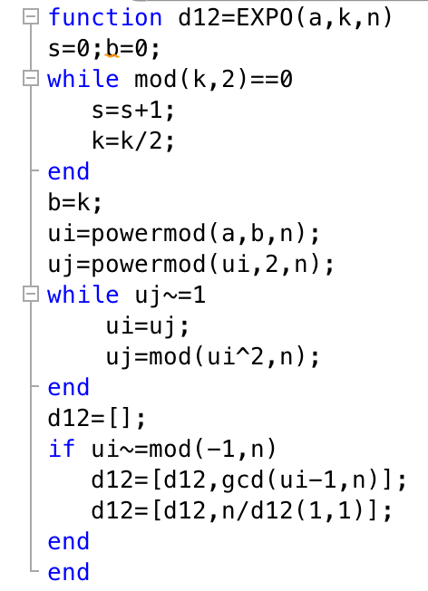

Result:

