REA: Explain It to a Friend
The idea, the workflow, and an honest demonstration
Prepared for Sam4d
18 October 2026

Contents and reading map
- 1. The idea in one conversation
- 2. The six things people often confuse
- 3. What “reverse engineering” means
- 4. Why evidence matters more than confidence
- 5. What is realistic for apps and games
- 6. A five-minute demonstration for friends
- The workflow at a glance
- What to say to the AI
This short companion explains the same repository as the complete technical handbook. It refers to source snapshot 4ac52b2a994826057504ccbad4ca3a6d4dd74190 and includes no claim that a specific third-party product has already been recreated.

1. The idea in one conversation
Imagine you like a feature in an app and want to understand how it works. A screenshot shows its appearance, but not its data model, failure handling, animation timing, or hidden dependencies. REA gives a coding AI a collection of inspection instruments so it can investigate the actual software and keep evidence of what it finds. The fork adds instructions for carrying that investigation through a reconstruction rather than stopping at a casual explanation.
A useful analogy is a workshop. The AI is the engineer deciding what to investigate and build. REA is the instrument bench: readers for packages and binaries, tools for observing supported runtimes, tools for comparing observations, and a notebook that preserves evidence. External engines such as Ghidra are specialised machines that can be connected to that bench. The recreated application is a separate project built using the findings.
There is no universal “copy application” button. Saying recreate X supplies an objective. The agent still has to identify X, obtain access, examine its accessible behaviour, choose an implementation, build it, and check differences. A missing reference app, unavailable server, or absent art asset remains missing until something supplies it.
A thirty-second explanation you can reuse: “REA helps a coding AI inspect software and retain evidence about how it works. My version adds a disciplined recreate-X workflow: research the whole accessible product, build it in stages, and compare the result with the reference. It is an engineering toolkit and working method, not a guarantee that every app can be copied exactly.”
Sources: README.md; RECREATE.md; .agents/skills/reverse-engineer-anything/SKILL.md.

2. The six things people often confuse
Thing | Everyday meaning | What it does here
AI model | The reasoning engine | Understands requests, plans experiments, writes and reviews code within its available tools
Coding agent | The model plus a working environment | Can inspect files, run commands, edit code, and use registered tools
REA CLI | A toolbox operated from a terminal | Runs an inspection or workflow and returns results
REA MCP server | The toolbox exposed through a standard tool interface | Lets a connected agent call REA operations using structured inputs
Skill/instructions | The workshop manual | Guides when and how the agent should use tools and perform recreation work
Analysis engine | A specialised instrument | Supplies native decompilation or other target-specific capabilities
Installing a skill does not register an MCP server. Starting a server does not install every analysis engine. Reading a prompt does not change model weights. A model that has no shell, browser, repository access, or connected tools cannot acquire those powers merely by being told to investigate deeply.
The practical consequence is simple: first give the agent a working environment and access to the reference. Then give it the objective and workflow. Judge progress by files, running software, captures, tests, and measured comparisons rather than by confident wording.
Sources: the packaged skill’s connection/recovery guide; docs/installation.md; src/main.ts; src/cli.ts.

3. What “reverse engineering” means
Reverse engineering means learning the structure or behaviour of a system from available evidence. With source code, the investigation can follow functions and data directly. With a shipped application, it may inspect packaged resources, module relationships, metadata, machine code, or runtime observations. These approaches answer different questions.
Static inspection reads an artifact without running the target application. It can show imports, declared resources, embedded metadata, or instructions. Dynamic observation examines an actual run. It can show that a particular input caused a particular output in a particular environment. Neither automatically covers every possible input or runtime path.
For example, a search icon proves that an icon exists. A function named search suggests a possible role. A recorded search interaction establishes one observed behaviour. A test that replays a sequence of queries and checks result ordering, persistence, errors, and timing provides stronger comparison evidence. REA’s architecture is built around preserving these differences.
Reconstruction is the next step: use the findings to build a working implementation. Decompilation may help explain logic, but it does not automatically recover original names, comments, tests, cloud services, source control history, textures, animation source files, or design intent.
Sources: docs/cli.md; docs/javascript-artifact-reconstruction.md; src/domain/evidence.ts.

4. Why evidence matters more than confidence
Suppose the AI says, “The app stores settings locally.” Ask what supports that statement. Did it find a string containing a path? Did it read the code that writes the settings? Did it change a setting, restart the app, and observe the saved state? These are different levels of support.
REA records observations with identity and provenance. A digest identifies bytes; locations indicate where facts came from; provider and environment information explain how they were obtained. Unknowns remain explicit. The AI can then say, “This was observed in version A under scenario B,” rather than silently generalising to every version and situation.
A cryptographic hash is a fingerprint, not a truth detector. Matching hashes show that the retained file matches the recorded fingerprint. They do not prove that a screenshot was taken from the claimed application or that a test result was honestly produced. Human review and meaningful runtime comparisons still matter.
The fork’s workbench adds an approachable project ledger on top of this idea. It tracks the requested product, scope, architecture, remaining unknowns, and requirements with reference, implementation, and test artifacts. REA’s native authenticated Evidence tools remain the stronger record system for REA-produced observations.
Sources: src/domain/evidence.ts; src/application/investigation/EvidenceLedger.ts; scripts/recreate.mjs.

5. What is realistic for apps and games
For an accessible web or desktop app, an agent can map screens, reproduce workflows, reconstruct data behaviour, compare screenshots, and iteratively improve the implementation. Accuracy depends on the quality and breadth of the reference evidence. A convincing landing page does not establish that account handling, offline behaviour, import/export, background processing, or error recovery works.
Games add more systems: simulation timing, input response, camera movement, collision, AI, lighting, materials, animation, sound, content, save/load, and possibly networking. Two screenshots can look similar while the games feel very different. Conversely, equivalent game rules can produce visibly different frames because the art, renderer, camera, or timing differs.
An exact commercial-game reconstruction cannot be promised from a title alone. Missing assets, proprietary runtimes, inaccessible services, nondeterminism, platform restrictions, and incomplete observations are material limitations. The workflow handles this by recording what was inspected and measured, separating replacements from recovered assets, and keeping unverified claims open.
The point of the fork is to make shallow completion harder to pass off as finished work. It is still the agent and developer’s responsibility to perform the investigation and produce the evidence.
Sources: .agents/skills/reverse-engineer-anything/references/recreation-workflow.md; RECREATE.md.

6. A five-minute demonstration for friends
Use a small application you own or a redistributable example. Avoid beginning with a huge game or a private service requiring several accounts. Show the original app and choose one journey, such as creating, searching, editing, and reopening a note.
Explain the reference: “These are the inputs and outcomes we will compare.” Start an investigation workspace, show the initially pending requirements, and let the agent inspect the source or supplied artifact. Show how findings and unknowns are written down. Build a small vertical slice, then demonstrate the same journey in the reconstruction.
Next, show a deliberate difference. Perhaps the reconstructed app forgets a note after restarting, or returns search results in the wrong order. A useful comparison should detect that mismatch. Fix it and rerun the check. This teaches what engineering validation means more clearly than showing a long list of successful shell commands.
End with the coverage ledger. Point to verified work and open gaps separately. The demonstration is successful if your friends understand how investigation, implementation, and testing connect—not if they believe the AI has become an infallible software copier.

The workflow at a glance
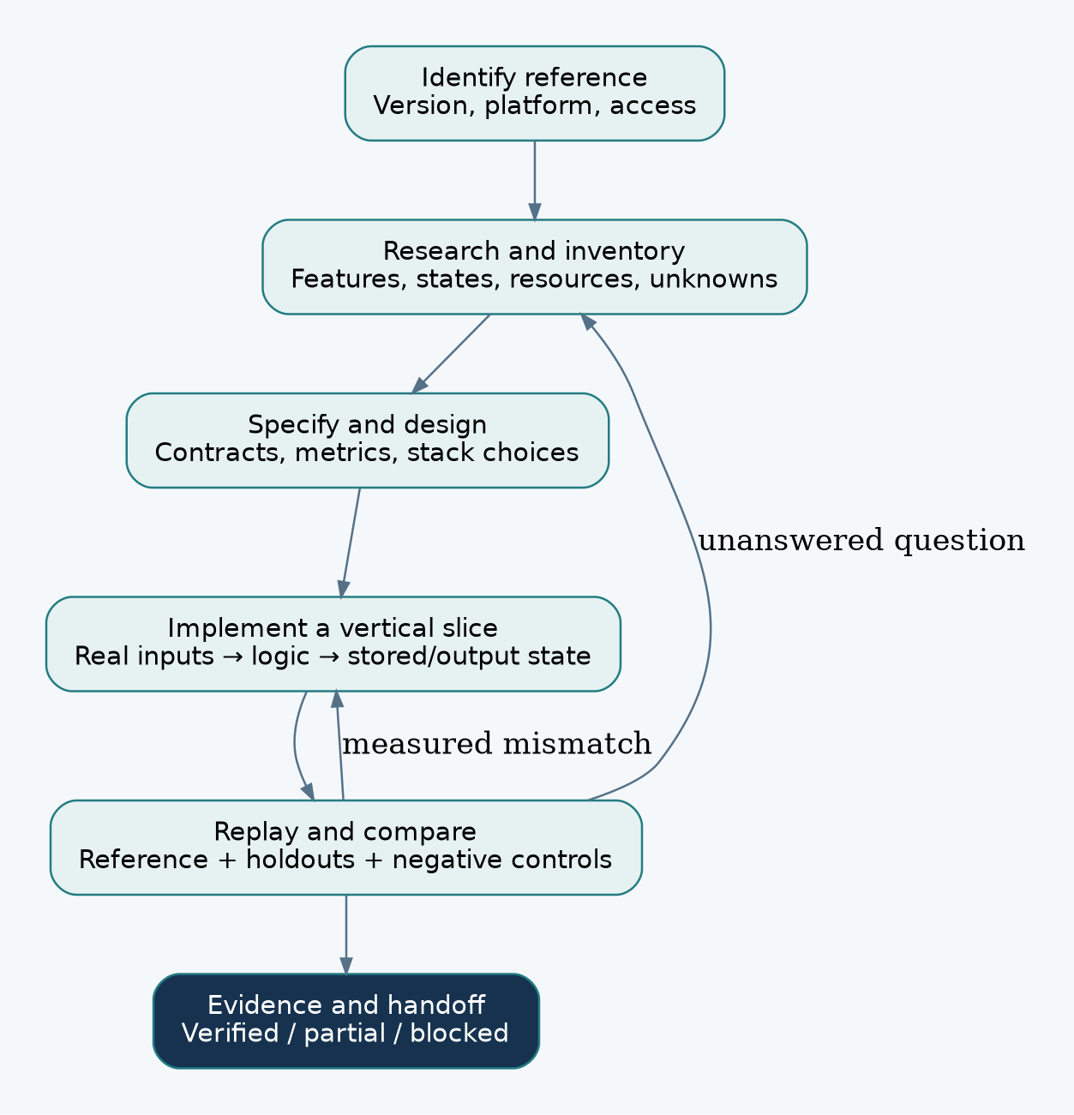
Research, implementation, and comparison

What to say to the AI
Recreate X from [the exact URL, source, package, or local reference].
Follow RECREATE.md. Research the full accessible product, implement it,
and compare behaviour, visuals, motion, and performance against evidence.
Keep the research and handoff current, and report gaps honestly.
Open the customized Sam4d/REA repository in a coding agent, or generate its portable instruction attachment using node scripts/recreate.mjs prompt. The AI still needs tools and access to the target. For installation, architecture, game engineering, testing, and the complete file/tool catalogs, use the main handbook.

