1. **Task Description**

The task involved developing a Todo List application using React and Redux. The application allows users to add, edit, complete, and remove tasks. It also includes a theme toggle feature to switch between light and dark modes. The app is styled using CSS and supports responsive design for various screen sizes.

1. **Task Output Screenshot**

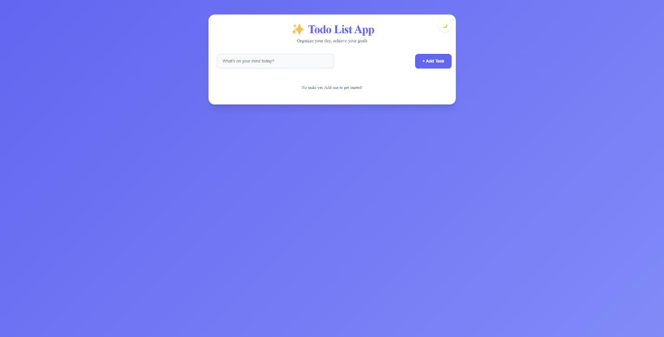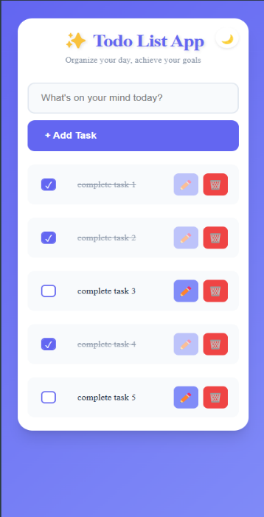

1. **Widget/Algorithm Used In Task**

* TodoList component for managing and displaying the list of todos.
* ThemeToggle component for switching between light and dark themes.
* App component as the main entry point of the application.