1. **Task Description**

The project is a web application built using React, which showcases a portfolio of projects. It includes several pages such as Home, Projects, About, and Contact. Each page is designed to provide a unique user experience with animations and responsive design. The application is structured to highlight various projects, provide information about the developer, and offer a way to contact the developer.

1. **Task Output Screenshot**

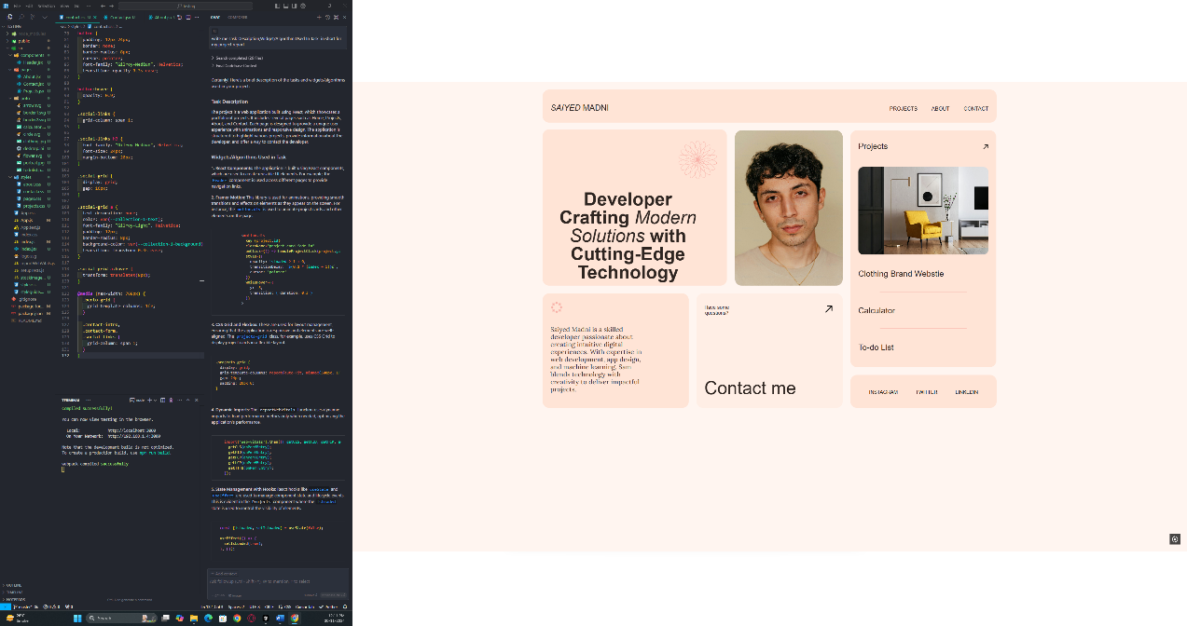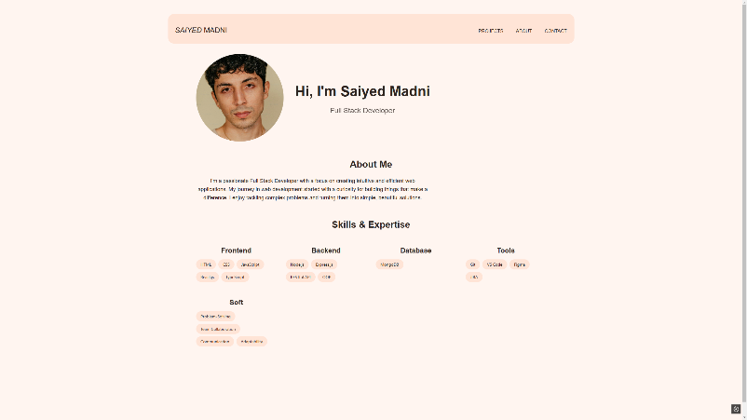

1. **Widget/Algorithm Used In Task**

* **React Components**: Modular and reusable UI elements that form the building blocks of the application.
* **Framer Motion**: A library for creating smooth animations and transitions to enhance user interaction.
* **CSS Grid and Flexbox**: Layout techniques used to create responsive and flexible designs across different screen sizes.
* **Web Vitals**: A set of metrics integrated to measure and report the performance of the web application.
* **React Router**: A library for managing client-side routing, allowing navigation between different pages without reloading.