1. **Task Description**

The task involves developing a React application that demonstrates pagination functionality. The application displays a table of user data with pagination controls, allowing users to navigate through multiple pages of data.

1. **Task Output Screenshot**

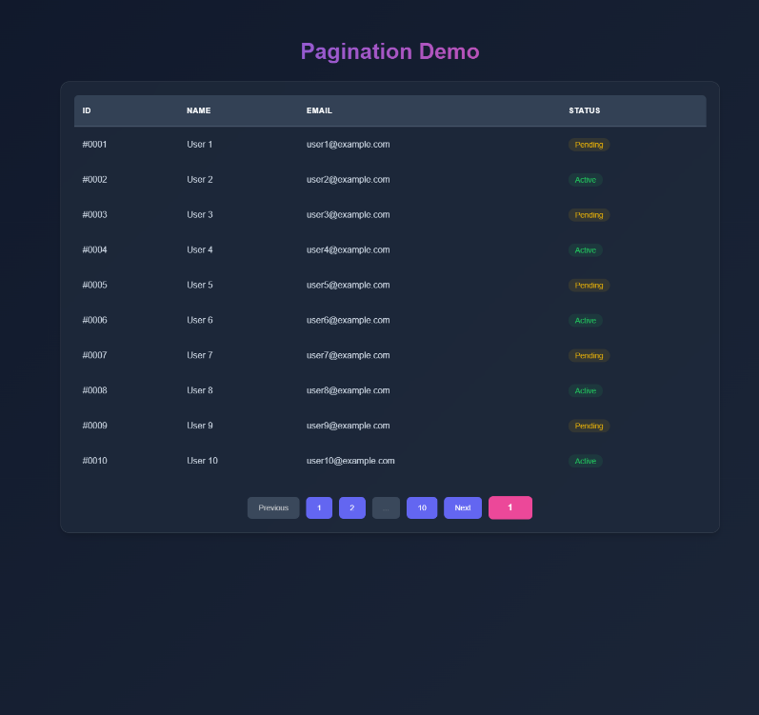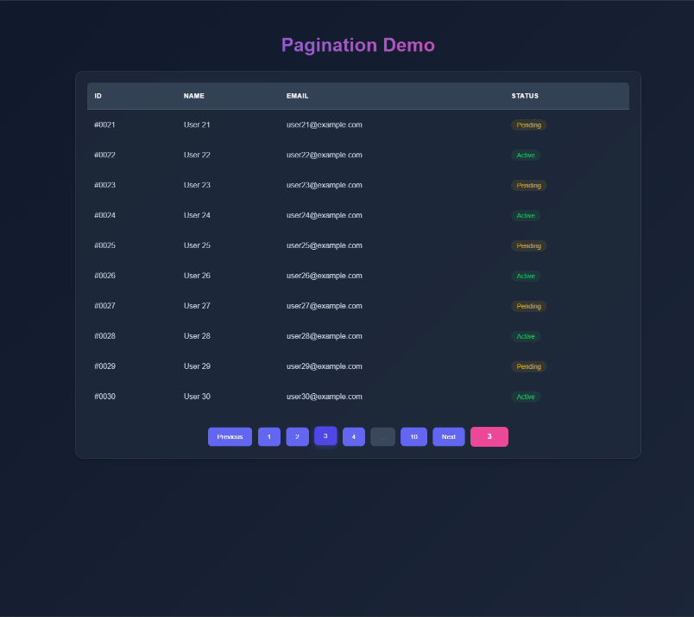

1. **Widget/Algorithm Used In Task**

* App: Main component that initializes the application and passes data to the Table component.
* Table: Displays user data in a paginated table format.
* Pagination: Provides pagination controls to navigate through pages.