1. **Task Description**

The task involves developing a role-based authentication dashboard application using React. The application provides different functionalities based on user roles, such as admin, user, and manager. It includes features like user management, notifications, and settings customization.

1. **Task Output Screenshot**

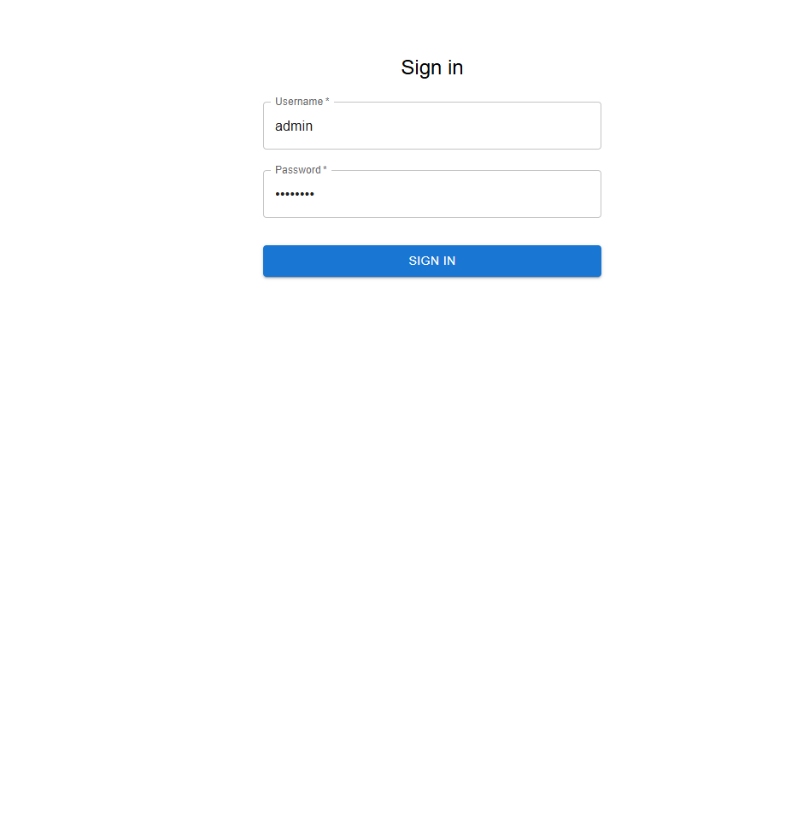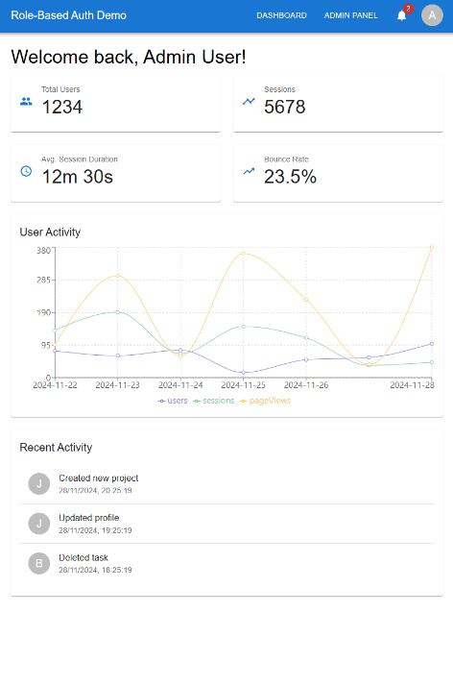

1. **Widget/Algorithm Used In Task**

* Implemented using React Context API to manage user sessions and roles.
* Protected routes are created to restrict access based on user roles.
* Provides real-time notifications using a custom notification service.
* Admin panel for managing users, including adding, updating, and deleting users.