1. **Task Description**

Develop a simple calculator application using React that allows users to perform basic arithmetic operations. The application should have a user-friendly interface with buttons for digits, operators, and functions like clear, toggle sign, and backspace. The calculator should also handle keyboard inputs for a seamless user experience.

1. **Task Output Screenshot**

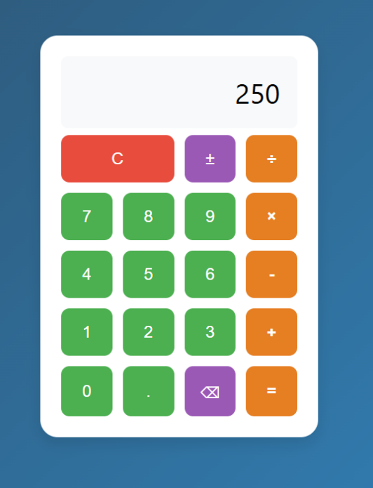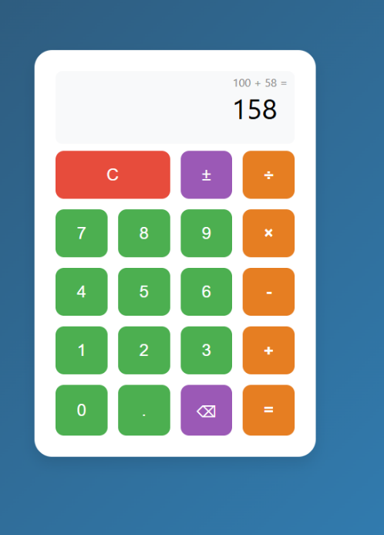

1. **Widget/Algorithm Used In Task**

* Calculator: Main component managing the state and logic of the calculator.
* Button: Reusable button component for calculator keys.
* useState: Used to manage the display, operands, operator, and other states.
* Functions to handle addition, subtraction, multiplication, and division.