[Name of procedure component 8.l: Implicit Association Test (IAT), (‘Black – White’ IAT)]
Description of the IAT task & Procedure:
The IAT is a stimulus-sorting visual task) administered via the iatgen software that allows for online administration of the IAT via Qualtrics.
[A demonstration of the survey can be found here: https://implicit.harvard.edu/implicit/Study?tid=-1 ]
[The Qualtrics javascript file is included in this zip folder, as well as stored in the public iatgen GitHub repository: https://github.com/iatgen/iatgen ]
Stimuli are presented in seven counter-balanced blocks in which participants were tasked with sorting valenced words and photos of White/Black faces into either pleasant/unpleasant categories as quickly as possible. Below is a screenshot example of one such trial:
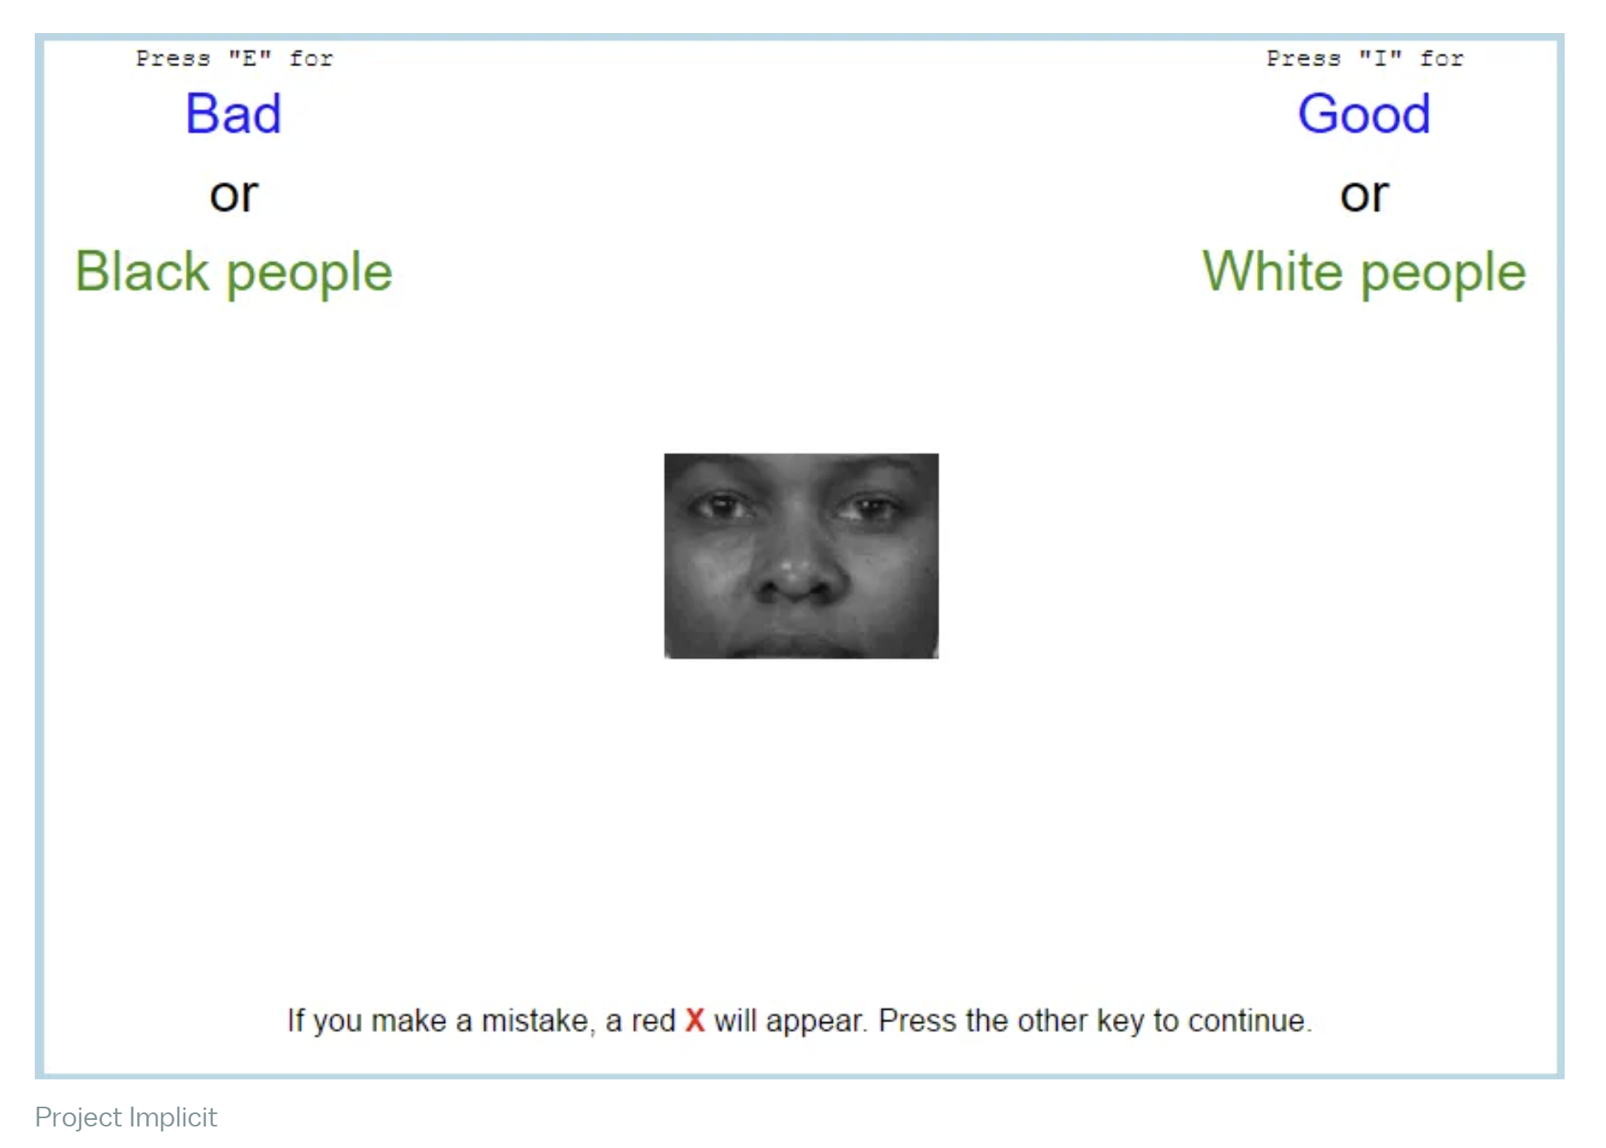

Instructions for participants:
In this study you will complete an Implicit Association Test (IAT) in which you will be asked to sort pictures and words into groups as fast as you can. In this IAT, you will be asked to categorize White and Black faces as well as positive and negative words.
In addition to the IAT, there are some questions about your beliefs, attitudes, and opinions, and some standard demographic questions. This study should take about 10 minutes to complete.

