Sam Allen

Knock Knock Joke CS120 Project

8/22/2024

This project is designed to create a knock knock joke using inputs from the user and if/elif conditions to output a suitable response.

Joke:

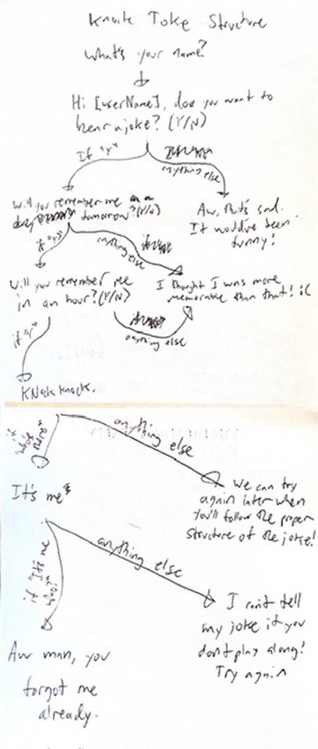

List of variables:

Create and store player’s name in variable {userName}

Create and store player’s answer to “Do you want to hear a joke” in variable {wantJoke}

Create and store player’s answer to “Will you remember me tomorrow” in variable {rememberTomorrow}

Create and store player’s answer to “Will you remember me in an hour” in variable {rememberHour}

Create and store player’s answer to” knock knock” in variable {knock}

Create and store player’s answer to “It’s me” in variable {me}

Psuedocode:

Create variable [userName] and store player’s response

Create variable [wantJoke} and ask user if they want to hear a joke.

If their response starts with a y, move to next step. If their response does not start with a y, print “Aw, that’s sad. It would’ve been funny.

Create variable {rememberTomorrow} and ask user if they’ll remember me tomorrow.

If their response starts with a y, move to next step. If their response does not start with a y, print “I thought I was more memorable than that.”

Create variable {rememberHour} and ask user if they’ll remember me in an hour.

If their response starts with a y, move to next step. If their response does not start with a y, print “I thought I was more memorable than that.”

Create variable {knock} and ask user “Knock knock”

If their reply is some version of “Who’s there?” move to next step. If their response is not, print “We can try again later. Try saying’“Who’s there?’”

Create variable {me} and say to user “It’s me”

If their reply is some version of “It’s me who?” move to next step. If their response is not, print “I can’t tell you my joke if you don’t play along! Try saying ‘It’s me who?’”

Print “Aw man, I can’t believe you forgot about me already.”