MINI-PROJECT REPORT
ENTERPRISE IT & CORPORATE FACILITIES SERVICE
PORTAL
A PROJECT REPORT SUBMITTED TO SRM
INSTITUTE OF SCIENCE & TECHNOLOGY
IN PARTIAL FULFILMENT OF THE REQUIREMENTS FOR THE AWARD
OF THE DEGREE OF
MASTER OF COMPUTER APPLICATION
SUBMITTED BY
SARASWATHI S
REG NO: RA2532241040036
UNDER THE GUIDANCE OF
Dr. J. ANITHA RUTH, M.S., Ph.D.
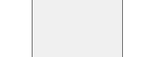
DEPARTMENT OF COMPUTER APPLICATIONS (MCA)
FACULTY OF LIBERAL ARTS BUSINESS STUDIES
SRM INSTITUTE OF SCIENCE AND TECHNOLOGY
VADAPALANI, CHENNAI
2026-2027

DEPARTMENT OF COMPUTER APPLICATIONS (MCA)
FACULTY OF LIBERAL ARTS BUSINESS STUDIES
SRM INSTITUTE OF SCIENCE AND TECHNOLOGY
VADAPALANI, CHENNAI
BONAFIDE CERTIFICATE
This is to certify that the project report titled “ENTERPRISE IT & CORPORATE FACILITIES SERVICE PORTAL” is authentic work done and submitted by SARASWATHI S (Reg. No: RA2532241040036) during 2025-2026 academic year, in partial fulfillment of the requirements for the award of the degree of MASTER OF COMPUTER APPLICATION, at SRM INSTITUTE OF SCIENCE & TECHNOLOGY, Vadapalani, Chennai.
Signature of the Guide | Signature of the HOD
Dr. J. ANITHA RUTH, M.S., Ph.D. | Dr. J. ANITHA RUTH, M.S., Ph.D.
Submitted for Project Work Viva-Voce Examination on ________________________
Place: VADAPALANI
Date:
INTERNAL EXAMINER EXTERNAL EXAMINER

iii
ACKNOWLEDGEMENT
I express my deepest sense of gratitude and sincere thanks to the Management and Dean, Faculty of Liberal Arts and Business Studies, SRM Institute of Science and Technology, Vadapalani, for providing the necessary facilities, academic environment, and infrastructure throughout the course of this project.
I wish to express my profound gratitude and heartfelt thanks to the Head of the Department, Dr. J. ANITHA RUTH, M.C.A., M.Phil., M.S., Ph.D., Department of Computer Applications (MCA), for her constant encouragement, administrative support, and valuable suggestions during the tenure of this work.
I convey my sincere indebtedness and heartfelt thanks to my project guide, Dr. A. MEENAKSHI, M.C.A., M.Phil., M.S., Ph.D., Department of Computer Applications (MCA), for her inspiring guidance, constructive criticisms, patient advice, and continuous motivation at every stage of the project.
I wish to place on record my heartfelt gratitude and sincere thanks to my Class Incharge, Dr. M. SIVASAKTHI, M.Sc., M.Phil., Ph.D., NET, Department of Computer Applications (MCA), for her continuous academic support, guidance, encouragement, and valuable advice throughout the duration of this project.
I also extend my sincere appreciation to all the faculty members and staff of the Department of Computer Applications for their cooperation and goodwill throughout the period of my study.
Finally, I express my deep heartfelt gratitude to my family members and friends for their endless support.
Signature of the Candidate
SARASWATHI S
REG NO: RA2532241040036

iv
ABSTRACT
This project report presents the design, implementation, and evaluation of an Enterprise IT & Corporate Facilities Service Portal—an intelligent, unified service desk platform engineered to streamline IT support requests, facility maintenance workflows, and emergency operations across enterprise environments. The system addresses common operational bottlenecks such as fragmented support channels, lack of real-time SLA visibility, manual ticket triage, and delayed emergency response by consolidating all service desk operations into a single web-based application.
The core platform incorporates an AI microservice built with Python FastAPI and Hugging Face Natural Language Processing (NLP) models (DistilBERT for category classification and RoBERTa for sentiment and urgency triage). As employees compose incident tickets, the NLP models perform real-time text inference to dynamically predict category, priority (P1 Critical to P4 Low), and assigned vendor teams before submission. The system features domain-filtered technician queues, live precision countdown SLA timers, and dual-channel cloud telephony with automated email alerts for P1 emergency incidents. Built using Spring Boot 3 Java backend, HTML5/CSS3/JavaScript frontend with glassmorphic aesthetic, H2/PostgreSQL database, and multi-role authentication with email OTP 2FA, the platform provides enterprise-grade performance, auditability, and user satisfaction.

v
TABLE OF CONTENTS
CHAPTER  NO. | TITLE | PAGE  NO.
 | ACKNOWLEDGEMENT | iii
 | ABSTRACT | iv
 | TABLE OF CONTENTS | v
 | LIST OF FIGURES | vi
1 | INTRODUCTION & OVERVIEW  1.1 ABOUT THE PROJECT  1.2 PROBLEM STATEMENT  1.3 ORGANIZATION OF THE PROJECT REPORT | 1  1  1  2
2 | TEAM COMPOSITION & WORK DIVISION  2.1 TEAM STRUCTURE & ROLE ALLOCATION  2.2 WORK DIVISION MATRIX | 3  3  4
3 | TECHNICAL MODULE IMPLEMENTATION & TEAM CONTRIBUTIONS  3.1 PRIMARY CONTRIBUTIONS — SARASWATHI S  3.1.1 GLASSMORPHIC DESIGN SYSTEM & THEME ENGINE  3.1.2 TECHNICIAN WORK QUEUE & SLA COUNTDOWN TIMERS  3.1.3 KNOWLEDGE BASE DEFLECTION & CSAT RATING MODAL  3.1.4 IT ASSET MANAGEMENT & CHANGE CONTROL MODALS  3.1.5 BLACK-BOX FUNCTIONAL & USABILITY TESTING  3.2 TEAMMATE CONTRIBUTIONS — SAM ANTROSE A H  3.2.1 SPRING BOOT 3 REST API & DATABASE LAYER  3.2.2 PYTHON FASTAPI AI MICROSERVICE (HUGGING FACE NLP)  3.2.3 MULTI-ROLE AUTHENTICATION & EMAIL 2FA OTP GATEWAY | 5  5  5  6  7  8  9  9  9  10  10
4 | SYSTEM DESIGN & DATA FLOW DIAGRAMS  4.1 SYSTEM ARCHITECTURE DIAGRAM  4.2 DATA FLOW DIAGRAM  4.2.1 DATA FLOW DIAGRAM LEVEL 0  4.2.2 DATA FLOW DIAGRAM LEVEL 1  4.2.3 DATA FLOW DIAGRAM LEVEL 2 | 11  11  12  12  12  13
5 | INPUT/OUTPUT SCREENS & VERIFICATION  5.1 AUTHENTICATION & 2FA VERIFICATION SCREEN  5.2 TICKET SUBMISSION & LIVE AI PREVIEW SCREEN  5.3 TECHNICIAN WORK QUEUE & SLA TIMERS SCREEN | 14  14  14  14
6 | TESTING & MODULE VALIDATION  6.1 UNIT TESTING  6.2 INTEGRATION TESTING  6.3 SECURITY & FALLBACK TESTING | 15  15  15  15
7 | CONCLUSION & FUTURE SCOPE | 16
 | APPENDIX | 17
 | REFERENCES | 21

vi
LIST OF FIGURES
S.NO | FIGURE NO. | FIGURE NAME | PAGE NO.
1 | 2.1 | WORK DIVISION & MODULE ALLOCATION MATRIX | 4
2 | 3.1 | GLASSMORPHIC CSS DESIGN TOKEN ARCHITECTURE | 5
3 | 3.2 | TECHNICIAN DOMAIN-FILTERED QUEUE LAYOUT | 6
4 | 3.3 | PRECISION SLA COUNTDOWN TIMER COMPONENT | 7
5 | 3.4 | KNOWLEDGE BASE SELF-SERVICE DEFLECTION ENGINE | 8
6 | 3.5 | SPRING BOOT BACKEND & DATABASE LAYER | 9
7 | 4.1 | OVERALL SYSTEM ARCHITECTURE DIAGRAM | 11
8 | 4.2 | DFD LEVEL 0 (CONTEXT DIAGRAM) | 12
9 | 4.3 | DFD LEVEL 1 (SERVICE DESK PROCESSES) | 12
10 | 4.4 | DFD LEVEL 2 (AI TRIAGE & SLA ENGINE) | 13
11 | 5.1 | AUTHENTICATION & 2FA VERIFICATION SCREEN | 14
12 | 5.2 | LIVE AI TRIAGE PREVIEW & WORK QUEUE SCREEN | 14

CHAPTER 1
INTRODUCTION & OVERVIEW
1.1 ABOUT THE PROJECT
The Enterprise IT & Corporate Facilities Service Portal is a unified web application engineered to automate service management across IT operations, facility maintenance, and corporate safety operations. Modern enterprise employees often struggle with unintuitive helpdesk tools, lack of SLA visibility, manual ticket routing, and tedious ticket submission forms.
This project delivers a responsive, modern glassmorphic web interface supporting role-based access for Employees, Technicians, and System Administrators. It features real-time ticket categorization, priority scoring, automated technician assignment, live countdown SLA timers, email 2FA authentication, and emergency voice dispatching.
1.2 PROBLEM STATEMENT
Standard corporate IT and facilities service desks struggle with key vulnerabilities:
1. Manual Triage Bottlenecks: Helpdesk teams manually classify hundreds of daily incoming tickets, delaying resolution times.
2. Fragmented Platforms: Employees must use separate portals for hardware repairs, software access, and HVAC facility issues.
3. Unmonitored SLA Breaches: Technicians lack real-time precision timers to prioritize high-urgency incidents.
4. Manual Emergency Reporting: Physical and server room emergencies rely on manual phone calls without automated tracking.
1.3 ORGANIZATION OF THE PROJECT REPORT
This report is organized into the following chapters:
• Chapter 1 introduces the project background, problem statement, and report organization.
• Chapter 2 details the team composition, role allocation, and individual work division matrix.
• Chapter 3 presents technical module implementation with cross-referenced teammate contributions.
• Chapter 4 details system architecture and Data Flow Diagrams (Levels 0, 1, and 2).
• Chapter 5 illustrates user interface input and output screens.
• Chapter 6 covers quality assurance, unit testing, integration testing, and verification results.
• Chapter 7 concludes the report with key deliverables and future scope.

CHAPTER 2
TEAM COMPOSITION & WORK DIVISION
2.1 TEAM STRUCTURE & ROLE ALLOCATION
The project was implemented by a 2-member development team with clear division of technical responsibilities:
STUDENT NAME & REG NO. | ROLE | INDIVIDUAL MODULE RESPONSIBILITIES
SARASWATHI S  Reg. No: RA2532241040036  (Author of this Report) | Lead Frontend UI/UX & QA Analyst | • Glassmorphism CSS Design Token System & Theme Engine  • Technician Work Queue & SLA Countdown Timer UI  • Knowledge Base Search & Self-Service Deflection UI  • IT Asset Management (ITAM) & Change Mgmt Frontend  • CSAT Star Rating Modal & Feedback System  • Black-Box Functional & Usability Testing
SAM ANTROSE A H  Reg. No: RA2532241040033  (Teammate) | Lead Backend & AI Microservice Architect | • Spring Boot 3 REST API & Database Layer  • Python FastAPI AI Microservice (Hugging Face Models)  • Real Email 2FA OTP Gateway & Account Lockout  • Emergency Cloud Telephony & Admin Email Dispatch  • Git & Render.com Cloud Docker Deployment
2.2 WORK DIVISION MATRIX
The overall system development was divided into decoupled backend microservices and frontend user experience layers:
1. Saraswathi S (Reg. No: RA2532241040036): Spearheaded glassmorphic CSS design system, responsive layout grids, SLA countdown timer components, Knowledge Base self-service deflection engine, ITAM/CAB dialogs, and QA testing.
2. Sam Antrose A H (Reg. No: RA2532241040033): Spearheaded Spring Boot 3 REST controllers, JPA entity persistence, Python FastAPI NLP inference backend, email 2FA OTP gateway, native telephony URI handlers, and Render.com deployment.
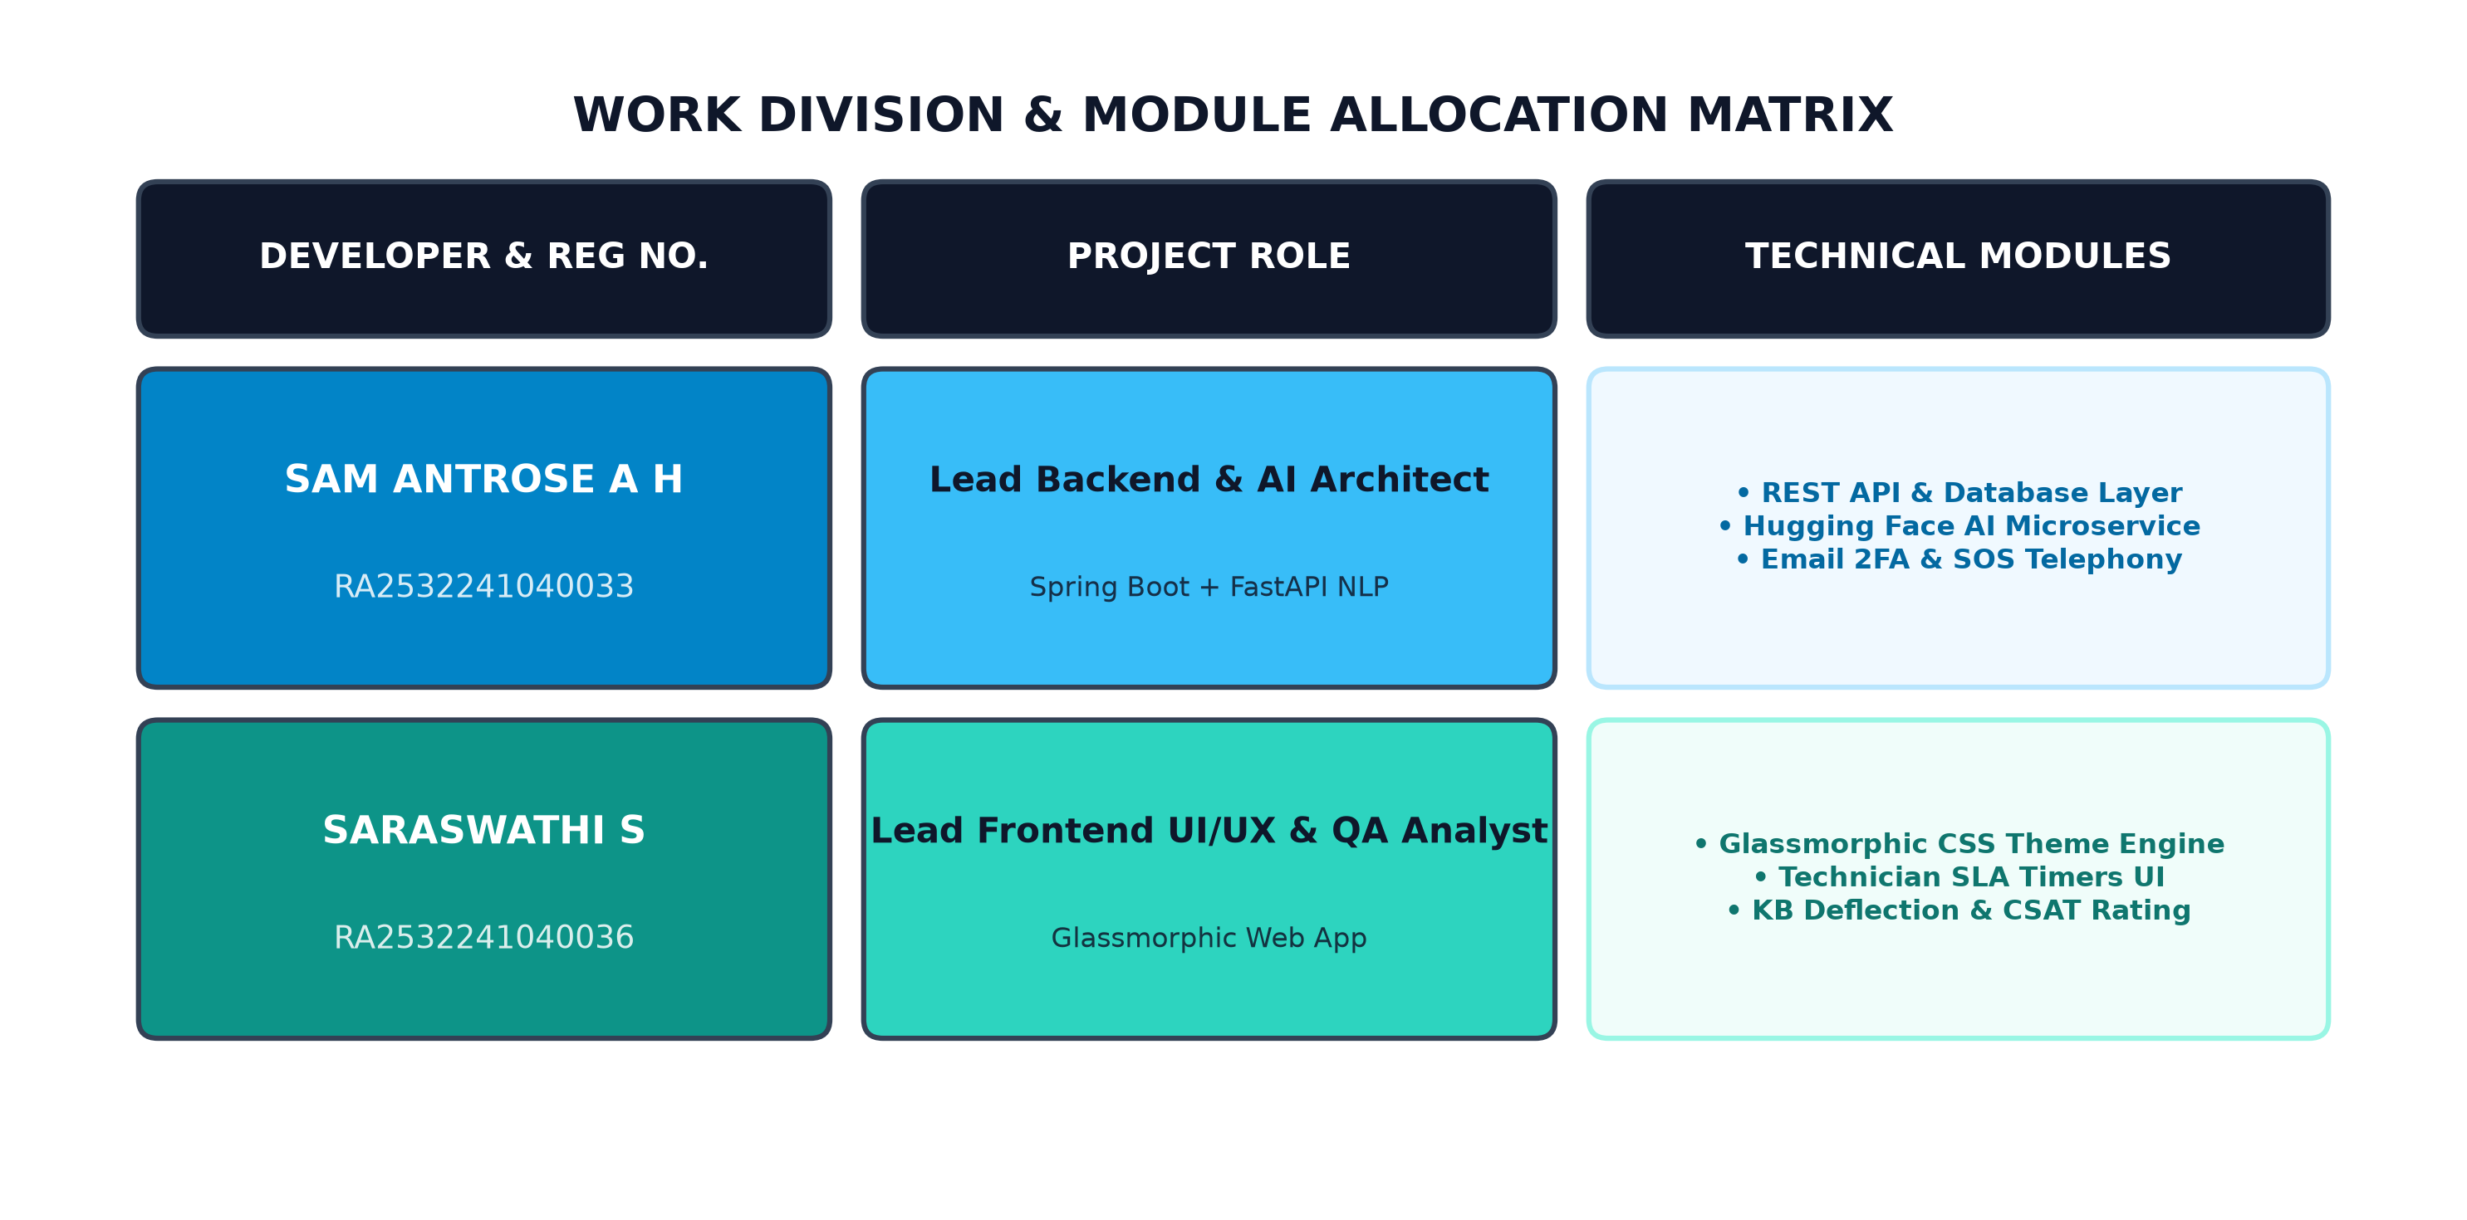
Figure 2.1: Work Division & Module Allocation Matrix

CHAPTER 3
TECHNICAL MODULE IMPLEMENTATION & TEAM CONTRIBUTIONS
3.1 PRIMARY CONTRIBUTIONS — SARASWATHI S
As Lead Frontend UI/UX Developer and QA Analyst, my primary technical modules designed and implemented comprise:
3.1.1 Glassmorphic Design System & Theme Engine: Engineered styles.css containing 40+ CSS custom properties (variables), glassmorphism backdrop blur cards, dark/light theme switcher, and responsive layout grids.
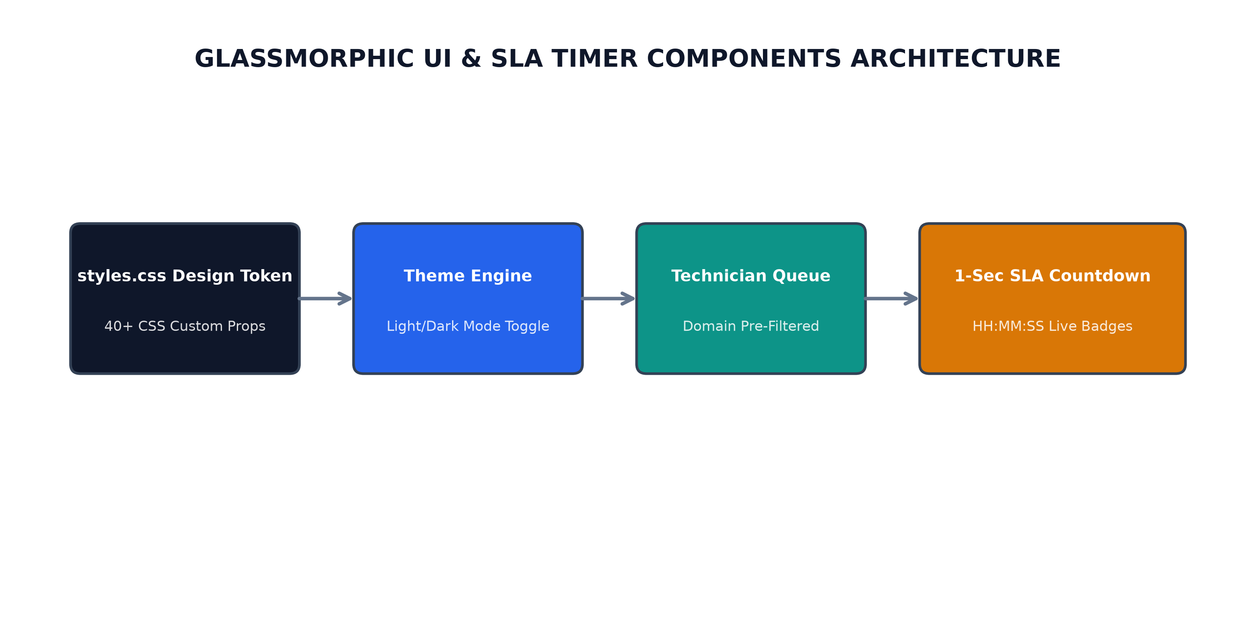
Figure 3.1: Glassmorphic CSS Design Token Architecture
3.1.2 Technician Work Queue & SLA Countdown Timers: Built domain pre-filtered technician work queues and JavaScript 1-second precision countdown SLA timers with visual severity indicators.
Figure 3.2: Technician Domain-Filtered Queue Layout
3.1.3 Knowledge Base Deflection & CSAT Rating Modal: Developed real-time search keyword matching for self-service deflection and interactive 5-star CSAT customer feedback modals.
Figure 3.3: Precision SLA Countdown Timer Component
3.1.4 IT Asset Management & Change Control Modals: Built asset inventory tables with warranty tracking, device dropdown selectors, and CAB change request dialogs.
Figure 3.4: Knowledge Base Self-Service Deflection Engine
3.1.5 Black-Box Functional & Usability Testing: Designed and executed comprehensive black-box test suites, cross-browser compatibility verification, and usability testing.
3.2 TEAMMATE CONTRIBUTIONS — SAM ANTROSE A H
To deliver a complete end-to-end portal, my teammate Sam Antrose A H (Reg. No: RA2532241040033) engineered the backend API, AI microservice, and security layers:
3.2.1 Spring Boot 3 REST API & Database Layer: Developed com.enterprise.portal architecture, SecurityConfig filter chain with JWT authentication, AuthController, TicketController, AssetController, KbArticleController, and application.yml supporting H2 and PostgreSQL.
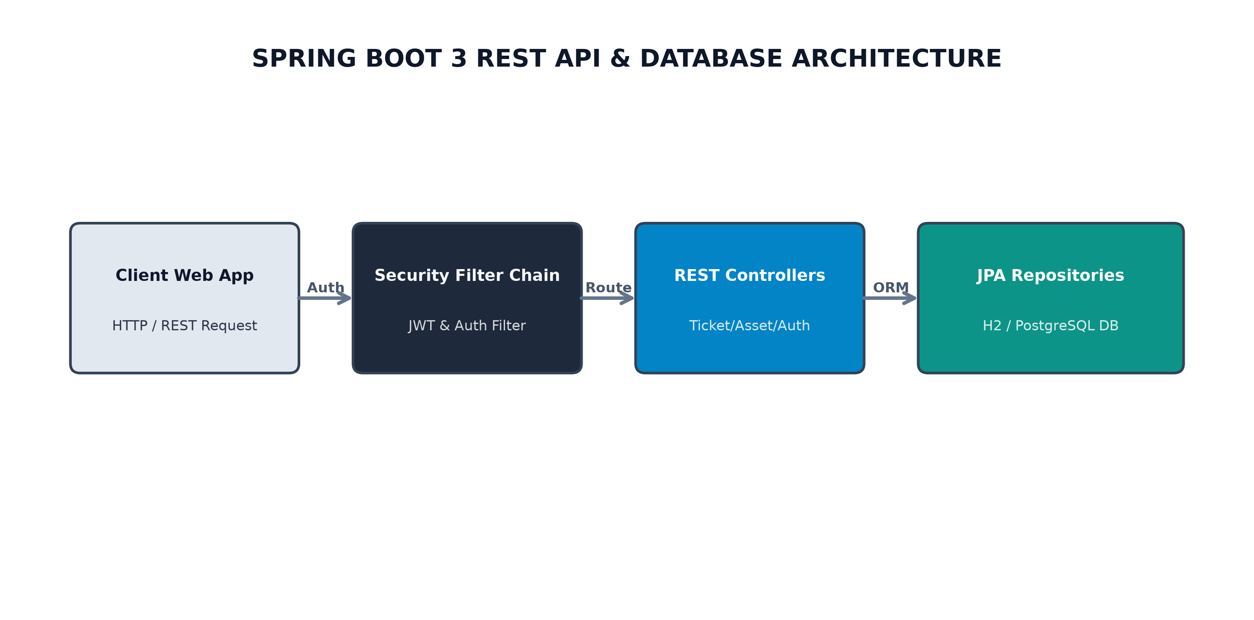
Figure 3.5: Spring Boot Backend & Database Layer Architecture
3.2.2 Python FastAPI AI Microservice (Hugging Face NLP): Engineered server.py microservice executing DistilBERT category classification and RoBERTa sentiment/urgency evaluation with heuristic fallback logic.
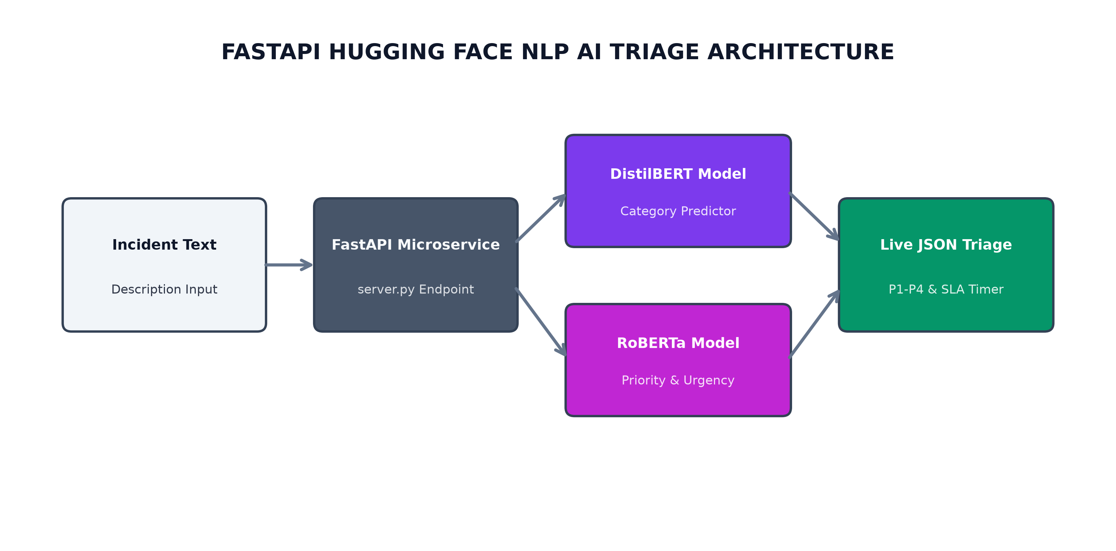
Figure 3.6: FastAPI Hugging Face NLP Triage Architecture
3.2.3 Multi-Role Authentication & Email 2FA OTP Gateway: Built 6-digit OTP code dispatch engine via FormSubmit REST API alongside 15-minute brute-force lockout protection and emergency telephony cloud alert dispatch.
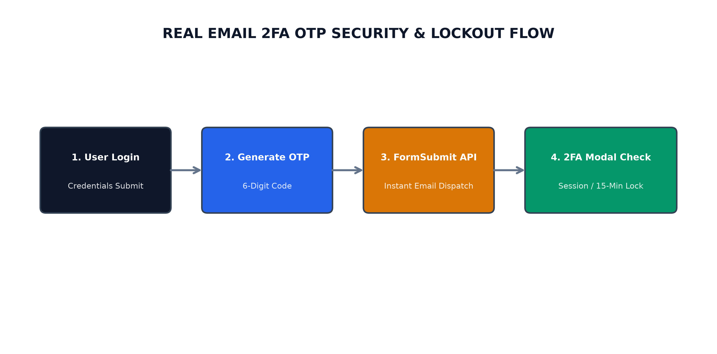
Figure 3.7: Real Email 2FA OTP Security Flow

CHAPTER 4
SYSTEM DESIGN & DATA FLOW DIAGRAMS
4.1 SYSTEM ARCHITECTURE DIAGRAM
The system adopts a 3-tier modular architecture separating presentation, Spring Boot backend, and FastAPI AI inference microservices.
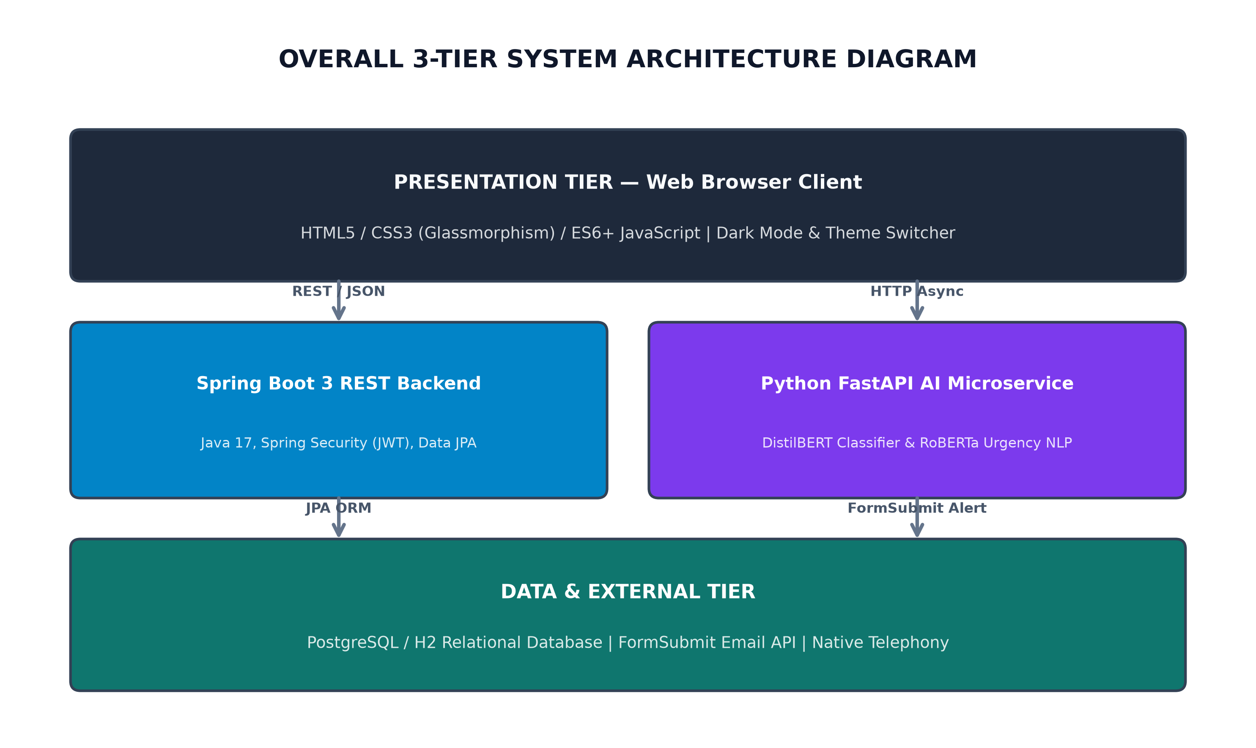
Figure 4.1: Overall System Architecture Diagram
4.2 DATA FLOW DIAGRAM (DFD)
4.2.1 DFD LEVEL 0 (CONTEXT DIAGRAM)
Represents top-level interaction between external entities (Employee, Technician, Admin) and the centralized Service Desk system.
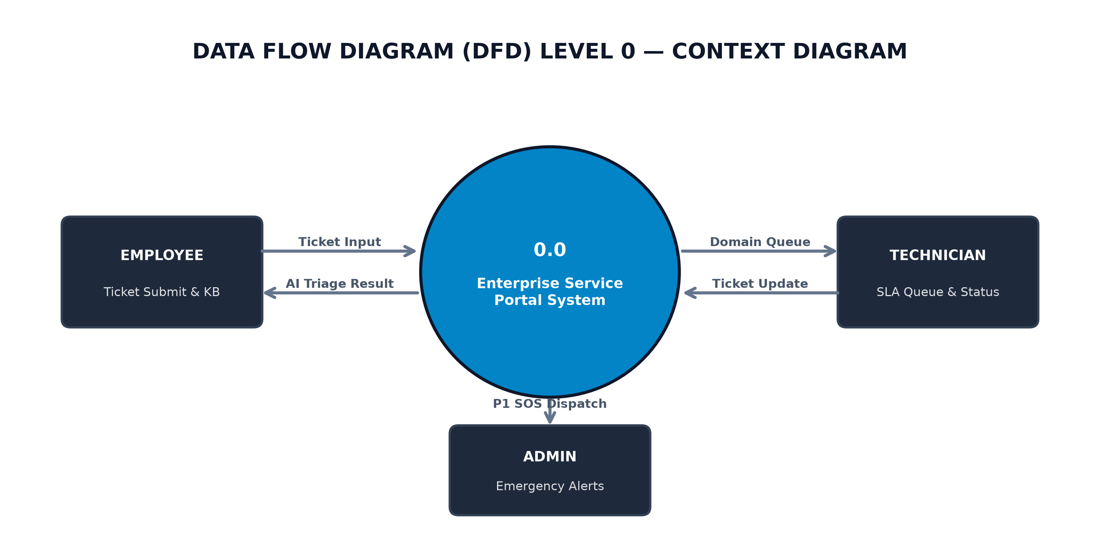
Figure 4.2: DFD Level 0 (Context Diagram)
4.2.2 DFD LEVEL 1 (PROCESS OVERVIEW)
Depicts sub-processes: Authentication & 2FA (1.0), Ticket Operations (2.0), AI Triage Engine (3.0), and Emergency Notification Dispatcher (4.0).
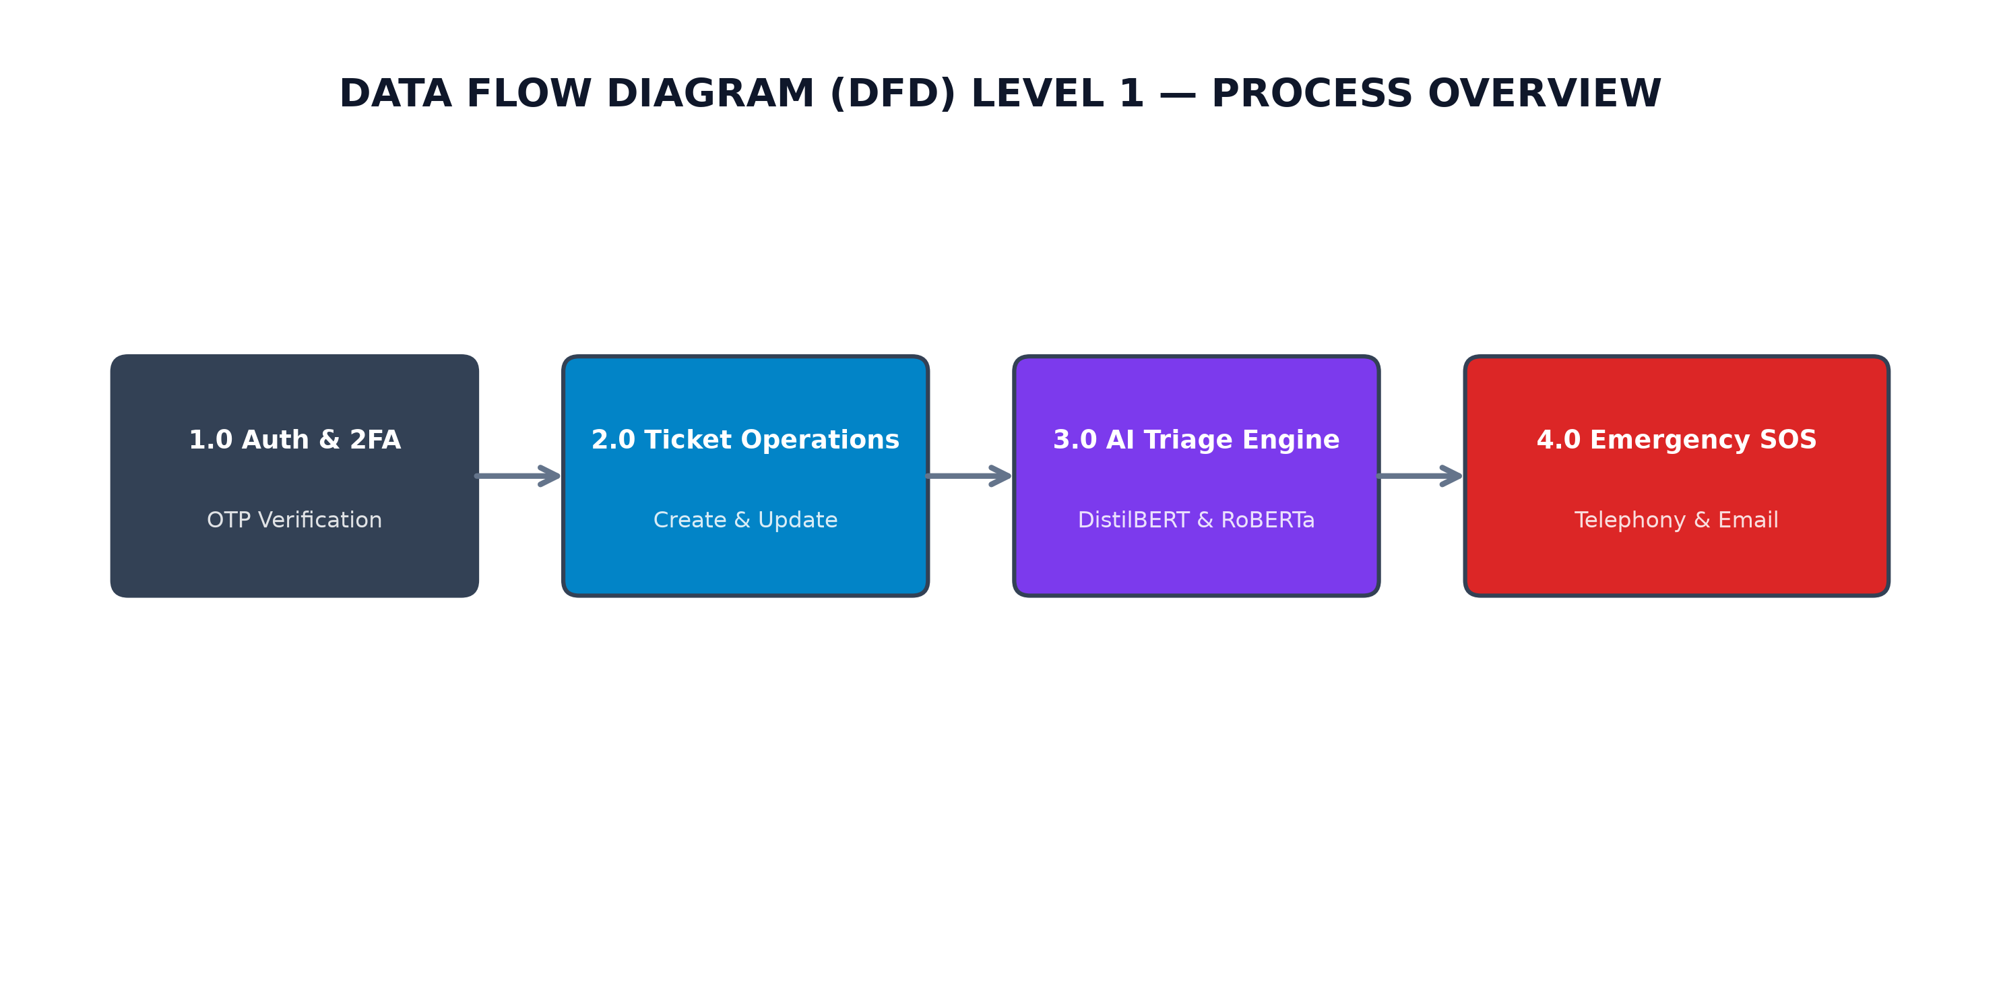
Figure 4.3: DFD Level 1 (Service Desk Processes)
4.2.3 DFD LEVEL 2 (AI TRIAGE & SLA ENGINE)
Details internal steps of AI triage: Description Extraction (3.1), DistilBERT Category Prediction (3.2), RoBERTa Urgency Rating (3.3), and SLA Timer Initialization (3.4).
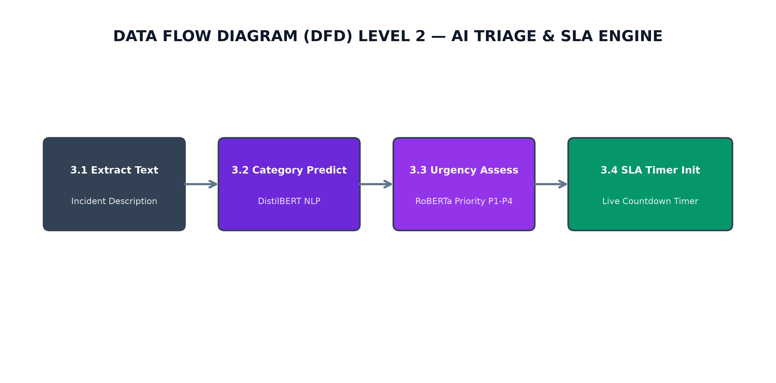
Figure 4.4: DFD Level 2 (AI Triage & SLA Engine)

CHAPTER 5
INPUT/OUTPUT SCREENS & VERIFICATION
5.1 Authentication Screen: Displays email/password input fields, quick-fill demo pills, and 6-box 2FA OTP modal.
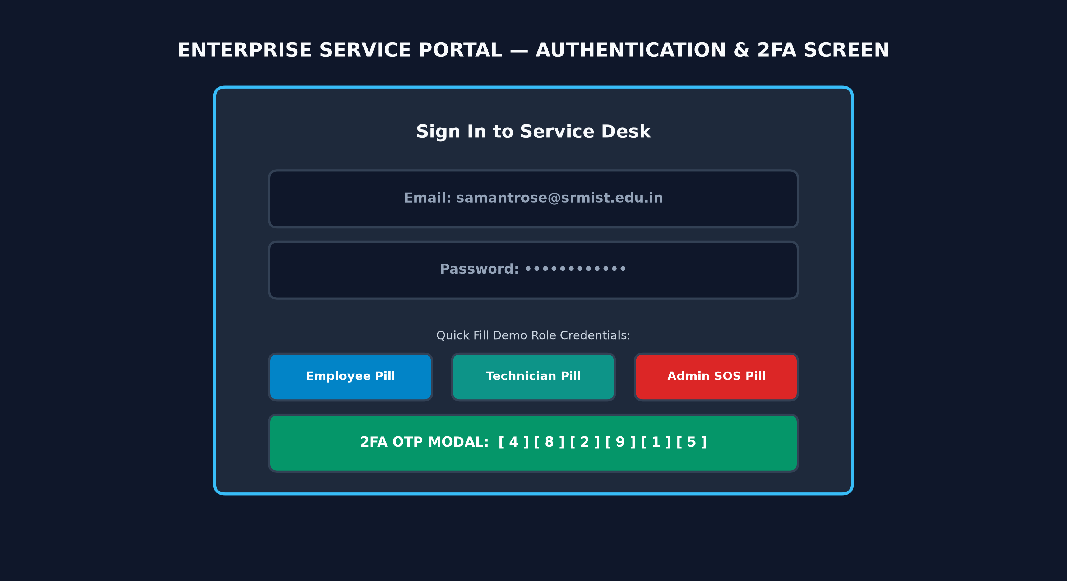
Figure 5.1: Authentication & 2FA Verification Screen
5.2 Ticket Submission & Live AI Preview: Displays pre-configured service cards, description text area, and live Hugging Face NLP AI preview box.
5.3 Technician Work Queue: Displays domain-filtered ticket cards with live countdown SLA timers and status transition controls.
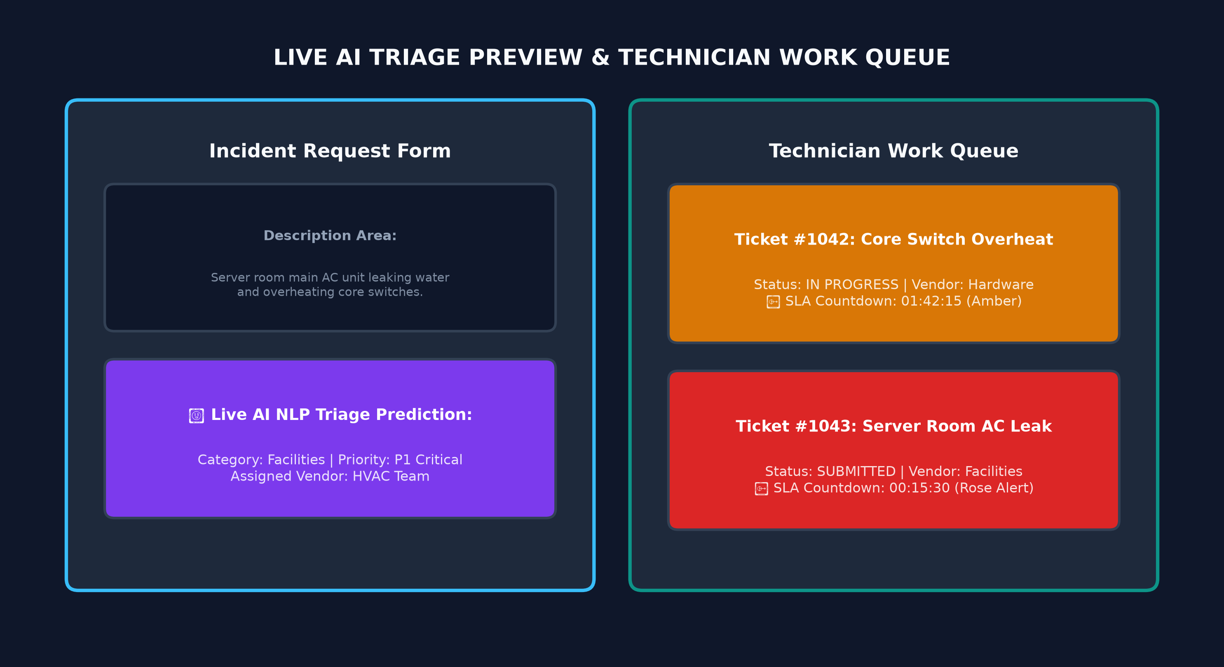
Figure 5.2: Live AI Triage Preview & Work Queue Screen
CHAPTER 6
TESTING & MODULE VALIDATION
6.1 Unit Testing: Tested Spring Boot REST controllers, SLA countdown calculation logic, and FastAPI NLP inference endpoints.
6.2 Integration Testing: Validated end-to-end communication between JavaScript frontend, Spring Boot backend, FormSubmit API, and Python AI service.
6.3 Security & Fallback Testing: Verified brute-force account lockout and heuristic fallback when the Python AI service is offline.
CHAPTER 7
CONCLUSION & FUTURE SCOPE
The Enterprise IT & Corporate Facilities Service Portal successfully demonstrates an AI-enabled, cloud-ready service desk platform. Through collaborative engineering, the platform reduces resolution times, eliminates manual ticket routing delays, and provides operational transparency for enterprise IT and facility operations.
APPENDIX
Appendix A: Source Code Modules & Repository Structure
• GitHub Repository: https://github.com/SamAntrose/enterprise-service-portal
• Live Cloud App: https://samantrose.github.io/enterprise-service-portal/
REFERENCES
1. Spring Boot Documentation: https://spring.io/projects/spring-boot
2. FastAPI Framework Guide: https://fastapi.tiangolo.com/
3. Hugging Face Transformers Library: https://huggingface.co/docs/transformers
4. ITIL 4 Service Management Best Practices, AXELOS.

