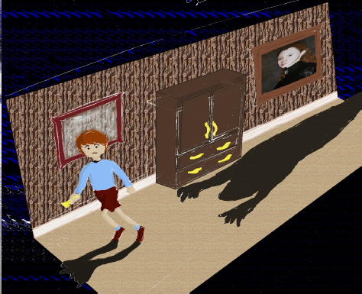

**Continuum**

*There’s a time and place for everything…*

Sam Assaf  
Alex Attar  
David Campbell  
Ralph D'Almeida

20 July 2012

Rev. 1

**Executive Summary**

*Continuum* is a puzzle game in which the player navigates a young boy through an old haunted house to the safety of the attic. To do so, the player must solve puzzles by travelling in time through portraits and teleporting from wardrobe to wardrobe, all while staying clear of the evil shadows that roam the house. Intended for all ages, *Continuum* will hook the player with increasingly challenging puzzles and innovative mechanics.

**Overview**

*Continuum* is a 2D side-scrolling puzzle game for the Xbox 360, aimed at players 12 and up who are fans of a Tim Burton-esque setting. Playing like a cross between Portal and Amnesia: The Dark Descent, the player controls a boy who finds himself in a run-down haunted house occupied by strange shadows and talking portraits. The boy is told by the portrait to make his way to the attic where he will be safe from the shadowy inhabitants. To reach the safety of the attic, the player will have to solve intricate puzzles using three items of furniture at his disposal: the talking portrait, the wardrobes and the chairs.

The wardrobes allow the boy to teleport from one location to another. By entering one wardrobe, the boy will exit from the matching wardrobe. In order to reach new locations in the house, the boy can move these wardrobes around.

The boy can enter the portraits to travel back in time, allowing for him to switch between the current run down state of the house and the pristine condition that the house was originally in. In the current state, staircases can be broken and rubble may block the boy’s path. In the past, the rubble will disappear and staircases will be fixed, but broken walls will also be restored. The player will have to constantly switch between the present and the past in order to reach the attic, bearing in mind that any changes made to the house in the past will affect the present state of the house, while the reverse is not true. In the final level, the boy will also be able to travel back to a third time frame, when the house was still being built, meaning that some objects will be in their original condition while others will not have been built yet.

Finally, the boy can use his unexplained ability to manipulate the chairs to distract the shadows as he moves around the house. Shadows will either stand still or patrol an area. While they do not exist in the past, it is not always possible to enter a portrait in order to avoid them. As an alternative, the boy can pick up chairs and move them around the house to draw the shadows away from the places that they are guarding. The boy must remain cautious however, as patrolling shadows will eventually return to their original location.

These three puzzle solving mechanics and the ways in which they interact constitute *Continuum*’s most original offering. While numerous 2D side scrolling puzzle games exists, the combination of time travel and teleportation make *Continuum* unique. Teleporting is not a unique feature on its own, but when combined with the ability to dynamically alter the state of the world it becomes very interesting. The notion of the past affecting the present but the present not affecting the past means that the player must always be aware of the state in which the changes to the world are being made. As such, the player must not only determine the series of wardrobe and chair manipulations to perform, but the state in which to perform them. The fact that these three mechanics do not have to be used together but instead can function individually is also critical. The optional interconnection of mechanics makes puzzle difficulty simple to adjust; by altering the degree of interaction between the different mechanics, the puzzle can be made easier or more difficult. This gives *Continuum* a very smooth increase in perceived difficulty as the game progresses.

The plot in *Continuum* also constitutes a point of interest. As the game progresses, the player discovers more about the main characters in the game. Initially, the player knows nothing about the character or the setting in which the game takes place; the player assumes that the setting is a generic one of a boy in a haunted house. However, as more of the mechanics are introduced, the player discovers that the boy is actually a ghost that inhabits the house, while the shadows are actually people that wish to move in and renovate it. This twist explains the boy’s mysterious abilities to teleport and control furniture as well as the portraits’ interest in protecting him. This interesting twist makes reference to certain well-known movies such as *The Others, Beetlejuice and* Casper. This unexpected twist in the plot keeps the player interested and allows for *Continuum* to be more than a simple puzzle game.

In addition to the aforementioned movies which help form *Continuum’s* setting, the game also borrows aspects from a few well-known games. Although these games vary in genre and tone, *Continuum* shares some common features with Portal 2, Quantum Conundrum and Limbo among others.

In *Portal 2*, the player controls the main character through a series of puzzle chambers. Using a portal gun to create spherical portals, the player must teleport between different areas of the map to solve unique and addictive puzzles. As the player progresses through the game, more puzzle solving items are unlocked for the player to use. Like *Portal 2*, Continuum focuses on puzzle solving using unique items, one of which (the wardrobe) behaves similarly to the portal gun. As in *Portal 2*, new mechanics are introduced as the game progresses. Unlike *Portal 2*, *Continuum* takes place in a darker setting and as such does not place an emphasis on humour. Finally, *Continuum* is a 2D side-scrolling puzzle whereas *Portal 2* is a 3D game.

In *Quantum Conundrum*, the player controls a young boy who must be guided through different puzzles in a large mansion. Different sections of the mansion have different properties, and the player must complete puzzles in four different dimensions: the Fluffy dimension where all objects are light, the Heavy dimension where objects become heavier and more durable, the Slow dimension in which time is slowed by a factor of ten, and finally the Reverse Gravity dimension where all objects experience a reversal in the direction of gravity. Later in the game, the player gains the ability to switch between these different dimensions at will. Like *Quantum Conundrum*, *Continuum* also bases puzzle solving on switching between different states in which objects behave differently. Although *Quantum Conundrum* places less of a focus on humour than *Portal 2*, *Continuum* places even less of a focus on humour, and is also not in 3D.

In *Limbo*, the player guides a young boy through a strange and dark environment. Through trial and error, the player learns to navigate an extremely harsh world where almost anything can cause the main character's demise. Like *Limbo*, *Continuum* also revolves around guiding a young boy through a hazardous and relatively unknown environment. Whereas *Limbo* focuses on puzzles where the player is expected to die numerous times, *Continuum* instead uses a more traditional puzzle solving where the player is expected to solve the puzzle in a few attempts; the goal is to discover the solution through thought, not trial and error. Frequent gruesome deaths play a large part in *Limbo's* setting and puzzle mechanic, but *Continuum* will not contain such graphic content, nor will it place such a large emphasis on the artistic aspect.

Overall, *Continuum* will seek to captivate the players of all ages with its challenging puzzles, its simple gameplay and its interesting story. While the game bears some similarities to other puzzle games such as *Portal 2*, *Quantum Continuum* and *Limbo*, the combination of original mechanics, good level design and a mysterious setting will ensure that *Continuum* constitutes a unique and worthwhile offering for fans of puzzle games and a Tim Burton-esque setting.

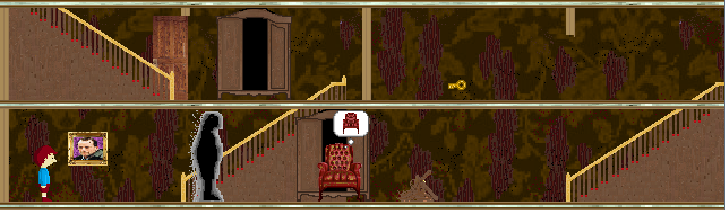

*Figure 1:**A sample screenshot of Continuum taken in the present state, featuring a portrait, a shadow, two wardrobes, a door and key, a rubble pile and a chair.*

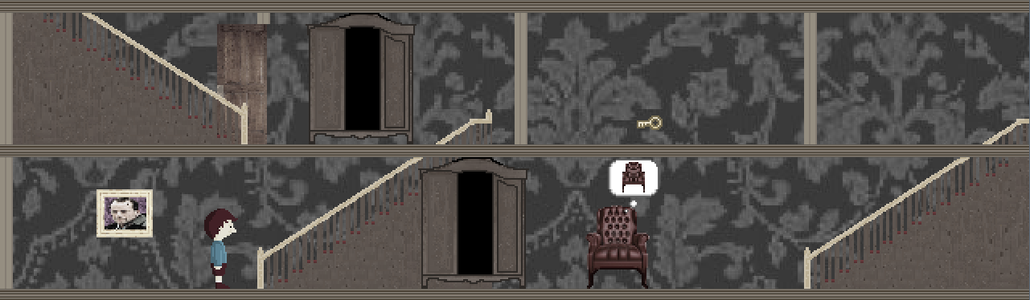

*Figure 2:**A sample screenshot of Continuum taken in the past state, featuring a portrait, two wardrobes, a door and key, and a chair. When compared with Figure 1, we can see that the broken wall on the second floor has been fixed and that the rubble pile has disappeared.*

**Related games**

**Portal 2 (2011)**

Valve

First Person Puzzle-Platform game for PS3, Xbox 360, PC, and Mac

In *Portal 2*, the player controls the main character through a series of puzzle chambers using a portal gun. This gun allows the player to create spherical portals on surfaces, and as such allows the player to teleport between different areas of the map all while conserving velocity. Using these portals, the player can also move objects or even laser beams from one area of the world to another. Taking advantage of this mechanic, the player must complete a number of test chambers, each of which features a unique puzzles involving water hazards, enemies and laser activated switches to name a few. New mechanics such as the repulsion gel, the propulsion gel and the conversion gel are introduced as the game progresses, leading to increasingly challenging and complex puzzles. The puzzle element of Portal 2 constitutes the primary similarity to Continuum, while the style constitutes the primary difference.

Like *Portal 2*, *Continuum*’s gameplay revolves around puzzle solving using an array of mechanics. In each the level, the player will have to use a combination of objects to solve the puzzle and reach the next level, eventually completing the game. Like Portal, the game is broken into small and discontinuous puzzles that do not affect each other. The puzzles also become increasingly challenging as the game progresses and more mechanics are introduced. This game design concept is a key feature implemented by *Continuum*.

*Portal 2* and *Continuum* primarily differ in setting and style. *Portal 2* places a large emphasis on humour and the game is known for its dark comedy. The contrast between the lighthearted and darker sides of Portal 2 give it a very unique setting. Continuum, on the other hand, will not place any focus on humour and will not feature a strange juxtaposition of light and dark elements. Instead, *Continuum*’s style falls somewhere between the darkest and lightest aspects of Portal. Other key differences between the games include *Continuum’s* 2D setting and reduced scale.

Portal 2 was extremely well received by critics, receiving multiple Game-of-the-Year awards and selling approximately 4 million copies worldwide. Among its many notable qualities, reviewers particularly enjoyed the quality of the puzzles, the comedic value of the script, the excellent plot development and the overall polish of the game.

The puzzles in Portal 2 were incredibly engaging. As a sequel to Portal, Portal 2 added new mechanics such as the various gels and the excursion funnel to increase the possible complexity of puzzles. The player started off only being able to use the portal gun. After a certain number of puzzle chambers, a new mechanic would be introduced to the player. The first few puzzles after the introduction of the new mechanic would drop in complexity, allowing the player to learn how to use the new tool. After a certain number of puzzles, the difficulty would jump back up and the new mechanic would begin being used with the existing mechanics. By the end of the game, the player had a large array of puzzle solving tools at his disposal, and the time just to determine the goal of the puzzle became more considerable. Timing also became more important in later levels. In all, the puzzles were refreshing, complex and increased in difficulty at a very steady pace, giving the player an extreme sense of accomplishment after completing the game.

The comedic value of the script was also crucial to the game’s success. Contrary to many puzzle games (and even most games in general), Portal 2 placed a large emphasis on the comedic entertainment value of the game. The humour was mostly supplied by the character of GLaDOS, the evil computer forcing the player to complete the test chambers. With a unique combination of dry, dark and sarcastic humour, GLaDOS kept the player entertained while solving the puzzle, offering entertaining running commentary which prevented the game from getting stale in slower stretches. Overall, the humour present in Portal 2 was a key element to its success.

Considering that most reviewers referred to the game as nearly-perfect, there are no real failures to speak of. One of the few things to be critiqued was the replay value of the game. Like most puzzle games, the value of playing the game a second time is put into question. Although the puzzles are extremely engaging, they do not change the second time through the game, and so the only reason to play through the game again is either to re-experience the game or to try and improve your completion time. The online multiplayer mode extends the life of the game, but since the level creator is only available on the PC version, console gamers do not have the ability to play the large amount of user created levels that exist. As such, replay value is the only real aspect of Portal 2 that can be criticized, but not only is this common among puzzle games but also only applies to console gamers.

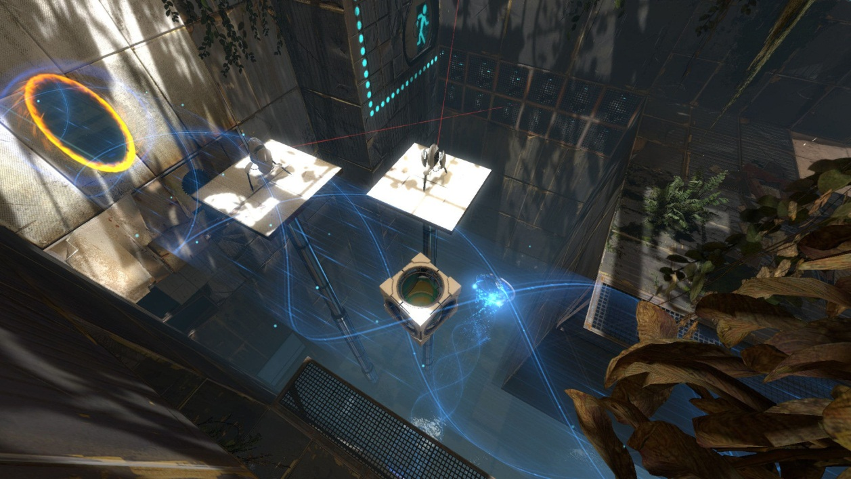

**Limbo (2010)**

Playdead

Third Person Side Scrolling Puzzle Horror for PS3, Xbox 360, PC, and Mac

In *Limbo*, the player guides a young boy through a strange and dark environment. The player is not given any background as to the origins of the character or even the setting of the game. Instead, through trial and error the player learns to navigate an extremely harsh world where almost anything can cause the main character's demise. Scattered throughout the world are traps that can kill the boy, and so the player must discover how to progress through the game while keeping the boy alive. With its very simple gameplay, beautiful art and dark setting, *Limbo* draws the player in and slowly reveals the story behind the game. *Limbo* and *Continuum* share certain puzzle and setting elements, but the styles in which these elements are presented vary.

Like *Limbo*, *Continuum* also revolves around guiding a young boy through a hazardous and relatively unknown environment. The player must solve puzzles in order to progress through the game, all while avoiding the shadows. Just as in *Limbo*, the plot is slowly revealed to the player, and strange hints or apparent breaches in continuity entice the player to keep playing.

Whereas *Limbo* focuses on puzzles during which the player is expected to die numerous times, *Continuum* instead uses a more traditional puzzle solving style where the player is expected to solve the puzzle in a few attempts. *Limbo* places a large emphasis on discovering solutions through frequent and gruesome deaths, but *Continuum* instead employs a traditional puzzle solving style that does not conflict with the target audience. Players can employ trial and error techniques if they choose, but *Continuum* provides the player with enough information about the puzzle for it to be solved in a single attempt. Due to a much smaller production scale and lack of any artists, *Continuum* also employs a much simpler art style.

*Limbo* was extremely well received by critics, receiving multiple Game-of-the-Year awards and art awards. As an indie game, *Limbo* had slightly more humble sales than more commercial games, but still managed to sell over one million copies, becoming one of the top 15 all-time best-selling games on Xbox Live Arcade in the process. Among its many notable qualities, players and critics particularly enjoyed the artistic presentation and the quality of the puzzles.

Without a doubt, the most recognizable and one of the most important aspects of *Limbo* is the artistic presentation. There is no confusing *Limbo* with any other game; the visuals are just that unique. The black and white images, use of blurring effects and incredibly fluid animation draw the player into the disturbing game world and never let the player go. While the visuals are fantastic in their own right, the sound design in *Limbo* is also incredible. The absence of any music adds to the mystery of the game world and the clarity of the sound effects immerse the player but also provide vital clues as to how to proceed. While *Limbo* offers much more than just a good looking game, the art plays an extremely important part in both setting the tone of the game and keeping the player immersed.

Given that *Limbo* is a puzzle game, the puzzles are also one of the defining features of Limbo. Based on a very simple control scheme, *Limbo* allows the player to interact with the world in a very simple manner. While the puzzles vary tremendously, interacting with the world remains extremely intuitive. With this simple interaction mechanism set in place, the player is free to solve the wide array of trial-and-death based puzzles. The disturbing game world is filled with hazards that will gruesomely put an end to the player’s life. Using only the visual and audio clues at his disposal, the player must try to move as far through the game as possible before inevitably dying. After this, the player restarts just prior to his death, and attempts to move passed this point based on information discovered during his previous failure to do so. Although the player dies repeatedly, the developers manage to keep the game from becoming frustrating all while challenging the player with diverse puzzle mechanics which sometimes include other humans and giant spiders. In all, the puzzles in Limbo and the trial-and-death game mechanic complement the presentation perfectly, and lead to an extremely immersive game.

As with most Game-of-the-Year winning games, there is very little to criticize in *Limbo*. In fact, one of the only prevailing criticisms of the game is its length. *Limbo* is a fairly short game and can be completed in six or seven hours. Being such an immersive and enjoyable game to play, players feel that the game ends too quickly. Although there are many hidden trophies to discover in the game, the experience comes to an end fairly quickly and there is nothing new experienced playing the game a second time. As stated previously, this is a common problem with puzzle games, and the replay value can almost always be put into question, and this is the case with *Limbo*. However, this is the only real criticism, and many would agree that it is better for a game to end too quickly than to drag on after it has grown stale.

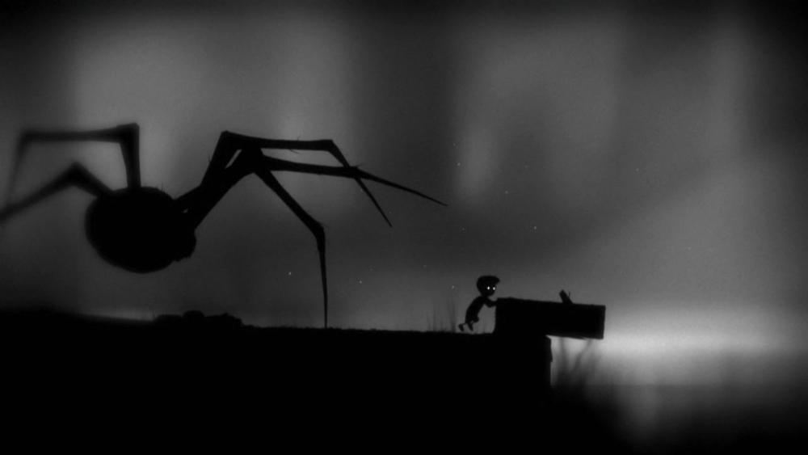

**Amnesia: The Dark Descent (2010)**

Frictional Games

First-Person Survival-Horror game for PC, Mac and Linux

In *Amnesia: The Dark Descent*, the main character Daniel awakes in a strange castle. Discovering a note that he's written telling himself to find and kill the master of the castle, Daniel must work his way through the castle to discover who its master is, why he needs to kill him and how he got to the castle in the first place. Because the castle is filled with mutated and murderous creatures, Daniel will not only have to find answers to the questions that haunt him, but he will have to watch his back while doing so. The main similarities between *Amnesia: The Dark Descent* and *Continuum* are the mysterious setting and the importance of non-offensive objects at the player’s disposal.

In *Amnesia: The Dark Descent*, the player begins the game knowing nothing about the character or the back story. With only the note to push the player onward, all that the player learns about the setting and the characters is learned playing the game. In a similar manner, the story of *Continuum* will develop as the player plays through the game. The player initially knows nothing about the boy, the portraits, the shadows or anything else, but as he progresses through the game the entire back story will be revealed.

In *Amnesia: The Dark Descent*, the player is given nothing to defend himself with. While navigating through the castle, any encounter with a monster will prove fatal. As a result, the player must be very cautious when exploring the rooms, and must use his cunning to discover the secrets of the castle while avoiding any encounters with its inhabitants. In the same way, *Continuum* also forces the player to avoid enemies rather than confront them. Using the wardrobes, portraits and chairs, the player must maneuver around the shadows, as any contact between a shadow and the boy will result in restarting a puzzle.

In the end, the main difference between *Amnesia: The Dark Descent* and *Continuum* is the genre. While *Amnesia: The Dark Descent* is a survival horror game based on scaring the player, *Continuum* is a puzzle game that focuses on challenging the player intellectually. As such, the target audiences are also very different.

TODO

Overall game reception, sales, etc. Main strengths and weaknesses intro.

Strength 1.

Strength 2.

Main weakness.

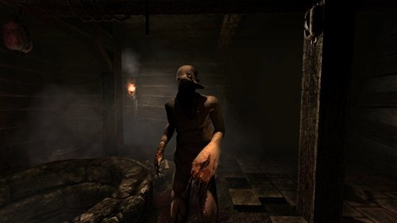

**Quantum Conundrum (2012)**

Airtight Games

First Person Puzzle Game for PS3, Xbox 360 and PC

In *Quantum Conundrum*, the main character controls a young boy who has gone to visit his uncle. However, his uncle, a professor and inventor, is in the middle of performing experiments when he arrives and the experiment unfortunately goes wrong. The uncle becomes trapped somewhere in the house and the player must go through the mansion and find a way to release him. In order to do this, the player will have to solve multiple puzzles involving different dimensions. The player is given a glove which allows the player to switch between four different dimensions: the Fluffy dimension where all objects are light, the Heavy dimension where objects become heavier and more durable, the Slow dimension in which time is slowed by a factor of ten, and finally the Reverse Gravity dimension where all objects experience a reversal in the direction of gravity. The main similarities between *Quantum Conundrum* and *Continuum* are the use of world state alteration in puzzle solving and while the tone consists of the main difference between the two games.

In *Quantum Conundrum*, the main puzzle solving mechanic is the alteration of the world state using the inter-dimensional shift glove. In order to access new locations in the mansion, the player will have to switch back and forth between the four dimensions, altering object properties in the process, but not the player’s properties. Initially, the player is limited in which dimensions he can travel, but as the game progresses he unlocks the ability to switch between them at will. Like *Quantum Conundrum, Continuum* also places an emphasis on solving puzzles through an alteration of the world state, in this case using the portraits that allow time travel to take place. All puzzles in *Quantum Conundrum* must be solved by switching dimension many times in order to benefit from specific object properties for specific tasks. This is similar in *Continuum,* the main difference being that the game world alteration is used to change the world you’re interacting with, not the objects that you’re interacting with. However, the concepts are similar.

The main difference between the two games is the tone in which these puzzles take place. While neither game has a particularly dark tone, *Quantum Conundrum* employs a much lighter tone than *Continuum.* In *Quantum Conundrum*, the lighter tone is reflected throughout the game, from the lighthearted commentary provided by the uncle, to the cartoonish visuals and sound effects. Continuum, on the other hand, sets a somewhat more serious tone using darker (albeit simple) visuals, more haunting music and a more serious story line. While the gameplay mechanics in the games are similar, the ways in which they are presented constitute the main difference between the two games.

*Quantum Conundrum* received good reviews and was generally well appreciated by gamers. *Quantum Conundrum* received an average score of 81% on Meta Critic, with 90% as the highest score and 67% as the lowest score. As a fairly recent downloadable game, the sale totals have not yet been made available. However, given the good reviews and well known creator (Kim Swift, developer on *Portal* and *Left 4 Dead*), it is reasonable to assume that *Quantum Conundrum* has known relatively good sales numbers. Among the qualities highlighted by the critics, the most prevalent quality is the game’s interesting puzzles while its main downside is the lack of polish.

*Quantum Conundrum*’s main appealing feature is not surprisingly the quality of the puzzles. FILL WITH DESCRIPTION OF PUZZLES. TODO

*Quantum Conundrum*’s most disappointing feature is its lack of polish. While the puzzles are appealing, the game lacks a certain polish found in similar games like *Portal*. The visuals are nice and colourful, but are not incredibly detailed. The voice acting is good, but not as good as the voice acting in *Portal 2*, nor is it as funny. Also, the story develops nicely, but the game is widely criticized for its ending. Finally, while the puzzles are good, the increase in difficulty is not as smooth as it should be, and as such some of the early puzzles when a mechanic is introduced are trivial. In all, the game has some good elements but lacks some overall polish when compared to its close competitors.

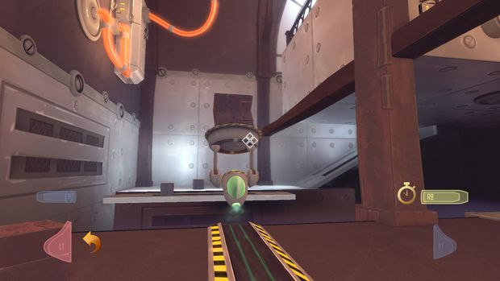

**Player composites**

*Continuum* is aimed at players of age 12 and up who enjoy puzzle games and mysterious settings. Here are a few of the types of players that the game targets.

Alex Sinclair is a 15 year old student currently attending senior high school. Alex is a good student who places a priority on school work. During his summers and other times away from class, he likes to play first person puzzle games like *Portal* and *Quantum Conundrum*, or fully immerse himself in expansive role playing games like *Elder Scrolls,* although he does this less than he used to. Alex enjoys the challenge that puzzle games provide, as well as the fantastic settings found in RPGs. When he’s too busy with school during the year to fully immerse himself in large-scale games, he enjoys playing quick matches of Call of Duty and Smash Brothers online. Alex has an Xbox 360 plugged into his computer monitor in his bedroom and a Wii in the family room. Most of the games that he owns are birthday or Christmas presents. Alex plays large scale games alone and action games online with other players, in addition to occasionally playing local multiplayer games at friendly get-togethers. Alex also enjoys playing soccer and hockey with his friends, as well as watching Montreal Canadiens games during the year. In all, Alex is a fairly busy individual who enjoys playing a wide variety of games depending on the time of the year; he likes playing very light action games during the school year, puzzle games during breaks and large scale role-playing games during the summer.

Brian Quincy is a 39 year old currently working as a high school math teacher. He is married and has an 11 year old daughter. Although Brian doesn’t have much time for games, he does enjoy occasionally playing very light games and considers himself a casual gamer. Brian has a long history of playing games and in his youth enjoyed classics puzzle and adventure games such as *Wario’s Woods* for the NES, *Hugo’s House of Horrors* for PC and *Myst* for PC. Brian enjoys playing other genres of games as well, but buying games that are also appropriate for his daughter to play has become one of his main concerns. Brian is primarily a PC gamer, playing old DOS games with DOS-Box and playing old console games on emulators. However, he recently bought and Xbox 360 Kinect bundle for his daughter. Brian mostly plays games on his own, although he occasionally plays local multiplayer games on Kinect with his daughter. Brian owns a 37” HDTV in his living room, although he uses it primarily to watch movies with his family or the occasional game show. Overall, Brian is a casual gamer looking for mentally stimulating but not overly time consuming games that both he and his daughter can enjoy.

Audrey Sylvester is a 17 year old high school student currently in senior high school. Audrey is part of the school’s art program and has been heavily involved is set design and artwork in the school plays and musicals. She is an active artist outside of school as well and spends most of her money or art supplies. She is a fan of American cinema, in particular of Tim Burton’s and M. Night Shyamalan’s work. Her favorite movies include *Nightmare before Christmas*, *Sixth Sense,* and *The Others*. Her older brother owns an Xbox 360 that is set up in the family room. Audrey is a very casual gamer and rarely plays video games, at most once or twice a month. The few games that she does play are mostly owned by her brother, although her parents have bought her a few games over the years. In fact, one of the few games that she has ever truly gotten into is *Limbo*. However, since completing *Limbo* she has become interested in finding more games with similar tones and settings. In all, Audrey is not someone that spends more time creating art and watching movies than playing games, but she is interested by games with interesting settings.

Felix Epson is a 10 year old boy in elementary school. Interested in most subjects, Felix is a fairly good student. However, his favorite subject is computing and he enjoys working on the school computers. When he finishes his computing work early, he enjoys playing platform and puzzle games on Miniclip.com. Felix owns an Xbox 360 that is connected to the family television. His parents buy him new games a few times a year, although they also encourage him to engage in other activities besides gaming. Felix enjoys playing puzzle games, platform games and sports games a few times a week for thirty to sixty minutes per session. He enjoys playing multiplayer games with his friends, but he mostly plays on his own. Felix does not get too immersed in games, and looks primarily for games that are fun to play, regardless of what the setting is. His favorite television shows are *The Simpsons* and *SpongeBob SquarePants*. Overall, Felix is a casual gamer who enjoys a variety of different game genres, but is not looking for something that requires much immersion to enjoy.

**World**

*Continuum* takes place in a modern day United States of America, in the state of Rhode Island. The game world is close to a normal world, the only difference being that ghosts exist. The mansion in which the action takes place is a 95 year old house, built by the Pershing family.

William and Margaret Pershing married in August of 1916. William, the son of a wealthy industrialist and a successful businessman himself, was wealthy enough to have a mansion constructed for him and his bride. Wanting to raise a family, William and Margaret decided to have the mansion built in a secluded area of Rhode Island. As architectural enthusiasts, William had the house designed in the style of the Breakers, a large Vanderbilt mansion built in the late 1800s. In addition to the style, William had another request. Fearing that the turmoil affecting Europe would spread to North America, William specified that a large safe room be built on the top floor of the house.

Because of unusually cold winter weather that year, construction of the mansion was halted during the winter months and did not recommence until March of 1917. Around the same time, the United States of America declared war on Germany and William was enlisted to join the troops. In his absence, the mansion was completed and Margaret moved into to it. In June, Margaret gave birth to a son and named him Bruce in honor of William’s father.

Although William returned home from the war, he was permanently scarred by what he experienced in Europe. Having witnessed many of his fellow soldiers die in a surprise mustard gas attack in addition to the numerous other horrors of trench warfare, William was never able to reconnect to his family. Haunted by the memories of war, William became silent and secluded. Convinced that she could help him rediscover who he once was, Margaret became almost entirely cut off from the rest of the world and put most of her effort into helping William. Her efforts failed and William died at an early age, completely disconnected from the world around him. However, having left a part of himself in Europe, William did not truly die but instead became a little more than a spirit that wandered the house aimlessly as he had done near the end of his life. Deeply affected by the death of her husband, Margaret began to battle depression. Exhausted by the effort required to raise a son on her own and attempt to help her husband, she became frail. In a moment of weakness, she gave into her depressive thoughts and committed suicide. Having given a part of herself to William, Margaret did not die either, but instead became a ghost just as William had.

Left alone to fend for himself and having never met anyone but his parents, Bruce did his best to take care of himself. However, he had always been cared for by his mother and thus was unprepared to fend for himself. He eventually ran out of food and starved to death. Having been robbed of a normal childhood, Bruce too became a ghost. Because Bruce never met anyone his own age, he assumed that what he was living was normal and so became a ghost without ever realizing it. He continued living as he had, playing games in the different rooms of the mansion and reading books.

Separated from his body and mind at death, William’s psychological wounds were eventually healed at which point his soul began to long for Margaret. Searching the house for her he discovered that she too had become a ghost and they were reunited. Upon reuniting, the two realized to their horror that they had completely failed as parents and had abandoned Bruce to his death. Longing to be with him but too ashamed to reveal themselves to him, William and Margaret chose to inhabit portraits of themselves. Living in portraits, they were able to keep an eye on him without revealing themselves.

Having been built in such a secluded area, the house was ignored for a very long time. People who did come across the mansion were not sure to whom it belonged. Eventually, the story came out that a family had lived there in the early 1900s but had all died early and mysterious deaths. People became convinced that the house was haunted and as such most who came across it from that point onward made a point to avoid it from then on. Kids in the area began to dare themselves to enter it (though none ever did).

In 2012, a couple visiting Rhode Island became enamored with the state and the architecture of the older buildings which it contained. Upon exploring the different parts of Rhode Island, they stumbled across the Pershing mansion. The couple was immediately drawn to the house’s design and was surprised to discover that no one owned it. Upon making further enquiries with the town officials, they were told that the house was indeed empty, though not for sale. Because the couple was very rich, they were able to bribe town officials into letting them purchase the house.

A few days later, the couple visited their newly acquired home with a group of renovators in order to assess its state and determine how extensive the renovations would have to be. When they entered the house, they were shocked to discover the poor state that it was in. Each member of the party went to examine a different part of the house, but in doing so alerted William and Margaret of their presence. Fearing that Bruce would no longer be safe with intruders in the house, William decided to reveal himself to Bruce in order to guide him to safety. It is at this point that *Continuum* begins.

**Characters**

The boy:

The Shadow:

The House:

**Progression graph**

asdfasdf

**Art direction**

With *Continuum*, the visuals consist of a mix of realistic and cartoonish art. The determining idea was to have moving characters (both playable and non-playable) be portrayed with a more cartoon style. As the game ended up only having two characters, Bruce and the shadows are the characters that demonstrate this idea.

Bruce is a silent main character in *Continuum*, and although he is involved in a tragic story, he is a very simple character. Being abandoned by his parents at an early age having never come into contact with other people, Bruce is a very simple character even if his story is not. The visuals reflect this nature. Bruce is drawn with a significantly oversized head and very little facial detail, a common visual style seen in such games as *A Boy and His Blob*, *Limbo,* and the *Smash Bros*. franchise when portraying characters from the *EarthBound* series (most recently Ness and Lucas). There is nothing intricate about his appearance, and not only does this match his personality, but it also makes him easy to draw and animate.

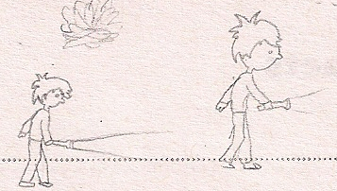

Figure 3: Original concept art for Bruce and his in-game rendition.

For the shadow, the idea was to have it be a fairly mysterious looking character; it should not look exactly like a monster, or a ghost or a human, but instead something like a cross between the three. As you can see in the game, the shadow has a fairly human profile that is just slightly distorted to confuse the player about its nature. To further confuse the player, the shadow moves not by walking but by instead gliding across the floor. The original idea was to have the shadow walk normally, but by instead having it glide, its nature is not so clear to the user. To add some effect to its sliding, the shadow leaves a trail of what looks like smoke behind it as it moves.

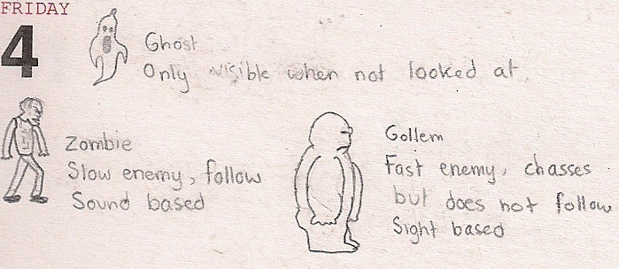



Figure 4: Original sketches for monsters in the game. However, when it was decided that Bruce was actually a ghost and that the monsters were actually human, the design was completely changed.

For all other items in the game including the portraits and the various items of furniture, the idea was to have them look as realistic as possible. Cartoonish visuals are very nice when they work, but the problem is that the player can become confused about the objects that he's looking at if the drawing is not done well enough, not to mention that the visuals will not look appealing if the style is at all inconsistent. To stop this problem from occurring, the remaining visuals were instead designed to look as realistic as possible by taking real images and altering them to fit the need of the game. As such, each of the images in the game started out as a real image of an object, and was edited to have the right look, size and feel. For example, in the case of the portrait, a picture of a picture frame was taken and scaled down to size. In MS Paint, the colors were modified to make the frame look more vibrant. Once this was done, the picture of a woman was taken and scaled down to size and placed inside the frame. The extreme amount of scaling means that although the people and objects do not look like photographs anymore, they look much more realistic than they would have looked had they been drawn by hand (especially with regards to the textures and the lighting).

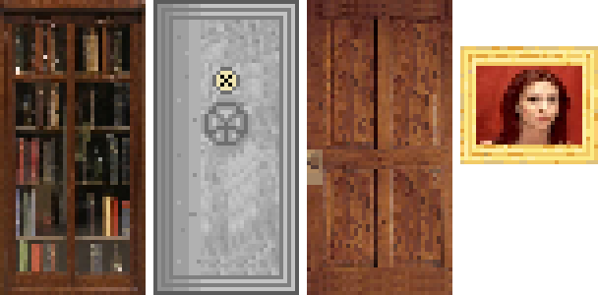

Figure 5: (Bookcase, safe door, open door and woman portrait). Some of the items found in *Continuum*. Each item in the game began as an image of a real object with the exception of the safe door, the staircase, the button, the rubble pile and the floor.

One of the key elements of *Continuum*'s artistic direction was the existence of the objects in multiple states. Because the player can travel back in time, each of the objects must be represented in multiple states of use. To do this, each object in the game is saved in two states: the present state and the past state. Objects in the past are much newer and as such show less wear than their current states. To create this difference in states, the same base drawing was used in both cases. After the past state had been created, dirt was added to the object, colors were faded and in some cases parts of the object were removed or broken. In the case of the floor, the asbestos between the floors of the house can e seen. This helps the player to distinguish which state he is in currently, in addition to ensuring continuity in the game.

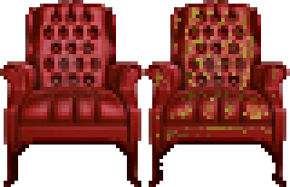

Figure 6: Comparison of the chair in past and present states. In the present state, the chair's leather is peeling off, the cushion is much dirtier and the legs are chipped.

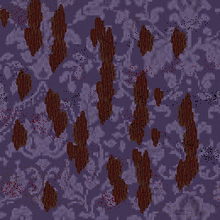

Figure 7: Comparison of the wallpaper in past and present states. In the present state, parts of the wall paper have been torn off and specs of dirt cover the pattern.

To further highlight the differences between the past and the present, a grayscale effect was also added to the game. Even with the different states of the objects, the look of the past and the present was too similar. The game revolves around constantly switching between these two states, and so it was necessary that they be extremely easy to tell apart. To achieve this, the amount of color present in the past state was removed. As such, when the player enters the past, the game visuals look as though they have been passed through some sort of filter. In the distant past (when player's enter the woman's portrait), color is drained almost entirely.

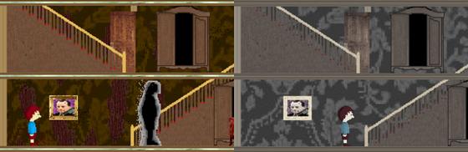

Figure 8: Comparison between the saturation in the past and the present.

A similar effect was used to differentiate between different levels. The entire game takes place in a house and the same objects are present in every room, so it is necessary for there to be some way to differentiate the levels from one another. To achieve this, each level has its own tint. As such, although the objects and wallpaper are the same, the background color of the world changes from level to level.

**UI storyboards**

adsfasdf

**Tags and dialogue**

adsfasdf

**Technology plan**

Code: The code is written with Visual Studio 2010 (C#) as an IDE. The game uses Microsoft’s XNA framework as a base. The code uses an Apache Subversion repository for version control. The repository is hosted by Google Code.

Art: Art is drawn and modified using Paint and GIMP 2;

Design Document: The document is written with Microsoft Word.

Hardware: The game was developed using PCs running Microsoft Windows 7. The game runs on both Microsoft Windows and Xbox 360.

**Software architecture**

sadfasdf

**Controls**

(Trigger) Move the nearest chair

Select, pause

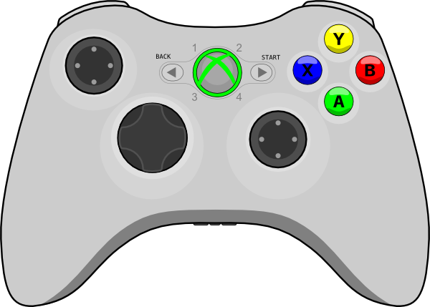

Move Bruce, control chair movement, navigate menus

Interact with objects

**Level design**

asdfasdf

**Mechanics analysis**

Puzzles: The game is laid out as one large area subdivided into discrete puzzles. The player must solve puzzles to progress. The start of every puzzle serves as a checkpoint allowing the game to be saved and for progress to be reset if the player gets stuck or if they are caught by The Shadow.

Movement: The player moves according to classic platform mechanics. The player can move left and right as well as jump. The player can also travel vertically by going up or down stairs or dropping through gaps.

Wardrobes: Wardrobes are scattered throughout the levels. The player can enter one wardrobe which will then teleport him to another. The wardrobes may be locked. The player cannot enter a locked wardrobe and entering a wardrobe whose destination is locked will not teleport the player. Wardrobes can be moved to allow the player to have a small amount of control over their destination.

Paintings: Paintings allow the player to travel through time. There are two periods: the past and the present. A room may be different in different time periods. For example, a staircase may be broken in the present but intact in the past. If the player travels to the past through a painting, they may return to the present by traveling through any other painting. Any actions carried out in the past will have an effect on the present, but actions in the present will have no effect on the past.

The Shadow: The player is constantly stalked by a dark shadow. If the player is caught by The Shadow, they are sent back to the start of the current puzzle. The player has no direct way to attack The Shadow and must rely on either hiding or evading it.

**Schedule**

July 30: Working prototype is due. Progress presentation.

August 13: Final deliverable due, game is presented.

**Budget**

asdfasdf

**Change log**

The mechanic of mirrors altering the world has been removed due to time and lack of implementation ideas. Mirrors will now simply be a static background object.

The mechanic of the player being equipped with a flashlight to fight off monsters has been removed due to mirrors being removed as well as a change in the game’s fiction. Since the character is a ghost, there is no good reason for him to be equipped with a flashlight.