Qualification details
Training Package Code and Title | ICT - Information and Communications Technology (Release 8.1)
Qualification National  Code & Title: | ICT50220 Diploma of information Technology (Release 2) |  |  | State code | BGJ4
Assessment Title | Assessment Task 2
Unit National Code & Title | ICTPRG443 Apply intermediate programming skills in different languages |  |  |  |  | OBT13
Unit National Code & Title | ICTICT430 Apply software development methodologies |  |  |  |  | OBU02
Unit National Code & Title | ICTICT523 Gather data to identify business requirements |  |  |  |  | OBU27
Date Due | Week 18 |  | Date Received
Student Name | Samuel Bailey 30106121
Student Declaration | I declare that the evidence submitted is my own work:  SBailey
Assessor Name
Assessment Decision | ☐ Satisfactory |  | ☐ Not Yet Satisfactory
Assessor Signature |  |  | Date
Is student eligible for reassessment (Re-sit)? | ☐No | ☐Yes | Reassessment Date: | Week Nineteen
Feedback to student
Via Blackboard (LMS) – Please check [Grade] section.

Feedback from student
Via Blackboard (LMS) – Please use [Comment] section during submission.

Student signature |  |  | Date

Assessment Instructions
TO THE ASSESSOR
Type of Assessment | Individual Project
Duration of Assessment | 8 Class Sessions (Week 10 - 18)
Location of Assessment | Classroom
Conditions | Assessor to ensure that the noise levels, natural interactions and time variances are maintained as it would be in the Software Development industry.  Learners are required to complete the required tasks in class and submit the required documentation electronically via Blackboard
Elements and Criteria | As detailed in the assessment plan  You are required to make sure that all students meet the elements, performance criteria and oral communication items as outlined in the provided solution.
TO THE STUDENT
Purpose of Assessment | You are required to show you can:  - Carry out intermediate programming activities, such as coding, debugging, testing, and creating applications.  - Use a traditional and non-traditional development methodologies for application development.  - Identify, analyse, and document business requirements according to project requirements.  The student must demonstrate the ability to complete the tasks outlined in this assessment and is expected to use systematic analytical processes and effect time management to meet the goals/deadlines outlined in the DAP.

Allowable Materials | Blackboard Topics will include the following: Weekly Readings, Class notes, and Weekly Activities.
Required Resources | Web links and example code can be downloaded from the Blackboard portal.  PC with MS Visual Studio, MSOffice.
Reasonable Adjustment | In some circumstances, adjustments to assessments may be made for you. If you require support for literacy and numeracy issues; support for hearing, sight or mobility issues; change to assessment times/venues; use of special or adaptive technology; considerations relating to age, gender and cultural beliefs; format of assessment materials; or presence of a scribe you need to inform your lecturer.
Assessment Submission | All questions and activities must be attempted. All written answers must be submitted in this assessment document in the appropriate space.  Use of research tools and peers in formulating answers are acceptable – but work submitted must be your own work.  Final portfolio documentation is to be uploaded to the appropriate area in the Blackboard course created for this unit.  If you are marked as NYS (Not Yet Satisfactory) on your first attempt, you will be provided with another opportunity to re-attempt the assessment.
Project contents | A project of programming tasks and written questions which should be completed in class and finished in the students’ own time on a weekly basis as per the Delivery and Assessment schedule.  - Question 1 – Service Application Proposal  - Question 2 – Interface Design  - Question 3 – Class Details  - Question 4 – Project Details  - Question 5 – Sign Off and Approval  - Question 6 – Programming Criteria  - Question 7 – UI Testing Report  - Question 8 – Demonstration and Submission

Scenario
As the Senior Programmer for CITE Managed Services, your task is to develop a fully functional Drone Service Application for Icarus Pty Ltd who operates a local service and repair company. The application will be used by front desk staff to log drones for service and repair.

Background Information
The Icarus organisation has a long history for servicing all types of drones and unmanned aircraft, their reputation for quality and discretion has made them the leaders in the service industry. The company offers two categories of service, regular and express. This service is unique because once a service tag is issued the policy is to repair or replace, which ensures all services are completed on time. The staff at Icarus has made the following requests that will need to be included in any solution.

Application Criteria
The Service Processing Application must use two Queue<T> data structures of a simple class which has the following five attributes: Client Name, Drone Model, Service Problem, Service Cost and Service Tag.
When a client delivers a drone to Icarus for attention the front desk staff will enter the details as required to populate the Drone class. The client will be able to select between a regular or express priority for the service of their drone. The express priority service will incur an additional 15% charge to the service cost. Once the priority has been selected the drone will be added to one of the two queues (regular or express). The client’s drone will be tagged and send to the service department for inspection and repair/service. Once the drone is repaired and returned to the front desk the Icarus staff will remove the details from the queue. This removal process will dequeue the appropriate data structure and add the details to the list of completed work. Finally, the client will be able to pay for the work and collect their drone; the staff on the front desk will then remove the item from the finished work list.
All user interactions must have full error trapping and feedback messaging which is displayed in a status strip at the bottom of the form. The need to use a message box for critical errors or general feedback is not necessary.
You should consult with the CITE representative (Your Lecturer) if you are unsure about any of the problems or questions. Your primary research should focus on the resources on the Blackboard website, additional information can be collected from the Internet, ensure all sources are referenced at the end of your report. You should write your answers in the standard templates provided in this assessment document.

Application Activity Diagram
The following activity diagram is supplied by the staff at Icarus to highlight the workflow.
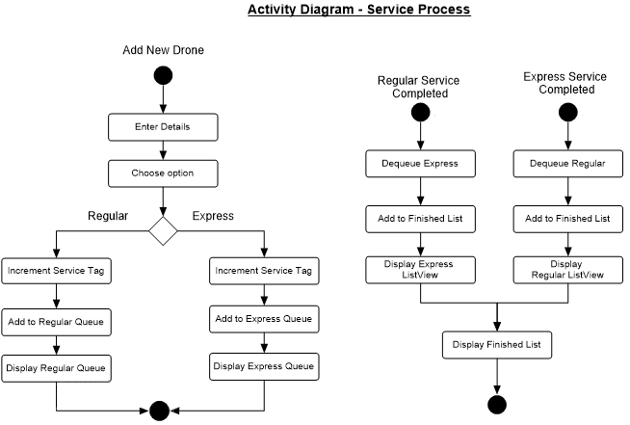

Question 1 Service Application Proposal
Complete the Service Application Proposal template with the project details, then provide a comprehensive list of requirements and features that satisfy the criteria outlined by the staff of Icarus Pty Ltd.
The scope of work should include an explanation of the goals for the application and what deliverables are expected as an outcome of the work.
Service Application Proposal
Project Name |  | Daedalus
Date |  | 20/11/2025
Student Name |  | Samuel Bailey
Scope of Work |  | WPF Application  C#  Appropriate Documentation
Stakeholders |  | Samuel Bailey: Programmer, Alisa Blakeney: Client/Lecturer
Icarus Staff Requirements
Req. # | Description |  | Importance | Notes
1 | Use of Queue Data Structure |  | High | Reflects actual order workflow for business
2 | Creation of Drone Data Model Class with provided attributes |  | Medium | Allows simple passing of all relevant data
3 | 15% cost increase function |  | High | Allows for company to easily supply express services
4 | Full Error trapping |  | High | Ensures proper workflow
5 | Feedback Messaging |  | Medium | Ensures UI readability and usability
6 | All inputs for relevant Drone Class attributes |  | High | Must be error guarded and easy to use
7 | Inputs to decide regular or express |  | High | Must be mutually exclusive
User Interaction and Specifications
- Add Data Inputs and Buttons (For adding new entry, should only work when all details filled)
- ListView for Regular Queue and Clear Button (Clear simply moves it to Finished Work)
- ListView for Express Queue and Clear Button (Clear simply moves it to Finished Work)
- ListBox for Finished Work and Order Completed Button (Maybe add an “are you sure” message to ensure payment is received)
- Status Strip with feedback warnings

Question 2 Interface Design
Create a detailed GUI Design along with details of all the components using a suitable GUI design software package (design cannot be hand drawn). Ensure your design covers all the features that are outlined by the Icarus Pty Ltd staff. Use the following template to complete this question.

GUI Design
Software Name | Daedalus | URL | https://www.figma.com/design/NXqhr6CrU8XTaWesAtQZ5Y/Drone-Repair-Tracking-Application?node-id=0-1&p=f&t=AB8fokNO44qRNY1z-0
Graphical User Interface Layout
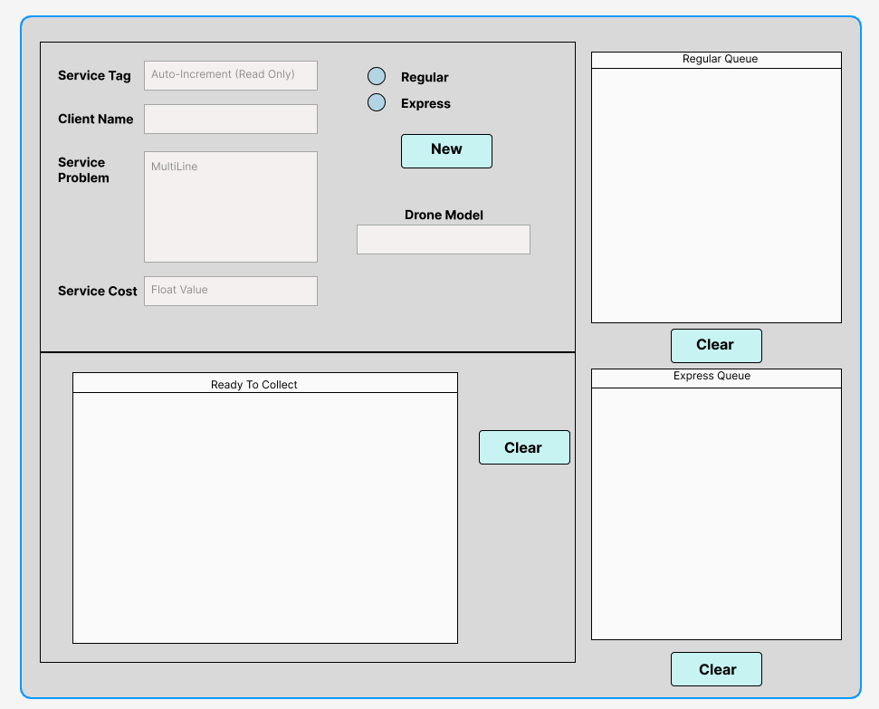
After meeting, decided to simplify and remove autoincrement. User can choose service tag.

Question 3 Class Details
Create a UML class diagram of the Drone data object and then define the data structure for the Queues and List in the target language. Use the following form to complete this question.
Class Details
UML Class Diagram
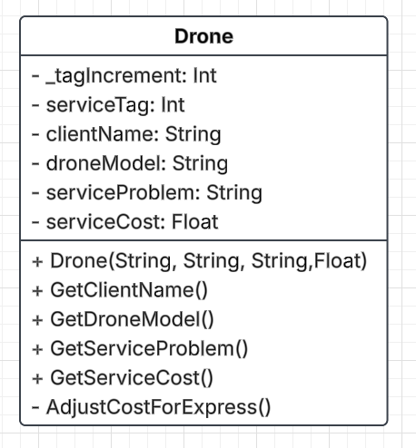

After meeting, decided to simplify and remove autoincrement. User can choose service tag.
Data Structure Definitions (in C# code)
Regular Queue

Queue<Drone> regularQueue = new Queue<Drone>();
regularQueue.Enqueue(latestDrone)

Express Queue

Queue<Drone> expressQueue = new Queue<Drone>();
expressQueue.Enqueue(latestDrone)

Finished Work List

List<Drone> finishedWork = new List<Drone>();
finishedWork.Add(latestDrone)

Question 4 Project Details
Using a CITE approved agile software development methodology, create a project plan. List and describe all the tasks required to complete the development of the Service Application. Create a new GitHub repository and then use the GitHub Project template to answer this question. Complete the following template as evidence of your work. Each of the project tasks should include their inputs, and outputs.

When selecting a SDLC for this project, include why it was chosen and compare it against at least two (2) other methods. Include tools that will ensure that the project runs in line with the selected methodology and how it achieves it.
Project Details
Project Name | Daedalus
Version Number | v 0.5 | Date | 20/11/2025
Repository Name: | Daedalus-DroneRepairApplication-
URL | https://github.com/SamB-TAFE/Daedalus-DroneRepairApplication-
Project Board | Style: Kanban Style Board  Name: @SamB-TAFE's Drone Application Development Plan  URL: https://github.com/users/SamB-TAFE/projects/2/views/1?system_template=kanban
Project Tasks | - Write Drone Model Class  {  Write this first so that the rest of the application can pass and use.  INPUTS: (string, string, string, float)  OUTPUTS: (string, string, string, float)  }  - Create GUI  {  Use the Windows Forms Designer window to ensure the appropriate buttons and inputs are present.  New Drone Button  Complete Regular Button  Complete Express Button  Clear Order Button  INPUT: <User Specified(strings, floats, clicks)>  OUTPUT: Visuals and Framework  }  - Create Drone Controller Class  {  Drone controller can hold all three data structures, handle the switching between them and how to handle the Drone class upon each input.  INPUTS: Drone Class Objects  OUTPUTS: Drones Class Objects, bools  }
Repository Details | Main Files:  Drone.cs  DroneController.cs  Program.cs  Various Visual Studio Project files and libraries
SDLC | Iterative
Justification | Iterative is good when asking for fast turnaround and the project may receive further requirements in the future. It allows for stable versions to be interacted with and then built again to include more after the client provides feedback and any new features they would like added.  Comparisons  Waterfall is more strict than Iterative because the whole project must be planned and completed in set stages. It does not handle changes well, and if something needs to be updated later, the earlier stages must be repeated. Waterfall less suitable for small projects where requirements may change.  Agile is similar to Iterative but involves more teamwork, planning, and constant communication. It uses short development cycles like sprints, but it can be too complex for a single-person student project. Agile also expects regular meetings and customer involvement.
Tools to support | GitHub and Visual Studio will the main technologies used within this project  Packages: Extended WPF Toolkit by Xceed (for numeric up down)

Question 5 Sign-off and Approval
Once you have completed the previous questions email your document to your lecturer to be reviewed by the Lecturer/Assessor for approval and feedback before completing the development and testing. Once your Design has been approved your lecturer record your progress.
Your document will include:
- Question 1 – Service Application Proposal.
- Question 2 – Interface Design.
- Question 3 – Class Details.
- Question 4 – Project Details (screen shots from source control)
Approval (Lecturer/Assessor use only)
Approver Name | Title | Signature | Date | Approved?
Lecturer Feedback

Question 6 Programming Criteria
Create and code the Service Application to demonstrate how a collection of information can be stored using a WPF Application (.NET WPF Application). This application will utilise a Queue<T> and a List<T> of a class object. Use the hardware and software supplied in the classroom to accomplish the development, debugging and internal documentation of the final Service Application. Use the Version Control System outlined in previous question to manage your code during the development. Your code must adhere to the CITEMS software development standards. (refer http://www.citems.com.au/)
The following programming criteria and features are required, the exact requirements of the Programming Criteria are essential. Any variation from them will need to be corrected in order to achieve a satisfactory performance.

GUI Features
- The input for the Service Tag must be a numeric control. The minimum value is 100, maximum is 900 with increments of 10.
- The input for the Service Priority must be two radio buttons inside the same GroupName. The two values are Regular and Express. This data is not part of the Drone class.
- The input for the Service Problem must be a multi-lined textbox.
- The service items must be displayed in a ListView which displays all the class attributes.
- The finished service items must be displayed in a ListBox which displays the Client Name and Service Cost.

Programming Criteria
- Create a separate class file to hold the data items of the Drone. Use separate getter and setter methods, ensure the attributes are private and the accessor methods are public. Add a display method that returns a string for Client Name and Service Cost. Add suitable code to the Client Name and Service Problem accessor methods so the data is formatted as Title case or Sentence case. Save the class as “Drone.cs”.
- Create a global List<T> of type Drone called “FinishedList”.
- Create a global Queue<T> of type Drone called “RegularService”.
- Create a global Queue<T> of type Drone called “ExpressService”.
- Create a button method called “AddNewItem” that will add a new service item to a Queue<> based on the priority. Use TextBoxes for the Client Name, Drone Model, Service Problem and Service Cost. Use a numeric control for the Service Tag. The new service item will be added to the appropriate Queue based on the Priority radio button.
- Before a new service item is added to the Express Queue the service cost must be increased by 15%.
- Create a custom method called “GetServicePriority” which returns the value of the priority radio group. This method must be called inside the “AddNewItem” method before the new service item is added to a queue.
- Create a custom method that will display all the elements in the RegularService queue. The display must use a List View and with appropriate column headers.
- Create a custom method that will display all the elements in the ExpressService queue. The display must use a List View and with appropriate column headers.
- Create a custom method to ensure the Service Cost textbox can only accept a double value with two decimal point.
- Create a custom method to increment the service tag control, this method must be called inside the “AddNewItem” method before the new service item is added to a queue.
- Create a mouse click method for the regular service ListView that will display the Client Name and Service Problem in the related textboxes.
- Create a mouse click method for the express service ListView that will display the Client Name and Service Problem in the related textboxes.
- Create a button click method that will remove a service item from the regular ListView and dequeue the regular service Queue<T> data structure. The dequeued item must be added to the List<T> and displayed in the ListBox for finished service items.
- Create a button click method that will remove a service item from the express ListView and dequeue the express service Queue<T> data structure. The dequeued item must be added to the List<T> and displayed in the ListBox for finished service items.
- Create a double mouse click method that will delete a service item from the finished listbox and remove the same item from the List<T>.
- Create a custom method that will clear all the textboxes after each service item has been added.
- All code is required to be adequately commented. Map the programming criteria and features to your code/methods by adding comments above the method signatures. Ensure your code is compliant with the CITEMS coding standards (refer http://www.citems.com.au/).

Question 7 UI Testing Report
Once you have completed coding the application, ensure your code is error free and functions correctly. Run the application and check all the UI features work correctly and the various controls are fully functional. You will need to complete the following testing report and provide appropriate evidence that your code functions as expected (references to screen captures). Complete the following Test Report template below.
System Testing Report
Project Name |  | Daedalus
Methods |  | Buttons  AddNewItem()  FinishRegularOrder()  FinishExpressOrder()  ClearFinishedOrder()  Text Input Use  CostInput_TextChanged()  Click Lists  RegularListView_Click()  ExpressListView_Click()  FinishedListBox_DoubleClick()
Description |  | This program lets you add drone repair jobs, sort them into regular or express queues, and move finished jobs into a list for payment.
Level of Testing |  | System Testing
Developer |  | Sam Bailey |  | Tester | Sam Bailey |  | Date |  | 26/11/2025
Test Case No | Test Case Name |  | Test steps |  |  | Test Data |  | Expected result |  | Pass / Fail
1 | Add Regular Queue Item |  | Input all relevant order details  Click Regular Radio Button.  Click New Order Button |  |  | Tag: 100  Client: Alyssa  Model: Flyer  Cost: 120.45  Description: Broken Rotors  Event:  Button Click |  | The order is placed in regular list view. Drone Attributes mapped to proper columns |  | P
2 | Add Express Queue Item |  | Input all relevant order details  Click Express Radio Button.  Click New Order Button |  |  | Tag: 110  Client: Sam  Model: Wheeled  Cost: 300.99  Description:  Engine smoking, need replacement wheels  Event:  Button Click |  | The order is placed in regular list view. Drone Attributes mapped to proper columns. Cost is increased by 15% |  | P
3 | Input Incorrect Cost Value |  | Input invalid data into Cost Text Input |  |  | 20 bucks  Event:  Text Input |  | Cost input returns to 0.00 |  | P
4 | Missing Input Failure |  | Input all relevant order details, except one  Click Regular Radio Button.  Click New Order Button |  |  | Tag: 120  Client: Sunju  Model: EMPTY  Cost: 210.75  Description: Currently on fire  Event:  Button Click |  | A message box tells to add model name. Order is not put in queue |  | P
5 | Click Regular List Item |  | Click an item within the Regular ListView |  |  | Event:  Click ListView |  | Client Name and Description are placed in relevant TextBoxes |  | P
6 | Click Express List Item |  | Click an item within the Express ListView |  |  | Event:  Click ListView |  | Client Name and Description are placed in relevant TextBoxes |  | P
7 | Finish Regular Queue Order |  | Click the relevant Finish Order Button |  |  | Event:  Button Click |  | Order is removed from regular queue and appears in finished ListBox |  | P
8 | Finish Express Queue Order |  | Click the relevant Finish Order Button |  |  | Event:  Button Click |  | Order is removed from express queue and appears in finished ListBox |  | P
9 | Double Click Finished List Item |  | Double click item within the Finished ListBox |  |  | Event:  Double Click ListBox |  | Order is removed from Listbox |  | P
10 | Clear Finished Item Button |  | Click the Pay and Clear Button |  |  | Event:  Button Click |  | Order is removed from Listbox |  | P

Test Screenshots

Add Regular
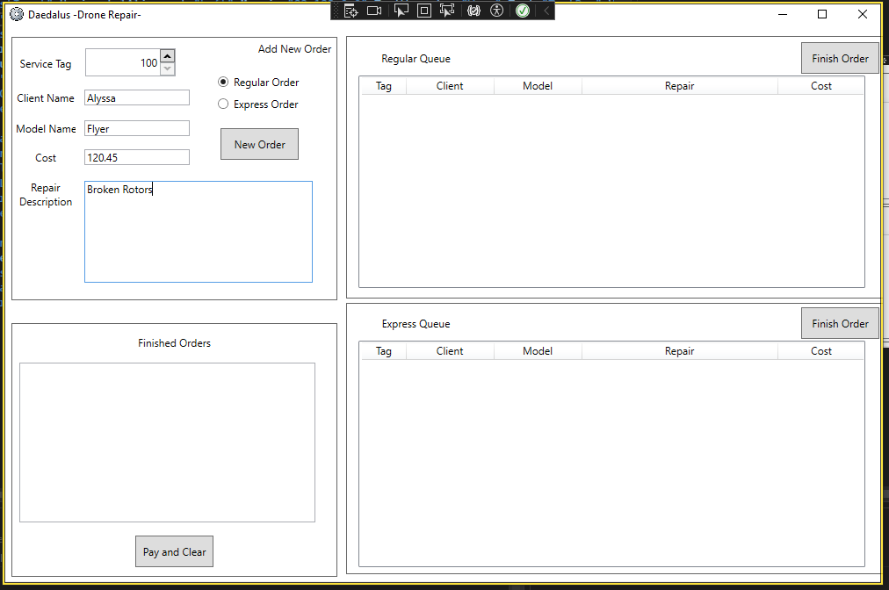
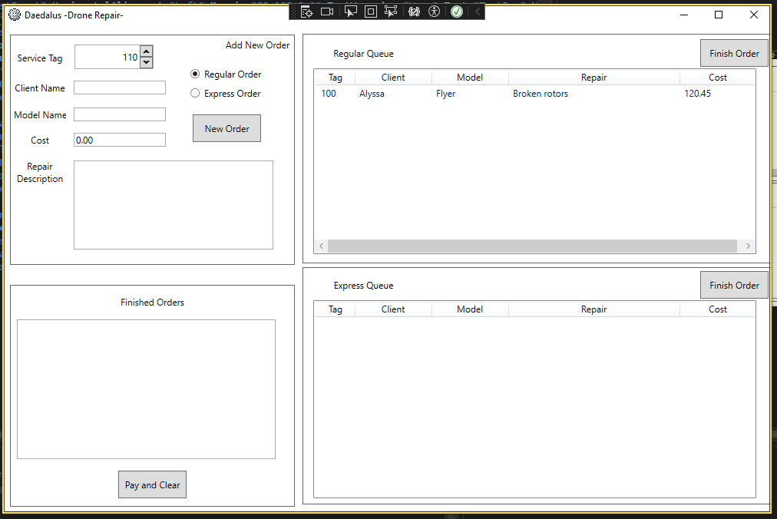

Add Express
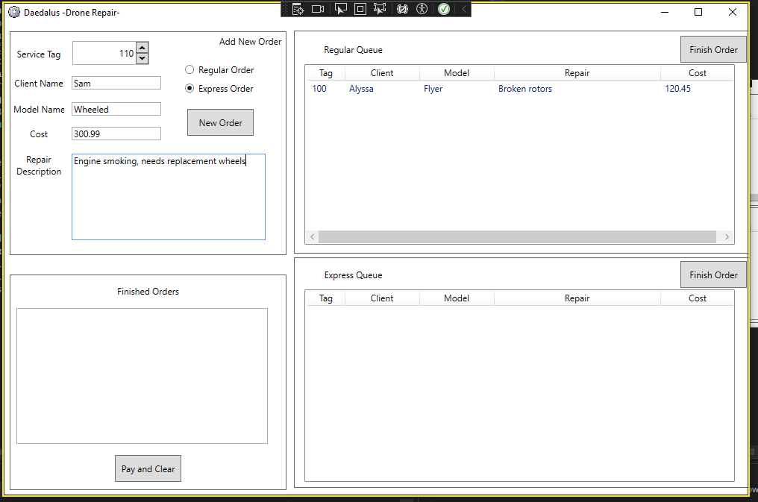
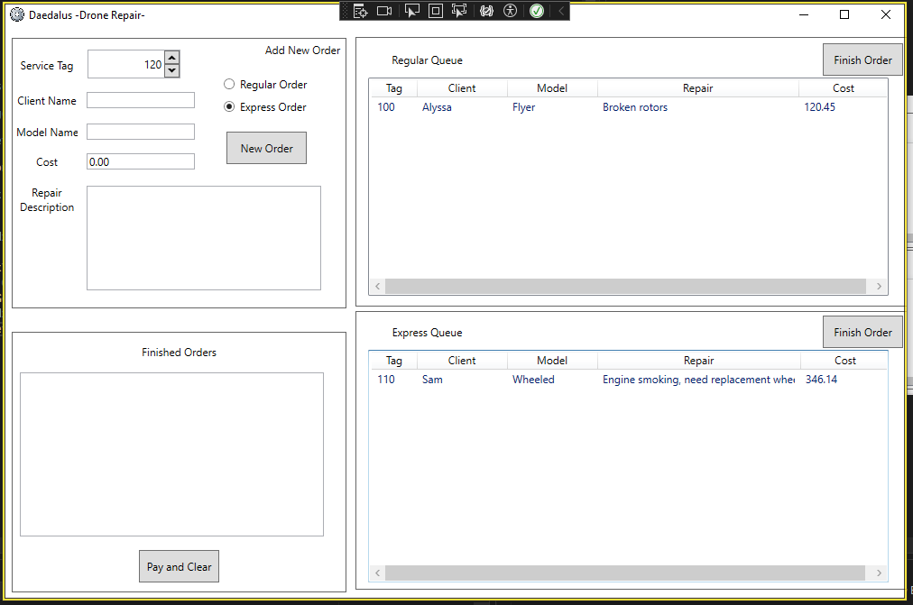

Incorrect Cost Input
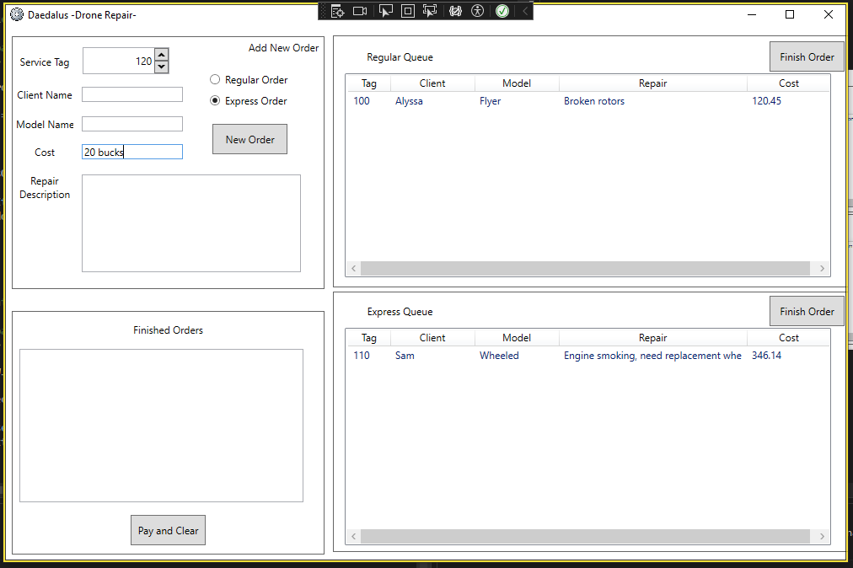
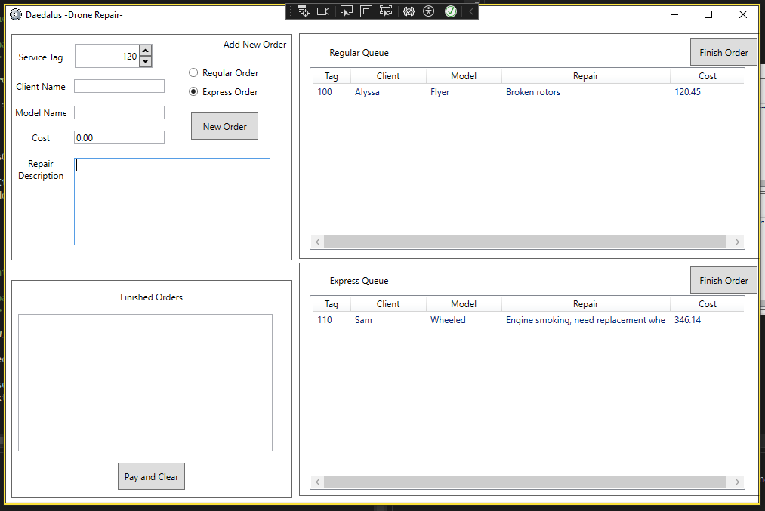

Missing Drone Input
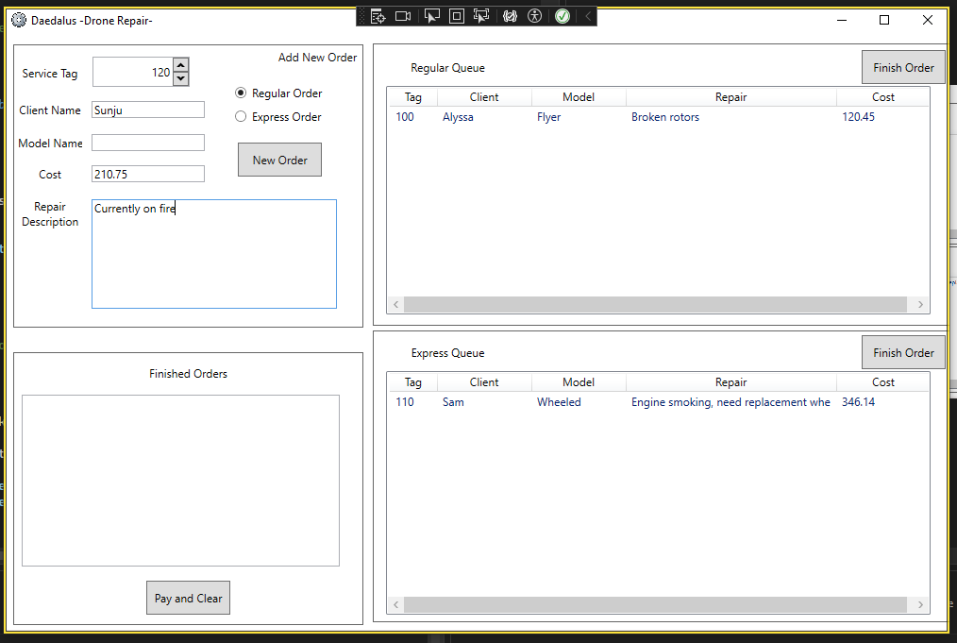
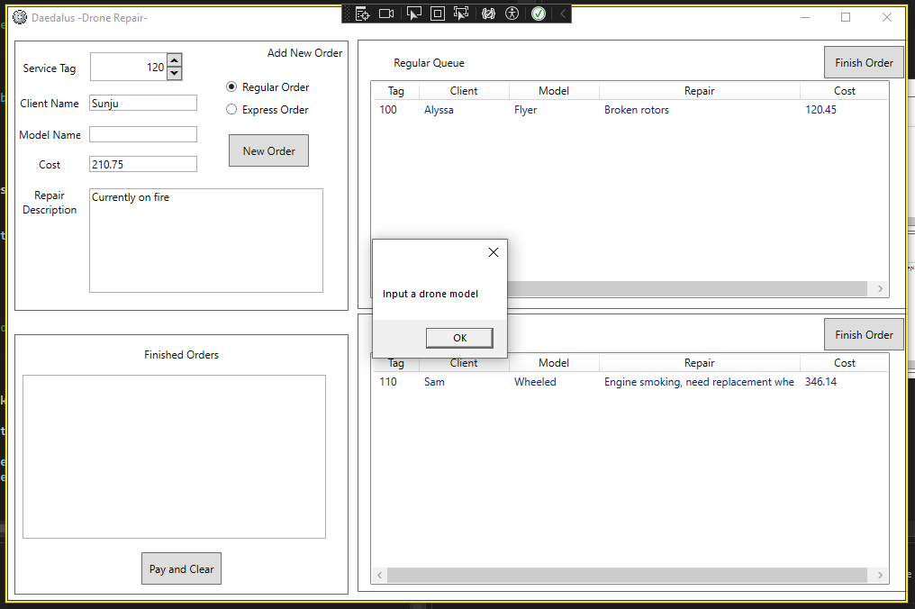

Click Regular Item
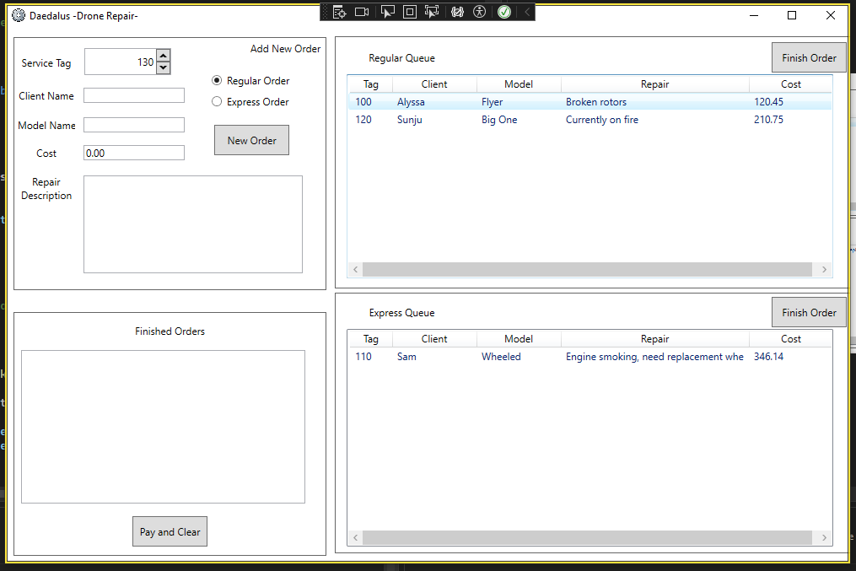
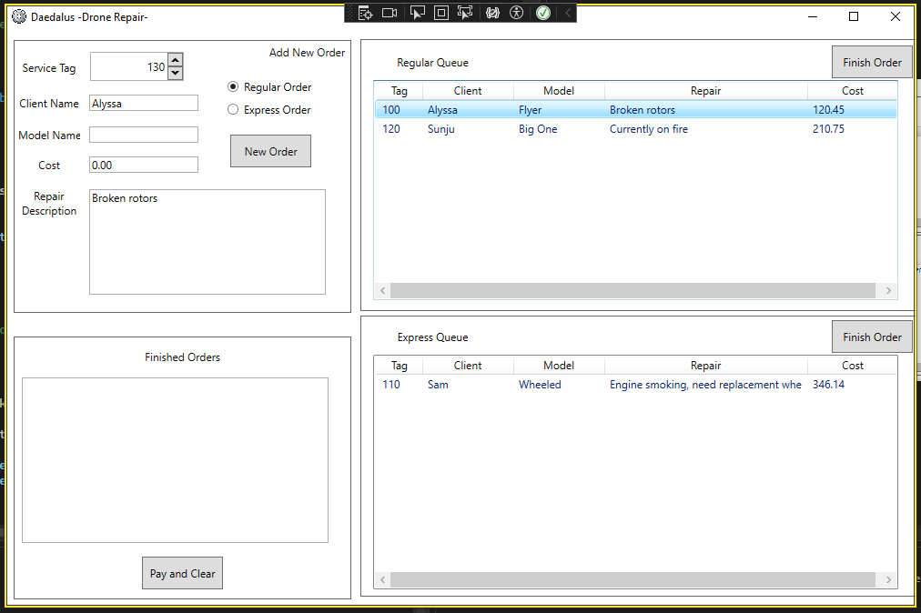

Click Express Item
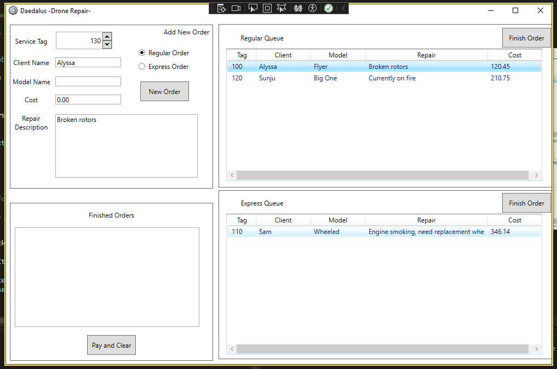
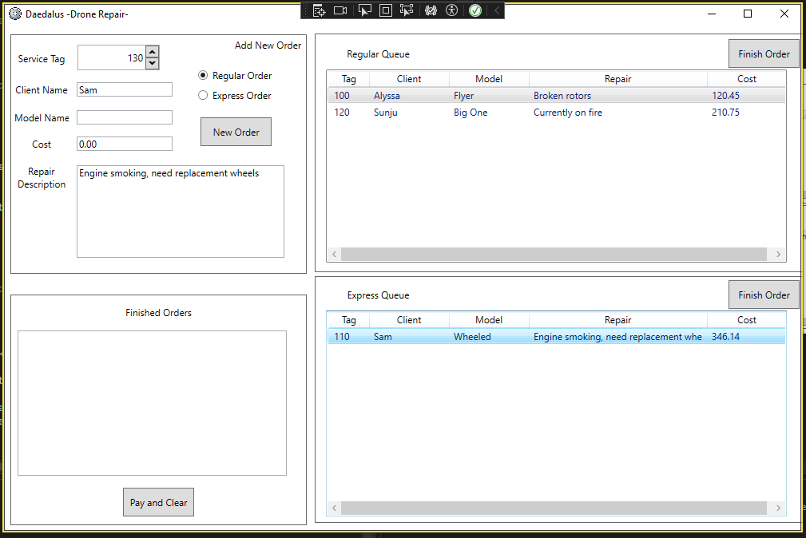

Finish Regular Button
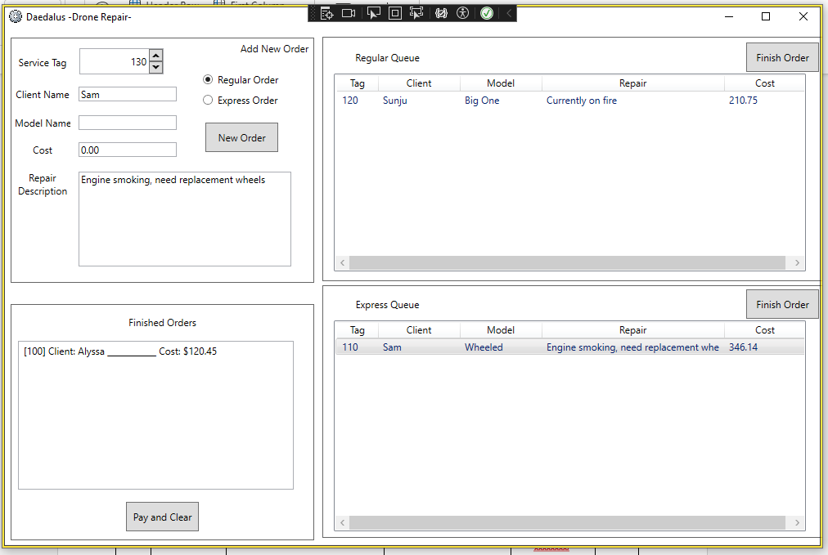

Finish Express Button
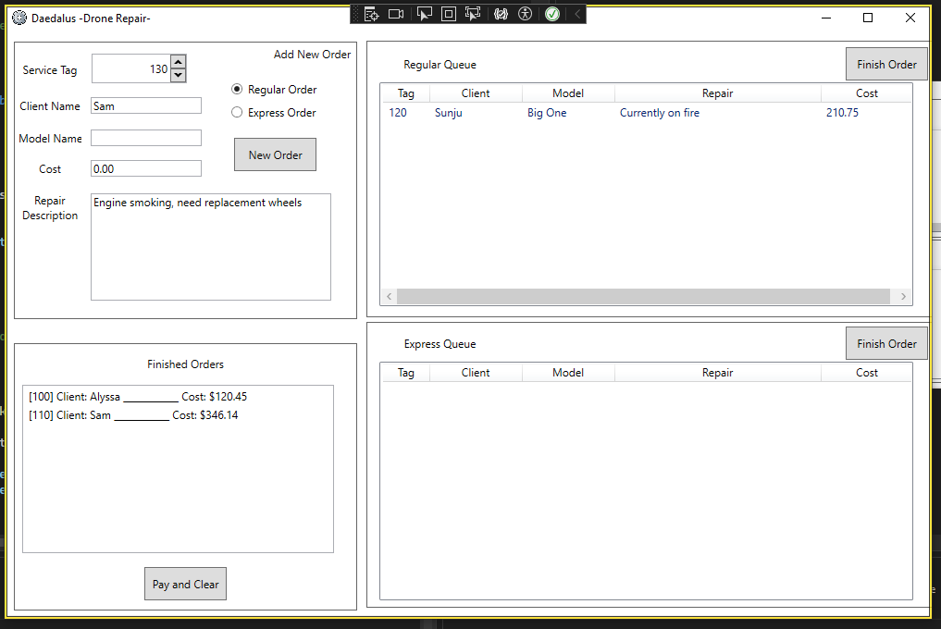

Double Click Finished List
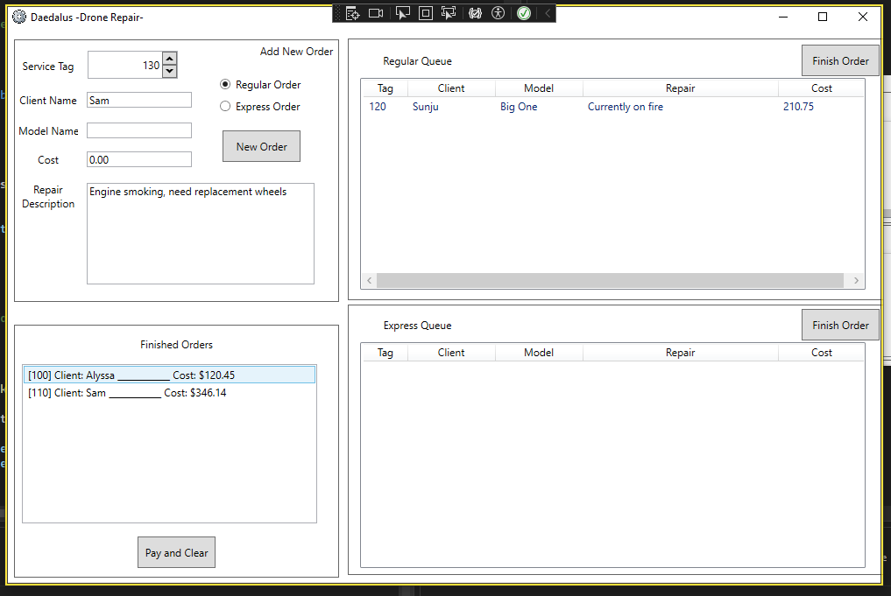
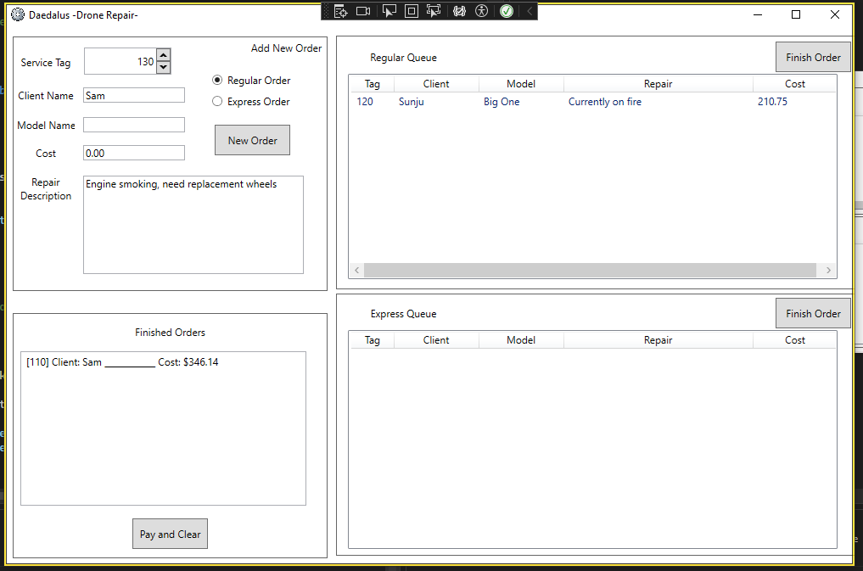

Pay and Clear Button
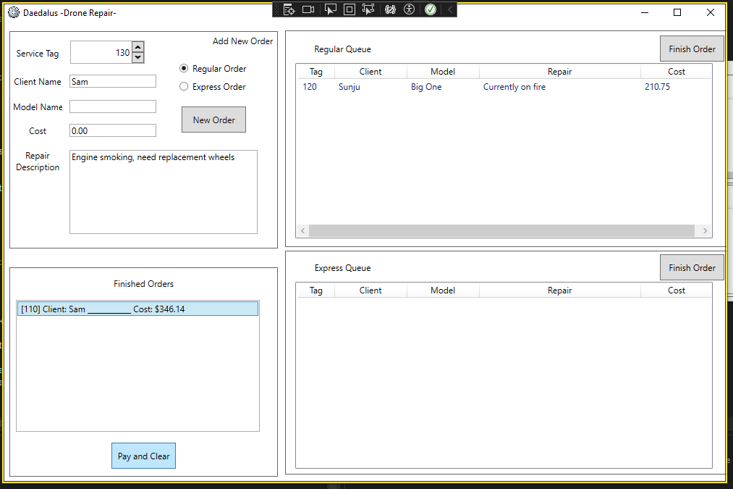
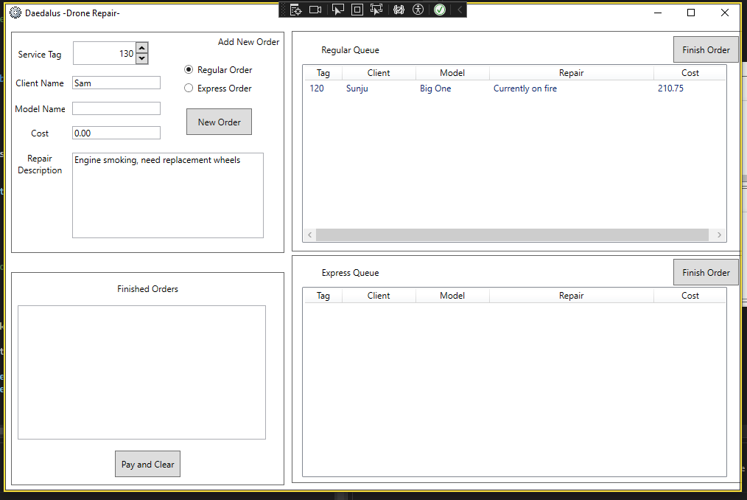

Question 8 Demonstration and Submission
Complete the documentation for the previous Questions and then request a suitable time to demonstrate your Service Application for approval. The demonstration will ensure your code is compliant and your documentation conforms to CITE standards.
Ensure that you have identified limitations that your application has, and how you would approach a similar task in the future.
Limitations
- It does not save any data, so all queues/data are cleared when the application closes.
- You can only dequeue the next item, it assumes that all work is done in queue order
- No search or filtering, so users must scroll through lists to find items.
Lessons Learned
- View Models are very useful for separating what needs to be seen and what needs to be stored. Also helped to map to ListView within WPF.
- Don’t overcomplicate, remember to read the assignment brief

Note: All documentation must use the supplied templates/forms.
Submit the zipped solution folder with relevant documents to Blackboard
End of Assessment Task Two

