Binary Classification

# APPA-Real Trained Model

'./models/ResNet50_fc+layer4_2025-01-22_v1.pth'

## UTKFace Test Data

## APPA-Real Test Data

# UTKFace Trained Model

‘ResNet50_fc+layer4_v3.pth’

## UTKFace Test Data

## APPA-Real Test Data



# Comparison of Bias

Clear bias towards white. APPA-Real trained model has notably poor performance for Asian. Low recall indicates that the model is missing many true positives (>25) for Asians, while the high precision indicates that when the model predicts positive for Asians it is generally correct.

Multiclass Classification

# APPA-Real Trained Model

‘multiclass/ResNet50_fc+layer4_2025-02-05_v1.pth’

## UTKFace Test Data

## APPA-Real Test Data

# UTKFace Trained Model

‘multiclass/ ResNet50_fc+layer4_v1.pth’

## UTKFace Test Data

## APPA-Real Test Data

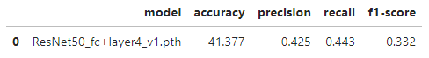

# Comparison of Bias

