Logging

Setup

Data Augmentation:

Stratified Batches to achieve balance of classes:

Data Batches:

Criterion & Optimiser:

# Pytorch ResNet-18 (ImageNet trained)

## Training weights of one FC layer (512->1)

## Training weights on ResNet layer 4 + FC layer

## Training weights on ResNet layer 4 + FC layer. With dropout before final FC layer.

Still see overfitting – likely occurs in layer 4…

# Pytorch ResNet-50 (ImageNet trained)

## Training weights of one FC layer (2048->1)

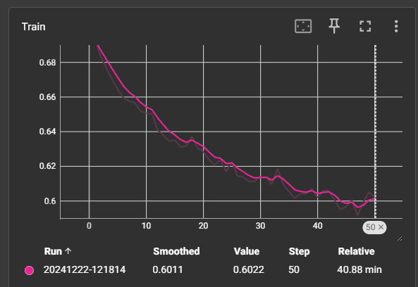

## Training weights on ResNet layer 4 + FC layer

# Pytorch ResNet-18 (ImageNet trained)

Same setup with different loss criterion



## Training weights of one FC layer (512->1)

