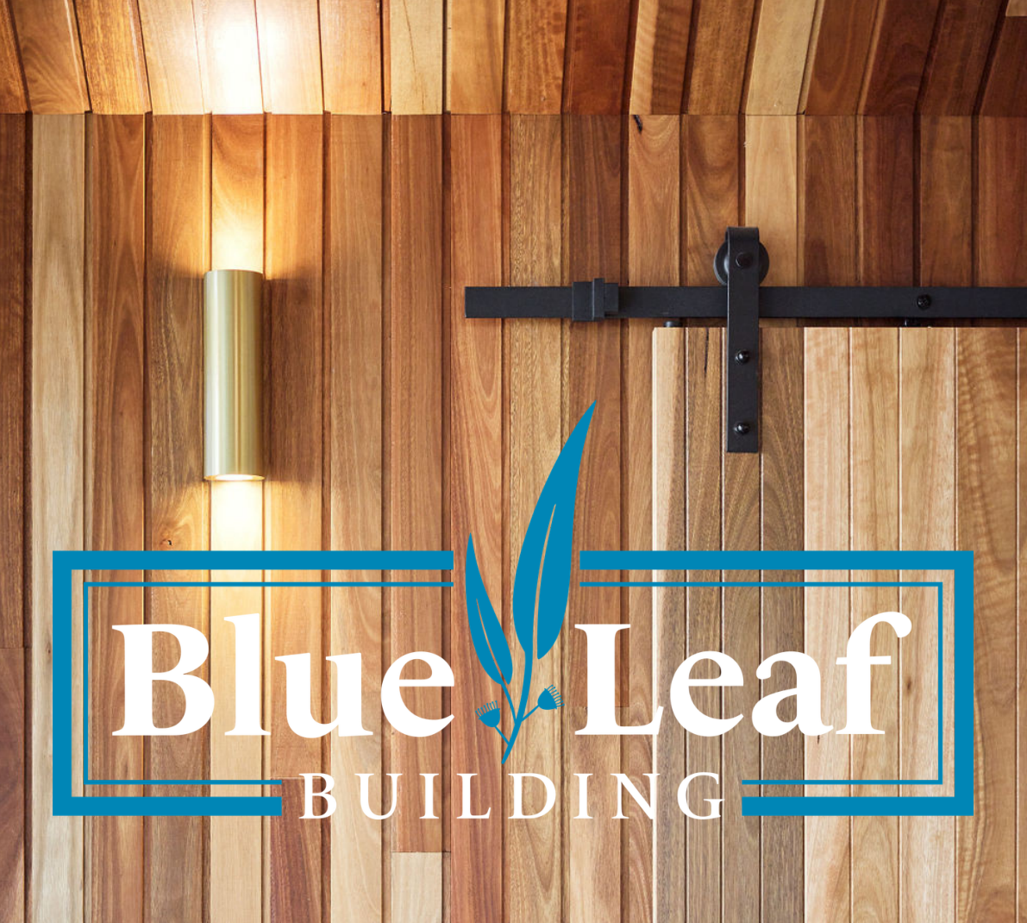
FIXED PRICE
CONSTRUCTION PROPOSAL
{NICHE_STATEMENT}
Prepared for
{CLIENT_SALUTATION}
At
{PROJECT_ADDRESS}
{QUOTE_NUMBER}
{DATE}

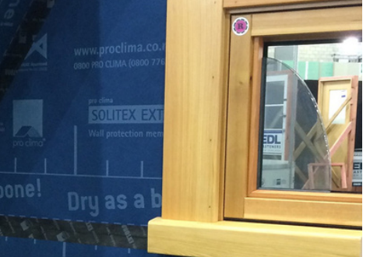
PROPOSAL OVERVIEW
P R O J E C T S N A P S H O T

CLIENT  {CLIENT_SALUTATION}  PROJECT ADDRESS  {PROJECT_ADDRESS}  QUOTE NUMBER  {QUOTE_NUMBER}  DATE  {DATE} | INVESTMENT SUMMARY  {TOTAL_INC_GST}  (inc GST)  The full scope, assumptions, inclusions, allowances and payment schedule are set out in the following pages.

DOCUMENT GUIDE
P R O P O S A L C O N T E N T S

01 Introduction
02 Fixed Price & Scope of Work
03 Why Build With Blue Leaf
04 Our Guarantees
05 Online Project Management
06 Inclusions
07 Prime Cost & Provisional Sums
08 Optional Upgrades & Cost Saving Alternatives
09 Construction Schedule
10 Testimonials
11 Licences & Associations
12 Responsibilities
13 Exclusions
14 Quote Summary
15 Fee Schedule
16 The Next Step
17 Summary

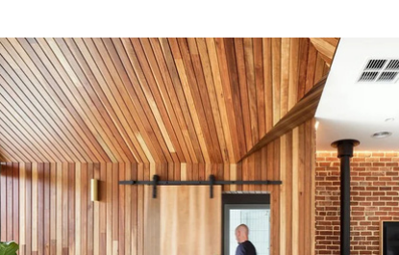
I N T R O D U C T I O N

Dear {CLIENT_SALUTATION}
{OPENING_PARAGRAPH}
This proposal and the pricing herein shall remain valid for a period of 30 days following the date shown above.
Yours sincerely,
{SIGNATORIES}

FIXED PRICE & SCOPE OF WORK
F I X E D P R I C E & S C O P E

Your total fixed price
{TOTAL_INC_GST}
(inc GST)
{VARIATIONS_CLAUSE}

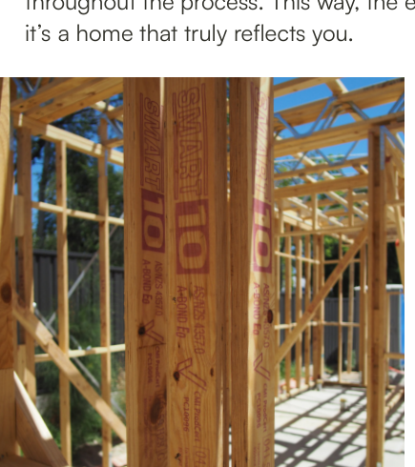
WHY BUILD WITH BLUE LEAF

Craftsmanship  Built around quality workmanship and careful supervision. | Energy & Comfort  Detailing that supports better-performing homes.
Communication  Clear updates, fewer surprises, better decisions. | Boutique Focus  Limited project load and direct involvement.

{WHY_BUILD_WITH_US}

CONFIDENCE AFTER HANDOVER
O U R G U A R A N T E E S

We do not just build homes. We stand behind the work long after handover.
{#GUARANTEES}
{GUARANTEE_HEADING}
{GUARANTEE_TEXT}
{/GUARANTEES}


ONLINE PROJECT MANAGEMENT

{ONLINE_PM_BODY}
Progress  Live updates and photos. | Selections  Decisions captured clearly. | Variations  No hidden surprises.

THE DETAIL BEHIND THE PROPOSAL
I N C L U S I O N S

The inclusions below are structured to give you a clear view of what has been allowed for in the proposal.
{#INCLUSION_SECTIONS}
{SECTION_HEADING}
{#SECTION_ITEMS}
- {ITEM_TEXT}
{/SECTION_ITEMS}
{/INCLUSION_SECTIONS}

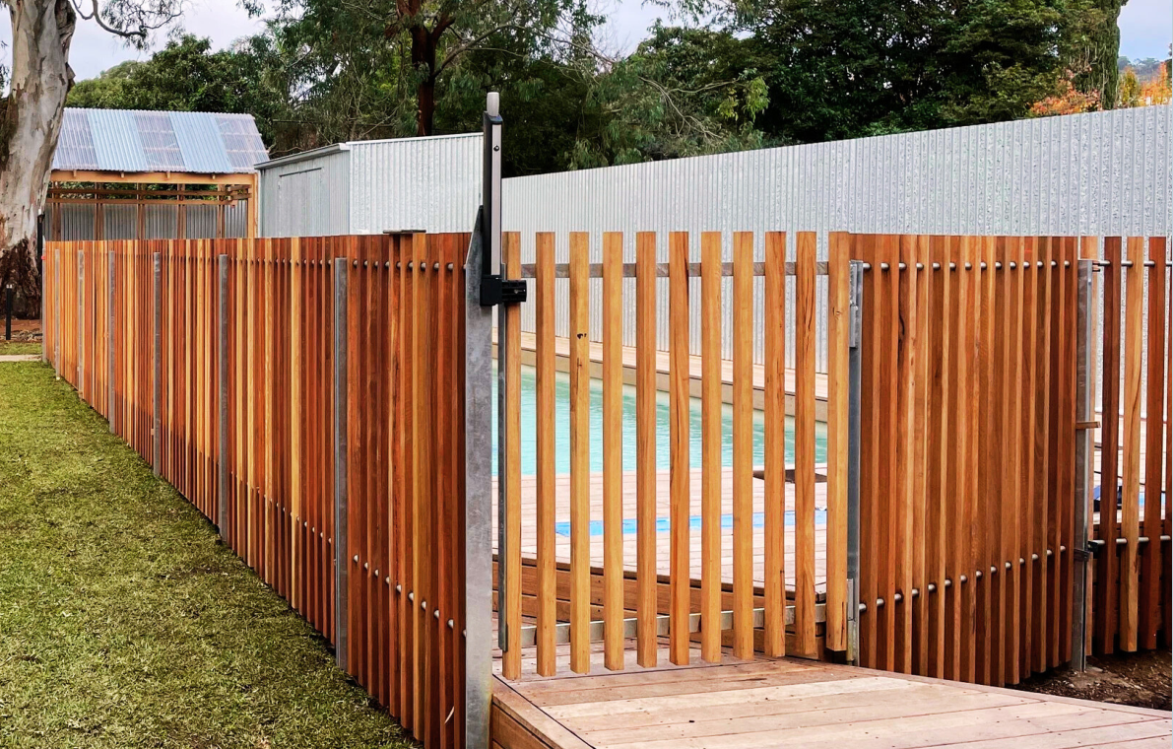
PRIME COST & PROVISIONAL SUMS

The following allowances are included for items not yet fully selected or confirmed. Any adjustment is treated as a variation.
{#PC_SUMS}
Description | Amount
{PC_DESCRIPTION} | {PC_AMOUNT}
{/PC_SUMS}

OPTIONAL UPGRADES & COST SAVING ALTERNATIVES
O P T I O N A L I T E M S

Below are items not included in the base contract price, but which can be added or reviewed before contract finalisation.
{#OPTIONAL_ITEMS}
{OPTION_DESCRIPTION} | {OPTION_PRICE}
{/OPTIONAL_ITEMS}


C O N S T R U C T I O N S C H E D U L E

{CONSTRUCTION_SCHEDULE_INTRO}
Indicative total duration
{TOTAL_WEEKS}
{#CONSTRUCTION_SCHEDULE}
{PHASE_LABEL} | {PHASE_WEEKS}
{#TASKS}  - {TASK_NAME}  {/TASKS} | Starts week  {START_WEEK}  Duration  {TASK_WEEKS}
{/CONSTRUCTION_SCHEDULE}

CLIENT EXPERIENCE
W H A T O U R C L I E N T S S A Y

{#TESTIMONIALS}
“
{TESTIMONIAL_TEXT}
{TESTIMONIAL_AUTHOR}
{/TESTIMONIALS}


LICENCES & ASSOCIATIONS

Blue Leaf Building is backed by relevant licences, industry relationships and supplier networks that support quality, compliance and delivery.
{#LICENCES}
{LICENCE_TEXT}
{/LICENCES}

CLEAR ROLES FROM THE START
R E S P O N S I B I L I T I E S

Our responsibilities | Your responsibilities
{#RESPONSIBILITIES_OURS}  - {RESP_TEXT}  {/RESPONSIBILITIES_OURS} | {#RESPONSIBILITIES_YOURS}  - {RESP_TEXT}  {/RESPONSIBILITIES_YOURS}

E X C L U S I O N S

The following items are excluded from this proposal unless specifically noted elsewhere in the scope.
{#EXCLUSIONS}
- {EXCLUSION_TEXT}
{/EXCLUSIONS}


Q U O T E S U M M A R Y

{#SUMMARY_ROWS}
Category | Cost inc GST
{CATEGORY_NAME} | {CATEGORY_COST_GST}
{/SUMMARY_ROWS}
Total investment
{TOTAL_COST_GST}
(inc GST)

SCHEDULE OF PROGRESS PAYMENTS
F E E S C H E D U L E

{#FEE_SCHEDULE}
Claim | Milestone | %
{STAGE_CLAIM} | {MILESTONE} | {PERCENTAGE}
{/FEE_SCHEDULE}


T H E N E X T S T E P

1  Review | 2  Approve | 3  Contract | 4  Commence
{NEXT_STEPS}

CLOSING SUMMARY
S U M M A R Y

{APB_SUMMARY_BODY}

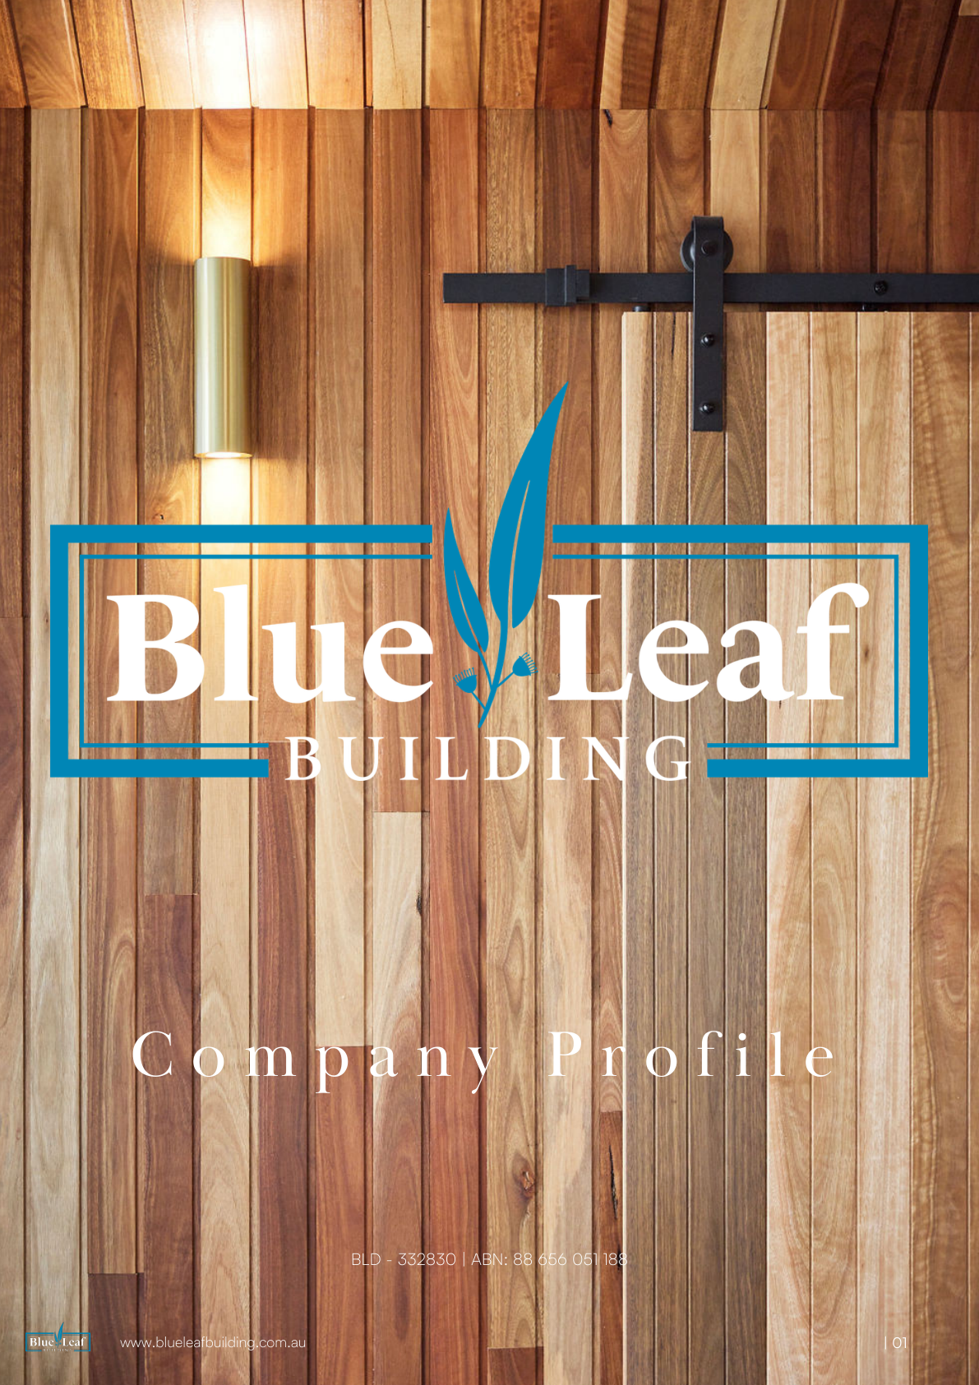
BLUE LEAF BUILDING
Custom New Homes & Bespoke Renovations
www.blueleafbuilding.com.au
info@blueleafbuilding.com.au

