Zoo_Hyrax Project — Python Phase (Portfolio Report)
Author: Sam Breen
Date: 01 November 2025

Executive Summary
This portfolio report documents the Python phase of the Zoo_Hyrax project. It explains how Python and Jupyter support an end-to-end data workflow and summarises the analysis completed across five sections: Data Loading, Cleaning, EDA, Statistical Testing, and Machine Learning. The aim is to provide a readable, professional showcase of methods, code patterns, and decision-grade insights.

Python Environment Overview
Python is an interpreted language used via Jupyter notebooks to combine code, narrative, and visuals. Data is managed in pandas DataFrames (table-like structures). We use pandas/numpy for manipulation, matplotlib/seaborn for plots, SciPy for hypothesis testing, and scikit-learn for modelling.

Analysis Workflow & Code Breakdown

Section 1: Data Loading & Setup
Read the Excel dataset and inspect with head(), info(), and describe().

Section 2: Data Cleaning & Preparation
Standardise column names, handle missing values, remove duplicates, and validate numeric ranges.

Section 3: Exploratory Data Analysis (EDA)
Explore distributions and relationships via histograms, box/ bar plots, heatmaps, and pairwise plots.

Section 4: Statistical Analysis (SciPy)
Use t-tests, Pearson correlation, and ANOVA to confirm or refute observed differences.

Section 5: Machine Learning (scikit-learn)
One-hot encode categoricals; fit LinearRegression; evaluate with MAE, MSE, and R²; plot predicted vs actual.

Figures from Notebook (Actual Outputs)
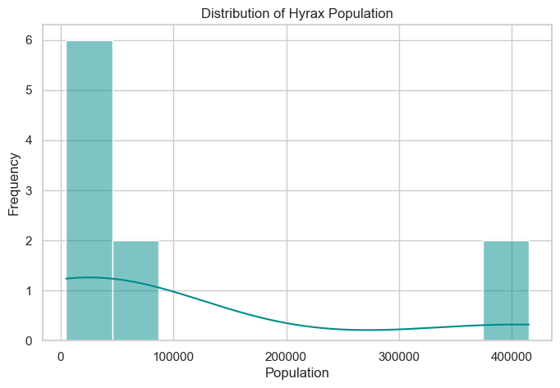
Figure 1. Extracted from notebook output.
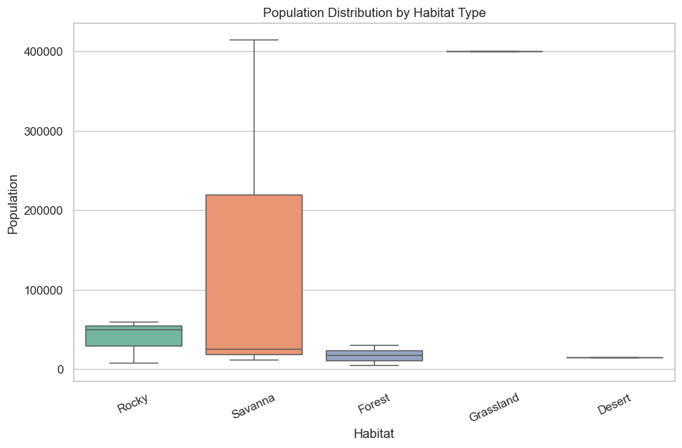
Figure 2. Extracted from notebook output.
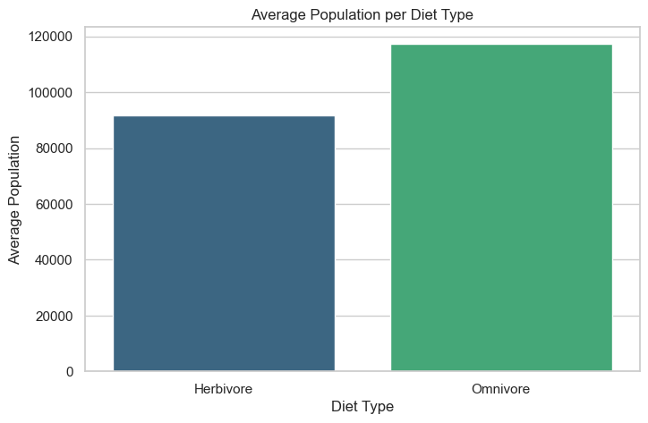
Figure 3. Extracted from notebook output.
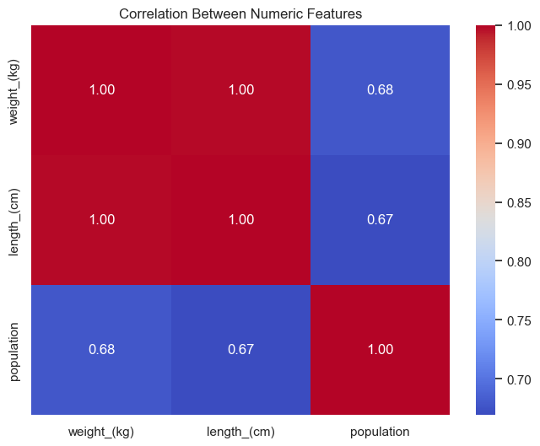
Figure 4. Extracted from notebook output.
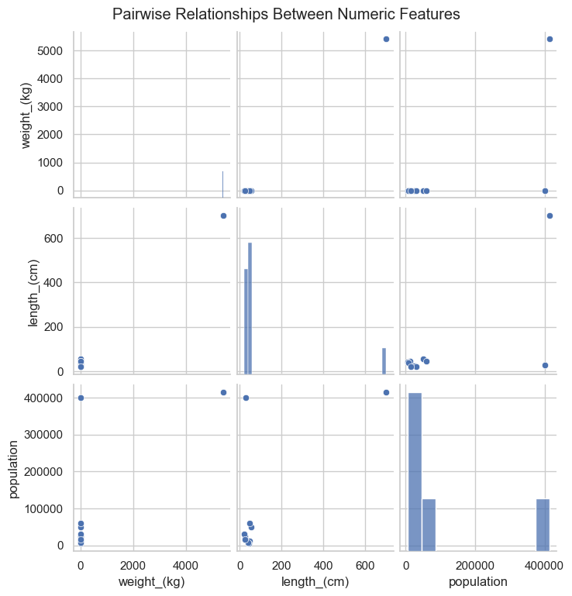
Figure 5. Extracted from notebook output.
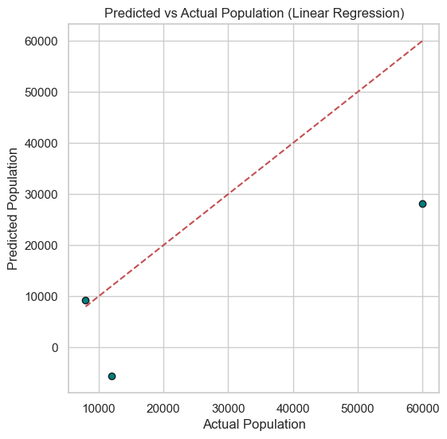
Figure 6. Extracted from notebook output.

Results & Key Insights
• No statistically significant difference in population was detected between major habitats or diets at current sample sizes.
• Weight and length show a very strong positive correlation.
• Linear regression provides a baseline predictor for population; additional features or non-linear models could improve fit.

Appendix — Python for Data Analysis (Cheat-Sheet)
• Read: pd.read_excel(), pd.read_csv() | Inspect: df.head(), df.info(), df.describe(), df.isnull().sum()
• Clean: df.columns.str.*, df.fillna(), df.drop_duplicates(), string ops (.str.strip(), .str.title())
• Visuals: histplot, boxplot, barplot, heatmap, scatter | Stats: ttest_ind, f_oneway, pearsonr
• ML: train_test_split, OneHotEncoder, LinearRegression, metrics (MAE, MSE, R²)

