REVOLUT Payment Acquirer
Integrating a Payment Acquirer can help reduce the number of abandoned baskets or leave the checkout page. The integration of the Odoo system with the Revolut Payment Acquirer offers customers the opportunity to pay from their Revolut account for the goods or services they want to purchase.
To install and configure the Revolut Payment Acquirer go to Apps Module - All Categories –search Revolut Module - click the Install button:
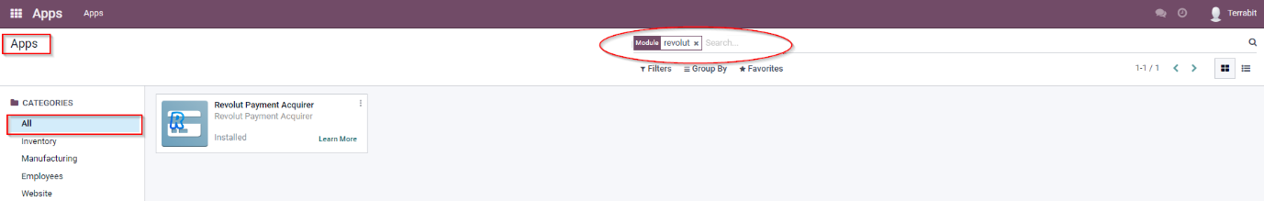
To configure the Payment Acquirer, access the menu Accounting:
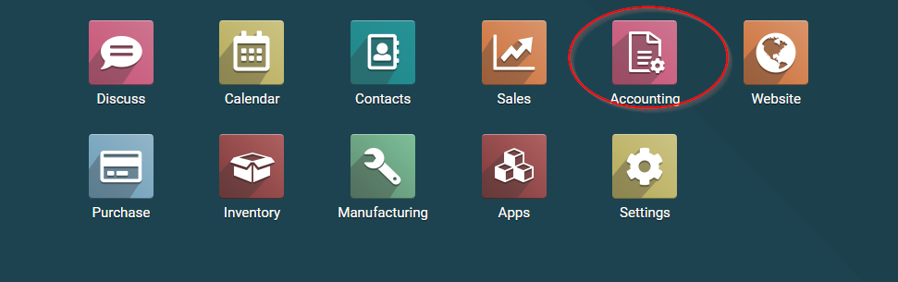
In Accounting – Configuration – click on Payment Acquirers:
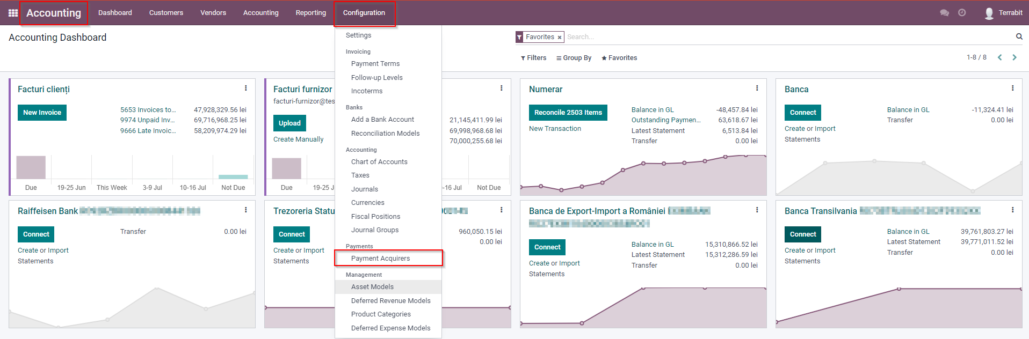
The Payment Acquirers window will open and access Revolut:
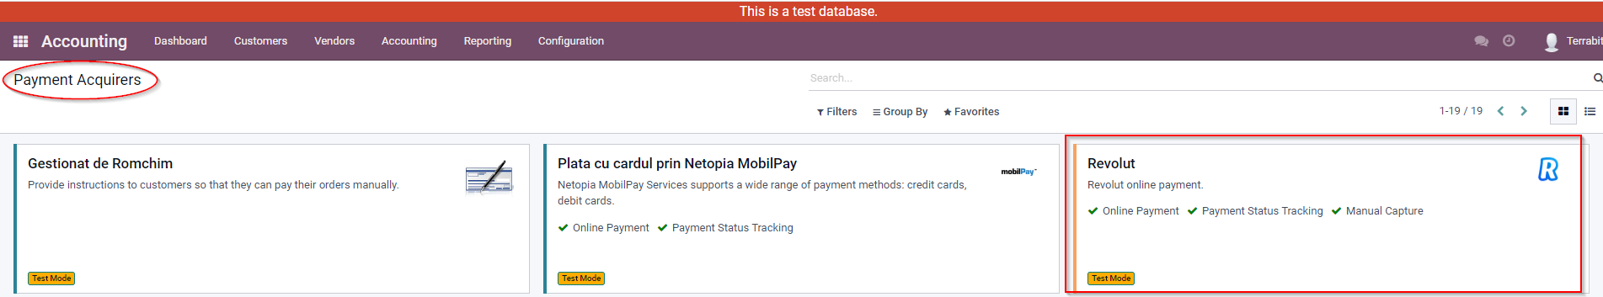
Click the Edit button and configure the Revolut Payment Acquirer by filling in the following data:
You will choose one of the State options.
- Disabled;
- Active;
- Test mode.
1) Credentials– fill with Revolut Api Key;
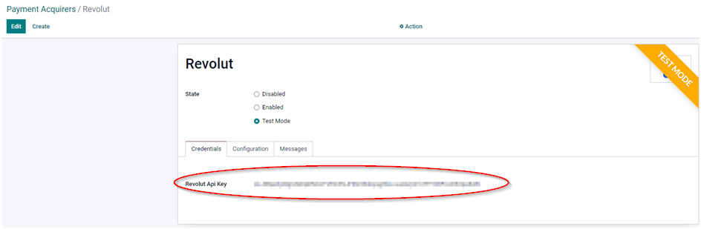
2) In the Configuration section:
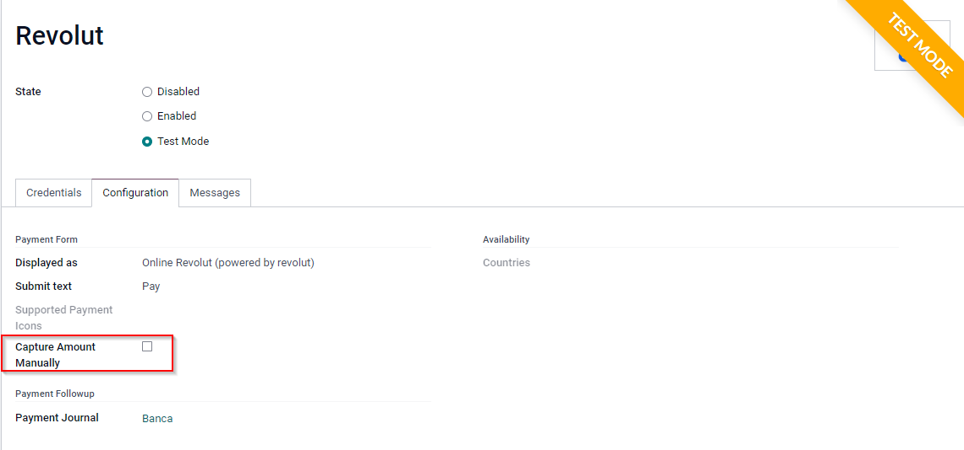
- Displayed as;
- Submit text;
- Capture Amount Manually –ticking the box allows you to capture the amount;
- Payment Journal – here you must select a Journal Bank.
IMPORTANT!!!
In the Sales Order, the Capture Transaction button will look like this:
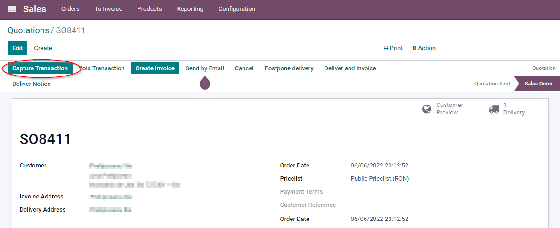
3) Messages– In this menu, you can set different messages, such as Help Message, Pending Message, Authorize Message, Done Message or Canceled Message.
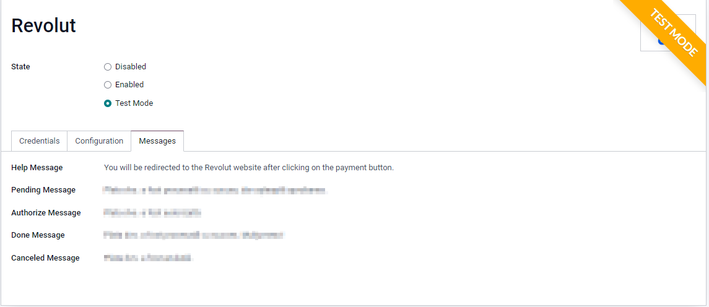
After setting up the Revolut Payment Acquirer, press the Save button:
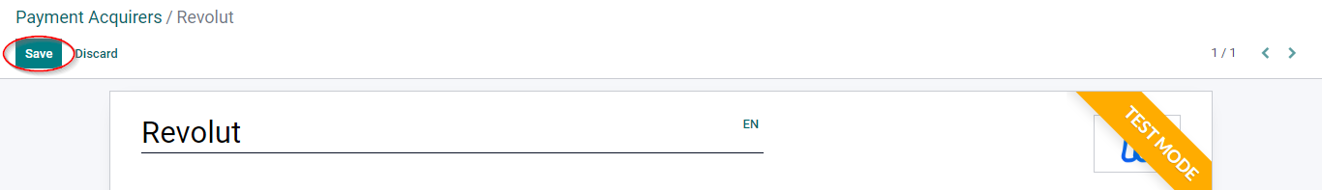
In this way, when ordering online, the customer can select the payment method through the Revolut Payment Acquirer.

