**SECURING**

**WEB APPLICATIONS**

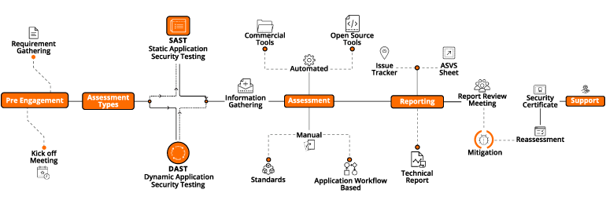

**Submitted By: SOURABH**

**DDOS:**

**Introduction:**

A distributed denial-of-service (DDoS) attack is a malicious attempt to disrupt normal traffic of a targeted server, service or network by overwhelming the target or its surrounding infrastructure with a flood of Internet traffic. DDoS attacks achieve effectiveness by utilizing multiple compromised computer systems as sources of attack traffic. Exploited machines can include computers and other networked resources such as IoT devices. From a high level, a DDoS attack is like a traffic jam clogging up with highway, preventing regular traffic from arriving at its desired destination.

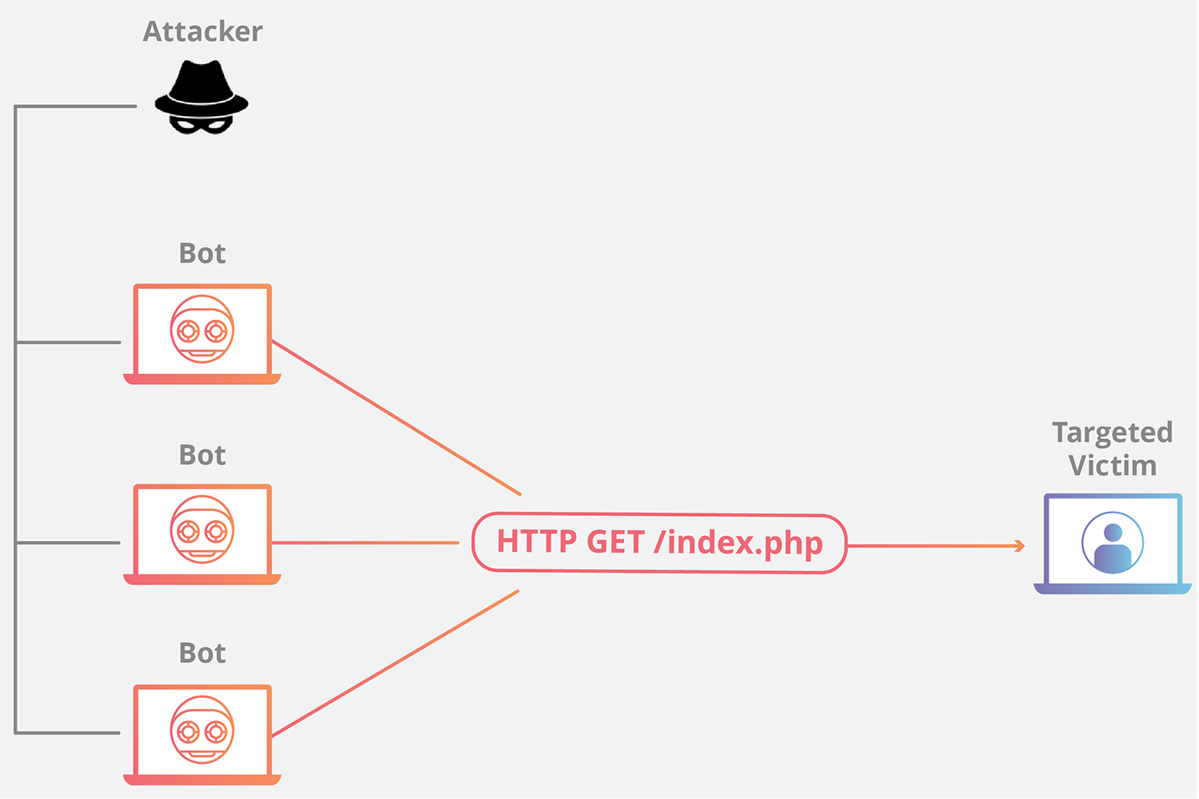

Fig-1.1 HTTP Flood DDOS attack

**Types of DDOS Attack:**

* Memcached DDOS Attack
* NTP Amplification Attack
* DNS Amplification Attack
* SSDP Attack
* DNS Flood
* HTTP Flood
* SYN Flood Attack
* UDP Flood Attack
* Ping (ICMP) Flood Attack
* Low and Slow Attack
* Application Layer Attack
* Cryptocurrency Attack
* Smurf Attack
* Ping of Death

**Implementation of attack:**

A few commonly used tools include:

* **Low Orbit Ion Cannon (LOIC):** The LOIC is an open-source stress testing application. It allows for both TCP and UDP protocol layer attacks to be carried out using a user-friendly WYSIWYG interface. Due to the popularity of the original tool, derivatives have been created that allow attacks to be launched using a web browser.

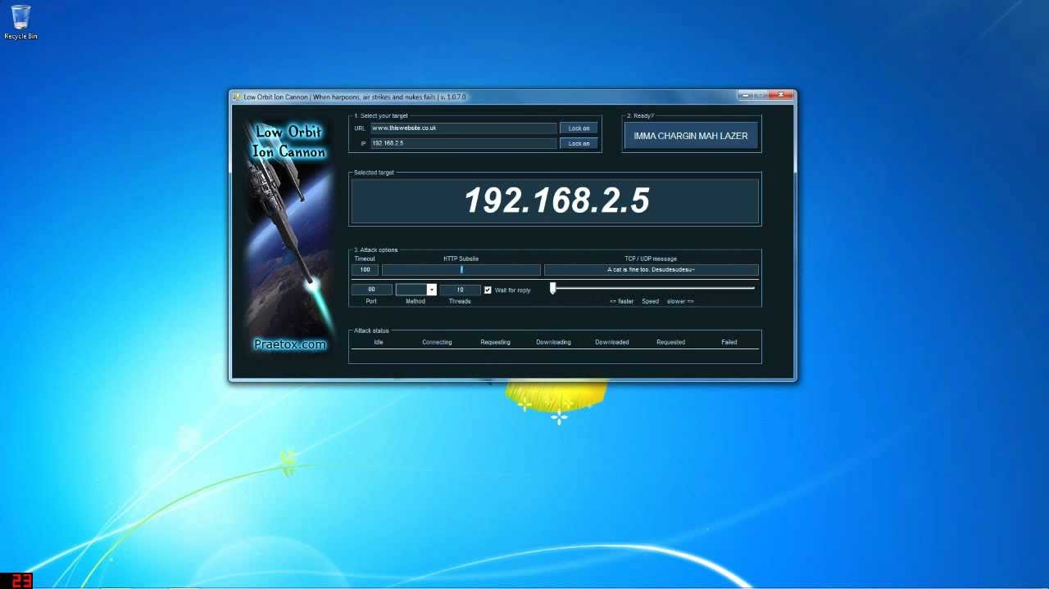

Fig-1.2 LOIC

* **High Orbit Ion Cannon (HOIC):**This attack tool was created to replace the LOIC by expanding its capabilities and adding customizations. By utilizing the HTTP protocol, the HOIC is able to launch targeted attacks that are difficult to mitigate. The software is designed to have a minimum of 50 people working together in a coordinated attack effort.

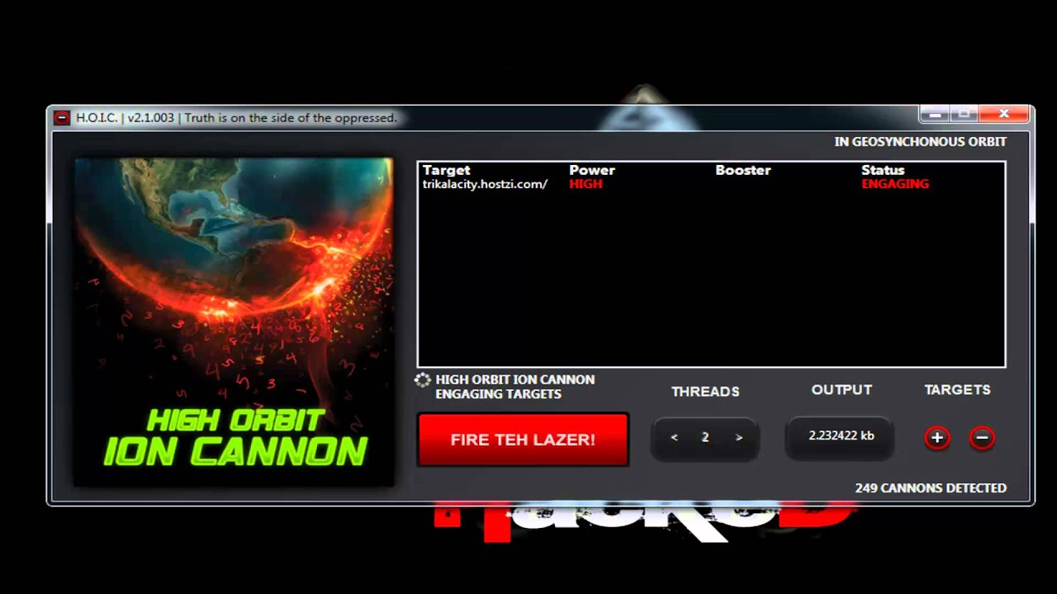

Fig-1.3 HOIC

* **Slowloris:** Apart from being a slow-moving primate, Slowloris is an application designed to instigate a low and slow attack on a targeted server. The elegance of Slowloris is the limited amount of resources it needs to consume in order to create a damaging effect.

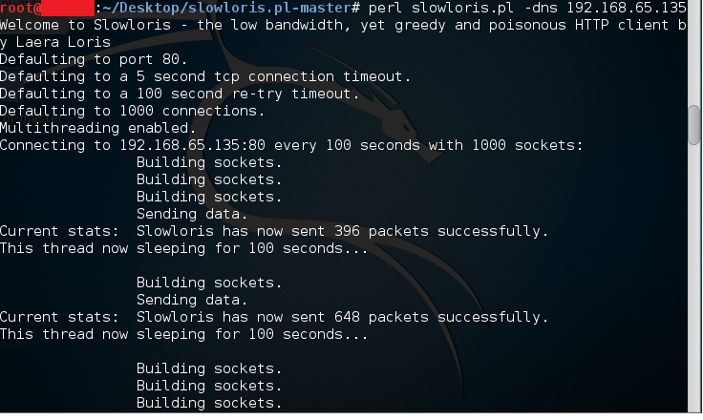

Fig-1.4 Slowloris

**Mitigation:**

DDoS mitigation refers to the process of successfully protecting a targeted server or network from a distributed denial-of-service (DDoS) attack. By utilizing specially designed network equipment or a cloud-based protection service, a targeted victim is able to mitigate the incoming threat.

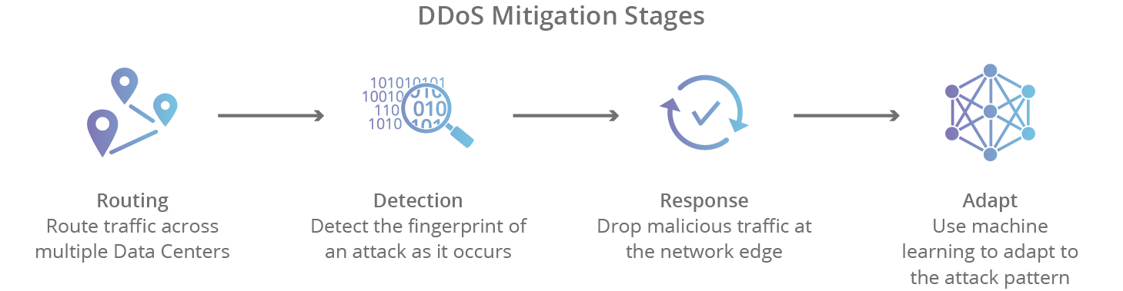

There are 4 stages of mitigation a DDOS attack:-

**Detection:** In order to stop a distributed attack, a website needs to be able to distinguish an attack from a high volume of normal traffic. If a product release or other announcement has a website swamped with legitimate new visitors, the last thing the site wants to do is throttle them or otherwise stop them from viewing the content of the website. IP reputation, common attack patterns, and previous data assist in proper detection.

**Response:** In this step, the DDoS protection network responds to an incoming identified threat by intelligently dropping malicious bot traffic, and absorbing the rest of the traffic. Using WAF page rules for application layer (L7) attacks, or another filtration process to handle lower level (L3/L4) attacks such as memcached or NTP amplification, a network is able to mitigate the attempt at disruption.

**Routing:** By intelligently routing traffic, an effective DDoS mitigation solution will break the remaining traffic into manageable chunks preventing denial-of-service.

**Adaption:** A good network analyzes traffic for patterns such as repeating offending IP blocks, particular attacks coming from certain countries, or particular protocols being used improperly. By adapting to attack patterns, a protection service can harden itself against future attacks.

**\*\*DDOS is mitigated by using IDS, Web Application Firewall and load balancers. \*\***

**SQL Injection:**

**Introduction:**

SQL Injection (SQLi) is a type of an injection attack that makes it possible to execute malicious SQL statements. These statements control a database server behind a web application. Attackers can use SQL Injection vulnerabilities to bypass application security measures. They can go around authentication and authorization of a web page or web application and retrieve the content of the entire SQL database. They can also use SQL Injection to add, modify, and delete records in the database.

**Types of sql injection:**

* **Union-Based SQL Injection:** It is the most popular type of SQL injection. This type of attack uses the UNION statement, which is the integration of two statements, to obtain data from database.
* **Error-Based SQL Injection:** An error-based SQL injection is the simplest type; but, the only difficulty with this method is that it runs only with MS-SQL Server. In this attack, we cause an application to show an error to extract the database. Normally, you ask a question to the database, and it responds with an error including the data you asked for.
* **Blind SQL Injection:** The blind SQL injection is the hardest type. In this attack, no error messages are received from the database; hence, we extract the data by asking questions to the database.

The blind SQL injection is further divided into two kinds:

1. Boolean-based SQL injection

2. Time-based SQL injection

**Implementation of attack:**

Consider, there is a bank’s web application which is vulnerable to SQL injection. The normal user only deals with its account and does the operation which is required.

The malicious user enters the credentials but he adds **‘ (single quote)** with the wrong password but this web application is vulnerable then in backend the **‘** is executed and renders the error on the page.

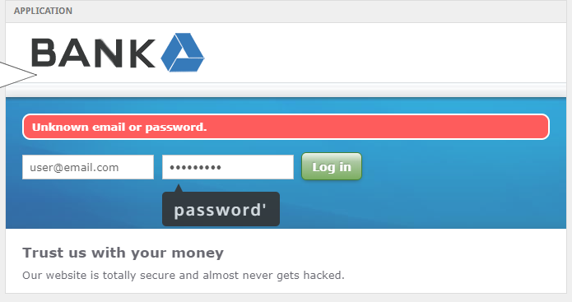

Due to this attacker tries to understand the backend and try to sanitize the query by its input.

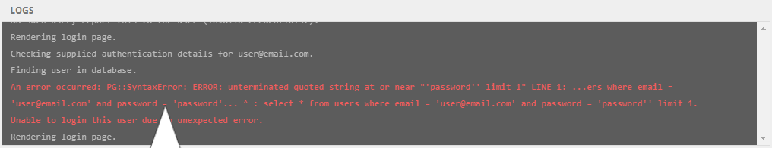

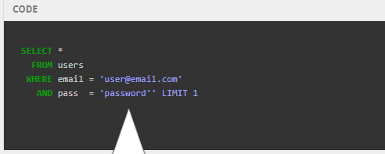

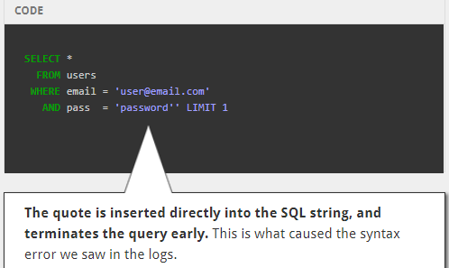

Now, attacker knows the sanitized query and he can easily access the account without password.

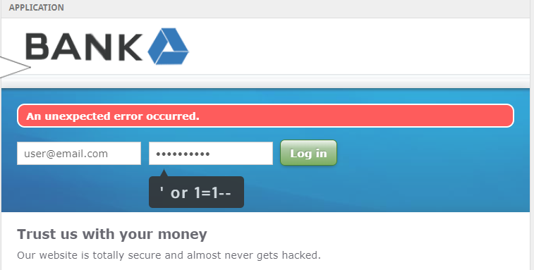

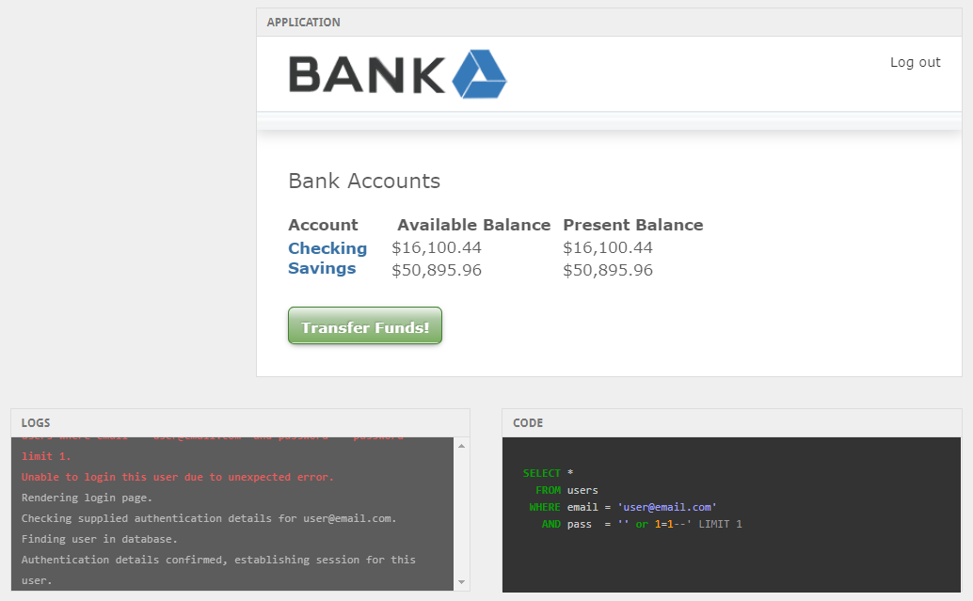

As we can see, attacker has accessed the application.

**Mitigation:**

SQL injection flaws typically looks like this:

The following (Java) example is UNSAFE, and would allow an attacker to inject code into the query that would be executed by the database. The unvalidated "customerName" parameter that is simply appended to the query allows an attacker to inject any SQL code they want. Unfortunately, this method for accessing databases is all too common.

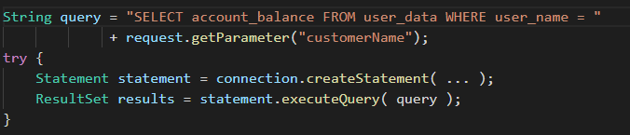

Fig-2. Unsafe code in Java

**Primary Defenses:**

**Use of Prepared Statements (with Parameterized Queries):** The use of prepared statements with variable binding (aka parameterized queries) is how all developers should first be taught how to write database queries. They are simple to write, and easier to understand than dynamic queries. Parameterized queries force the developer to first define all the SQL code, and then pass in each parameter to the query later. This coding style allows the database to distinguish between code and data, regardless of what user input is supplied.

Prepared statements ensure that an attacker is not able to change the intent of a query, even if SQL commands are inserted by an attacker. In the safe example below, if an attacker were to enter the userID of tom' or **'1'='1**, the parameterized query would not be vulnerable and would instead look for a username which literally matched the entire string tom' or **'1'='1**.

Language specific recommendations:

1. **Java EE** – use PreparedStatement() with bind variables
2. **.NET** – use parameterized queries like SqlCommand() or OleDbCommand() with bind variables
3. **PHP** – use PDO with strongly typed parameterized queries (using bindParam())
4. **Hibernate** - use createQuery() with bind variables (called named parameters in Hibernate)
5. **SQLite** - use sqlite3_prepare() to create a statement object

* **Safe Java Prepared Statement Example:** The following code example uses a PreparedStatement, Java's implementation of a parameterized query, to execute the same database query.

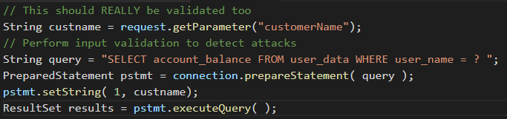

Fig-2. Safe code in Java

* **Safe C# .NET Prepared Statement Example:** With .NET, it's even more straightforward. The creation and execution of the query doesn't change. All you have to do is simply pass the parameters to the query using the **Parameters.Add()** call as shown here.

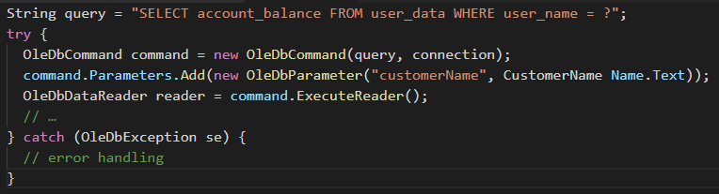

* **Hibernate Query Language (HQL) Prepared Statement (Named Parameters) Examples:**

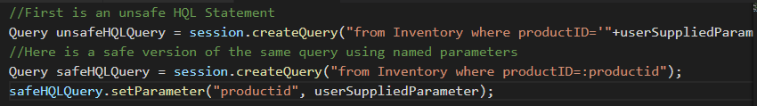

Developers tend to like the Prepared Statement approach because all the SQL code stays within the application. This makes your application relatively database independent.

**Use of Stored Procedures**

* Stored procedures are not always safe from SQL injection. However, certain standard stored procedure programming constructs have the same effect as the use of parameterized queries when implemented safely which is the norm for most stored procedure languages.
* They require the developer to just build SQL statements with parameters which are automatically parameterized unless the developer does something largely out of the norm.
* The difference between prepared statements and stored procedures is that the SQL code for a stored procedure is defined and stored in the database itself, and then called from the application.
* Both of these techniques have the same effectiveness in preventing SQL injection so your organization should choose which approach makes the most sense for you.

**Safe Java Stored Procedure Example:**

The following code example uses a CallableStatement, Java's implementation of the stored procedure interface, to execute the same database query. The sp_getAccountBalance stored procedure would have to be predefined in the database and implement the same functionality as the query defined above.

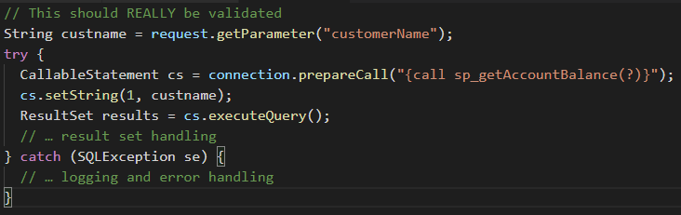

**Safe VB .NET Stored Procedure Example:**

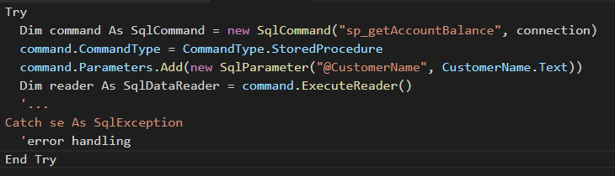

The following code example uses a SqlCommand, .NET’s implementation of the stored procedure interface, to execute the same database query. The sp_getAccountBalance stored procedure would have to be predefined in the database and implement the same functionality as the query defined above.

**Whitelist Input Validation:**

Various parts of SQL queries aren't legal locations for the use of bind variables, such as the names of tables or columns, and the sort order indicator (ASC or DESC). In such situations, input validation or query redesign is the most appropriate defense. For the names of tables or columns, ideally those values come from the code, and not from user parameters.

But if user parameter values are used to make different for table names and column names, then the parameter values should be mapped to the legal/expected table or column names to make sure unvalidated user input doesn't end up in the query.

The example of table name validation:

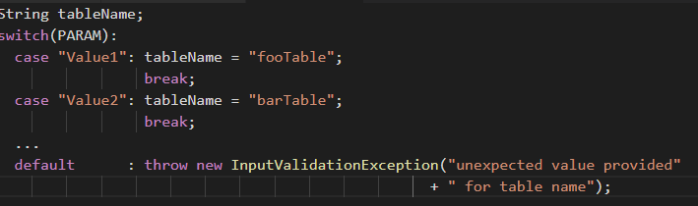

The code may be in Java would be:

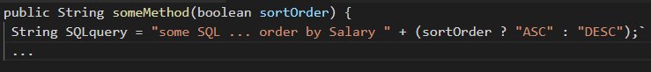

Any time user input can be converted to a non-String, like a date, numeric, boolean, enumerated type, etc. before it is appended to a query, or used to select a value to append to the query, this ensures it is safe to do so.

**Escaping All User Supplied Input:**

This technique is to escape user input before putting it in a query. It is very database specific in its implementation. It's usually only recommended to retrofit legacy code when implementing input validation isn't cost effective. Applications built from scratch, or applications requiring low risk tolerance should be built or re-written using parameterized queries, stored procedures, or some kind of Object Relational Mapper (ORM) that builds your queries for you.

At this time, ESAPI currently has database encoders for:

* **Oracle**

**Escaping Dynamic Queries:**

To use an ESAPI database codec is pretty simple. An Oracle example looks something like:



The code can be written as:

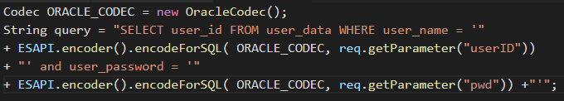

**Turn off character replacement:**

Use ***SET DEFINE OFF*** or ***SET SCAN OFF*** to ensure that automatic character replacement is turned off. If this character replacement is turned on, the ***&*** character will be treated like a SQLPlus variable prefix that could allow an attacker to retrieve private data.

**Escaping Wildcard characters in Like Clauses:**

The ***LIKE*** keyword allows for text scanning searches. In Oracle, the underscore ***_***character matches only one character, while the ampersand ***%*** is used to match zero or more occurrences of any characters. These characters must be escaped in LIKE clause criteria.

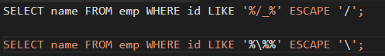

* **MySQL** : Both ANSI and native modes are supported.

MySQL supports two escaping modes:

1. ***ANSI_QUOTES*** SQL mode, and a mode with this off, which we call
2. ***MySQL*** mode.

**ANSI SQL mode:** Simply encode all ' (single tick) characters with '' (two single ticks).

**Escaping SQLi in PHP:**

Use prepared statements and parameterized queries. These are SQL statements that are sent to and parsed by the database server separately from any parameters. This way it is impossible for an attacker to inject malicious SQL.

Basically, we have two options to achieve this:

* Using PHP data objects:

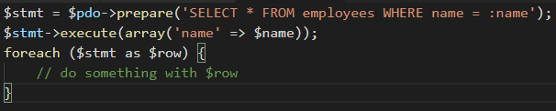

* Using MySQLi:

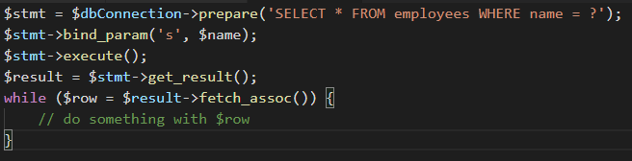

Moreover, we can use ***mysqli_real_escape_string()***.

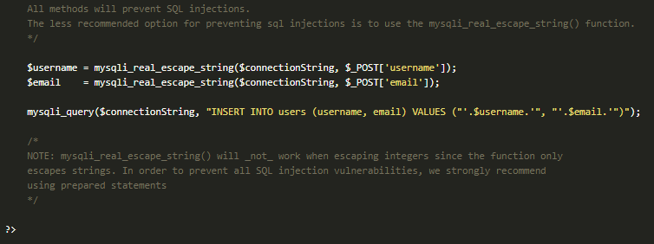

**Additional Defenses:**

* **Enforcing Least Privilege:** The practice of limiting access rights for users to the bare minimum permissions they need to perform their work.
* **Performing Whitelist Input Validation as a Secondary Defense:**All input validation and encodingroutines should be implemented on the serversideoutside the reach of an attacker. Just as with the input rejection you should make sure thatafter validating the userinput, whenever the input is bad it actually rejects, sanitizes or formats your userinput into not malicious data.

The recommended method for validating user input would be the positive validation method. Whitelist input validation means allowing only input that is explicitly defined as valid, as opposed to blacklist input validation, which filters out known bad input.

**SYN Cookies:**

**Introduction:**

To resist against SYN flooding attacks, a technique called SYN cookies was proposed. SYN cookies are used to distinguish an authentic SYN packet from a faked SYN packet. When the server sees a possibility of SYN flooding on a port, it generates a syn cookie in place of an ISN, which is transparent to the client. Actually, SYN cookies can be defined as “particular choices of initial TCP sequence numbers by TCP servers”. SYN cookies have the following properties:

1. They are generated when the SYN queue hits the upper limit. The server behaves as if the SYN queue has been enlarged.

2. The generated SYN cookie is used in place of the ISN. The system sends back SYN+ACK response to the client and discards the SYN queue entry.

3. If the server receives a subsequent ACK response from the client, server is able to reconstruct the SYN queue entry using the information encoded in the TCP sequence number.

**Implementation of SYN Cookies:**

The challenge is design a way for the server to generate its ISN, such that SYN flooding attacks will not work.

1. Consider to have a SYN cookie generation equation as follows:

**cookie = hash(saddr, daddr, sport, dport) + sseq**

where

saddr: Source IP Address

daddr: Destination IP Address

sport: Source Port

dport: Destination Port

sseq: Source Sequence Number

1. Consder a different SYNCookie generation equation as follows:

**cookie = hash(saddr, daddr, sport, dport, random) + seq**

random: a random number generated at the boot time.

1. Consider one more equation of SYNCookie generation:

**cookie = hash(saddr, daddr, sport, dport, random) + sseq + count**

count to be a number that gets incremented every minute.

**HTTP Caching:**

**Introduction:**

HTTP caching occurs when the browser stores local copies of web resources for faster retrieval the next time the resource is required. As your application serves resources it can attach cache headers to the response specifying the desired cache behavior.

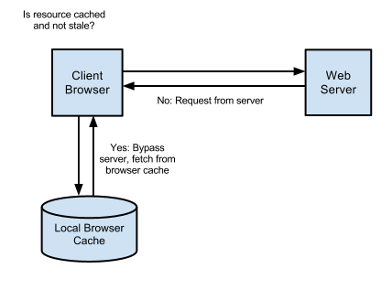

When an item is fully cached, the browser may choose to not contact the server at all and simply use its own cached copy:



**HTTP cache headers:**

1. Cache-Control: The Cache-Control is the most important header to set as it effectively ‘switch on’ caching in the browser. With this header in place, and set with a value that enables caching, the browser will cache the file for as long as specified. Without this header the browser will re-request the file on each subsequent request.

***public*** resources can be cached not only by the end-user’s browser but also by any intermediate proxies that may be serving many other users as well.



***private*** resources are bypassed by intermediate proxies and can only be cached by the end-client.



The value of the ***Cache-Control*** header is a composite one, indicating whether the resource is public or private while also indicating the maximum amount of time it can be cached before considered stale. The ***max-age*** value sets a timespan for how long to cache the resource (in seconds).



1. **Expires:**

When accompanying the Cache-Control header, Expires simply sets a date from which the cached resource should no longer be considered valid. From this date forward the browser will request a fresh copy of the resource. Until then, the browsers local cached copy will be used:



**Spoofing:**

**Introduction:**

A spoofing attack is when a malicious party impersonates another device or user on a network in order to launch attacks against network hosts, steal data, spread malware or bypass access controls.

**Types of spoofing attacks:**

* **IP Address Spoofing Attacks:**

IP address spoofing is one of the most frequently used spoofing attack methods. In an IP address spoofing attack, an attacker sends IP packets from a false (or “spoofed”) source address in order to disguise itself. Denial-of-service attacks often use IP spoofing to overload networks and devices with packets that appear to be from legitimate source IP addresses.

* **ARP Spoofing Attacks:**

ARP is short for Address Resolution Protocol, a protocol that is used to resolve IP addresses to MAC (Media Access Control) addresses for transmitting data. In an ARP spoofing attack, a malicious party sends spoofed ARP messages across a local area network in order to link the attacker’s MAC address with the IP address of a legitimate member of the network. This type of spoofing attack results in data that is intended for the host’s IP address getting sent to the attacker instead. Malicious parties commonly use ARP spoofing to steal information, modify data-in-transit or stop traffic on a LAN. ARP spoofing attacks can also be used to facilitate other types of attacks, including denial-of-service, session hijacking and man-in-the-middle attacks. ARP spoofing only works on local area networks that use the Address Resolution Protocol.

* **DNS Server Spoofing Attacks:**

The Domain Name System (DNS) is a system that associates domain names with IP addresses. Devices that connect to the internet or other private networks rely on the DNS for resolving URLs, email addresses and other human-readable domain names into their corresponding IP addresses. In a DNS server spoofing attack, a malicious party modifies the DNS server in order to reroute a specific domain name to a different IP address. In many cases, the new IP address will be for a server that is actually controlled by the attacker and contains files infected with malware. DNS server spoofing attacks are often used to spread computer worms and viruses.

**Implementation of attack:**

1. We need to edit the Ettercap configuration file since it is our application of choice for today. Let's navigate to /etc/ettercap/etter.conf and open the file with a text editor like gedit and edit the file. We can use Terminal for that.



1. Edit the value of uid and gid to 0.

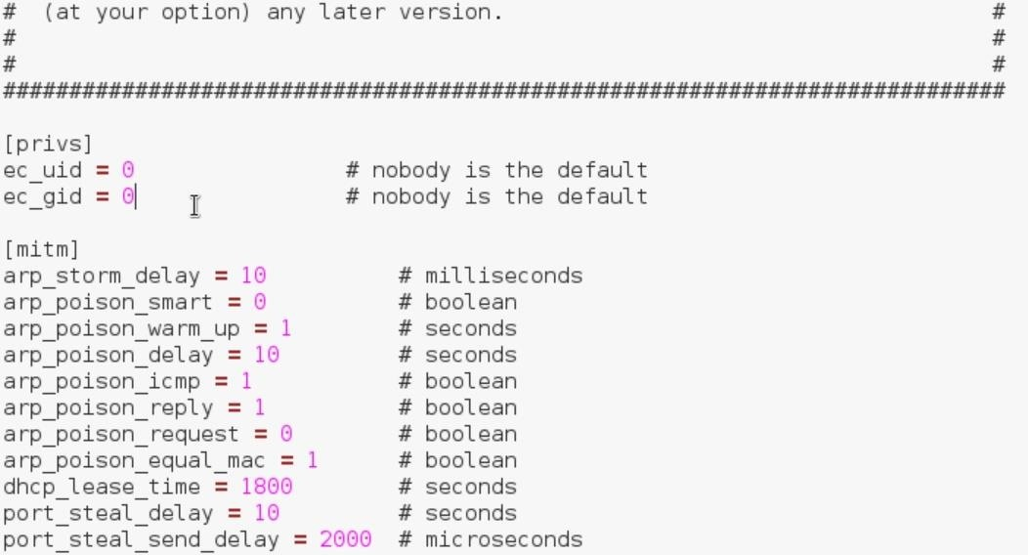

1. Now scroll down until you find the heading that says Linux and under that remove both the # signs below where it says "if you use iptables".

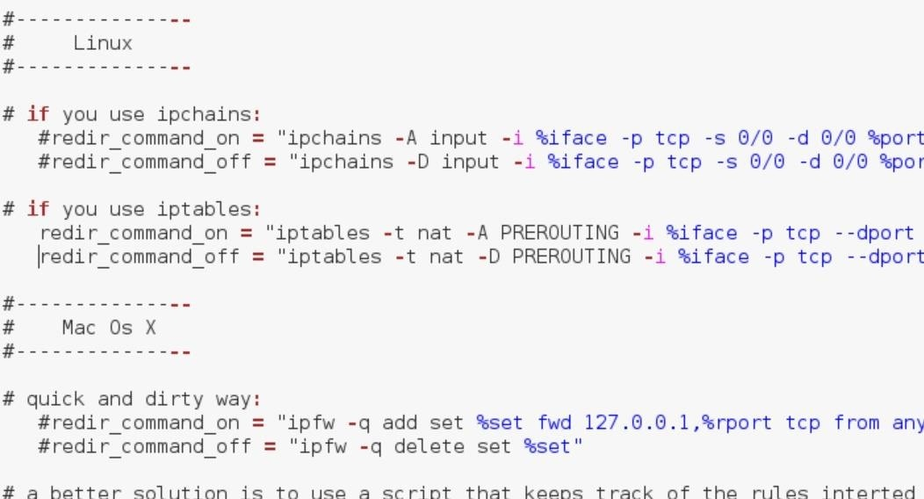

1. Now, we can call ettercap in gui mode using the command ‘ettercap –G’.



1. Select sniff > Unified sniffing… > (Select the interface connected to the internet) > OK. Then swiftly do Start > Stop sniffing because it automatically starts sniffing after we press OK and we don't want that.
2. Now what we want to do is add our victim machine to Target 1 and our network gateway to Target 2 but first we need to know both of their IP addresses. To find out our victim's IP address, we first need to know who we are attacking, and we can do so using **nmap** to find the information we need on the target machine. Once you are sure who your victim is, select their IP address from the host list in Ettercap and choose **Add to Target 1**. Now you need to find your gateway IP address (your router). To do this, open Terminal and type *ifconfig* and look at where it says **Bcast:** and that will tell you the IP address of your gateway. Alternatively, you can also use the route -n command. Now select the gateway IP from the host list and choose **Add to Target 2**.

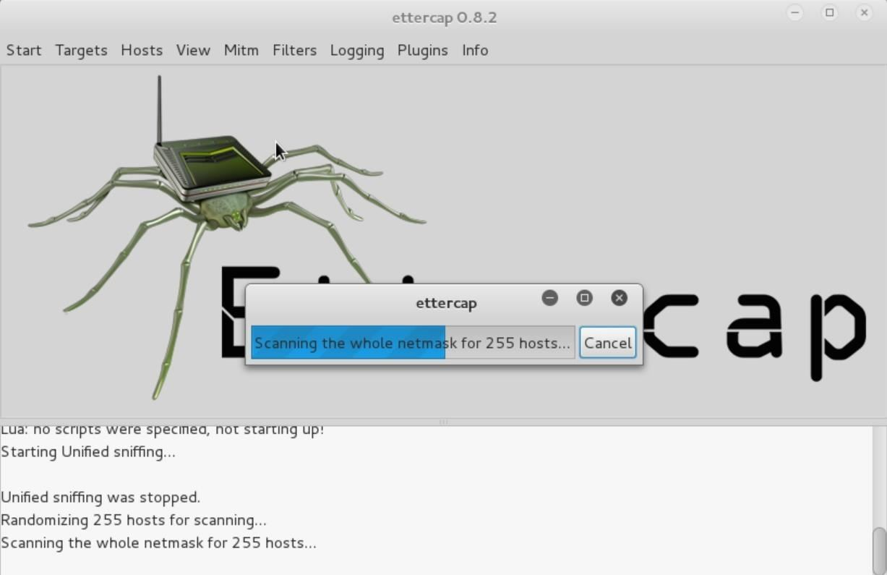

1. Now that we have both Targets set to our victim and gateway, we can proceed to the attack.
2. Go to the **MITM** tab and select **ARP poisoning**, choose **Sniff remote connections** and press OK. Now go to Plugins > Manage the plugins and double click dns_spoof to activate that plugin.

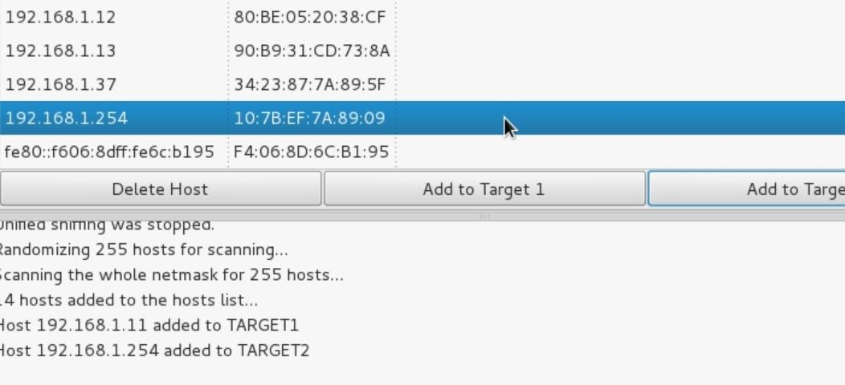

1. This etter.dns file is the hosts file and is responsible for redirecting specific DNS requests. Basically, if the target enters facebook.com they will be redirected to Facebook's website, but this file can change all of that. This is where the magic happens, so let's edit it.



1. First, redirect traffic from any website you would like to your Kali machine. For that, go down to where it says "microsoft sucks ;)" and add another line just like that below it, but now use whatever website you would like. Also, don't forget to change the IP address to your IP address.

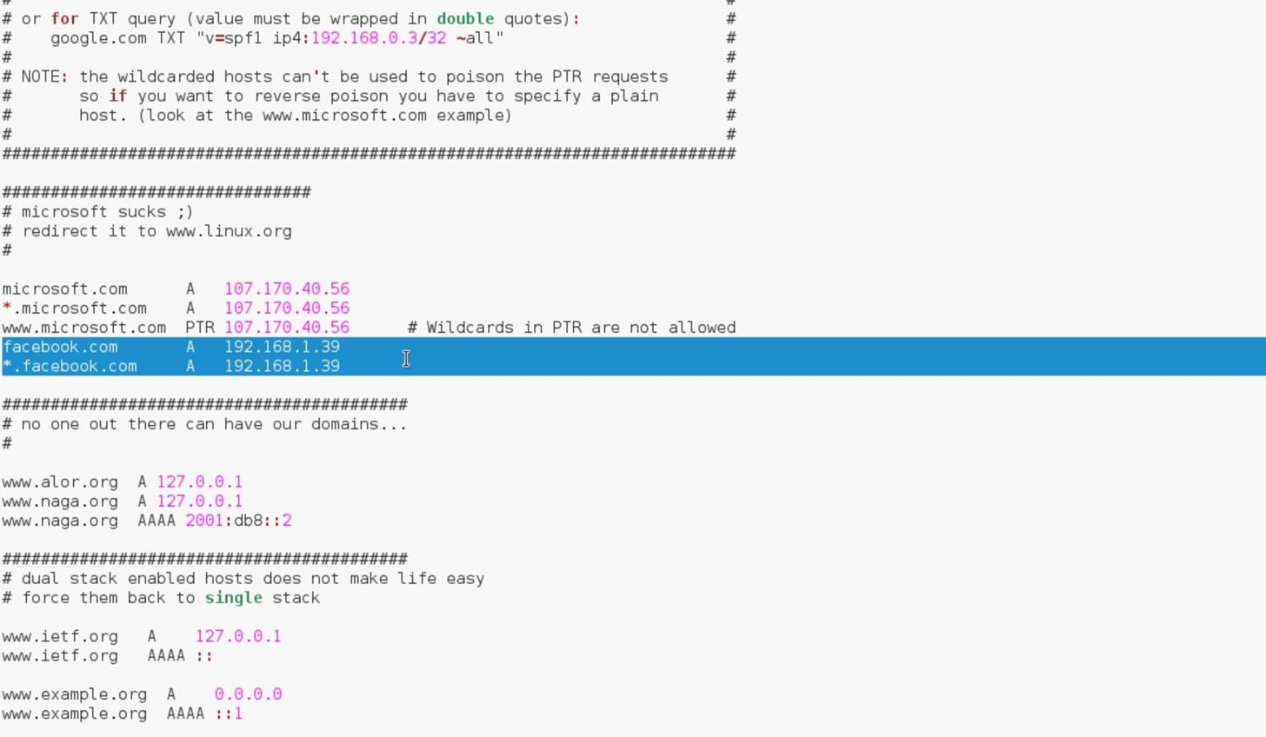



1. Now every time the victim visits the webpage you indicated in the etter.dns file (in my case it's facebook.com) they will be redirected to the fancy and inconspicuous page above. You can see how this can be extremely malicious, since the attacker could write a script that fetches the requested page immediately and sets up the etter.dns file and listens in on the login, all automatically.

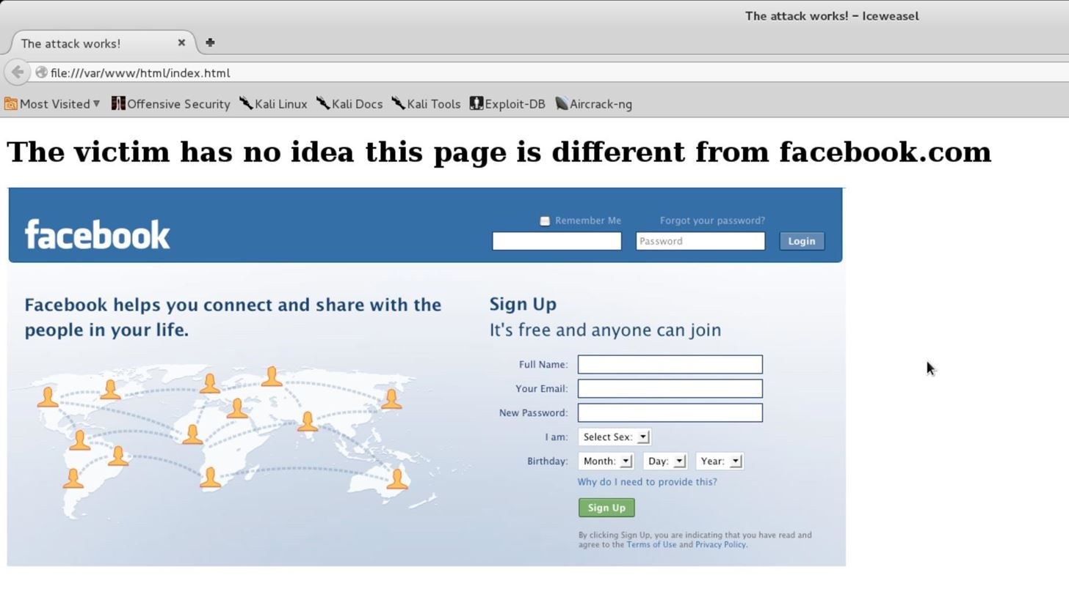

**Mitigation:**

* **Packet filtering:** Packet filters inspect packets as they are transmitted across a network. Packet filters are useful in IP address spoofing attack prevention because they are capable of filtering out and blocking packets with conflicting source address information (packets from outside the network that show source addresses from inside the network and vice-versa).
* **Avoid trust relationships:** Organizations should develop protocols that rely on trust relationships as little as possible. It is significantly easier for attackers to run spoofing attacks when trust relationships are in place because trust relationships only use IP addresses for authentication.
* **Use spoofing detection software:** There are many programs available that help organizations detect spoofing attacks, particularly ARP Spoofing. These programs work by inspecting and certifying data before it is transmitted and blocking data that appears to be spoofed.
* **Use cryptographic network protocols:** Transport Layer Security (TLS), Secure Shell (SSH), HTTP Secure (HTTPS) and other secure communications protocols bolster spoofing attack prevention efforts by encrypting data before it is sent and authenticating data as it is received.

**Illegal Code Execution:**

**Introduction:**

Command injection is an attack in which the goal is execution of arbitrary commands on the host operating system via a vulnerable application. Command injection attacks are possible when an application passes unsafe user supplied data (forms, cookies, HTTP headers etc.) to a system shell. In this attack, the attackersupplied operating system commands are usually executed with the privileges of the vulnerable application. Command injection attacks are possible largely due to insufficient input validation. This attack differs from Code Injection, in that code injection allows the attacker to adds his own code that is then executed by the application. In Code Injection, the attacker extends the default functionality of the application without the necessity of executing system commands.

**Implementation of attack:**

* Consider, there is an application which is vulnerable to remote code injection.
* This application performs DNS lookups and prints the result.

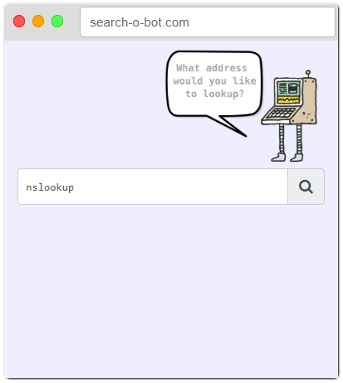

* As we can see the vulnerable ‘php’ code in which input is processing without any additional check and sanitization.

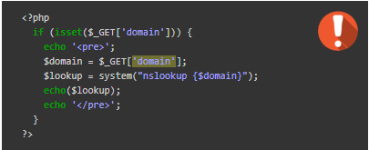

* Notice how the 'domain' parameter is taken in from the GET request, and immediately interpolated into a command string.
* In search bar user can input the name of website.

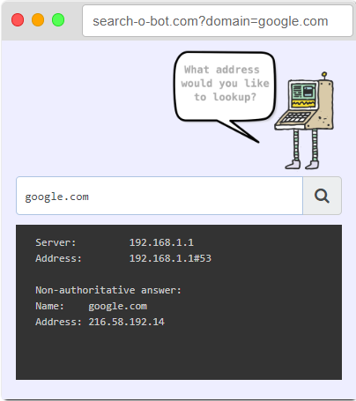

* As malicious user tries to execute the arbitrary code which may lead large compromises.

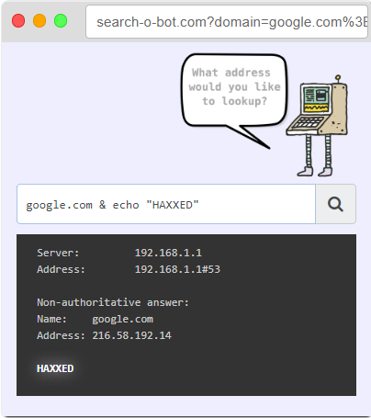

**Mitigation:**

* Userinput that is used in a shell command should not contain dangerous characters.
* A blacklist of characters is not a good option because it may be difficult to think of all of the characters to validate against. A white list containing only allowable characters should be created to validate the userinput.

**XSS Prevention:**

**Introduction:**

Cross-site Scripting (XSS) is a client-side code injection attack. The attacker aims to execute malicious scripts in a web browser of the victim by including malicious code in a legitimate web page or web application. The actual attack occurs when the victim visits the web page or web application that executes the malicious code. The web page or web application becomes a vehicle to deliver the malicious script to the user’s browser. Vulnerable vehicles that are commonly used for Cross-site Scripting attacks are forums, message boards, and web pages that allow comments.

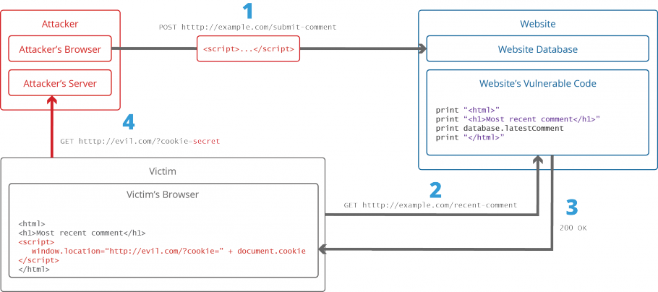

**Types of XSS:**

**Persistent XSS:** A persistent XSS also was known as stored XSS because through this vulnerability the injected malicious script get permanently stored inside the web server and the application server give out it back to the user when he visits the respective website. Hence when the client will click on payload which appears as an official part of the website, the injected JavaScript will get executed by the browser. The most common example is comment option on blogs, which allow the users to POST their comment for the administrator or another user.

**Non-persistent XSS:** The non-persistent XSS is also known as reflected XSS occurs when the web application responds immediately on user’s input without validating the inputs this lead an attacker to inject browser executable code inside the single HTML response. It’s named as “non-persistent” since the malicious script does not get stored inside the web server, therefore attacker will send the malicious link through phishing to trap the user.

**DOM-Based XSS:** The Document Object Model (DOM) is an API that increases the skill of programmers or developers to produce and change HTML and XML documents as programming objects.

The JavaScript language is used in DOM, which is also used for other websites. Through JavaScript it allows the programmer to make the dynamic changes in HTML document can be accessed, modify, deleted, or added using the DOM.

When an HTML document is loaded into a web browser, it becomes a document object.

The document object is the root node of the HTML document and the “owner” of all other nodes

The HTML DOM model is constructed as a tree of Objects.

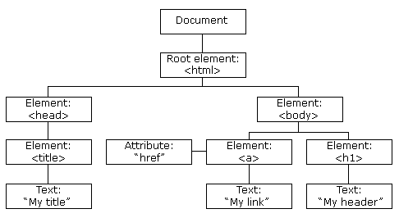

**Implementation of attack:**

* Here, we can see inplace of full name, the malicious user inputs the JS code and trying to extract the victim’s cookies.

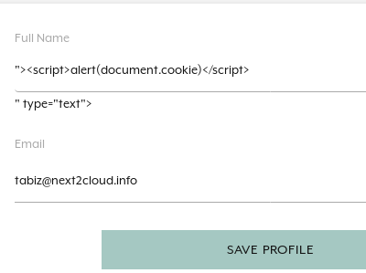

* As an output, we can see the alert box where cookies are printed.

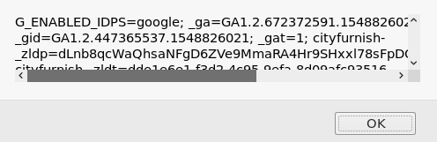

**Mitigation:**

* In order to prevent XSS injections, all userinput should be escaped or encoded.
* You could start by sanitizing userinput as soon as it is inserted into the application, by preference using a so called whitelisting method. This means you should not check for malicious content like the tags or anything, but only allow the expected input. Every input which is outside of the intended operation of the application should immediately be detected and login rejected.
* Do not try to help use the input in any way because that could introduce a new type of attack by converting characters.
* The second step would be encoding all the parameters or userinput before putting this in your html with encoding libraries specially designed for this purpose.
* You should take into consideration that there are several contexts for encoding userinput for escaping XSS injections.
* HTML encoding is for whenever your userinput is displayed directly into your HTML.
* HTML attribute encoding is the type of encoding/escaping that should be applied whenever your user input is displayed into the attribute of your HTML tags.
* HTML URL encoding ;This type of encoding/escaping should be applied to whenever you are using userinput into a HREF tag.
* JavaScript encoding should be used whenever parameters are rendered via JavaScript; your application will detect normal injections in the first instant. But your application still remains vulnerable to JavaScript encoding which will not be detected by the normal encoding/escaping methods.
* There are some code examples:

**PHP:**

**Vulnerable code:**

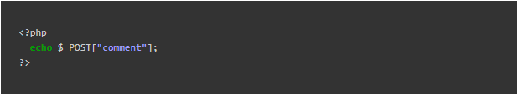

**Patched code:**

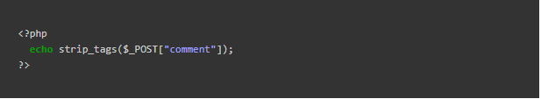

* **JAVA:**

**Vulnerable code:**

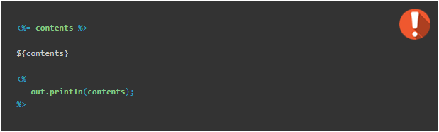

**Patched code:**

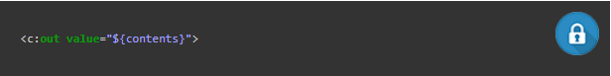

**0-day exploit prevention:**

**Introduction:**

Zero-day attacks as attacks on vulnerabilities that have not been patched or made public, while others define them as attacks that take advantage of a security vulnerability on the same day that the vulnerability becomes publicly known (zero-day).

The zero-day exploits can be found on exploit-db, CVE-mitre, etc.

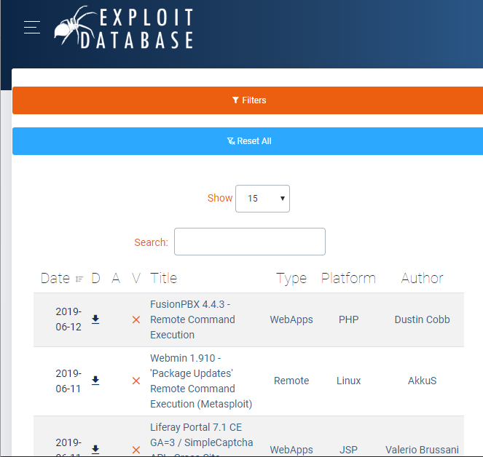

**Mitigation:**

* Regular updation and patching.
* Implement the use of Web Application Firewall (WAF) to protect your website. It helps to identify possible website attacks with much accuracy
* Install Internet Security suite that is loaded with smart antivirus, sandboxing techniques, default deny protection, heuristic file behavioral analysis.

**CSRF:**

**Introduction:**

Cross-site request forgery also known as single-click attack or session traversing, in which a malicious website will throw a request to a web application that the user is already authenticated against from a different website. This way an attacker can access functionality in a targeted web application via the victim’s already authenticated browser.

If the victim is an ordinary user, a successful CSRF attack can force the user to perform state-changing requests like transferring funds, changing their email address, and so forth. If the targeted end-user is the administrator account, this can compromise the entire web application.

CSRF attacks in the past have been used to:

* Steal confidential data.
* Manipulate online surveys.
* Spread worms on social media.
* Install malware on mobile phones.

**Implementation of attack:**

Here the attacker is able to add the item in cart with the exploit code without any verification.



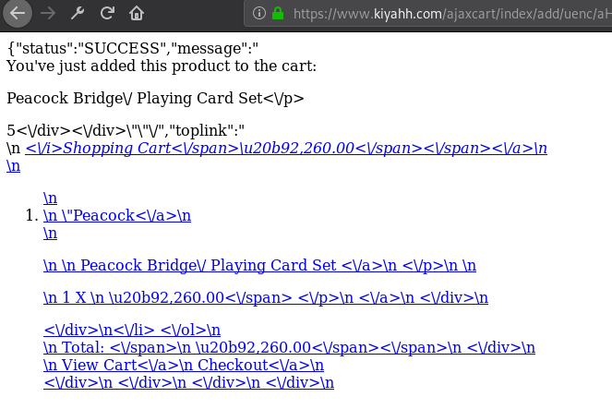



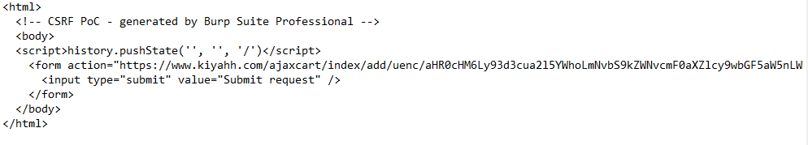

**Mitigation:**

Protecting against CSRF (commonly pronounced “sea-surf”) requires two things: ensuring that GET requests are side-effect free, and ensuring that non-GET requests can only be originated from your client-side code.

**REST**

Representation State Transfer (REST) is a series of design principles that assign certain types of action (view, create, delete, update) to different HTTP verbs. Following REST-ful designs will keep your code clean and help your site scale. Moreover, REST insists that GET requests are used only to view resources. Keeping your GET requests side-effect free will limit the harm that can be done by maliciously crafted URLs–an attacker will have to work much harder to generate harmful POST requests.

**Anti-Forgery Tokens**

Even when edit actions are restricted to non-GET requests, you are not entirely protected. POST requests can still be sent to your site from scripts and pages hosted on other domains. In order to ensure that you only handle valid HTTP requests you need to include a secret and unique token with each HTTP response, and have the server verify that token when it is passed back in subsequent requests that use the POST method (or any other method except GET, in fact.)

This is called an anti-forgery token. Each time your server renders a page that performs sensitive actions, it should write out an anti-forgery token in a hidden HTML form field. This token must be included with form submissions, or AJAX calls. The server should validate the token when it is returned in subsequent requests, and reject any calls with missing or invalid tokens.

Anti-forgery tokens are typically (strongly) random numbers that are stored in a cookie or on the server as they are written out to the hidden field. The server will compare the token attached to the inbound request with the value stored in the cookie. If the values are identical, the server will accept the valid HTTP request.

Most modern frameworks include functions to make adding anti-forgery tokens fairly straightforward.

**Ensure Cookies are sent with the SameSite Cookie Attribute**

The Google Chrome team added a new attribute to the Set-Cookie header to help prevent CSRF, and it quickly became supported by the other browser vendors. The Same-Site cookie attribute allows developers to instruct browsers to control whether cookies are sent along with the request initiated by third-party domains.

Setting a Same-Site attribute to a cookie is quite simple:



A value of Strict will mean than any request initiated by a third-party domain to your domain will have any cookies stripped by the browser. This is the most secure setting, since it prevents malicious sites attempting to perform harmful actions under a user’s session.

A value of Lax permits GET request from a third-party domain to your domain to have cookies attached - but only GET requests. With this setting a user will not have to sign in again to your site if the follow a link from another site (say, Google search results). This makes for a friendlier user-experience - but make sure your GET requests are side-effect free!

**Include Addition Authentication for Sensitive Actions**

Many sites require a secondary authentication step, or require re-confirmation of login details when the user performs a sensitive action. (Think of a typical password reset page – usually the user will have to specify their old password before setting a new password.) Not only does this protect users who may accidentally leave themselves logged in on publicly accessible computers, but it also greatly reduces the possibility of CSRF attacks.

**Sample code for CSRF in PHP:**

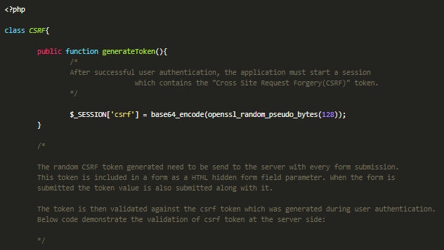

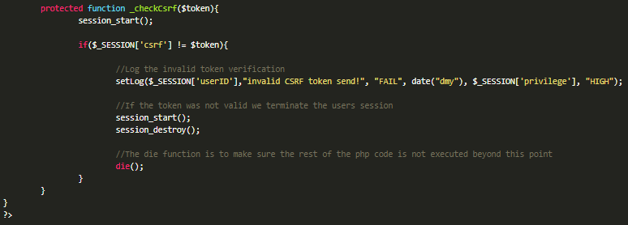

**Sample code for CSRF in JAVA:**

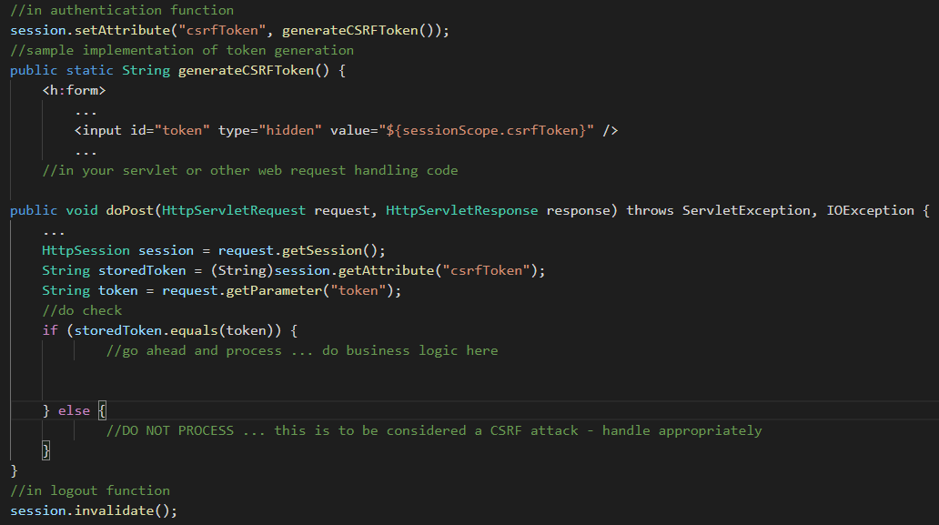

**Phishing:**

**Introduction:**

Itis the fraudulent attempt to obtain sensitive information such as usernames, passwords and credit card details by disguising oneself as a trustworthy entity in an electronic communication.

**Implementation of attack:**

* Download the source code of required login webpage. Here example is Facebook.

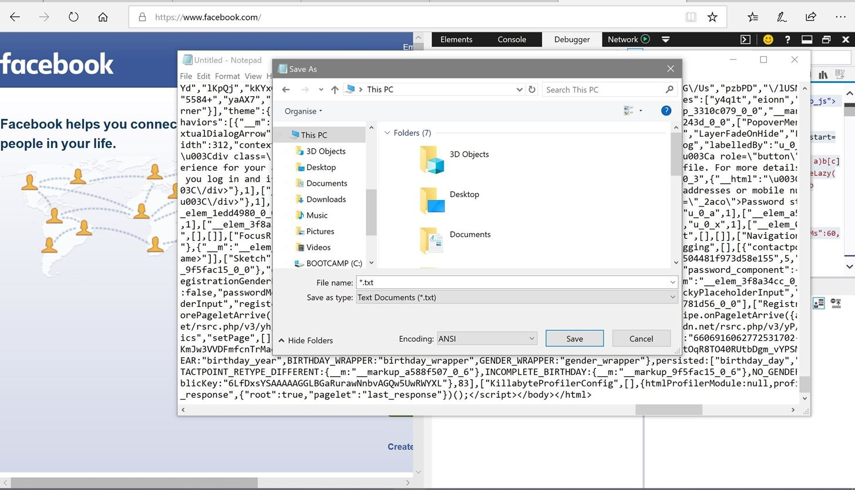

* Save this PHP file in phishing page directory.

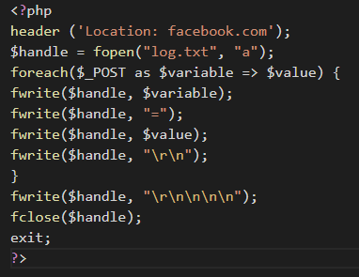

* Find the action tag and replace the address with this PHP file.

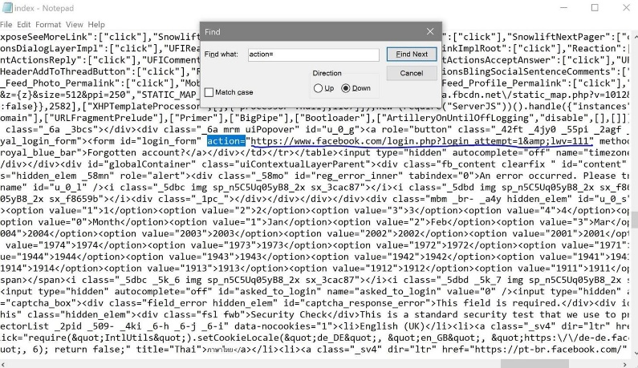

* Host it on any webserver.

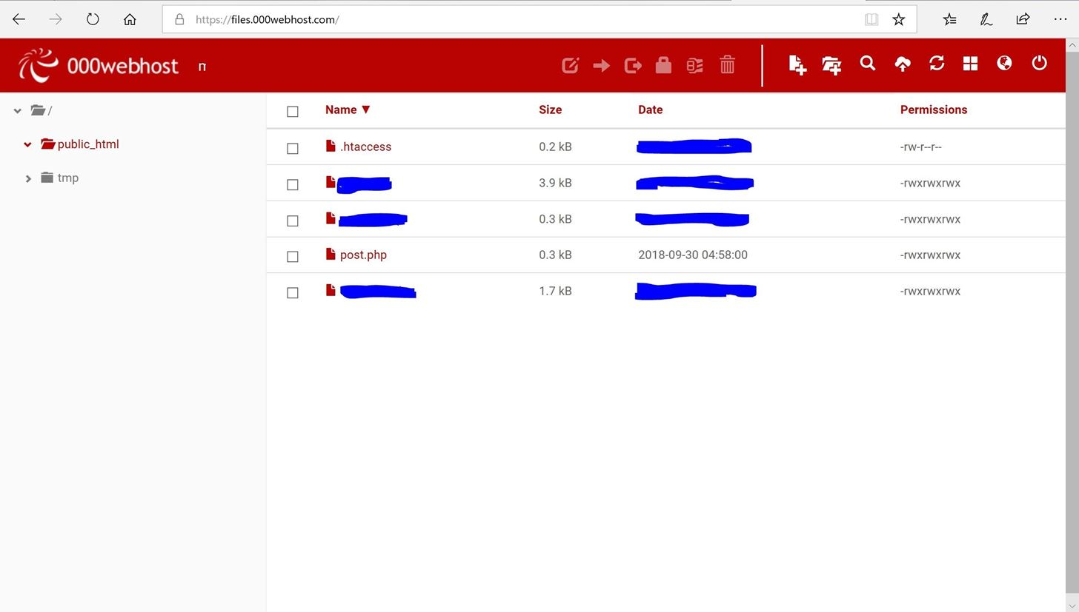

* Boom!! We have created our Phishing page.

There are also many automated tools for Phishing which creates more advanced phishing pages like **goPhish, SocialPhish**, etc.

**Mitigation:**

* Educate your employees and conduct training sessions with mock phishing scenarios.
* Deploy a SPAM filter that detects viruses, blank senders, etc.
* Keep all systems current with the latest security patches and updates.
* Install an antivirus solution, schedule signature updates, and monitor the antivirus status on all equipment.
* Develop a security policy that includes but isn't limited to password expiration and complexity.
* Deploy a web filter to block malicious websites.
* Encrypt all sensitive company information.
* Convert HTML email into text only email messages or disable HTML email messages.
* Require encryption for employees that are telecommuting.