**Online Course Enrollment System Report**

**Name:** Manju Samartha K S  
**USN:** 21SECD92  
**Course:** Full Stack Development

**Project Overview**

The Online Course Enrollment System is a web application developed using Django. It allows students to enroll in multiple courses while enabling administrators to efficiently manage registrations. The system establishes a Many-to-Many relationship where students can register for multiple courses, and each course can have multiple students.

This project includes an interactive user interface, an admin panel for easy management, and a database to store enrollments securely. The system is designed to be scalable and user-friendly, making it a robust solution for academic institutions.

The need for an automated enrollment system is crucial in today’s educational landscape. Traditional manual enrollments are time-consuming, prone to errors, and inefficient in handling a large number of students. A digital solution eliminates these inefficiencies, providing a streamlined process with enhanced accuracy.

**Features Implemented**

* **Course & Student Models:** Uses Django ORM to create a Many-to-Many relationship between students and courses, ensuring seamless database management.
* **Django Admin Panel:** Provides an interface for managing students and courses, simplifying administrative tasks.
* **Course List Page:** Displays available courses using Django’s ListView, allowing users to browse offerings easily.
* **Enrollment Form:** Enables students to select and enroll in courses, ensuring a smooth user experience.
* **Confirmation Page:** Redirects students after successful enrollment using reverse_lazy(), confirming their registration.
* **Custom Styling:** Includes a separate CSS file to improve UI aesthetics, making the interface visually appealing.
* **Modular Codebase:** Follows Django’s MVC pattern for easy maintainability and future enhancements.
* **Error Handling:** Implements form validation and error messages for user input, reducing data entry errors.
* **Scalability:** Built with future enhancements in mind, such as authentication and analytics, ensuring long-term usability.

**Technologies Used**

* **Backend:** Django (Python)
* **Frontend:** HTML, CSS, JavaScript
* **Database:** SQLite for development, scalable to PostgreSQL for production
* **Admin Management:** Django Admin for managing users and course registrations
* **Deployment:** Localhost for testing, adaptable to cloud platforms like AWS or Heroku

**System Design & Architecture**

**1. Database Design**

The system uses Django’s ORM to handle database operations. The primary tables include:

* **Student Model:** Stores student details like name, email, and enrolled courses.
* **Course Model:** Holds information about available courses, descriptions, and instructor details.
* **Enrollment Model:** Establishes the Many-to-Many relationship between students and courses.

**2. User Interface**

* A homepage that displays available courses.
* A student registration page for enrolling in courses.
* A confirmation page displaying successful enrollment details.
* An admin panel for managing students, courses, and enrollments.

**Steps to Run the Project**

1. **Navigate to the project directory and activate the virtual environment:**
2. cd enrollment_system
3. source env/bin/activate (For macOS/Linux)
4. env\Scripts\activate (For Windows)
5. **Install required dependencies:**
6. pip install -r requirements.txt
7. **Apply migrations:**
8. python manage.py makemigrations
9. python manage.py migrate
10. **Run the server:**
11. python manage.py runserver
12. **Open a browser and visit:**
13. http://127.0.0.1:8000/

**Conclusion**

This project successfully demonstrates a functional Online Course Enrollment System using Django. It provides an intuitive interface for students to enroll in courses and for administrators to manage course registrations efficiently. The use of Django's robust framework ensures scalability and security.

The system simplifies the enrollment process by offering a digital platform where students can browse courses, register seamlessly, and receive confirmation. Administrators benefit from an efficient course management system that reduces manual workload.

Future improvements can include user authentication, email notifications, and enhanced course filtering. Integrating additional features such as real-time analytics, student progress tracking, and personalized course recommendations would make the system even more effective.

**Future Enhancements**

* **Student Authentication:** Implement user login and profile management.
* **Email Notifications:** Send automated emails upon successful enrollment.
* **Instructor Role:** Allow instructors to create and manage courses.
* **Payment Integration:** Enable paid courses with secure transactions.
* **Downloadable Course Materials:** Provide PDF handouts and other resources.
* **Interactive Dashboard:** Include charts and statistics for student enrollments.
* **AI-Based Course Recommendations:** Suggest relevant courses based on student interests.
* **Cloud Deployment:** Host the system on AWS, Heroku, or another cloud service.

By incorporating these enhancements, the system can evolve into a comprehensive learning management platform that caters to both students and educators.

Screenshots :

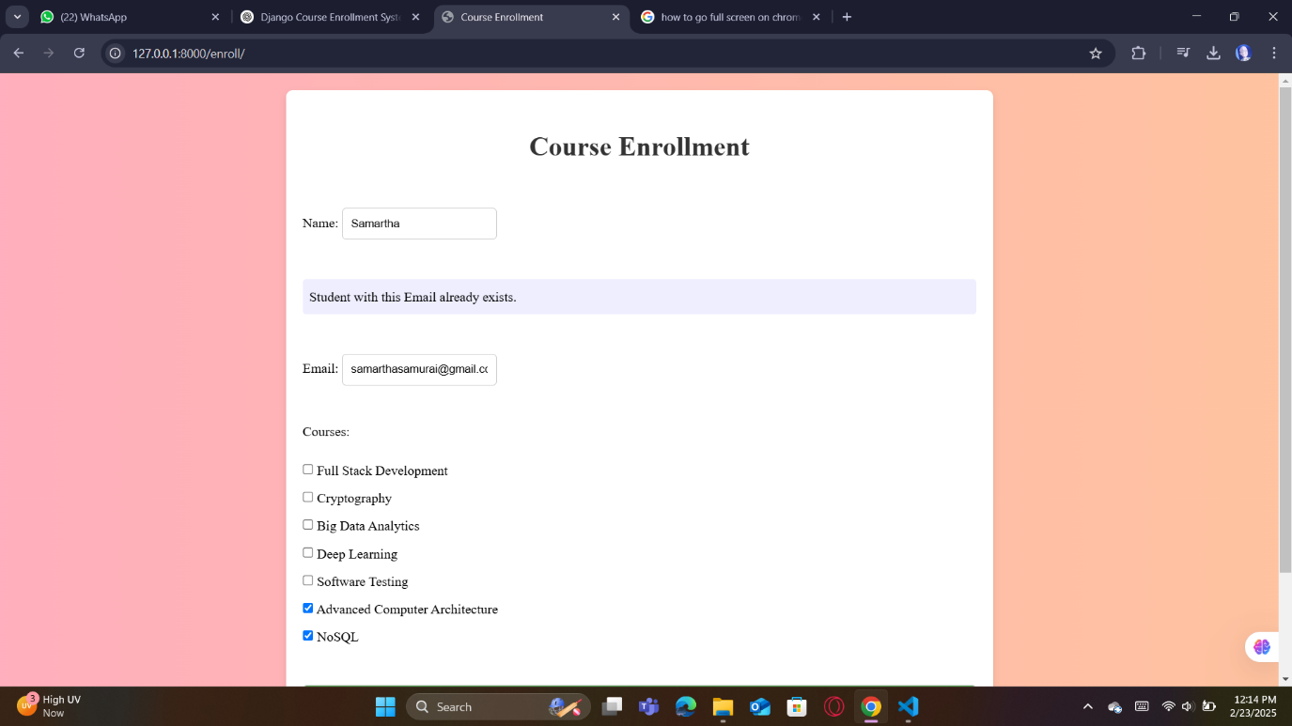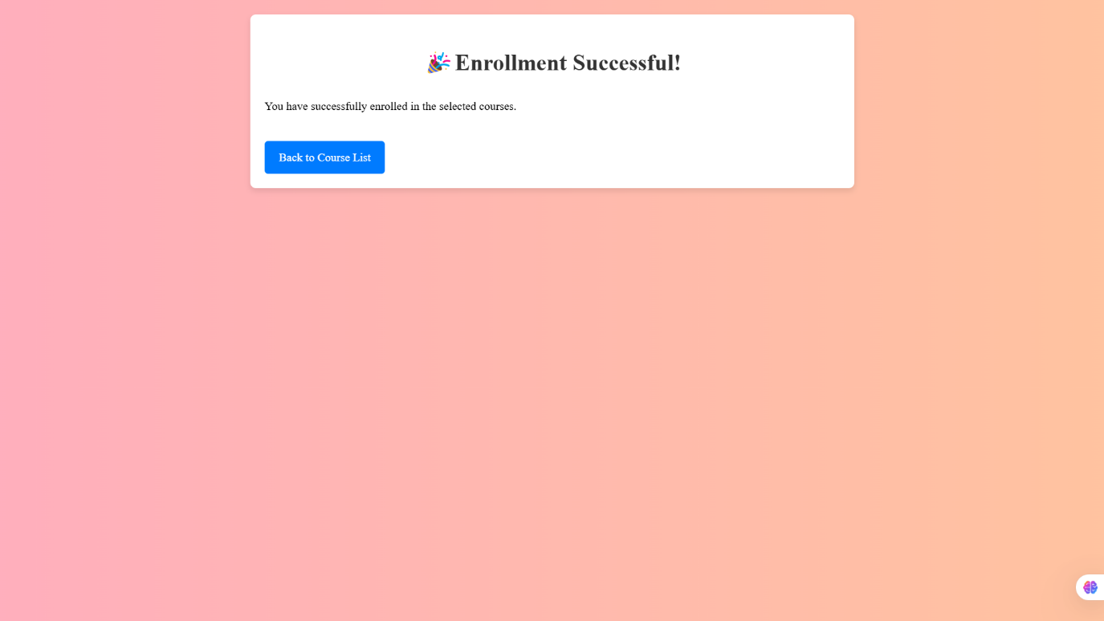

If the mail exists on the database it shows :