Hardware:

Hardware specifications:

GTX 745 NVIDIA

GPU name: GM107

CUDA Cores - 384

Base Clock speed - 1033

Memory Clock - 1.8 Gbps DDR3

Memory Size: 4 GB

PCI Express 3.0

**Report:**

Work was done on Windows and Linux machines for testing, but all data reported on was collected using the Linux labs. I used the GPUs to be able to parallelize the matrix multiplication. I used 3 functions to do the process of data collection, CPU implementation, GPU shared, and GPU naive. The combination of threads and blocks was calculated with respect to the size of the problem space, which increments in powers of 2.

Once I have allocated the space of the array, values were initialized with random values for comparison purposes. The allocations of host and device were made, and after the clock would be recorded using Cuda’s function of cudaEvent_t for the calculation of memoryCopy and the execution of the kernel.

I compiled the program using nvcc compiler using the command: nvcc --gpu-architecture=sm_50 -std=c++11 <filename>.cu . I also used scripts for testing, but hardcoded values for ease of use. The one boundary case to be aware of is whenever a value is larger than the hardware arch, as well as when the size is not equal to a power of 2, which the values may be off. I tried to negate this by accounting for it with the execution configuration, but there could be some occurrences of errors.

I was trying to calculate the residual using BLAS but I was running into errors pertaining the library and the operation of compiling it with the Linux lab, so I tried multiple options, but went with using an iteration of my GEMM to be able to get a host completion of a matrix multiplication configuration. In order to calculate the residual, I collected the sum of the possible error that could occur between the device and host versions and averaged them by the size. The condition is met if the size is squared for the majority of properties.

Figure 1:

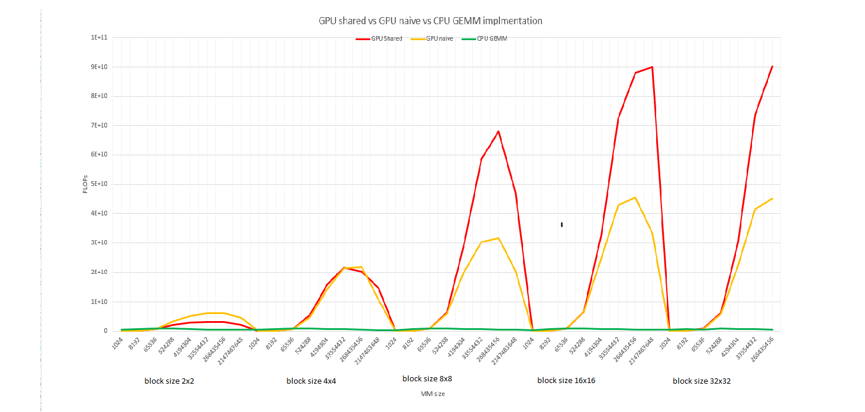

My first graph shows the relationship between the shared blocked, naive, and CPU implementations and their speeds. It is interesting to see how the allocation in memory and how they are affected by the increases in size and the importance of locality affects the FLOP of the dot product. I believe that the reason behind getting these results has to do with the way memory is allocated and is specified in the execution call. When implementing the shared blocked memory version, I chose to have a precondition that makes the size of the arrays equal to a dimension that is of base 2. This is to stay in its squared dimension which is a formal makeup of the hardware architecture that I am using for the assignment. Understand that there is an early trend that shows closer values as the size of the block and the size of the array is smaller than the naive and blocked version are similar. I believe this to be so, because of the low movement of data since there is not a large amount of allocated data being used to compute the information. The communication bandwidth is lowered but as the effective size gets closer to infinity, the values of the FLOP meet a higher differentiation in comparison. This can also be seen through the memory comparison in Figure 2 which shows this dynamic as the size of the gets bigger.

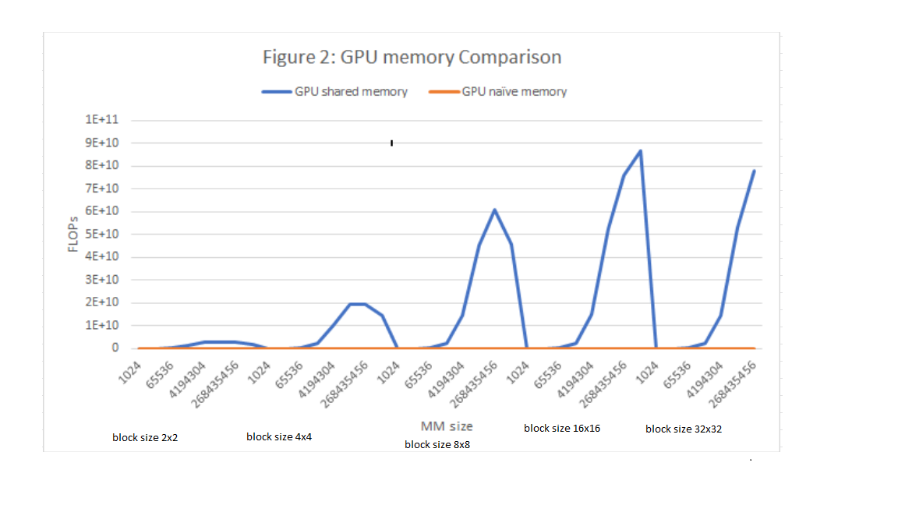

This shows the contrast in speed with the comparison to the On-chip location of the shared memory, and the off-chip operation, which is done on the global scope provide the visualization that as the block size increase so does the intensity of the GPU for the shared version of the computation.

**OUTPUT:**

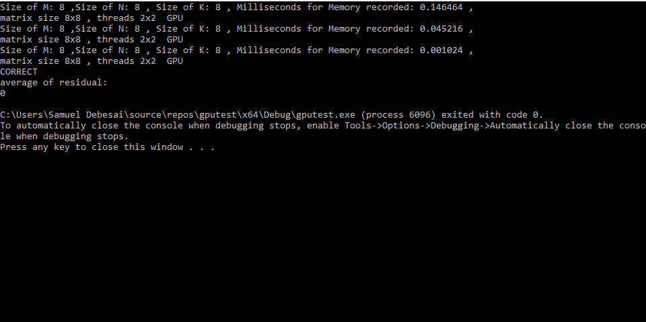

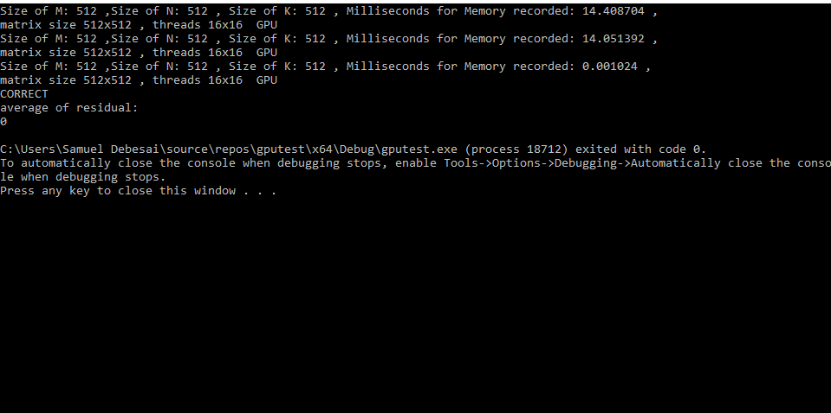

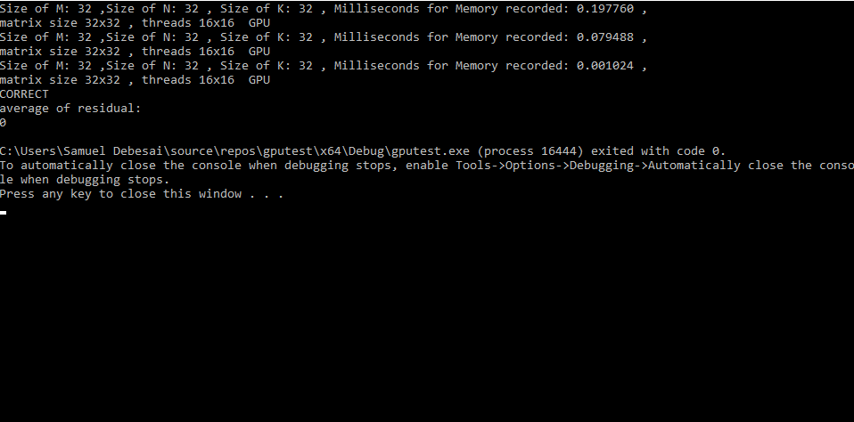

**DATA:**

|  |  |  |  |  |  |  |  |  |  |  |  |  |  |
| --- | --- | --- | --- | --- | --- | --- | --- | --- | --- | --- | --- | --- | --- |
| **Block size** | **size** | **GPU(n) time** | **GPU(s) time** | **CPU time** | **GPU(n) FLOP** | **GPU(s) FLOP** | **CPU FLOP** | **GPU(s) MEM ms** | **GPU(s) MEM time** | **GPU(n) MEM ms** | **GPU(n) MEM time** | **GPU(s) mem FLOP** | **GPU(n) mem FLOP** |
| **4** | **1024** | **0.000085184** | **0.000083616** | **0.000002176** | **12021036.81** | **12246460.01** | **470588235.3** | **0.202912** | **0.000202912** | **0.171552** | **0.000171552** | **5046522.6** | **8.36E-05** |
| **4** | **8192** | **0.000079392** | **0.000070304** | **0.000010144** | **103184199.9** | **116522530.7** | **807570977.9** | **0.214912** | **0.000214912** | **0.176096** | **0.000176096** | **38117927** | **7.03E-05** |
| **4** | **65536** | **0.000097568** | **0.000086976** | **0.000073408** | **671695637.9** | **753495217.1** | **892763731.5** | **0.294176** | **0.000294176** | **0.190176** | **0.000190176** | **222778201** | **8.70E-05** |
| **4** | **524288** | **0.000246016** | **0.00016304** | **0.000576192** | **2131113424** | **3215701668** | **909918915.9** | **0.397184** | **0.000397184** | **0.26832** | **0.00026832** | **1.32E+09** | **0.00016304** |
| **4** | **4194304** | **0.001428672** | **0.000814464** | **0.005282592** | **2935806119** | **5149772120** | **793985982.6** | **1.581824** | **0.001581824** | **0.921472** | **0.000921472** | **2.65E+09** | **0.00081446** |
| **4** | **33554432** | **0.010700608** | **0.005499808** | **0.053315742** | **3135750043** | **6101018799** | **629353184.3** | **10.86928** | **0.01086928** | **5.640864** | **0.005640864** | **3.09E+09** | **0.00549981** |
| **4** | **268435456** | **0.086442627** | **0.043777023** | **0.5107005** | **3105359767** | **6131880096** | **525622074** | **87.078178** | **0.087078178** | **44.225697** | **0.044225697** | **3.08E+09** | **0.04377702** |
| **4** | **2147483648** | **1.062792114** | **0.484636505** | **4.838290527** | **2020605554** | **4431122348** | **443851735.7** | **1063.367432** | **1.063367432** | **488.251343** | **0.488251343** | **2.02E+09** | **0.48463651** |
| **16** | **1024** | **0.000083488** | **0.000071392** | **0.000002048** | **12265235.72** | **14343343.79** | **500000000** | **0.20576** | **0.00020576** | **0.171456** | **0.000171456** | **4976671.9** | **7.14E-05** |
| **16** | **8192** | **0.000072128** | **0.000072064** | **0.00001024** | **113575865.1** | **113676731.8** | **800000000** | **0.201376** | **0.000201376** | **0.168512** | **0.000168512** | **40680121** | **7.21E-05** |
| **16** | **65536** | **0.000080896** | **0.000079712** | **0.000073248** | **810126582.3** | **822159775.2** | **894713848.8** | **0.21568** | **0.00021568** | **0.179776** | **0.000179776** | **303857567** | **7.97E-05** |
| **16** | **524288** | **0.000097152** | **0.000111136** | **0.000575936** | **5396574440** | **4717535272** | **910323369.3** | **0.235648** | **0.000235648** | **0.203776** | **0.000203776** | **2.23E+09** | **0.00011114** |
| **16** | **4194304** | **0.000265696** | **0.0002952** | **0.005293152** | **15786101409** | **14208346883** | **792401956.3** | **0.417152** | **0.000417152** | **0.402048** | **0.000402048** | **1.01E+10** | **0.0002952** |
| **16** | **33554432** | **0.001550368** | **0.001569888** | **0.051183617** | **21642882206** | **21373774435** | **655569769.5** | **1.740992** | **0.001740992** | **1.696736** | **0.001696736** | **1.93E+10** | **0.00156989** |
| **16** | **268435456** | **0.01325152** | **0.012321728** | **0.510722046** | **20256955881** | **21785536574** | **525599899.4** | **13.827584** | **0.013827584** | **12.790976** | **0.012790976** | **1.94E+10** | **0.01232173** |
| **16** | **2147483648** | **0.147692505** | **0.200769913** | **5.010881348** | **14540234442** | **10696242360** | **428564058.7** | **148.683655** | **0.148683655** | **201.727997** | **0.201727997** | **1.44E+10** | **0.20076991** |
| **64** | **1024** | **0.000103392** | **0.000069632** | **0.00000272** | **9904054.472** | **14705882.35** | **376470588.2** | **0.218048** | **0.000218048** | **0.169536** | **0.000169536** | **4696213.7** | **6.96E-05** |
| **64** | **8192** | **0.0000712** | **0.000071808** | **0.000010208** | **115056179.8** | **114081996.4** | **802507837** | **0.20336** | **0.00020336** | **0.168928** | **0.000168928** | **40283242** | **7.18E-05** |
| **64** | **65536** | **0.00007296** | **0.000072064** | **0.000073376** | **898245614** | **909413854.4** | **893153074.6** | **0.203648** | **0.000203648** | **0.171264** | **0.000171264** | **321810182** | **7.21E-05** |
| **64** | **524288** | **0.000083136** | **0.00009088** | **0.000572416** | **6306389530** | **5769014085** | **915921288** | **0.218304** | **0.000218304** | **0.1992** | **0.0001992** | **2.40E+09** | **9.09E-05** |
| **64** | **4194304** | **0.00014256** | **0.00020864** | **0.005261024** | **29421324355** | **20103067485** | **797240993.4** | **0.283488** | **0.000283488** | **0.314592** | **0.000314592** | **1.48E+10** | **0.00020864** |
| **64** | **33554432** | **0.000572352** | **0.00110752** | **0.049633343** | **58625517164** | **30296908408** | **676046181.3** | **0.742368** | **0.000742368** | **1.252288** | **0.001252288** | **4.52E+10** | **0.00110752** |
| **64** | **268435456** | **0.003946016** | **0.008478976** | **0.503546631** | **68026955795** | **31658947496** | **533089568** | **4.400256** | **0.004400256** | **8.907488** | **0.008907488** | **6.10E+10** | **0.00847898** |
| **64** | **2147483648** | **0.045621346** | **0.104847389** | **3.943130615** | **47071904630** | **20481994530** | **544613876** | **46.666882** | **0.046666882** | **106.073853** | **0.106073853** | **4.60E+10** | **0.10484739** |
| **256** | **1024** | **0.0000728** | **0.000071904** | **0.000004** | **14065934.07** | **14241210.5** | **256000000** | **0.265824** | **0.000265824** | **0.17216** | **0.00017216** | **3852172.9** | **7.19E-05** |
| **256** | **8192** | **0.000071104** | **0.00007136** | **0.000010176** | **115211521.2** | **114798206.3** | **805031446.5** | **0.208384** | **0.000208384** | **0.171872** | **0.000171872** | **39312039** | **7.14E-05** |
| **256** | **65536** | **0.000073632** | **0.000070848** | **0.000073216** | **890047805.3** | **925022583.6** | **895104895.1** | **0.20256** | **0.00020256** | **0.17024** | **0.00017024** | **323538705** | **7.08E-05** |
| **256** | **524288** | **0.00008208** | **0.0000824** | **0.000587936** | **6387524366** | **6362718447** | **891743319** | **0.219808** | **0.000219808** | **0.200032** | **0.000200032** | **2.39E+09** | **8.24E-05** |
| **256** | **4194304** | **0.000128064** | **0.00016912** | **0.005278816** | **32751624188** | **24800756859** | **794553930.3** | **0.28176** | **0.00028176** | **0.273216** | **0.000273216** | **1.49E+10** | **0.00016912** |
| **256** | **33554432** | **0.000461984** | **0.00078176** | **0.051409664** | **72631156057** | **42921653704** | **652687245.7** | **0.635808** | **0.000635808** | **0.924** | **0.000924** | **5.28E+10** | **0.00078176** |
| **256** | **268435456** | **0.003050688** | **0.005888704** | **0.519179199** | **87991776281** | **45584810512** | **517038156.6** | **3.525824** | **0.003525824** | **6.312032** | **0.006312032** | **7.61E+10** | **0.0058887** |
| **256** | **2147483648** | **0.023868065** | **0.064636383** | **4.07297876** | **89973093671** | **33224068989** | **527251374.1** | **24.788544** | **0.024788544** | **65.515907** | **0.065515907** | **8.66E+10** | **0.06463638** |
| **1024** | **1024** | **0.000085728** | **0.000081792** | **0.000001984** | **11944755.51** | **12519561.82** | **516129032.3** | **0.218464** | **0.000218464** | **0.16928** | **0.00016928** | **4687271.1** | **8.18E-05** |
| **1024** | **8192** | **0.000072416** | **0.000069152** | **0.000010112** | **113124171.5** | **118463674.2** | **810126582.3** | **0.202784** | **0.000202784** | **0.1688** | **0.0001688** | **40397665** | **6.92E-05** |
| **1024** | **65536** | **0.000072224** | **0.000080032** | **0.00010512** | **907399202.5** | **818872451** | **623439878.2** | **0.203872** | **0.000203872** | **0.178528** | **0.000178528** | **321456600** | **8.00E-05** |
| **1024** | **524288** | **0.00008304** | **0.000090432** | **0.000600896** | **6313680154** | **5797593772** | **872510384.5** | **0.223968** | **0.000223968** | **0.195296** | **0.000195296** | **2.34E+09** | **9.04E-05** |
| **1024** | **4194304** | **0.00013856** | **0.000187456** | **0.00526752** | **30270669746** | **22374871970** | **796257821.5** | **0.282944** | **0.000282944** | **0.292832** | **0.000292832** | **1.48E+10** | **0.00018746** |
| **1024** | **33554432** | **0.000454016** | **0.0008056** | **0.052437824** | **73905835918** | **41651479643** | **639889862.7** | **0.629312** | **0.000629312** | **0.9448** | **0.0009448** | **5.33E+10** | **0.0008056** |
| **1024** | **268435456** | **0.002977664** | **0.005933184** | **0.510623901** | **90149679749** | **45243069488** | **525700922.9** | **3.43008** | **0.00343008** | **6.283712** | **0.006283712** | **7.83E+10** | **0.00593318** |