Saumil Shah

20151179

Guide: Sutirth Dey

Adaptation to the same environment can result in loss or gain of a trait based on different population sizes

Fall 2018

Mid Semester Report

# Introduction

Fitness is a central concept in evolutionary biology. The classical description of the fitness of an individual is related to its reproductive output. Fitness was considered to be an attribute of an individual, but it can also be used to elucidate other higher or lower biological units such as the population or the gene. In the context of altruistic behavior, group selection eventuates, and a set of individuals with the highest group fitness prevails. Allelic or genotypic fitness describes the contribution of an allele or a genotype to the next generation.

However, the fitness of a particular allele or genotype depends on several other factors. There are interactions in the genome between different loci which lead to epistasis, meaning fitness of a gene depends on the available genetic background of the organism. Epistasis can be classified into various categories based on the description of the interaction of the genes. One such class of epistasis is called sign epistasis, where the sign of the fitness of a gene is under epistatic control. This indicates that a mutation is beneficial in some genetic backgrounds while deleterious in other.

Another such controlling factor is the environment. The fitness of a genotype depends on the surrounding environment. For example, the fittest genotype during an ice age might not be the fittest genotype once the ice age is over. A population must alter its genotype according to the change in environment, and this takes place via interaction of characteristics with the given environment. The heritable genetic basis of any trait that gives it a fitness advantage over other traits becomes more common in the population. Therefore the trait becomes enhanced for a given environment in the population.

Recent experiments have revealed that adaptation to the same environment can result in the decay or enhancement of the same character based on differences in population size. *Escherichia coli* were subjected to growth in an environment with a cocktail of three antibiotics in the experiments. While adapting to this environment E. coli cultures with small population size enhanced their efflux activity compared to the ancestors, whereas large population lost the efflux activity. Noting the tendency of the trait to undergo a retroverted description based on numerical changes, we are interested in understanding how quantitative changes can give rise to qualitative changes. Here we have developed a simple model using a toolkit of basic evolutionary mechanisms that reproduce similar results as the experiments.

# Objectives

1) Simulate for the result proposed in the title

2) Determine the minimal set of conditions which can lead to such behavior

3) Verify whether this phenomenon is deterministic and explore the possibility of mathematical modeling

# Methods

Asexual haploid individuals were chosen to simulate in order to keep the complexity to a minimum. Agent-based computer simulations, constructed from simple Wright-Fisher Model were carried out having only random genetic drift along with mutations to mimic the dynamics of such populations. The simulations were subjected to discrete generations and were parameterized by population size, i.e., during the simulation, all the replicates maintained the specified population size after the random genetic drift being applied every generation. These simulations were carried out at a wide range of population sizes, spanning over several orders of magnitudes.

The genotype of all individuals was composed of two loci, A and B, each with three alleles L (low expression), 0 (intermediate expression), and H (high expression). This gave rise to nine genotypes. All the simulations started with clonal populations of wild-type individuals. A0B0 was chosen as the wild-type for the simulations.

One could think of locus A as something that requires significant maintenance cost for its expression and is large in length. On the other hand, locus B can be thought of as a structural protein that does not require much maintenance and is shorter in length. Locus A exhibited sign epistasis on locus B backgrounds. Which suggests that as the expression of gene B increases the slope of the fitness landscape gets flipped from positive to negative in the direction of the expression of gene A as illustrated in **figure 1**.

Mutations occurred with probabilities shown in **figure 2**. Mutation probabilities were kept low such that multiple mutations cannot occur at the same time. Mutations on locus A were more common than mutations on locus B and mutations that lower the expression of a gene were much more common than mutations that enhanced its expression.

Figure 1

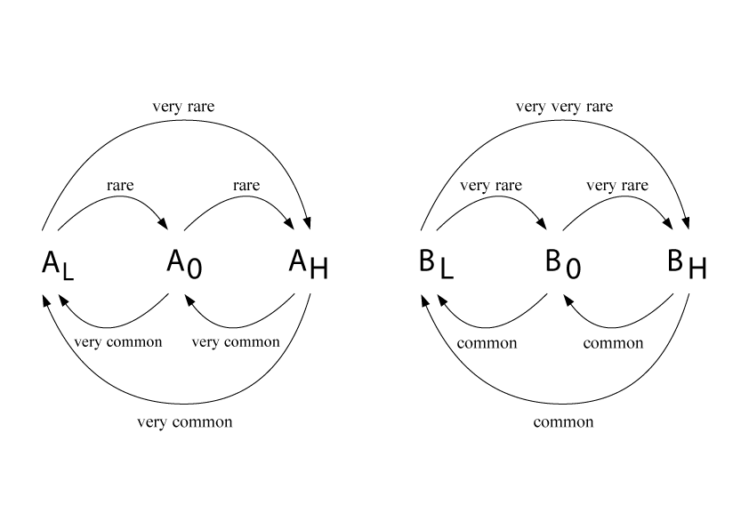

Figure 2a Figure 2b

Figure 2

# Results

All populations were observed to increase their average fitness as seen in figure 3. The small populations converged to AHB0 genotype whereas the large populations converged to ALBH genotype. Adapting to the same environment led to gain of a biological trait in small populations while losing the same trait in larger populations.

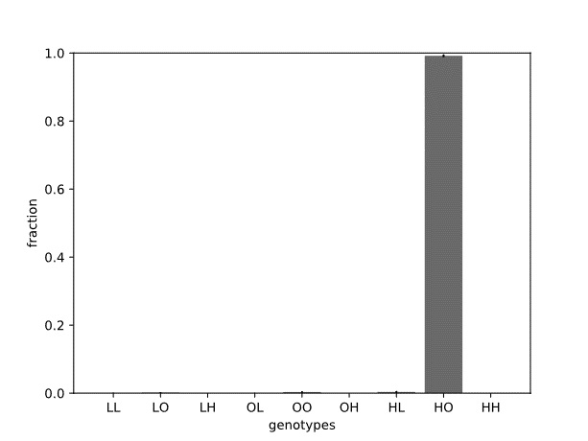 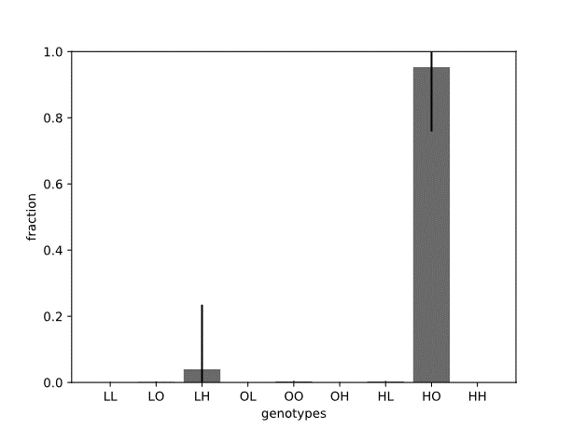

Figure 3a N=103 Figure 3b N=104

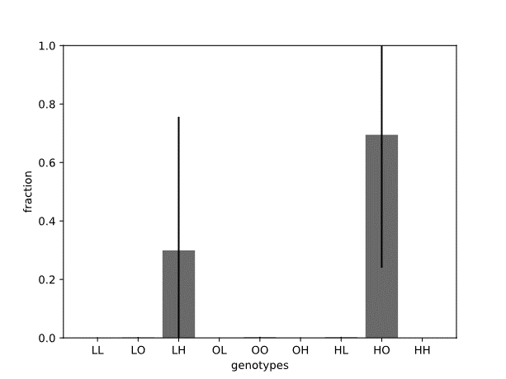 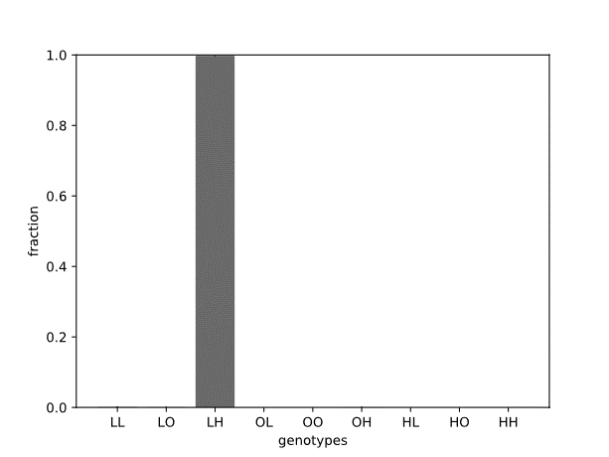

Figure 3c N=105 Figure 3d N=106

Figure 3