CSci 435: Formal Languages and Automata Sam Dressler

Instructor: Dr. M. E. Kim Name: ________________________

**Home Assignment 1: 97/110 points + 10 points (optional)**

Q1. [21/25] For Σ = {a, b}, construct the minimal DFA that accept the language consisting of

1. [7/8] all strings with an even number of *a*’s and an odd number of *b*’s.

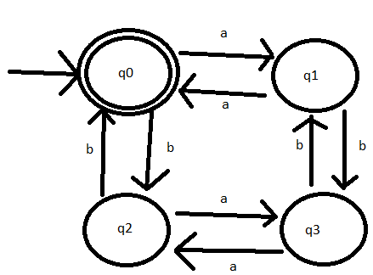

* This system does not accept all strings with an even number of *a*’s and an odd number of *b*’s.
* q3 is a final state, not a q0.
* See the attached solution.

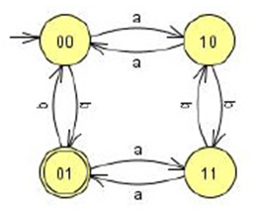

1. [5/8] every ‘*aa’* is followed immediately by a ‘*b’*. For example, the strings *aab*, *aaba*, *aabaabbaab* are in the language, but *aaab* and *aabaa* are not. Construct a DFA with 4 states.

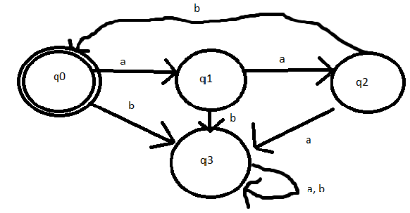

* See the attached solution

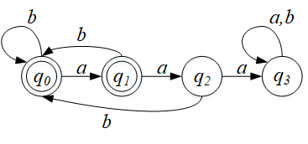

1. [9/9] L = {w | ( *na*(*w*) – *nb*(*w*) ) mod 3 = 0 }. Construct a DFA with 3 states.

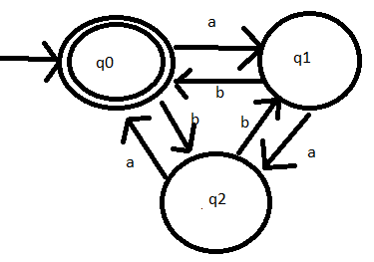

Q2. [10/10] Show that the language L = { *a****n***| *n* ≥ 0, *n* ≠ 3 } is regular.

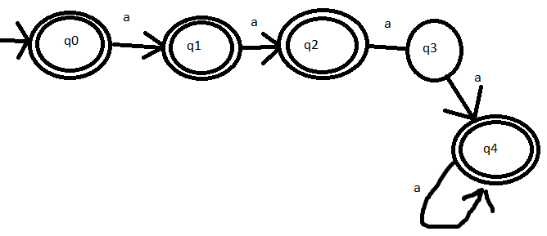

Q3. [13/15] For the language L = {*an* | *n* ≥ 1 } ∪ {*bmak* | *m* ≥ 0, *k* ≥ 0}

1. [6/8] Construct an NFA with three states that accepts L.

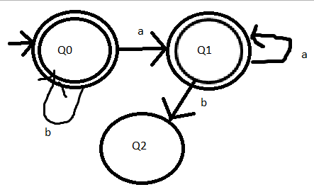

* See the attached solution

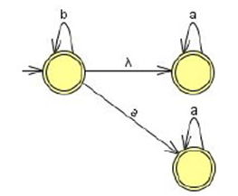

1. [7/7] Can you construct an NFA with the fewer states that accepts L? If so, construct it; otherwise, justify why your NFA in 1) is the minimal NFA.

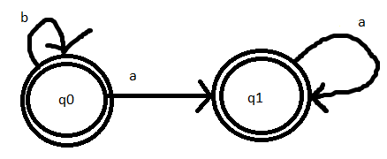

Q4. [17/20] For a given NFA in the figure,

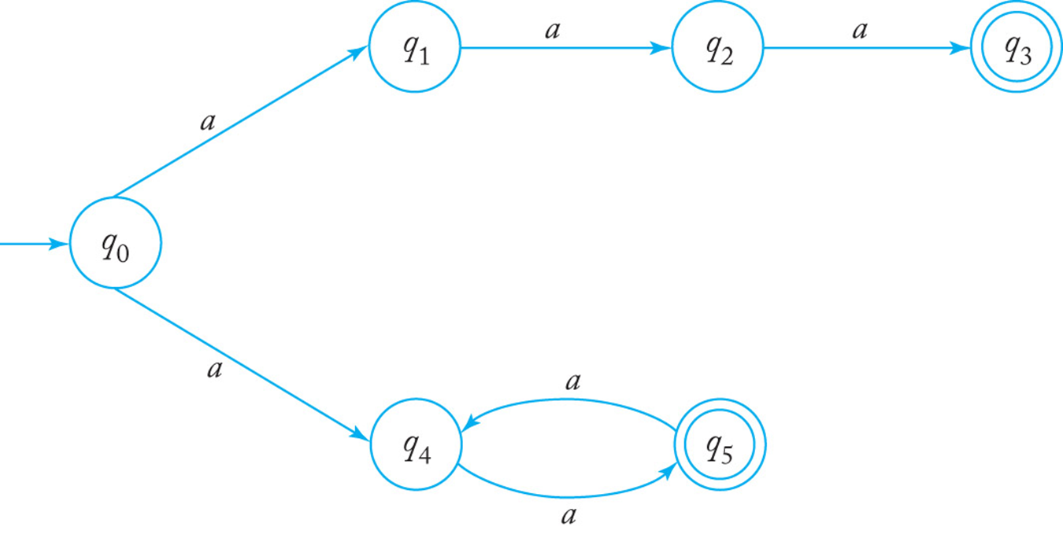

1. [10/10] Give a language *L* that is accepted by the NFA. Describe L in the proper mathematical format, not in the verbal English description. E.g.) L = { *a****n***| *n* ≥ 0, *n* ≠ 3 }

L= {an | n = 3} U {an | n mod 2 = 0}

1. [7/10] Find a *DFA* that accepts the ***complement*** of the language defined by the NFA, i.e. .

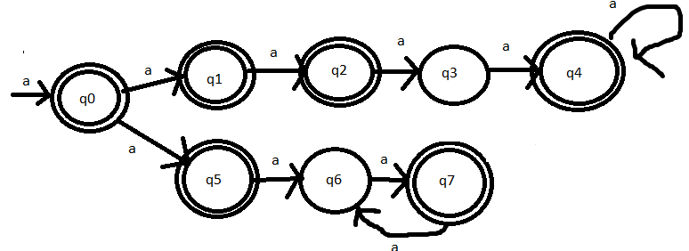L= {an | n != 3} U {an | n mod 2 = 1}

* First, you need an equivalent DFA to the given NFA then complement of it.
* See the attached solution

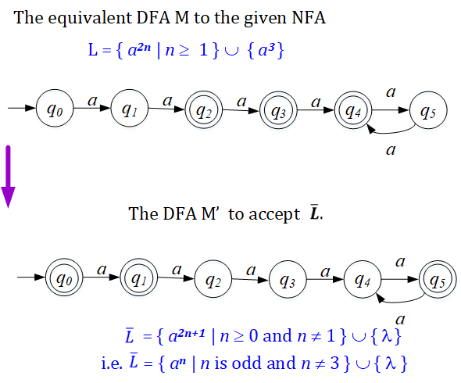

Q5. [10/10] Construct an NFA with the ***minimum*** number of states that accepts

*L* = { *an* | *n* ≥ 0 } ∪ { *bna* | *n* ≥ 1 }.

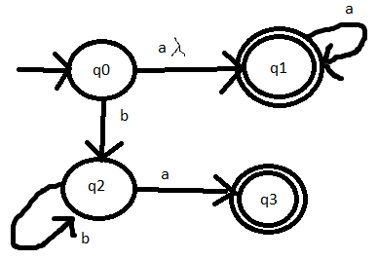

Q6. [6/10] Convert the NFA defined by the transitions below with the initial state *q0* and the final state *q2* into an *equivalent DFA*. Draw the transition graph of the DFA.

|  |  |  |
| --- | --- | --- |
| NFA-DFA | a | b |
| q0 | q0, q1 | - |
| q0, q1 | q0, q1 | q1, q2 |
| q2 | q2 | - |
| q1, q2 | q2 | q1, q2 |

δ(*q0, a*) = { *q0, q1* }, δ(*q1, b*) = { *q1, q2* }, δ(*q2, a*) = { *q2* }, δ(*q1,* λ) = { *q1, q2* }.

|  |  |  |  |
| --- | --- | --- | --- |
| NFA | a | b | Λ |
| q­0 | q0, q1 | -- | -- |
| q1 | -- | q1, q2 | q1, q2 |
| q2 | q2 | -- | -- |

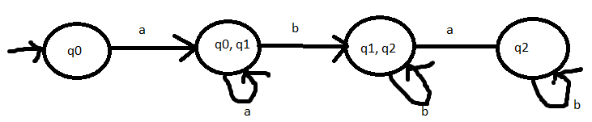

* See the attached solution

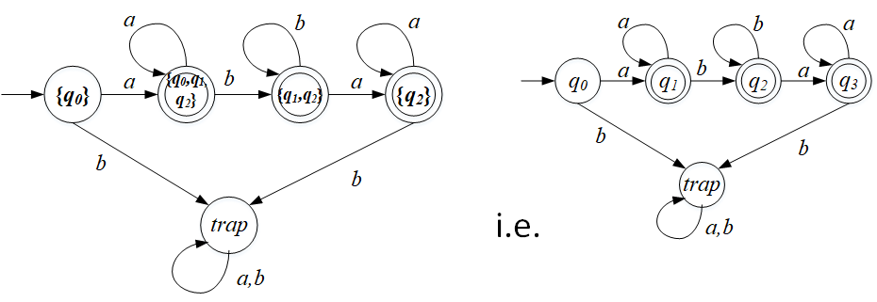

Q7. [20/20] For a given language, L = { *anb* | *n* ≥ 1 } ∪ { *bna* | *n* ≥ 1},

1. [10/10] Construct a *minimal DFA* with the minimum number of states that accepts L.

`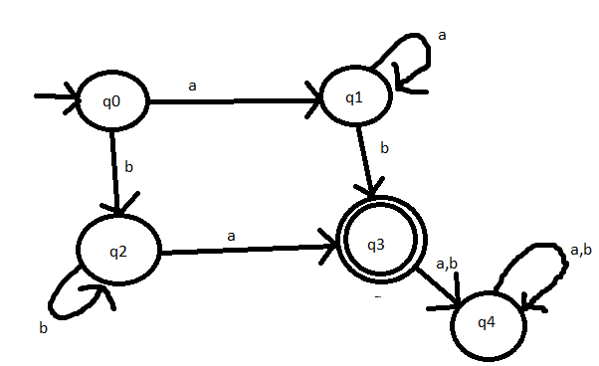

1. [10/10] Prove that your DFA in 1) is minimal. Hint: Check if any pair of the states are indistinguishable to be merged in the same class so that the number of states are minimized

To prove that the DFA in 1) is minimal, show that all the states are distinguishable from each other and cannot be merged;

q0 & q1: δ (q0, b) = {q2}, δ (q1, b) = {q3}: distinguishable.

q0 & q2: δ (q0, a) = {q1}, δ (q2, a) = {q3}: distinguishable.

q0 & q3: δ (q0, a) = {q1}, δ (q3, a) = {q4(trap)}: distinguishable.

q1 & q2: δ (q1, a) = {q1}, δ (q2, a} = {q3}: distinguishable.

q1 & q3: δ (q1, a) = {q1}, δ (q3, a} = {q4(trap)}: distinguishable.

q2 & q3: δ (q2, b} = {q2}, δ (q3, b} = {q4(trap)}: distinguishable.

The DFA is minimal since all pairs of states including the trap state are distinguishable.

For q0 and q1, and input of “a” would result in q1 and q3

Q8. [0/10, optional] Prove or disprove the following conjecture: If L is regular, so is LR.

If it is true, construct a NFA MR s.t. L(M’) = LR , from a NFA M that accepts L, i.e. L(M) = L. Then, show that L(M’ ) = LR .

Otherwise, give a counter example.

1. Since L is regular, there exists an NFA M that accepts L s.t. L = L(M) where M = (*Q*, Σ, δ, *q0*, *F* ),

To show LR is regular, let’s construct M’ that accepts LR as follows.

* + The start state *q0*, in *M* becomes the final state in *M’*.
  + Since there may be multiple final states in M, i.e. |F| ≥ 1, create a new start state p0  in M’ . Then, add a transition with λ from p0 to each of *qf* ∈ F.
  + The direction of all transition edges in *M* is reversed.
  + Thus, *M’* = (*Q*, Σ, δR, *p0’*, *q0* )

where ∃ (*qj, a*) = *qi* ∈ δR , ∀(*qi, a*) = *qj*∈δ

and (*p0,* λ) = *qf* for each *qf* ∈ F .

1. Then, show that L(M’) = LR .

→) Claim: For any *w∈ L(M’), w* ∈ *LR .*

Since *w∈ L(M’), w* is accepted by *M’,*

i.e. there is an transition from *p0* leading to the final state *q0* with *w* in M’ :

*δ R* (p0, w) = δ R* (p0, λw) = δ R* (δ R (p0, λ), w) = δ R* (qf* .*, w) = q0* for any *qf* ∈ F .

Since every transition in *M’* is the reverse of the transition in *M,*

for any *δ R* (p0, w) = δ R* (qf* .*, w) = q0 in M’,* there exists  *δ* (q0, wR) = qf*  in *M.*

Thus, *wR ∈ L, i.e. w ∈ LR .*

←) Claim: For any *w* ∈ *LR , w∈ L(M’)*

For any *w* ∈ *LR , wR∈ L.*

Since *L* is a regular language accepted by *M, wR∈ L = L(M).*

So, there exists an extended transition *δ* (q0, wR) = qf*  in *M.*

Since *M’* was defined with the reverse transitions of *M,*

*δ* (q0, wRλ) =δ (δ* (q0, wR ), λ)=δ (qf , λ)= δ* (δ R (p0, λ), wR) = δ R* (δ R (p0, λ), w)*

*=* *δ R* (p0, λw) =* *δ R* (p0, w) = q0 .* So, *w* ∈ *L(M’).*

Thus, L(M’) = LR .

Therefore, LR  is regular. Q.E.D.