CSci 435: Formal Languages and Automata

Instructor: Dr. M. E. Kim Name: __Sam Dressler_________

**Home Assignment 2: 100 points + 10 points (optional)**

Q1. [10] Find all strings in L((*ab* + *b*)* b (*a* + *ab*)*) of length ***less than*** four.

L = {b, bb, ba, abb, bab, bbb, baa}

Q2. [10] Give a ***regular expression*** for the language

1. [10] L = {*anbm* | (*n*+*m*) is odd}.

L((aa)*(bb)*a +(aa)*(bb)*b ) ={a, b, aaa, abb, baa, bbb, …}

1. [10, optional] L = {*w* ∈ {*a, b*}* | ( *na*(*w*) - *nb*(*w*) ) mod 3 = 0}. Hint: Apply Thm 3.2. .

Q3. [10] Using the construction in Theorem 3.1, construct an NFA that accepts the complement of the

Language L(*ab*\**aa* + *bba*\**ab*).

Q4. [20] Construct a ***minimal DFA*** that accepts the following language

1. [10] L(*ab*(*a*+*ab*)*(*a*+*aa*))
2. [10] L((*aa*\*)\**b*)*)

Hint: Start with constructing an NFA (by Theorem 3.1), convert it to DFA, then get the minimal DFA by mark & reduce procedures.

Q5. [20] Find ***regular expressions*** for the languages accepted by the following automaton.

1. [10]

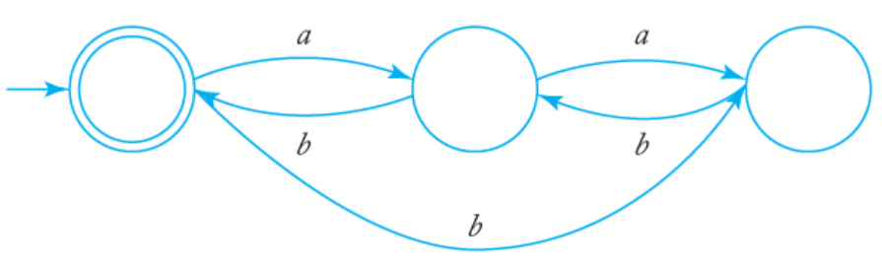

L=(a+b)

1. [10]

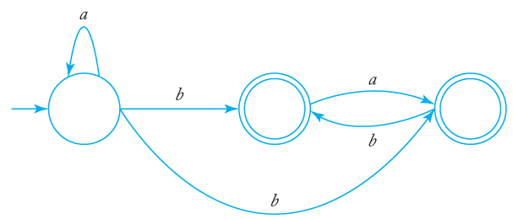

Q6. [10] Construct a ***DFA*** that accepts the language generated by the *grammar*

S → *ab*S | B, A → *a*B | *bb,* B → *ba*A.

Q7. [20] Find a ***regular grammar*** that generates the language on Σ={a, b}

1. [10] *L*(*aa*\*(*ab*+*a*)*)
2. [10] the language consisting of all strings with no more than two *a*’s.