CSci 435: Formal Languages and Automata

Instructor: Dr. M. E. Kim Name: Sam Dressler

**Home Assignment 5: 100 points + 15 points (optional)**

In any (N/D) PDA, assume that a start stack symbol z is already in the stack; so, you don’t have to insert z into the stack at the beginning of transition.

*Q1. [20] For a given language L = { *w* | *na*(*w*) + *nb*(*w*) = *nc*(*w*) } where Σ = Γ = {*a*, *b, c*}

1. [10] Construct a PDA M that accepts L with Σ = Γ = {*a*, *b, c*}

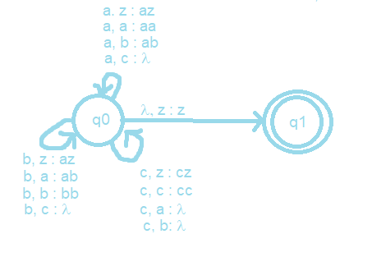

The cycles from q0 can be compressed to one cycle but were split here for ease of reading.

1. [10] Show the sequence of instantaneous descriptions for the acceptance of *acacbcbc* by M in 1).

(q0, acacbcbc, z)

˫ (q0, cacbcbc, az) //’a’ as input symbol and ‘z’ on top of stack so push ‘az’

˫ (q0, acbcbc, z) // ‘c’ as input symbol and ‘a’ on top of stack so pop ‘a’

˫ (q0, cbcbc, az) // ‘a’ as input symbol and z’ on top of stack so push ‘az’

˫ (q0, bcbc, z) // ‘c’ as input symbol and ‘a’ on top of stack, so pop ‘a’

˫ (q0, cbc, bz) // ‘b’ as input symbol and ‘z’ on top of stack, so push ‘bz’

˫ (q0, bc, z) // ‘c’ as input symbol and ‘a’ on top of stack, so pop ‘b’

˫ (q0, c, bz) // ‘b’ as input symbol and ‘z’ on top of stack, so push ‘bz’

˫ (q0, λ, z) // ‘c’ as input symbol and ‘a’ on top of stack, so pop ‘b’

˫ (q1, λ, z) // ‘λ’ as input symbol and ‘z’ on top of stack, so we are finished.

1. [10, optional] Give a CFG G that generates L, L(G) = L.

S-> aX | bX | λ

X -> cS | Sc

*Q2. [20] Construct an NPDA for the following languages.

1. 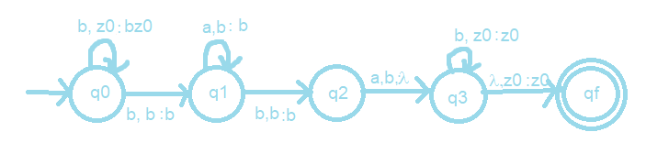[10] L1 = {*bba*\**bab*\* }
2. 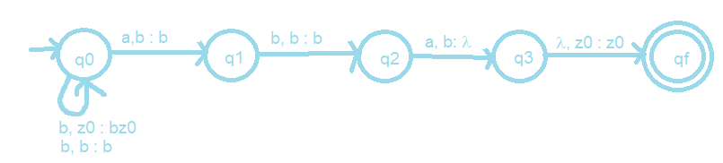[10] L2 = {*bbb*aba* }
3. [5, optional] L4 = L2 – L1.

*Q3. [10] Give the language that is accepted by the NPDA M in a formal expression (including a regular expression) where M = ({*q0, q1, q2*}, {*a, b*}, {*a, b*, z}, δ, *q0*, z, { *q0* , *q1*, *q2*}), with transitions

♦ δ(*q0*, *a*, z) = {(*q1*, *a*), (*q2*, λ)},

♦ δ(*q1*, *b*, *a*) = {(*q1*, *b*)},

♦ δ(*q1*, *b*, *b*) = {(*q1*, *b*)},

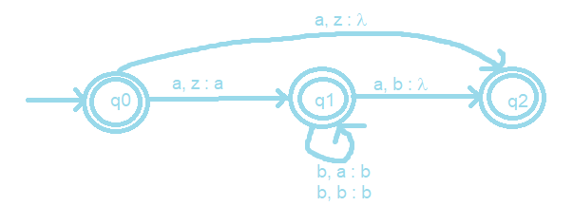 ♦ δ(*q1*, *a*, *b*) = {(*q2*, λ)},

L(M) = {l + a + ab* + ab*a}

Q4. [20] (A) Construct a NPDA that accepts the language defined by the given grammar and (B) give the language in a formal expression (including a regular expression).

Hint: Convert the grammar into Greibach Normal Form, then apply Thm. 7.1..

1. S → *ab*S*b* | λ.

Greibach Normal Form:

S->aBSB | aBB

B -> b

NPDA for above GNF of Grammar:

M = ({q0, q1, q2}, {a, b, l), {B, S, z}, d, q0, z, {q2})

d{

d (q­0, l, z) = {(q1, Sz)}

d (q­1, a, S) = {(q1, BSB), (q1, BB)}

d (q­0, b , B) = {(q1, l)}

d(q1, l, z) = {(q2, z)}

}

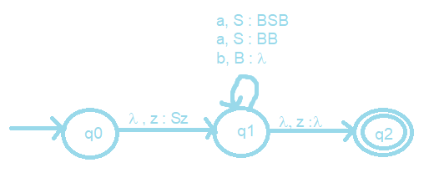

L = {(ab)nbn | n > 0}

Regex: abb + (ab)*b*

1. S → AA | *a*

A → SA | *ab*.

M = ({*q0, q1*}, {*a, b*}, {*A*, z}, δ, *q0*, z, {*q1*}), with the transitions

S->AA | a

A->SA | ab

S = A1, A = A2

GNF:

A1 -> aA2A2 | aBA2 | aA2B2A2 | aBB2A2 | a

A2 -> aA2 | aB | aA2B2 | aBB2

B2 -> aA2A2A2 | aBA2A2 | aA2B2A2A2 | aBB2A2A2

B2 -> aA2A2A2B2 | aBA2A2A2B2 | aA2B2A2A2A2B2 |aBB2A2A2A2B2

B -> b

NPDA for above GNF of Grammar:

M = ({q0, q1, q2}, {a, b, l), {A1, A2, B, B2, z}, d, q0, z, {q2})

d{

d(q0, l, z) = {(q1, A1z)}

d(q1, a, A1) = {(q1, A2A2), (q­1, BA2), (q1, A2B2A2), (q1, BB2A2), (q1, l)}

d(q1, a, A2) = {(q1, l), (q1, B), (q1, A2B2), (q1, BB2)}

d(q1, a, B2) = {(q1, A2A2A2), (q1, BA2A2), (q1, A2B2A2A2), (q1, BB2A2A2),

(q1, A2A2A2B2), (q1, BA2A2A2B2), (q1, A2B2A2A2A2B2),

(q1, BB2A2A2A2B2)}

d(q1, b, B) = {(q1, l)}

d(q1, l, z) = {(q2, z)}

}

L(G) = (aab + aa + aba+abab)(a, ab)n | n >= 0

Regex = a(a,ab)(a,ab)* + ab(a,ab)(a,ab)*

Q5. [20] Find a (minimal) Context-Free Grammar that generates the language accepted by the NPDA M where M = ({*q0, q1*}, {*a, b*}, {*A*, z}, δ, *q0*, z, {*q1*}), with the transitions

♦ δ(*q0*, *a*, z) = {(*q0*, *Az*)},

♦ δ(*q0*, *b*, *A*) = {(*q0*, *AA*)},

♦ δ(*q0*, *a*, *A*) = (*q1*, λ).

Simplify the production rules by eliminating the useless variables and productions.

S-> (q0zq­­0) | (q­­0zq1)

(q0zq0) -> a(q0Aq1) (q1zq0) | a(q0Aq0) (q0zq0)

(q0zq1) -> a(q0Aq0) (q0zq1) | a(q0Aq1) (q1zq1)

(q0Aq0) -> b(q0Aq0) (q0Aq0) | b(q0Aq1) (q1Aq0)

(q0Aq1) -> b(q0Aq0) (q0Aq1) | b(q0Aq1) (q1Aq1)

(q0Aq1)-> a

There are no transitions for (q1Aq1), (q1Aq0), and (q1zq1), so they are useless and can be removed.

S-> (q0zq­­0) | (q­­0zq1)

(q0zq0) -> a(q0Aq1) (q1zq0) | a(q0Aq0) (q0zq0)

(q0zq1) -> a(q0Aq0) (q0zq1)

(q0Aq0) -> b(q0Aq0) (q0Aq0)

(q0Aq1) -> b(q0Aq0) (q0Aq1)

(q0Aq1)-> a

Q6. [10] Construct a Deterministic-PDA that accepts L= {*an bm* | 0 ≤ *m* < *n* } to show L is a Deterministic-CFL.

Grammar for L

S -> aA | a

A -> aA | aB | a

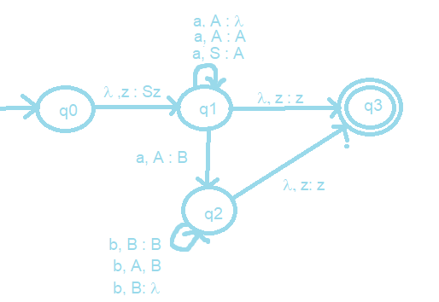B -> bB | b