Senior Design - Partial Hand Prosthetic – Related Works Summary

11/1/2020

Sam Dressler and John Neis

Prosthetics have been used for nearly 3000 years with the oldest being discovered in Egypt as a replacement for a lost toe. Since then, prosthetics have become more and more advanced replacing whole arms or legs or even a variety of joints throughout the human body. The advances in prosthetics have not just been limited to new locations, but through the advent of modern technology, the capabilities have also been increased. Prosthetics that function electronically, controlled by muscle signals are known as myoelectric prosthetics and are the focus of our group’s project. These devices are different than body-powered prosthetics in the fact that they do not require an intricate system involving a harness and cable that connect to a terminal device. The choice of a myoelectric or body-powered upper-limb prosthetic can be decided using a variety of different metrics. These include function, feedback, and control amongst others. The purpose of this paper is to survey the market and research field for current applications of myoelectric prosthetics that are available.

Specifically, our group is designing a partial hand prosthetic for a subject’s left hand that was lost because of a form of cancer. Our group’s device will offer a fully operable replacement for the candidates lost two fingers. During our analysis of the overall market, we found several companies that offer products with solutions for regaining full or partial functionality for an amputation of the hand. The companies we chose to assess and compare to our team’s work in this summary are Ӧssur and Partial Hand Solutions LLC. Each of these organization’s products will first be described and then analyzed based on how they are similar or different to what our team is doing.

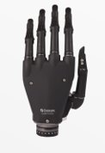Ӧssur offers a variety of options for upper-limb prosthetics ranging from whole arm prosthetics to prosthetics including 1-5 digits. The products from Ӧssur include the i-Limb Access as well as the i-Digits Quantum.   The first of these, the i-Limb Access, is a myoelectric hand that is powered by 5 individually powered digits and a manual rotatable wrist. This device was chosen because the functionality is like our team’s proposed solution in the fact that they also use individually powered digits. Additionally, the device has key features such as auto-grasp, touch screen capabilities, four sizes, and a user app which offers 12 grips. One of this device’s downside that it will not work in environments where the temperature is below zero degrees centigrade.

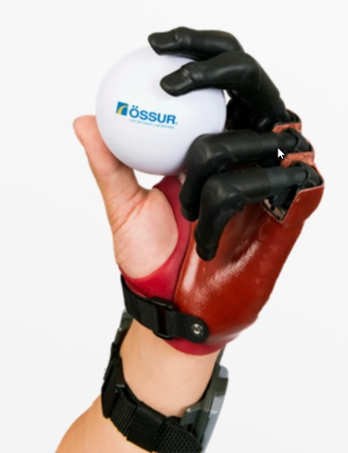Ӧssur’s second product in our analysis is the I-Digit Quantum. This device is a fully customizable partial-hand prosthetic that includes individually powered digits. Users are limited to candidates that fit the requirements of having the absence or disability with 1 to 5 digits where the amputation is distal to the wrist and proximal to the metacarpophalangeal joint. This means that amputation is at the base of the finger by the first knuckle. This product, like the previous product described, can also connect to a user app where the user has access to up to 32 automated grips. The device is powered by a pair of batteries attached to a wristband which also contains the device’s microprocessor. The final feature for this product is an option to increase the speed of the device by up to 30 percent with the user app.

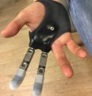Partial Hand Solutions LLC offers a series of products known as the TITAN series. The one that we are interested in is the TITAN Full which offers a full replacement for loss fingers. The TITAN series are a series of heavy-duty solution for amputees which are made from high strength titanium and hardened steel. The Titan Full is advertised as perfect fit, durable, and natural, meaning it has two joints. This device is not mechanically controlled but is used by manually positioning the fingers using a ratchet design. This mechanism is expected to give the user a secure grasp of objects and provides a feeling of control and strength when performing work tasks. Some of the downsides for this device is that it does not offer a solution for control and it is also not designed to replace part of the wrist.

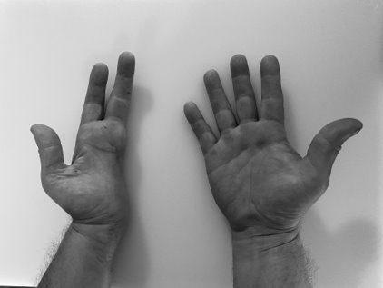Now that we have thoroughly described some of the chosen products, we can begin to compare them to our team’s proposed solution. After researching these products, one of the main differences in our project and these other companies’ solution is that they do not include an option for amputees who are also missing part of their hand.  The image below is the candidate our team has chosen for our project. As you can see, the person is missing part of the hand and would not be a valid candidate to use the products available on the market. There are over 61,000 partial hand removals in the US each year, and it is an unfortunate reality that there will be other amputees who are missing more or less of the palm.

While the TITAN Full offers a solution to replace entire fingers, the product does not offer the same kind of control that a myoelectric prosthetic would offer. Because of this, the product is not in the same market space as our team’s project. The Ӧssur i-digit, on the other hand, will offer a myoelectric solution which means it is a direct competitor to what we are trying to do. The same argument can be made that their solution does not address the users who have partial palm loss but it is still very similar. Additionally, the Ӧssur products utilize a user application where they can choose premade grips. This is an idea that our team had as well, and we plan on differentiating our product by giving the user options for sign language signs in the app as well as similar pre-determined grips. Furthermore, where I-Digit offers a feature to increase the speed of the digits, our group plans on implementing a feature where the user will be able to adjust the strength of the grip to ensure that the correct amount of force is applied for different tasks.

Our team did an analysis of where our device would fit into the market currently available and came up with strengths, weaknesses, and opportunities. Some of the key advantages that our device will offer to the consumer include, full partial hand and digit loss, as well as a feedback system that will give information to the user on their current grip. Our group has the disadvantage of a limited budget as well as limited resources that we can utilize to develop our device.

The challenge is clear and the competitors we face in this campaign have been around much longer than we have been involved; however, this does not mean that our device would not be able to compete with the products already in the market. The problem that we are working to resolve is close to home and this gives us motivation to innovate and find creative solutions to the probable niches that will come up during development. While the future of this market is not clear due to possible leaps in technology, such as a breakthrough with biological solutions with stem cell manipulation, the problem still remains and our device will offer a full arsenal of valuable features to the user.

Sources

<http://unyq.com/the-history-of-prosthetics/>

<https://www.ossur.com/en-us/prosthetics/arms/i-digits-quantum>

<https://www.rehab.research.va.gov/jour/2015/523/jrrd-2014-08-0192.html>

<http://upperlimbprosthetics.info/index.php?p=1_9_Body-Powered>

<https://en.wikipedia.org/wiki/Prosthesis>

<https://partialhandsolutions.com/products/>