Motor Trend - MPG Comparison

### Executive Summary

Miles per gallon (MPG) is an important metric for any person considering to buy a car. Motor trend magazine has collected data from a series of cars to understand how different car attributes affect MPG. Specifically, we are interested in understanding:

1. Is an automatic or manual transmission better for MPG?
2. How much difference is there between automatic and manual transmission for MPG consumption?

The analysis concluded that: - automatic cars have a lower MPG. - but this analysis is limited by confounding variables such as weight which could influence the results.

### Exploring the data

We collected 32 observations to inform our study:

Summary of observations

|  |  |  |
| --- | --- | --- |
| transmission | Number of Observations | Mean MPG |
| automatic | 19 | 17.15 |
| manual | 13 | 24.39 |

To understand how transmission type effects MPG, we can compare the MPG observation between the two transmission types. From an initial comparison, it looks clear that automatic cars have a better (lower) MPG result than manual transmission cars.

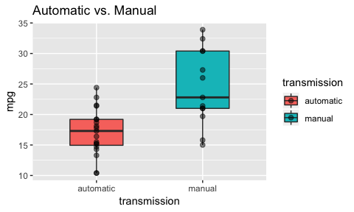

We will now fit several models to understand if the difference is statistically significant, and if the method of predicting MPG using transmission type is useful.

### Model #1

Our first model will consider only MPG and transmission type. Using this simple model, we predict that:

* if a car is automatic it will have a MPG of 17.1474
* if a car is manual it will have a mean of 24.3923

The model also shows us that:

* a low p-value indicates that the the difference is statistically significant
* r-squared of 0.3598 means that there is still a lot of variance not yet explained by the model

|  |  |  |  |  |
| --- | --- | --- | --- | --- |
|  | * Estimate S | * td. Error | * t value P | * r(>|t|) |
| * (Intercept) | * 17.147368 | * 1.124602 | * 15.247492 | * 0.000000 |
| * transmissionmanual | * 7.244939 | * 1.764422 | * 4.106127 | * 0.000285 |

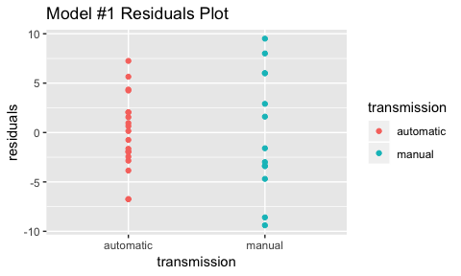

### Model #2

With model #2 we will seek to explain more of the variance by introducing more variables into the model. With the introduction of weight interacting on transmission, our model now tells us that:

* r-squared of 0.833 means that most of the variance is explained by the model
* the residual plot shows no patterns in the data, supporting the model is appropriate
* for automatic transmission cars:
  + the intercept of 31.4160554 is the MPG at the theoretical weight of 0
  + for each 1000lb increase in weight, MPG will change by -3.7859075
* for manual transmission cars:
  + the intercept of 46.2944779 is the MPG at the theoretical weight of 0
  + for each 1000lb increase in weight, MPG will change by -9.084268

One limitation of this model is that there is not a lot of overlap in weight between manual and automatic transmission cars. Generally, manual cars tend to be heavier which also correlates a lower MPG. For example at lighter weights manual cars have a lower MPG.

|  |  |  |  |  |
| --- | --- | --- | --- | --- |
|  | Estimate | Std. Error | t value | Pr(>|t|) |
| (Intercept) | 31.416055 | 3.0201093 | 10.402291 | 0.0000000 |
| wt | -3.785907 | 0.7856478 | -4.818836 | 0.0000455 |
| transmissionmanual | 14.878422 | 4.2640422 | 3.489276 | 0.0016210 |
| wt:transmissionmanual | -5.298361 | 1.4446993 | -3.667449 | 0.0010171 |

