
CS 120 Web Programming
Project 2: Wordle

Tasks
Create the game of Wordle

Objectives
Create an interactive game using HTML/CSS/JavaScript utilizing programming elements and UI/UX.

Requirements

Implement the game of Wordle similar to the NY Times version. In the game, the user gets 6 tries to guess a 5 letter word. Each guess must be a 5 letter word.
IMPORTANT: see the screenshot for a model of how your implementation should appear. You are welcome to add enhancements as long as you meet the requirements.
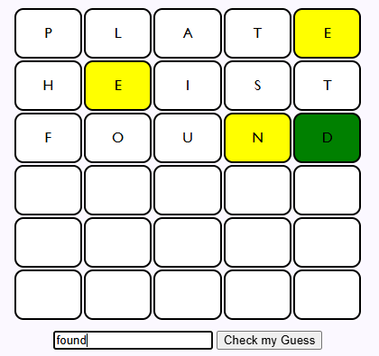

After each guess report the following to the user using a visual cue such as changing the background to indicate the status of each letter.

Letters that are in the correct place. (usually green)

Letters that are in the word but are in the wrong position. (usually yellow)

Note: If a letter appears twice in the guess but only once in the answer, you must eliminate all possible yellow/green responses from with one of the letters and then consider the second letter.
For example – if the answer is create and the guess is tacit
t is yellow
a is yellow
c is yellow
i is grey
t is grey

- Get the guess from the user using an input text field and a button. Note: this is different from the online version.
- Get the answer randomly from a “dictionary” (array) of 5 letter words that you create (you must have at least 30 words).

- Display a used letter board indicating letters used. The used letter board must include a visual indicator of whether the used letter was correct/in the wrong place/ or not in the word. An example is shown below:
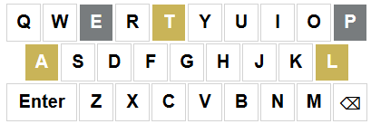
- Display the answer for each game in the console (to assist with debugging)
- Include a button that will restart the game when clicked. Hide the button until the game is won or lost.
- If the user uses up all 6 guesses without guessing the word, show the answer word in a popup (and show the button to restart the game).
- The game should be responsive down to 600px
- You must include the following constructs as a minimum:
- An array
- An arrow function
- An event handler
- .map or .forEach
- A JavaScript class
Example response:
Answer: PRIDE
Guess: DOPED
the D is in the wrong place, yellow
the O is not in the word, grey
the P is in the wrong place, yellow
the E is in the wrong place, yellow
the second D is not in the word, grey
We will be looking for a creative implementation, not merely getting it to work.
You MAY NOT look up how to code the game online – that will be considered cheating.

Optional extra credit: Add an API (10 points)
Incorporate an API – you only need to do ONE of the following:
- Use an API to get a 5 letter word for the answer in real time when the game starts
- Use an API to check if a 5 letter guess word is a valid word
Note: Find a free API. You may need to try more than one to get it to work as you want.

Optional extra credit (5 points):
- Display the average guesses needed for the user on that device over multiple browser sessions (hint- use a cookie)
Important Note: This MUST work online for credit

Rubric:
Deliverables 10 points
Works online and meets all requirements 70 points
Excellent user interface 10 points
Code quality 10 points
Extra credit – up to 15 pts

Hints!
The following are suggestions for the development process of creating your Wordle website as well as how to break this problem down. These are suggestions- not requirements.
- Create the board first.
  - Create a function to do one word and then loop to call it six times.
  - Use a <div> for each of the cells
  - You may add the div’s with document.write
  - Add a class to the <div> to be able to style each letter. Add a second class to identify the position of the letter. Elements can have two or more classes separated by a space
- Add the guess input box and button to submit the guess. Attach an event handler to the button that reads the word entered, validates that the word is 5 letters (display an error if it is not) and displays the word in an alert.
- Change the event handler to place the word in the letter boxes for the first word
- Set a variable to indicate the “current” word – ie, it should move down to the next word after a word is entered. Update the event handler to be able to fill in all 6 words. After the 6th word, display “game over” in an alert.
- Hard code a word to be a guess – update the event handler display in an alert the status or each letter: correct/wrong place/not in word
- Update the event handler to shade letters based on their status – suggestion: add a class to a letter to color it as correct/wrong place
- Update the event handler to report a win or after 6 words, to display the answer word
- After that is all working, then add API, extra credit, other enhancements.

Deliverable worksheet

- All html/css/js files (combine into a compressed/zip file)
- URL for wordle game
URL: https://samfarrington-tufts.github.io/p2/wordle.html

Project requirements- check off those you completed.

- Game is complete and runs online
- An array
- An arrow function
- An event handler
- .map or .forEach
- A JavaScript object
- Used letter board
- Optional: use of an API
- Optional: track average score

Are there any extra features you added that are not listed above?
I decided to create a function that would set the display styles of the user input, “check my guess” button, and the keyboard to “none” after the user correctly guessed the word or ran out of guesses. This allowed me to create a “Restart” button that would appear immediately under the board after the game concluded. While this is a small feature, I believe it improves overall aesthetics of the game. It also prevents the users from trying to submit guesses after the game concluded, which could lead to undefined behavior of the website.

What is your favorite topic in the course so far?
My favorite topic in the course so far has been CSS. Prior to this class, my programming classes were focused on backend programming, so this is my introduction to website design. The problem-solving skills from previous courses have translated well going into this course, however, the creative liberty that CSS provides is new to me. Unlike my previous courses, which were mostly confined to a terminal window, being able to immediately see visual results from the code I write is very satisfying. I’ve enjoyed learning about how changing the size, spacing, colors, and layouts of elements can completely change the aesthetic of a page. Overall, CSS has been my favorite topic because it combines logic with creativity and feels very rewarding to create a visually pleasing website.

