
CS 120 Web Programming
Project 3

Your assignment is to create an interactive e-commerce website utilizing your skills in HTML/CSS/JavaScript/MySQL/PHP. You do not need to build the entire site – only the pages identified below.
Note: the total number of points possible for this assignment intentionally exceeds 100. If you complete everything, you will have extra credit.

Tasks
Your task is to create several pages that would be part of an e-commerce website as well as a database to support the website. Each page must have a logo and navigation that links to each of the other pages (except the thank you page). You are not required to build additional pages unless you want to.
The list of pages is:
- home page
- catalog/products page
- cart page
- thank you page (after ordering)
- admin/orders page
Database: (20 points)
Use MySQL as the database with PHP.
Deliverable for this part is a screen shot of the populated database tables (with data).
Create a database that can store products and orders. You may choose any product type (food, cosmetics, books, clothing, etc). You must have at least 8 products.
- Product data should include: id, name, price, description, url of a product image, and a Boolean called “featured”. Featured is true if the item is to be featured on the home page.
- Each product image should be able to be rendered at the same size (ie, they need to be the same aspect ratio). Product images greater than 70k in size should have their quality or dimensions adjust using https://birme.net or other photo editor.
- The images should be uploaded to the hosting server in a subfolder of the project root folder. Name the subfolder: ”images”.
- Orders should include: id, item id, order date, quantity for up to 5 items.
Optionally, add an Assignment table to allow any number of items to be ordered.

Page: Home page (15 points)
The home page should inform the user about the name of the business, what they sell, and why you might want to use them.
Include a section with featured products (for products with featured = true in the database). All information for this section should come directly from the database.
The section can be presented as a slider or a row of products. Name and Image only should be displayed.
Proper content and styling is required to receive full credit for this page.
Page: Products page (25 points)
Display all products. Create a “card” for each product to include the product image, name, price, and two buttons labeled: “Add to Cart” and “More”.
A possible layout for each product is as follows:
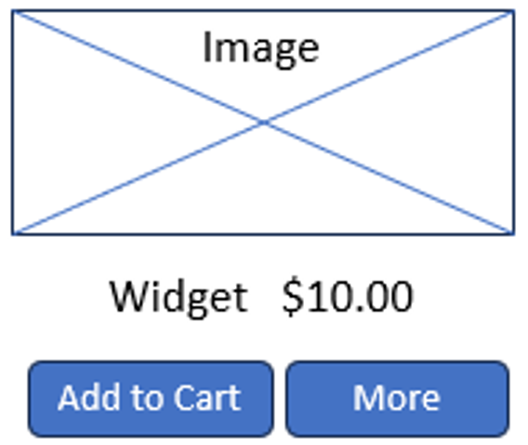

Add to Cart should add the product to a shopping cart list (use a session variable or local storage- do not store in the database) and proceed to the cart page. If an item is added to the cart more than once, add one to the quantity already in the cart.
“More” should reveal a div positioned near or below the buttons containing a description of the product and the text on the button face should change to “Less”.
Clicking “Less” should hide the description and change the text on the button back to “More”.
Pages: Cart page and Thank you page (35 points)
The cart page should display a list of all items currently in the cart. For each item, display the name, quantity, price and total cost for that item. Do not show the image.
Each item should also have a button adjacent to it that is labeled “Remove from cart”. Click the button to remove that item from the display and the cart.
Below the list of cart items, show the total for the order (no shipping or tax calculation is needed). There should also be two buttons: “Check Out” and “Continue Shopping”.
- When “Check Out” is clicked, go to a thank you page which will do the following:
  - store the order in the database and clear the cart. Include a message that thanks the user for their order.
  - List the order total and expected ship date on the page (calculate and display the date to be 2 days from now)
  - Clear the shopping cart
- “Continue Shopping” will go back to the Product page without clearing the shopping cart.
Page: Orders Page (15 points)
Show all orders including the date, order id, order total.
Additionally, for each item in the order, display:
- Item name
- Quantity
- Total cost for that item
The most recent order should be displayed first.

Suggestion: Populate a few orders in the database to test the home and orders pages PRIOR to creating the product and cart pages.

Deliverable Worksheet
__ All code files (combine into a compressed/zip file – do not add the deliverable worksheet to
the zip file)
__ Paste screenshots of each table in the database below
** Images can be found on the following pages
URL for home page: https://samuelf.sgedu.site/p3/home.php
URL for orders page: https://samuelf.sgedu.site/p3/orders.php

Project requirements- check off those you completed.
__ Database created to store orders and products
__ Home Page
__ Products page
__ Cart page
__ “Thank you” page
__ Orders page

Questions: Are there any extra features you added that are not listed above?
No significant additional features. I added 1-2 media rules per page to prevent parts of the page from being cut off when the screen size gets smaller. One of these rules alters the nav bar when the screen gets too small to prevent overlapping of the nav links. I also implemented an alert that prevents the users from checking out with an empty cart. This prevents empty orders from being logged into the database.

What was the most interesting part of this project?
This project and the SQL/PHP assignments were a nice introduction to interacting with databases within our code. The database part was what I was most excited about when completing this project because it felt like a very important skill to have. In my search for a software engineering job, I’ve frequently seen MySQL and PHP as requested skills, which made this project feel even more relevant. This project has highlighted the importance of databases to platforms that manage products and orders. I can also see how applicable these skills would be for developing systems storing user login information, inventory tracking, etc. Therefore, improving my skills with databases and seeing the real-world application of what I was learning was by far my biggest takeaway from this project.

