
CS 120 Web Programming
Assignment 8: Deliverables

- Create and upload a zip file of all code files: fibo.php, assoc_array.php, db1.php, db2.php, any css files
- Part 1 Fibonacci – screenshot from postman.com (paste below)
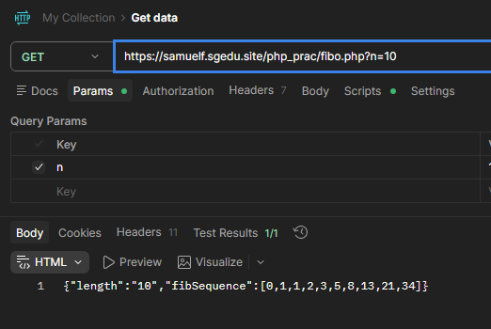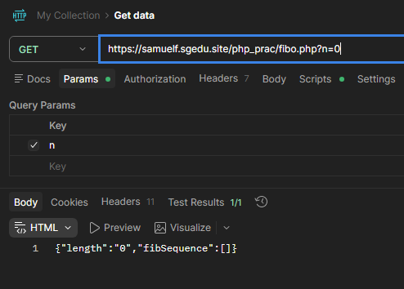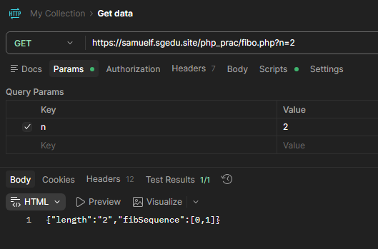
- Part 2 Associative array - URL of assoc_array.php online: https://samuelf.sgedu.site/php_prac/assoc_array.php

- Part 3: Database - URL of db1.php online:
Did not complete

